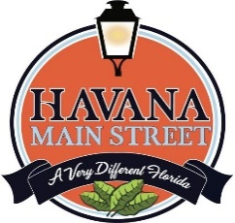Havana Bucks Merchant Enrollment Form
Thank you for joining the Havana Bucks digital gift card network!
Please complete the information below so we can set up your account and promote your business as a participating merchant.

Business Information
Business / Store Name:
Business Street Address:
City / State / Zip:
Business Phone:
Website:
Business Email:

Primary Contact Information
Contact Name:
Title / Role:

Direct Contact Phone:

Direct Email:

Program Participation
Brief Description of Business (for directory / promotion):

Authorization
I certify that the information above is accurate and that our business agrees to participate in the Havana Bucks merchant program.
Authorized Signature: ___________________________________________
Printed Name: _________________________________________________
Date: _________________________________________________________
If you have questions or need more information, contact:
Tony Lombardo Tony.HavanaMainStreet@gmail or
Pat Dudley-Gregory at ED.HavanaMainStreet@gmail.com 850-755-2999

