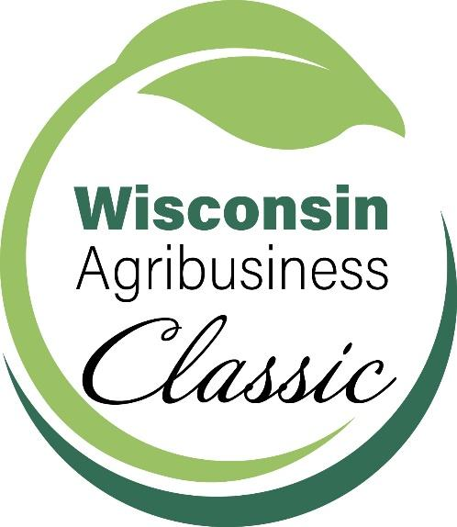

Sponsorship Benefits

Gold Sponsorship - $1,500
Introductory Video of your Organization Featured in a Session (2-3 min.)
Logo on Signage at Evening Reception
Listing on Classic Website
Listing on all Signage
Individual Feature on WABA Social Media
Recognition in the WABA Quarterly Magazine
Full Page Black and White Ad in Show Program
Three free admittance tickets to the Ag Classic ($600 value)

Silver Sponsorship - $800
Listing on Classic Website
Individual Feature on WABA Social Media
Recognition in the WABA Quarterly Magazine
Listing on all Signage
Half Page Black and White Ad in Show Program
Two free admittance tickets to the Ag Classic ($400 value)

Bronze Sponsorship - $500
Listing on Classic Website
Group Feature on WABA Social Media
Recognition in WABA Quarterly Magazine
Listing on all Signage
Quarter Page Black and White Ad in Show Program
One free admittance ticket to the Ag Classic ($200 value)

Friend of WABA Sponsorship - $300
Listing on Classic Website
Listing on all Signage
Listing in the Show Program

