Religious Education Handbook – 2026-2027

Staff: Kathie Brewer, Coordinator of Grades K-5
Sofia Lech, Coordinator of Grades 6-8

Office Hours: June - August 9:00AM - 2:30PM Monday through Thursday
September - May 9:00AM - 3:30PM Monday through Thursday

Voice mail and email is available if we are unable to take your call; kathieb@stjohnwinfield.org 630-682-4400 ext.613 (Kathie) or ext. 612 (Sofia). Calls and emails will be returned as soon as possible.

Class Times: ALL CLASSES MEET ON TUESDAYS

4:30PM - 5:45PM Grades Kindergarten – 5th
6:15PM - 8:00PM Gr 6 biweekly
6:15PM – 8:00PM Gr 7/Confirmation 1 (Yr 1 Conf Prep) biweekly
6:15PM – 8:00PM Gr 8/Confirmation 2 (Yr 2 Conf Prep) biweekly

Emergency Closings
When the public school closes due to inclement weather, we will cancel Religious Ed classes. Please watch your email for closing information. The only way we communicate is through email. If you change your email, please contact us. If the weather becomes inclement enough to cancel classes during the day, we will notify you through email.

Registration Procedure

Registration forms are available on the Parish website (www.stjohnwinfield.org). These may be returned to the RE office anytime, however student placement is on a first come, first serve basis. New families are asked to bring the following items when registering for the first time. The following items are necessary for each child/teen when registering:
Completed registration form (available on website)

Copy of the child’s Baptismal and First Eucharist Certificate *
Completed Diocese of Joliet Permission/Medical Form for Minors (1 per child)
Tuition/material Fee (A $100 deposit is required at time of registration)
Up to date email address

* All sacramental certificates are required for all students upon initial registration; registration will not be processed until these are provided. If your child was baptized at St. John's, please provide the date of Baptism to the Religious Education Office.

Religious Education Philosophy/Mission Statement

Religious Education is primarily the responsibility of parents. Our program builds on this family foundation and uses a life-centered approach throughout all levels of our program.

Parents, children and catechists are involved in the dynamic process of relating the experience of daily living to the insights of the Catholic Christian tradition. Along with this life-centered approach "to teach as Jesus did," the foundation of the Catholic faith is laid in prayer, scripture, service, and doctrine.

Jesus often used the experiences of the people as the starting point of His parables. Catechists will use examples from the child's daily life to draw out the meaning of God's revelation and show its relevance to contemporary life.

Goals
- To help families develop a deeper relationship with Jesus Christ
- To inspire SJB parishioners, adults and children, to develop Christian values and to personalize their Catholic faith through weekly Mass attendance, prayer experiences and prayers
- As Catholic Christians, we are always about service; therefore, to offer Parishioners ways to embrace this call to serve others by learning the teachings of Christ and His Church
- To raise awareness and to foster participation of parents in the formal Religious Education of their children
- To develop Christian spirit among all of our Parish children/teens

We encourage families to utilize their family Bibles as a source of discussion. Other resources, such as At Home with the Word, offer the Sunday readings and reflection questions.

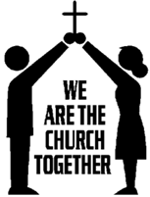

FROM VATICAN II
"Since parents have given children their life, they are bound by the most serious obligation to educate their offspring and therefore, must be recognized as the primary and principal educators. The role in education is so important that only with difficulty can it be supplied where it’s lacking. Parents are the ones who must create a family atmosphere animated by love and respect for God and man, in which the well-rounded personal and social education of children is fostered."
(Declaration on Christian Education)
Parent Role and Responsibility

The Religious Education program is a service to parents. We aid parent/s in their Christian responsibility to raise and educate their children in the Catholic Christian tradition. With encouragement and reinforcement of class activities in the home, the children will truly personalize their faith. It becomes part of their lives rather than a segment of time on Tuesday, Saturday, or Sunday. "Word and example are the first preachers of the Faith to their children." (Vatican II Church, #11).

In support of our program the following is asked from all of our families:
- Participate at Mass on Sundays and Holy Days and receive the Sacraments. This is the most important thing you do to pass on the Faith to your child/ren. Your support of the church in time, talent and treasure is essential.
- Pray with your child/ren daily and stress the power of prayer. Help them memorize prayers.
- Show interest each week in what your child is learning. Spend time each week reviewing the lesson. Your responsibility is not just “drop-off and pick-up”; model for them how you live the Gospel.
- If possible, become an aide or substitute catechist.
- Make sure your child comes to class each week with their binder, books (including their Bible if applicable), any homework and a filled water bottle.
- Help your child be conscientious about the homework given. Memorization of prayers is necessary. See end of handbook for the required prayers.
- If your child is unable to attend a class, be sure to call your child in absent to the REO. (630-682-4400 x 612 or 613 or email to kathieb@stjohnwinfield.org or slech@stjohnwinfield.org). In addition, please be sure to do the weekly lesson as a family and return to the catechist completed. Any missed session should be done at home.

Stewardship

St. John the Baptist Parish embraces Stewardship as a way of life. We recognize the gifts we have received from God. In gratitude for these gifts, we share our time, talent, and treasure with our community. It is in sharing what we have that we truly model Christ to one another.

Gift of Time and Talent
Sharing the gifts of time and talent is an integral part of our faith. Even the very youngest child is encouraged to share their time and talent with the community. Age-appropriate service activities are planned for each grade. The most effective experience in Christian service is for the child to engage in service activities as a family.
The following opportunities are offered in our curriculum:
- Providing canned goods, paper products, cleaning supplies and gift cards for SJB food pantry
- Collecting items for the Vets living at Larson House, Tammy’s Trace and Miller House
- Collecting items for Alex’s Blessing bags – details throughout the year
- Purchasing Christmas gifts/gift cards for needy families and participation in the Wish Tree
- Altar server (for girls and boys in 6th grade and up)
- Helping the Knights of Columbus at the various events they sponsor
- Helping with the Parish Picnic, stuffing the eggs and helping with the Easter Egg Hunt
- Other service opportunities that the parish may offer

Children receive the most benefit from participating in service projects when parents participate, inviting the child to help plan what they will be able to do. Service is a way of life and should be done all the time and every year. Service is not done just to receive a sacrament. We encourage and expect each family to find opportunities volunteer at least once during the school year.

Gift of Treasure
In addition to sharing time and talent, true stewardship encourages us to give from our treasure. Parents should model for their children giving to God (the Church) first.
We ask the children to make sacrifices during Advent and Lent. Sometimes, these sacrifices are connected to monetary donations in support of other service ministries. If money is a requirement for the service, parents are asked to have the child earn the money they donate. Families are encouraged to share their time, talent, and treasure not only within our parish, but in outreach to the larger community as well

Curriculum
Kindergarten, Grades 1, 3, 4, & 5
Lectionary-Based Catechesis using Pflaum Gospel Weeklies

Lectionary-Based Catechesis is a form of instruction based on the readings taken from the Sunday Lectionary. This helps children/teens grow in their faith and grow into our faith community. Every person, in all grades, studies the same Sunday scripture presented and developed for their age. This format offers parents a starting question to share our faith with their children. As an enhancement to this program, we also use a grade appropriate book entitled What the Church Believes and Teaches, to reinforce our Catholic foundation.

2nd grade Sacramental Preparation for First Reconciliation and First Eucharist
REJOICE

Students preparing to receive the sacraments of Reconciliation and Eucharist use two textbooks – REJOICE for Reconciliation and REJOICE for First Eucharist. These textbooks are published by Loyola Press. These texts help children understand and appreciate the incredible gifts we are offered in both sacraments through engaging high-quality videos, fun and interesting activities, and much more.

Grade 6
Encounter

Encounter is a middle school Bible study program from Ascension Press. Students also receive their own BibIe where they read Old Testament stories. They come to know how God remains faithful to us throughout history and the trials and troubles of life. They come to understand His saving plan for us

7th/8th Grade and Confirmation Preparation
Chosen

At the beginning of September, Confirmation 1 students and parents will be asked to attend a meeting where Confirmation material is distributed and the Confirmation Program is explained. By the beginning of October, all forms are to be completed and returned to the office so the next step can be taken towards Confirmation.

Our Confirmation program uses Chosen by Ascension Press. This program consists of 24 lessons designed to provide intellectual and spiritual catechesis for the Confirmand. The goal of the program is to bring about a personal relationship with Jesus Christ not only for the teen but also for their Sponsor and Parent. The name of the program reflects the idea of “God choosing the Confirmand, not the teen choosing God.” Chosen is based on the RCIA model of catechesis/conversion. In addition to the 24 sessions, retreats, Stations of the Cross, Adoration and Penance services are incorporated into the program.

Parents and Sponsors have a role in preparing their confirmand. You will be given a password to Ascension Press to view all the videos. You will also receive a workbook that correlates to the student’s Confirmation book. This program is intended to enhance the faith of both Parent and Sponsor.

Classroom Snacks

Unfortunately, due to allergies and safety concerns, we cannot allow snacks. If your child needs a snack before our session, please feed them at home to protect them and other children

Communication with Parents/ Personal Conference
Communication between the parents, child/teen, Catechist and the Religious Education Office is vital to the success of the program. Catechists are encouraged to communicate weekly/bi-monthly with families. Student’s progress is evaluated at the end of each semester and sent home. Special notes may be distributed to students during class time. Always ask your child for any correspondence and check your email.



PLEASE NOTE: ALL CORRESPONDENCE IS DONE THROUGH EMAIL. Please notify the REO if you have a change of home/email address or telephone number. To make an appointment, please call 630-682-4400 X 613. If you wish to speak with a catechist, call 630-682-4400 X 613 and leave a message. We will contact the Catechist and have her/him call you back

Attendance Policy
Your child/teen is expected to attend every class and to be on time. Please contact the REO if your child/teen is going to be tardy or absent, by phone or email. Since we are meeting in several spaces on campus, if your child is late, they must check in at the RE Office in the school building and be escorted to their class by an adult. Parents will be called if we are not notified. If a message is left on your phone, a return call would be appreciated.
- When a child is absent the child/teen is responsible for acquiring and completing missed work; completed work is to be signed by the parent and turned in to the catechist.
- Two (2) absences without notification indicate a need for a parent/coordinator conference.
- Three (3) absences in a semester questions the readiness for reception of sacraments or advancement to the next grade level
- Four (4) consecutive absences indicate a withdrawal.

All tardiness or early dismissals must be cleared with the REO.

Standards for Behavior

“Where there is no vision the people get out of hand; happy are they who keep the law.” Proverbs 29:18

Discipline is integral - it promotes within each child the development of a solid system of moral values. Good discipline is based on the fundamental Christian principle of thoughtfulness and responsibility toward others.

Parents, please review the following guidelines with each child/teen. Impress on them the importance of respecting others and their property. During the first session, each catechist will establish with his/her group their Rules of Behavior.
- This is your parish – take pride in belonging and respect the buildings and people within. All private property on the premises must not be disturbed.
- Each of us is unique and valued individuals to be respected. Children/teens must respect the rights of catechists, their aides, fellow classmates, and guests in the classroom through action and language. Appropriate behavior is expected in Church, class, and any other meeting area.
- Children/teens bring their binder, materials and for Grades 6 - Confirmation 2 Bible to every class. Parents/children/teens are required to replace lost or destroyed materials.
- All clothing should reflect the values of modesty and respect. Just as is expected in the sacred space of the church, clothing should not be low-cut, skin-tight, or see-through. Shoulders and midriff must be covered. Any inscriptions on clothing should reflect Chirstian values. Clothing with alcohol, cigarette, profanity, and/or sexual references will not be tolerated.
- No hats or gum chewing will be allowed on the grounds or in the buildings.

A positive atmosphere is encouraged throughout the year. Children/teens disrupting this atmosphere are disciplined in the following manner:

1st Offense – The child/teen is removed from the class/function and taken to the REO. Depending on severity of problem, a talk with Coordinator regarding the offense usually is sufficient. Missing work must be made up.

2nd Offense - In addition to the above, a call is placed to the parent/s to come immediately and pick up the child/teen. A conference between the Coordinator, the Catechist and the parent is scheduled.

3rd Offense - Permanent removal from the program for the remainder of the program year.

When a child/teen’s classroom behavior does not meet the Standards of Behavior policy he/she is asked to complete the religious education lessons at home as an alternative. The above policy is in effect for all Religious Education functions. It is enforced at the discretion of the Religious Education staff.

Drop Off and Pick Up Procedure (see diagram)

Our drop off and pick up procedure remains the same. Please enter the parking lot from Sunnyside through the southeast entrance. Form one line and proceed in a large circle around the parked cars, until you arrive at the drop off point. A staff member will direct all cars. Please do not let your child get out of the car unless you are in the drop off zone. At no time should a child walk between cars. After dropping off, exit the parking lot onto Sunnyside, using the driveway south of the gym. Follow the same procedure to pick up your child. If you choose to walk your child to the door, please park your car in parking lot C and wait until the staff member tells you to cross. For safety purposes – no child will be able to walk into any parking lot without a parent or guardian walking with them. Please do not drop your child off in the front of the school building or along the side between the school and the Church. Please do not park your car in the drop-off lane.
Catechists at all sessions, park in the lot between the Church and school. Parents do not park in this area.

Sunnyside Avenue

Gym

SCHOOL

Entering and Leaving the Building

- RE Students must enter the school building through the northeast school entrance, door #10.
- Students assemble in School Hall (St. Cecilia) to pray together before going to their assigned class location.
- At the end of class Catechists/and or aides will escort students to the same door #10, Students are dismissed through the northeast school doors only!
- For safety reasons, running is not permitted at any time in the school or church buildings.
- Parents pick up their children/teens in the coned off area.

Diocese of Joliet Policies

The PROTECTING GOD'S CHILDREN™ Program
“The Ad Hoc Committee for Sexual Abuse of the United States Conference of Catholic Bishops (USCCB) developed the document Charter for the Protection of Children and Young People. It was approved by the full body of U.S. Catholic bishops at its June 2005 General Meeting and has been authorized for publication.”
Out of concern for the safety and well-being of children, every diocesan, parish, school or religious education employee/volunteer who has significant or sustained contact with children is to participate in the Protecting God's Children Program, a seminar designed to protect children from sexual abuse. The seminar will identify the risks and give information to prevent child sexual abuse from occurring. All adult volunteers working with children are mandated by our Bishop to attend this seminar and to complete a form whereby agreeing to a background check.
Of all the safe environment programs available, Protecting God's Children was selected for the Joliet Diocese. It was determined to be the best possible program primarily because it is comprehensive, professional and appealing. Additional Information Related to Protecting Children at the Diocese of Joliet: Go to http://www.dioceseofjoliet.org then click on Office of Youth Protection. All PGC workshops are offered online only. If you have any questions, call Kathie at 630-682-4400 ext.613 for assistance.

Diocese of Joliet Permission/Medical Release Form

Annually, the Diocese requires that each family complete a Permission/Medical Release form. The Medical Release form allows the Religious Education Staff or anyone in charge to administer first aid and/or for transport of the child/teen by ambulance to treat a medical emergency. The form states that the parent/guardian will be notified promptly in the event of a serious illness or accident. Insurance, doctor and emergency contact information is also included.
The Permission lists a Code of Behavior and Expectations. It also gives permission for videos, photos and virtual platforms. These forms are available at registration and on the website.

Policy Regarding Preparation for Sacraments
One should never stop growing in love of Jesus Christ and His Church and in knowledge of the Catholic faith. For this reason, enrollment in religious education is the norm for children and youth.
Parents seeking to register a child in the religious education and sacramental preparation program at a parish should themselves be registered parishioners who actively practice their Catholic faith. When registering a child, parents should do so at the earliest possible date to ensure placement in the parish program. In the first year of enrollment, parents will need to bring a copy of the child’s baptismal certificate showing the church and city of the baptism.
Because children have reached an age of reason and maturity that enables them to understand the significance of the sacraments they are preparing to receive, the diocese requires two consecutive years of catechesis in preparation of receiving First Communion and Confirmation. When, out of necessity, families relocate to a new parish at the end of a first year of sacramental preparation, they will need to provide verification to the receiving program that a previous year of catechesis was completed.
Diocese of Joliet Anti-Bullying Policy
All religious education and other programs for youth in the Diocese of Joliet shall actively seek to provide a supportive, caring environment in which all people are safe from all forms of intimidation including bullying, which is unacceptable, unchristian, and strictly prohibited. For the purpose of this policy, bullying is defined in conformity with Illinois Law as follows: “Any severe or pervasive physical or verbal act or conduct, including communications made in writing or electronically, directed toward a student or students that has or can be reasonably predicted to have the effect of one or more of the following: (1) Placing the child/youth in reasonable fear of harm to the child/youth’s person or property; (2) Causing a substantially detrimental effect on the child/youth’s physical or mental health; (3) Substantially interfering with one/more child’s or one/more youth’s academic performance; or (4) Substantially interfering with one/more child’s or one/more youth’s ability to participate in or benefit from the services, activities, or privileges provided by a parish.” 105 ILCS 5/27-23.7

Bullying Conduct - Bullying conduct covered by this policy is conduct that occurs on parish property or at parish sponsored activities or events; while children/youth are being transported or walking to or from the parish or parish sponsored activities or events; while children/youth are waiting in transportation pick-up/drop-off zones; or cyber bullying as defined hereinafter.
Cyber Bullying - This policy prohibits bullying and intimidation of children/youth through the use of internet and social media sites on any electronic device (private, public, or parish owned), whether on or off the parish campus, or during non-attendance hours. Any child/youth who engages in bullying will be subject to appropriate discipline, up to and including suspension or expulsion and referral to local law enforcement. Behavioral interventions may be included as a component of the disciplinary actions. This may include but is not limited to mandatory counseling.
104 Retaliatory behaviors by a child/youth accused of bullying will also incur consequences. False accusations of bullying will result in disciplinary action being taken against the accuser. Any reported bullying issue will be promptly brought to the attention of the appropriate party: the Pastor or Director of Religious Education/Parish Catechetical Leader or designee, and there after investigated. Reference: The Illinois School Code, 105 ILCS, 5/27-23.7

.Epi Pen Procedures
Some children/youth in our faith formation programs may have severe allergic reactions to such things as peanuts or bee stings. All parents bringing children with severe allergies who may need to receive immediate emergency medication, such as an EpiPen, should fill out the revised Permission to Administer Medication form, Appendix 15 in the policy and procedures area of Faith Formation in the Diocese of Joliet, found on the REO website. Parents should never drop off an EpiPen or other medication for their child without providing legal permission and instructions for administering it. Ideally, the child should bring his or her own medication with him/her each time he/she comes to the RE session, leave it with the catechist, and take it home after the session is over. If the catechist is not the person who will assist or administer the medication, he or she should know the procedure for obtaining immediate alternate assistance. Who would administer or assist the child in administering the injection is decided by the parish. Obviously, a trained person is preferable, but any parish personnel or volunteer may do this - only if the medication permission has been signed. The parents should provide instructions, preferably in person to the catechist, the leader and if possible, another person as backup. Please note that even when an EpiPen is administered, its effects are only temporary. The child will still need immediate medical treatment, so someone should call 911. A notation on the class roster next to the child’s name as to the medication and a procedure should be listed so that if a substitute is in the classroom they would also have the information.

Everyone who has regular contact with a child with known food allergies should be informed. Other parents in the child's class should be told that another (unnamed) child in their child's session has an allergy — and request that they never send food items to religious education containing this allergen. Many programs have food-bans already in place, but it is best not to assume that no child would ever bring food. Educating other families about the seriousness of the affected child's allergy is good practice.

Questions about this can be directed to the Office of Catechetical Formation at 815-221-6142.

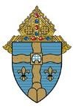
Diocese of Joliet
Department of Catechesis & Evangelization
Office of Catechetical Formation
MEDICAL PROVIDER AUTHORIZATION FORM
PRESCRIPTION MEDICATION
Student’s Name: | DOB:
School: | Grade:
Diagnosis:
DAILY MEDICATION
Medication:  1. | Dosage: | Route: | Frequency: | Start Date: | Stop Date: | Side Effects:
2.
AS NEEDED OR PRN MEDICATION
Medication:  1. | Dosage: | Route: | Frequency: | Start Date: | Stop Date: | Side Effects:
2.
MEDICAL PROVIDER CONSENT
I authorize the school to the give the above medication(s) to this student.

Asthma Inhalers and Epi-Pens Only: This student and his/her parents have been instructed in self-administration and the student may carry an inhaler or Epi-Pen and self administer at school. Yes No
Print Medical Provider Name: | Date:
Medical Provider Signature:
PARENT CONSENT
I give the school permission to administer the above medications as directed by the medical provider. Inhaler/EpiPen Only: My child may or may not carry and self-administer.

The Precepts of the Church

The Precepts of the Church describe the minimum effort we must make in prayer and in living a moral life. All Catholics are called to move beyond the minimum by growing in love of God and love of neighbor.
The Precepts are as follows:
- Attendance at Mass on Sundays and Holy Days of Obligation
- Confession of serious sin at least once a year
- Reception of Holy Communion at least once a year during the Easter season
- Observance of the days of fast and abstinence
- Providing for the needs of the Church
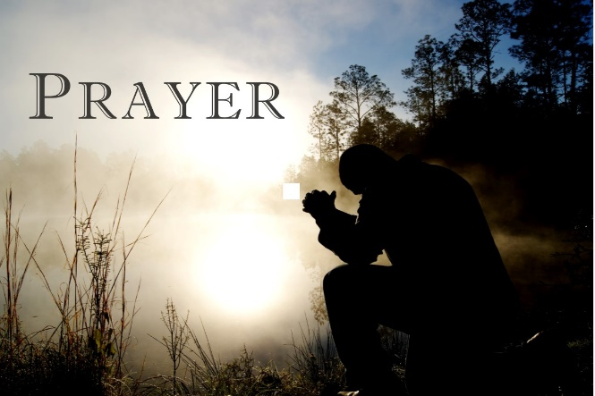

PRAYERS (Should be memorized)
Grades 6, 7, 8
All prayers Pre - 5 plus Nicene Creed, Prayer of the Dead and Prayer to the Holy Spirit
Grades 4 & 5
All the prayers for Pre - 3 plus the Apostles’ Creed and Mass responses
Grades 2 & 3
All the prayers for Preschool & Grade 1 plus Act of Contrition
Preschool & Grade 1
Sign of the Cross, Our Father, Hail Mary, Glory Be, Grace before meals.

Sign of the Cross
In the name of the Father, and of the Son and of the Holy Spirit. AMEN

Grace before Meals
Bless us O Lord, and these thy gifts which we are about to receive, from thy bounty, through Christ Our Lord. AMEN

Our Father
Our Father, who art in heaven, hallowed be Thy Name. Thy kingdom come, thy will be done on earth as it is in heaven. Give us this day our daily bread and forgive us our trespasses, as we forgive those who trespass against us and lead us not into temptation, but deliver us from evil. AMEN

Hail Mary
Hail Mary full of grace, the Lord is with you. Blessed are you among women, and blessed is the fruit of thy womb, Jesus. Holy Mary, Mother of God, pray for us sinners, now and at the hour of our death. AMEN

Glory Be
Glory be to the Father and to the Son and to the Holy Spirit, as it was in the beginning, is now and ever shall be, world without end. AMEN

Act of Contrition
My God, I am sorry for my sins with all my heart. In choosing to do wrong, and failing to do good, I have sinned against You, whom I should love above all things. I firmly intend, with Your help, to do penance, to sin no more, and to avoid whatever leads me to sin. Our Lord, Jesus Christ, suffered and died for our sins. In his name, my God, have mercy. AMEN

Apostles’ Creed
I believe in God, the Father Almighty, Creator of heaven and earth, and in Jesus Christ, His Only Son, our Lord, Who was conceived by the Holy Spirit, born of the Virgin Mary, suffered under Pontius Pilate, was crucified, died and was buried; he descended into hell; on the third day He rose again from the dead;
He ascended into heaven, is seated at the right hand of God the Father Almighty; from there He will come to judge the living and the dead. I believe in the Holy Spirit, the holy Catholic Church, the communion of saints, the forgiveness of sins, the resurrection of the body, and life everlasting. AMEN

Nicene Creed
I believe in one God, the Father almighty, maker of heaven and earth, of all things visible and invisible. I believe in one Lord Jesus Christ, the Only Begotten Son of God, born of the Father before all ages. God from God, Light from Light, true God from true God, begotten not made, consubstantial with the Father; through him all things were made. For us men and for our salvation he came down from heaven and by the Holy Spirit was incarnate of the Virgin Mary, and become man.

For our sake he was crucified under Pontius Pilate, he suffered death and was buried, and rose again on the third day in accordance with the Scriptures. He ascended into heaven and is seated at the right had of the Father. He will come again in glory to judge the living and the dead and his kingdom will have no end.

I believe in the Holy Spirit, the Lord, the giver of life, who proceeds from the Father and the Son, who with the Father and the Son is adored and glorified, who has spoken through the prophets. I believe in one, holy, catholic and apostolic Church. I confess one baptism for the forgiveness of sins and I look forward to the resurrection of the dead and the life of the world to come. AMEN

Prayer of the Dead
Eternal rest grant unto them, O Lord. And let perpetual light shine upon them. May their souls and the souls of all the faithful departed, through the mercy of God rest in peace. AMEN

Prayer to the Holy Spirit
Come, Holy Spirit, fill the hearts of your faithful, and kindle in them the fire of your love. Send forth your Spirit, O Lord, and our hearts will be created. And you will renew the face of the world. O God, who taught the hearts of the faithful by the light of the Holy Spirit, grant us by the same Spirit to delight in what is right and always to rejoice in his consolation. Through Jesus Christ our Lord. AMEN

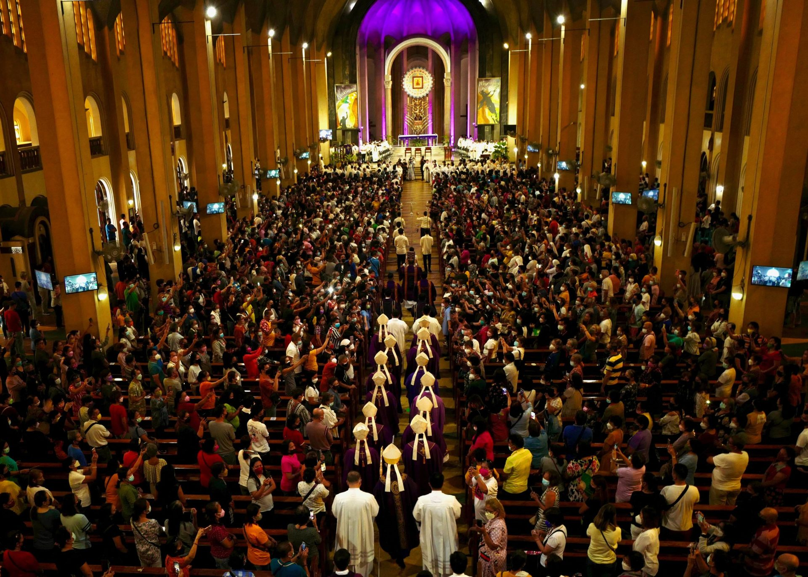
Mass Responses

Greeting
Priest: The Lord be with you.
People: And with your spirit.

Kyrie of Lord have mercy
Lord have mercy
Christ have mercy

Or

Confiteor
I confess to Almighty God, and you, my brothers and sisters, that I have greatly sinned in my thoughts and in my words, in what I have done and in what I have failed to do, through my fault, through my fault, through my most grievous fault; therefore I ask Blessed Mary, ever virgin, all the angels and saints and you, my brothers and sisters, too pray for me to the Lord out God.

Gloria
Glory to God in the highest, and on earth peace to people of good will. We praise you, we bless you, we adore you, we glorify you, we give you thanks for your great glory, Lord God, heavenly King, o God, almighty Father. Lord Jesus Christ, only Begotten Son, Lord God, Lamb of God, Son of the Father, you take away the sins of the world, have mercy on us, you take away the sins of the world, receive out prayer, you are seated at the right hand of the Father, have mercy on us. For you alone are the Holy One, you alone are the Lord, you alone are the Most High Jesus Christ, with the Holy Spirit, in the glory of God the Father. Amen

After Readings
Thanks be to God

Before Gospel
Glory to you O Lord (make sign of cross on forehead, lips and over heart)

After Gospel
Glory to you, Lord Jesus Christ

Invitation to Prayer
Priest: Pray brethren, that my gift and yours may be acceptable to God the almighty Father.
People: May the Lord accept the sacrifice at your hands for the praise and glory of his name, for our good and the good of all his holy Church.

Preface
Priest: The Lord be with you.
People: And with your spirit.
Priest: Lift up your hearts.
People: We lift them up to the Lord.
Priest: Let us give thanks to the Lord our God.
People: It is right and just.

Holy, Holy, Holy
Holy, holy, holy Lord God of hosts. Heaven and earth are full of your glory. Hosanna in the highest. Blessed is he who comes in the name of the Lord. Hosanna in the highest.

The Mysteries of Faith
Priest: The mystery of faith
People: We proclaim your death O Lord, and profess your Resurrection until you come again.
Or
When we eat this Bread and drink this Cup, we proclaim your death O Lord, until you come again.
Or
Save us, Savior of the world, for by your Cross and resurrection you have set us free.

Sign of Peace
Priest: The peace of the Lord be with you always.
People: And with your spirit.

Invitation to Communion
Priest: Behold the Lamb of God, behold him who takes away the sins of the world. Blessed are those call to the supper of the Lamb.
People: Lord, I am not worthy that you should enter under my roof, but only say the word and my soul shall be healed.

Response when receiving Communion
Priest or Eucharistic Minister: The Body of Christ
People: AMEN

Concluding Rites
Priest: The Lord be with you.
People: And with your spirit.

Priest blesses the congregation.
People: AMEN

Priest or Deacon sends us forth.
People: Thanks be to God

