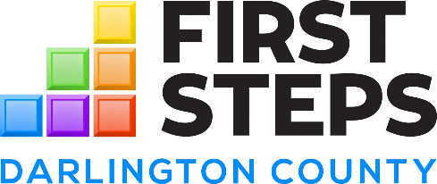
Darlington County First Steps Board Meeting
Tue, Nov 12, 2024
Present: Vice Chair, Lucretia Bellamy and Lilkenya Jenkins, Barbara Carraway
Absent: Howard Nettles (excused), Linda George (excused), Rudell Dubose (excused) Thomas T.C. Sawyer (unexcused)
Staff Present: Darnell Byrd McPherson, Britney Dargan, Jacqueline Bowman, Elijha Enoch, Whitney Davis
MEETING MINUTES
The meeting discussed updates on the new state director, who aims to improve training opportunities for child care providers despite budget limitations. Darnell voiced concerns regarding the upcoming recount and the difficulties associated with provisional ballots, while also celebrating a new five-year grant to hire a community health worker. The team expressed enthusiasm for ongoing community programs, such as men's meetups and educational initiatives, underscoring the importance of early intervention and collaboration with local organizations. Lucretia's dedication to supporting South Carolina's youth emphasized the meeting's focus on promoting positive change and community involvement.
Updates on State Department Changes
Darnell Byrd McPherson confirmed the appointment of a new state director, while Lucretia Bellamy elaborated on the ongoing division of DHEC into two separate departments. She expressed satisfaction with the decision to streamline operations, mentioning that the new department may be named the Department of Health Finance. The transition is anticipated to occur in phases.
Updates on New Director and Training Initiatives
Darnell Byrd McPherson introduced the new state director, who is expected to bring valuable experience to the position. Although they have not yet met, she has expressed interest in collaborating with state and federal organizations to provide training for child care providers. This initiative aims to enhance professional development opportunities within the sector.
Updates on Grants, Programs, and Community Engagement
Darnell Byrd McPherson expressed concerns about the lack of appointments to the board by the legislative delegation and shared positive news about receiving a five-year grant to hire a community health worker. The team is also working on several smaller grants and initiatives, including men's meetups and adult education programs, to effectively engage the community. Elijha Enoch and Whitney Davis contributed to the discussion, emphasizing the importance of these initiatives.
* Updates on grants received and funding for community health initiatives.
* Engagement strategies for male involvement in child development programs.
Community Engagement and Support for Children
Lucretia Bellamy shared her excitement about collaborating with others to support South Carolina's youngest citizens. She highlighted the crucial role of early education and the lasting impact that teachers can have on children's lives. Bellamy urged her colleagues to continue striving for excellence, as their efforts can significantly influence the future of these children.

