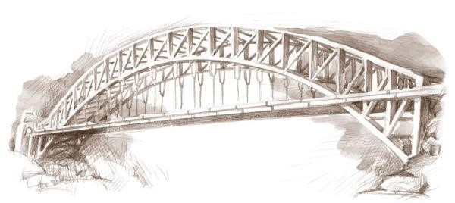
Bridges Community Center
Partners in Recovery

Peer Support, Advocacy and Empowerment for Adults Recovering with Mental Illness.
MAY 2026
MENTAL HEALTH AWARENESS MONTH
MONDAY | TUESDAY | WEDNESDAY | THURSDAY | FRIDAY
 | TUESDAY 10:00  HOW TO  SHARE AND WRITE  YOUR MH STORY | MENTAL  HEALTH  MATTERS | MENTAL HEALTH  AWARENESS  THURSDAYS AT 1 | 1  10-COLOR & JOURNALING  11-WALKING GROUP  12-CLOSED ART GROUP 4 PAINT PARTY  1-SOBEROKEE
4  9-LIGHTHOUSE CLIMB  10-WOMENS GROUP  11-BIPOLAR SUPPORT  12-TBI SUPPORT  1-SMART | 5  9-DEPRESSION SUPPORT  10-CREATIVE WRITING  11-SCHIZOPHRENIA AND SCHIZOAFFECTIVE SUPPORT  12-WALKING GROUP  1-ANGER MANAGEMENT | 6  10-AUTISM SUPPORT  11- LGBTQ+  12- WALKING GROUP  1-WRAP  2:30-TRAUMA RECOVERY  ROSIE 9:00-10:00 | 7  9-SKILLS 4 LIFE  10-MENS GROUP  11-BPD & DID  12-WALKING GROUP  1-MENTAL HEALTH AWARENESS  2:30-RELATIONSHIP  RECOVERY/ WOMEN ONLY | 8  10-COLOR & JOURNALING  11-ART  12-WALKING GROUP  1-SOBEROKEE
11  9-ANXIETY & PANIC SUPPORT  10-WOMENS GROUP  11-BIPOLAR SUPPORT  12-TBI SUPPORT  1-SMART  RIVER 8:45-9:45 | 12  9-DEPRESSION SUPPORT  10-CREATIVE WRITING  11-SCHIZOPHRENIA AND SCHIZOAFFECTIVE SUPPORT  12-WALKING GROUP  1-ANGER MANAGEMENT | 13  10-AUTISM SUPPORT  11- LGBTQ+  12- WALKING GROUP  1-WRAP  2-TX COURT  2:30-TRAUMA RECOVERY | 14  9-SKILLS 4 LIFE  10-MENS GROUP  11-BPD & DID  12-WALKING GROUP  1-MENTAL HEALTH AWARENESS  2:30-RELATIONSHIP  RECOVERY/ WOMEN ONLY | 15  10-COLOR & JOURNALING  11-ART  12-WALKING GROUP  1-SOBEROKEE  VIVENT TESTING 12:00-2:30
18  9-ANXIETY & PANIC SUPPORT  10-WOMENS GROUP  11-BIPOLAR SUPPORT  12-TBI SUPPORT  1-SMART | 19  9-DEPRESSION SUPPORT  10-CREATIVE WRITING  11-SCHIZOPHRENIA AND SCHIZOAFFECTIVE SUPPORT  12-WALKING GROUP  1-ANGER MANAGEMENT | 20  10-AUTISM SUPPORT  11- LGBTQ+  12- WALKING GROUP  1-WRAP  2-TX COURT  2:30-TRAUMA RECOVERY  5:00-OPEN HOUSE  6:00-NAMI VIGIL | 21  9-SKILLS 4 LIFE  10-MENS GROUP  11-BPD & DID  12-WALKING GROUP  1-MENTAL HEALTH AWARENESS  2:30-RELATIONSHIP  RECOVERY/ WOMEN ONLY | 22  10-COLOR & JOURNALING  11-ART  12-WALKING GROUP  1-SOBEROKEE
25  CLOSED FOR HOLIDAY | 26  9-DEPRESSION SUPPORT  10-CREATIVE WRITING  11-SCHIZOPHRENIA AND SCHIZOAFFECTIVE SUPPORT  12-WALKING GROUP  1-ANGER MANAGEMENT | 27  10-AUTISM SUPPORT  11- LGBTQ+  12- WALKING GROUP  1-WRAP  2-TX COURT  2:30-TRAUMA RECOVERY | 28  9-SKILLS 4 LIFE  10-MENS GROUP  11-BPD & DID  12-WALKING GROUP  1-MENTAL HEALTH AWARENESS  2:30-RELATIONSHIP  RECOVERY/ WOMEN ONLY | 29  10-COLOR & JOURNALING  11-ART  12-WALKING GROUP  1-SOBEROKEE
Phone: 262-657-5252 Fax: 262-657-7414 5718 7th Avenue ® Kenosha, WI 53140

https://www.facebook.com/facebook.comwalkamileinourshoes/

