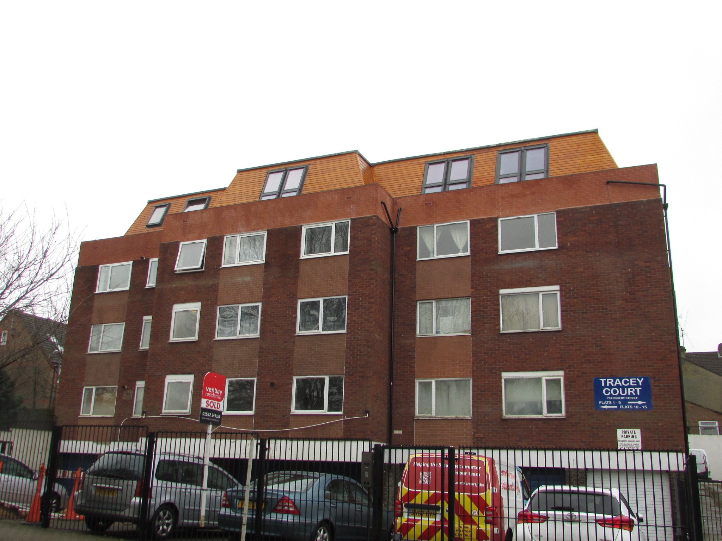
TRACEY COURT
Hibbert Street, Luton, Bedfordshire, LU1 3XH
Freehold Block & Income-Producing Flats
Guide Price: £1,400,000
A rare opportunity to acquire the freehold interest plus 8 individual flats in a purpose-built residential block arranged over ground and three upper floors. The asset also includes 7 garages, off-street parking, and ongoing ground rent/service charge income. | Investment  Highlights
Overview
Tracey Court comprises 20 self-contained flats together with 7 garages and off-street parking, creating several income streams within a single freehold block.
The sale includes the freehold interest and 8 flats in total: 3 two-bedroom units and 5 one-bedroom units.
In addition to rental income from the included flats, the freehold generates continuing ground rent and service charge income from the remaining flats, with potential future value from lease extensions.
Key Facts
Asset Type | Freehold residential block investment
Included in Sale | Freehold plus 8 flats (3 x 2-bed and 5 x 1-bed)
Additional Assets | 7 garages and off-street parking
Income Sources | Rental income, service charge, ground rent, and potential lease extension premiums
Flats Included in the Sale
Flat | Type | Size | Guide Value
9 | 2-bed | 48 sqm | £175,000
12 | 2-bed | 52 sqm | £175,000
15 | 2-bed | 52 sqm | £175,000
16 | 1-bed | 32 sqm | £135,000
17 | 1-bed | 30 sqm | £135,000
18 | 1-bed | 37 sqm | £135,000
19 | 1-bed | 31 sqm | £135,000
20 | 1-bed | 30 sqm | £135,000
Location & Investment Highlights
Location  • Approximately 31 miles north of London and close to Luton town centre.  • Minutes from London Luton Airport.  • Luton railway station offers direct services to London St Pancras in around 25-30 minutes.  • Good access to the M1 via Junctions 10 and 11. | Why it stands out  • Multiple income streams from flats, garages, ground rent and service charges.  • Rare freehold block opportunity in an established commuter market.  • Strong local rental demand supported by commuters, airport employment and relative affordability versus London.  • Potential future upside through lease extension premiums and capital growth.
Floor plans received and added for Flats 16, 17, 18, 19 and 20.

Flat 16 Floor Plan
Tracey Court, Hibbert Street, Luton
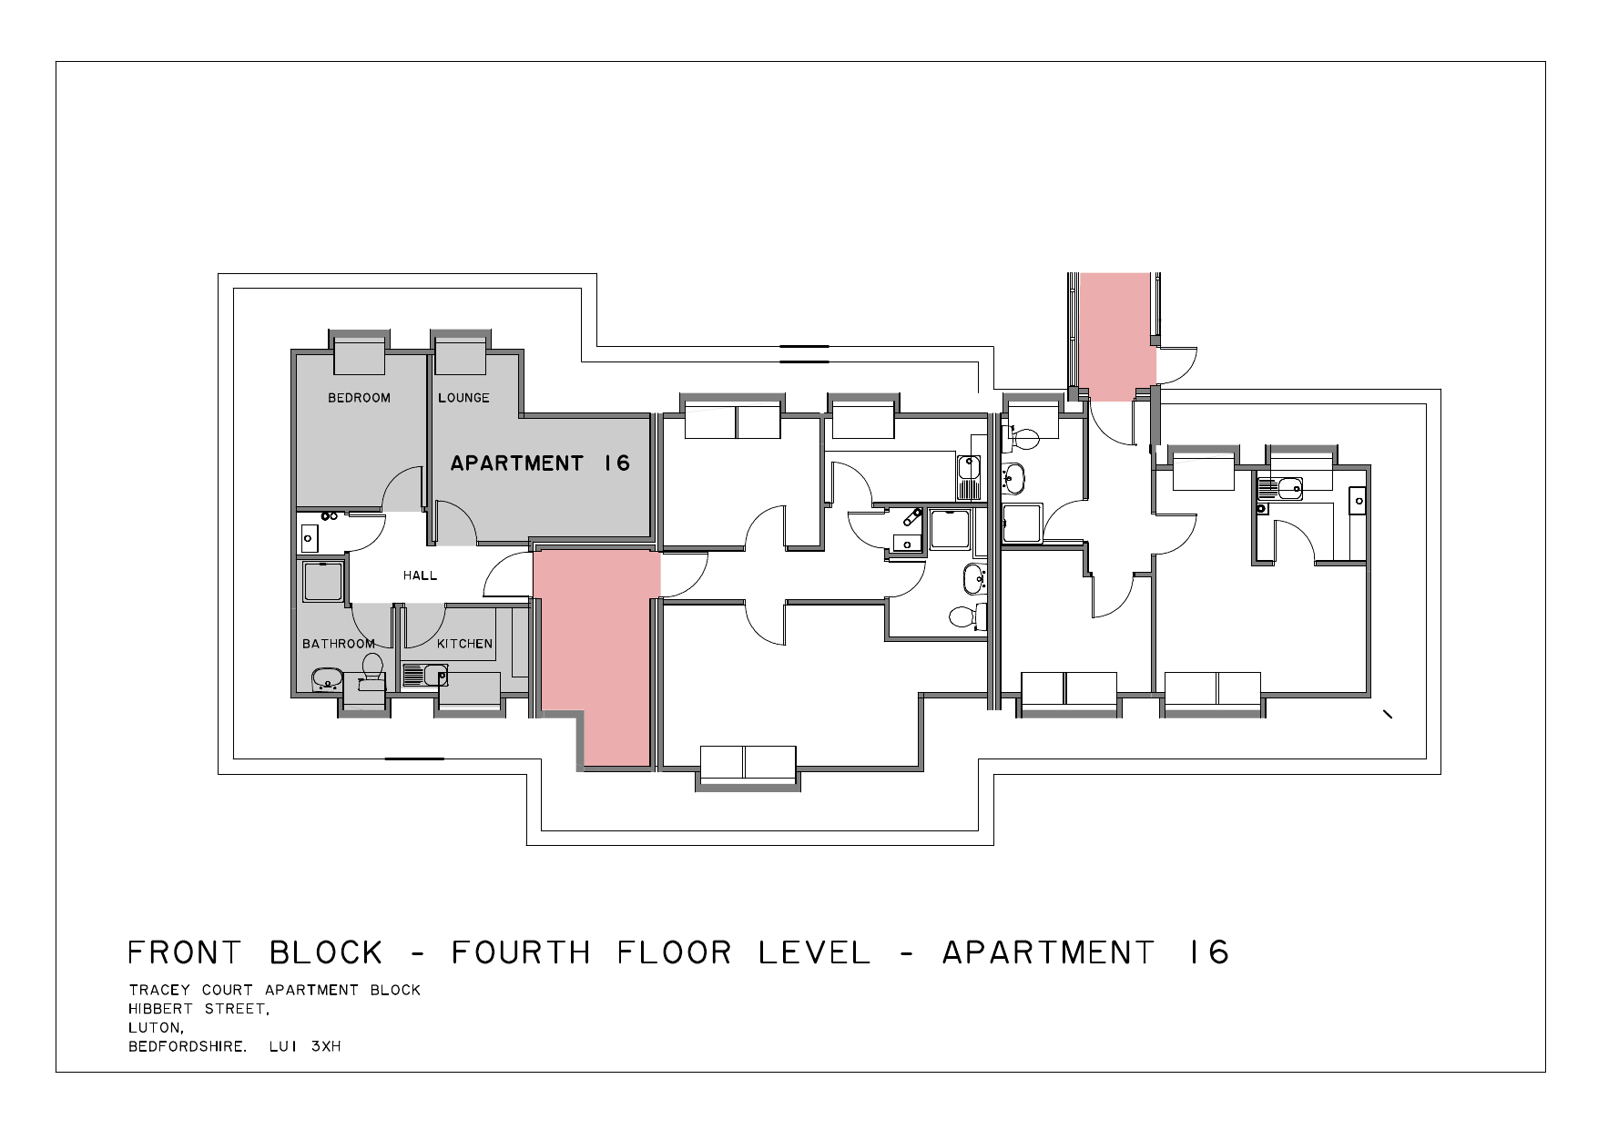

Flat 17 Floor Plan
Tracey Court, Hibbert Street, Luton
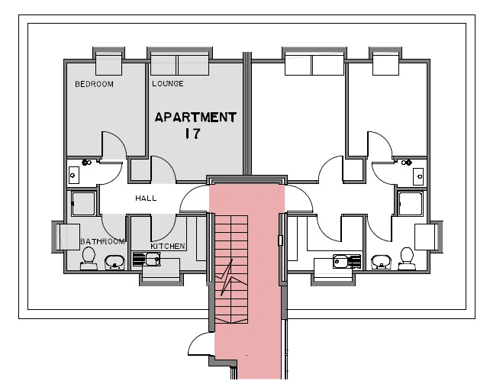

Flat 18 Floor Plan
Tracey Court, Hibbert Street, Luton
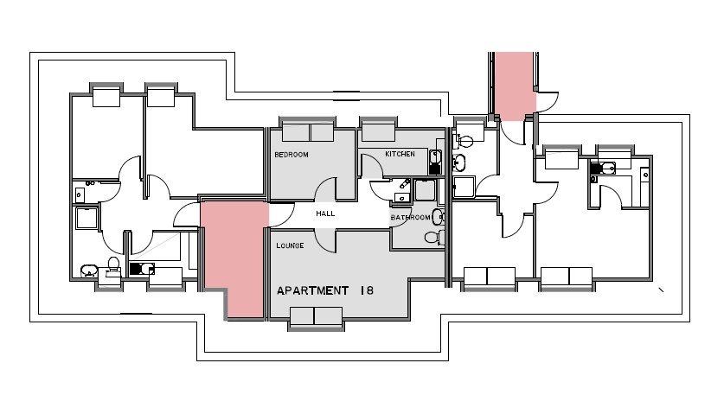

Flat 19 Floor Plan
Tracey Court, Hibbert Street, Luton
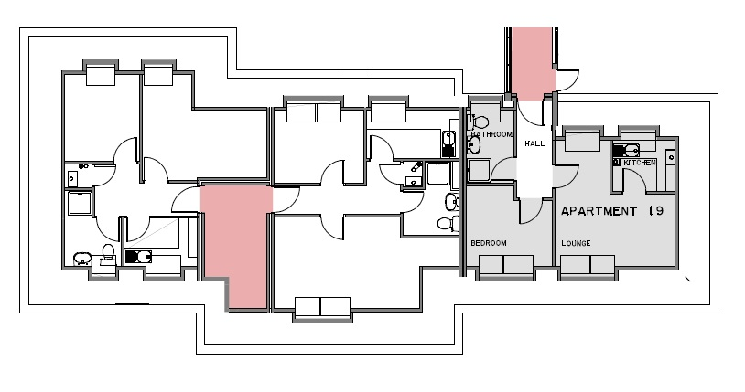

Flat 20 Floor Plan
Tracey Court, Hibbert Street, Luton
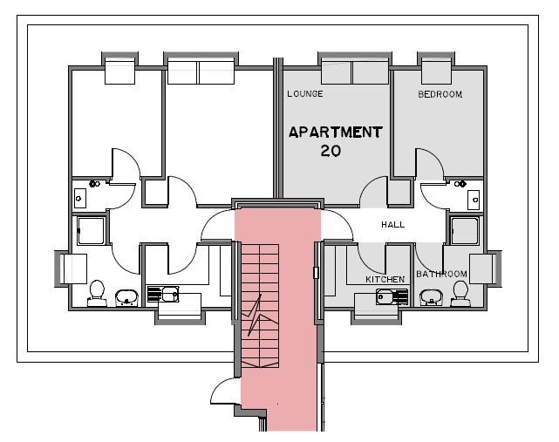
For further information contact Sam Bains 07850 520642 or Sabbi Bains 07894 414046

Property Photography
Selected external and outlook images. Each photo is shown once only.
Front elevation | 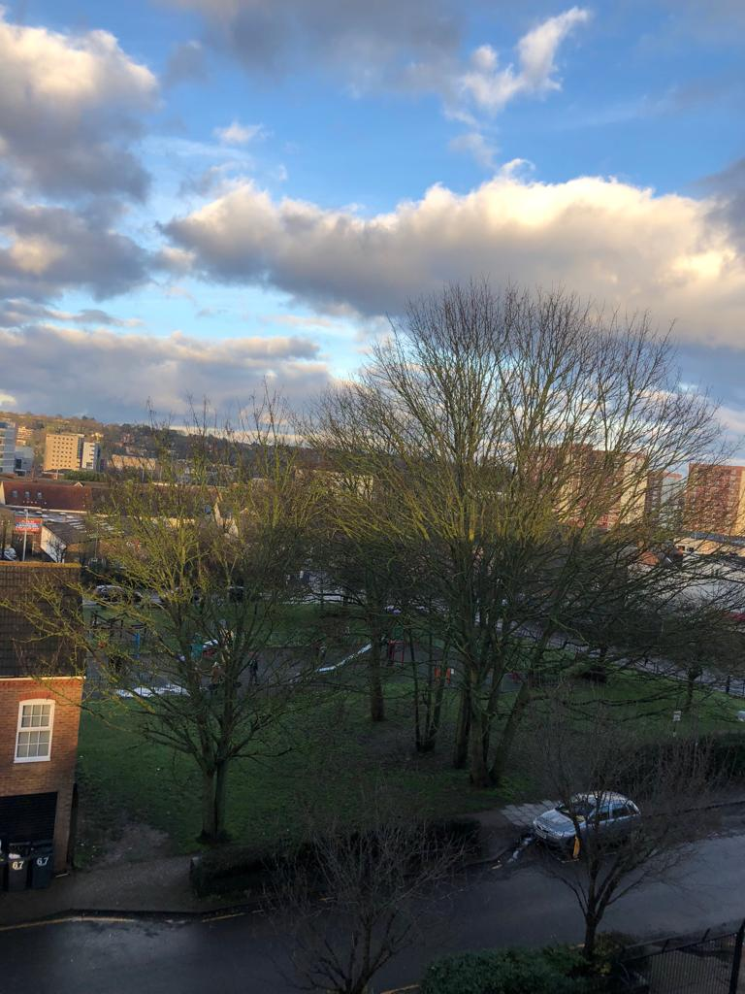  View from apartment
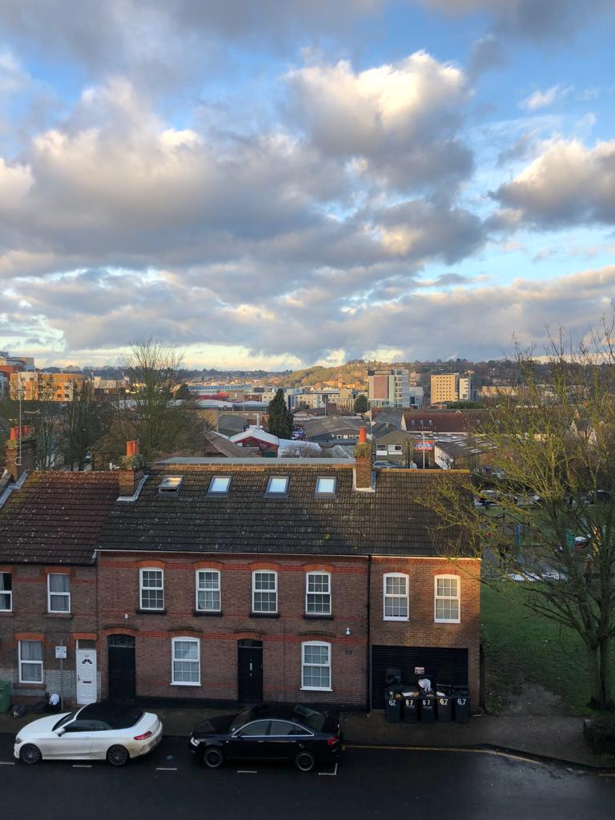  Wider town outlook | 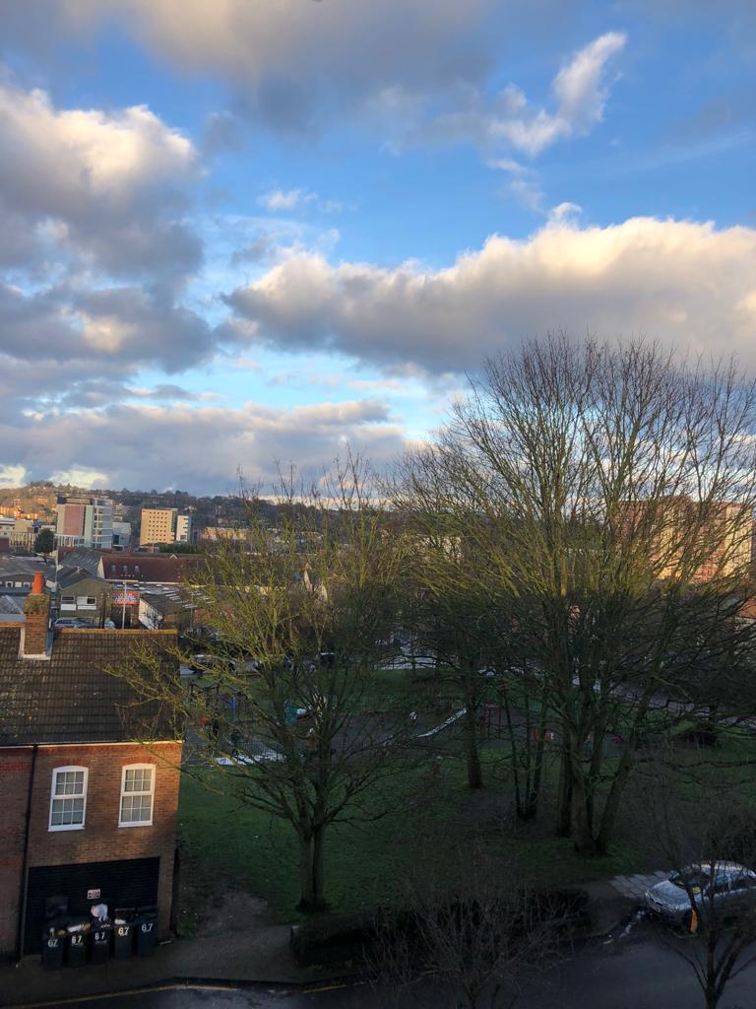  Green outlook / nearby aspect

Additional Floor Plans
Apartment 19
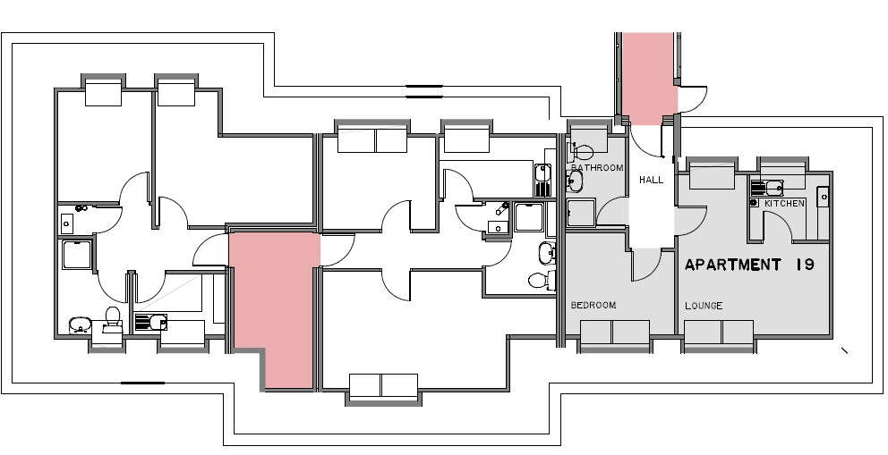
Apartment 20
