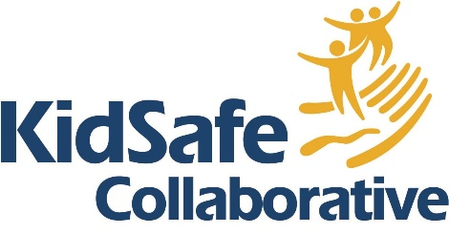
Nomination of an Individual

Individual Award Nominee Information
Name
Organization
Position/Title
Email
Address
Phone
How many years has this nominee been working with children and families?
- Less than 10
- 10-20
- more than 20

Nominator Information
Name
Organization
Position/Title
Email
Mailing Address
Phone

How do you know this person?
Is this person aware of this nomination?
If your nominee is not selected, would you like us to share with them that they were nominated?
- Yes, please tell them
- Yes, but do not share my name
- No

Select which category for which you are submitting the nominee. KidSafe Collaborative reserves the right to present a nominee with a different award than they were nominated for.
- Outstanding Professional
- Promising Professional
- Outstanding Volunteer
- Janet S. Munt Prevention Award
- Gregory Packan Outstanding Children’s Advocacy Award
- Lifetime Achievement

Nomination of an Individual cont.

Award nominees are considered by their demonstration of outstanding achievement in the following areas: activities/achievements, leadership/initiative, collaboration, making a difference/inspiration. To ensure the best possible consideration of your nominee by the Selection Committee, you are encouraged to provide comprehensive response to the following questions. Specific examples and stories are recommended.

- Tell us about this nominee’s work or service. What activities and achievements have made a significant difference in improving the health, safety, and/or wellbeing of children in our community? (between 300-600 words)
- How has this nominee’s work or service gone “above and beyond” the standard expectations of their position? (between 100-400 words)
- How has this nominee demonstrated leadership and initiative to improve the healthy, safety and wellbeing of children and families (e.g. new or innovative approaches, guidance for others, successful advocacy, etc.) (between 200-500 words)
- Describe how this nominee collaborates with others, especially across agencies and disciplines, and the impact that this has had on child health, safety, and wellbeing. (between 100-400 words)
- Has this nominee’s work had a significant impact on systems (e.g. child welfare system, legal system, educational system, etc.) which has contributed to improving the health, safety, or wellbeing of children? (between 100-400 words)
- Describe how this nominee’s outstanding working or services has made a difference and inspired others. (between 100-400 words)

Other relevant or supplemental information about nominees is acceptable. To submit, please email the information to KidSafe@KidSafeVT.org and include the nominees name in the subject line

For a nomination to be complete, and considered by the selection committee, please ensure that the nomination form is submitted along with at least two additional letters of reference. References may be submitted by emailing them directly to kidsafe@kidsafevt.org or the completing the reference form

Reference Form

For a nomination to be complete, and considered by the selection committee, please ensure that the nomination form is submitted along with at least two additional letters of reference. References may not be written by the nominator.
References may be submitted by emailing them directly to kidsafe@kidsafevt.org or the completing the reference form and submitting
Reference Information
Name
Organization
Position/Title
Email
Mailing Address
Phone

Name of the nominee you are providing a reference for:

How do you know this person or group?

Award nominees are considered by their demonstration of outstanding achievement in the following areas: activities/achievements, leadership/initiative, collaboration, and making a difference/inspiration.
To ensure the best possible consideration of your nominee by the Selection Committee, you are encouraged to consider the following questions when writing your reference. Specific examples and stories are often helpful.

- How long have you known or worked with this nominee
- How does this person/group’s work align or promote the mission of KidSafe Collaborative to improve the safety and well-being of children in Chittenden County?
- What specific qualities or achievements make this nominee deserving of an Outstanding Service Award?
- How does this person demonstrate excellence or going “above and beyond” in their role

