St. Peter’s by-the-Sea Episcopal Church
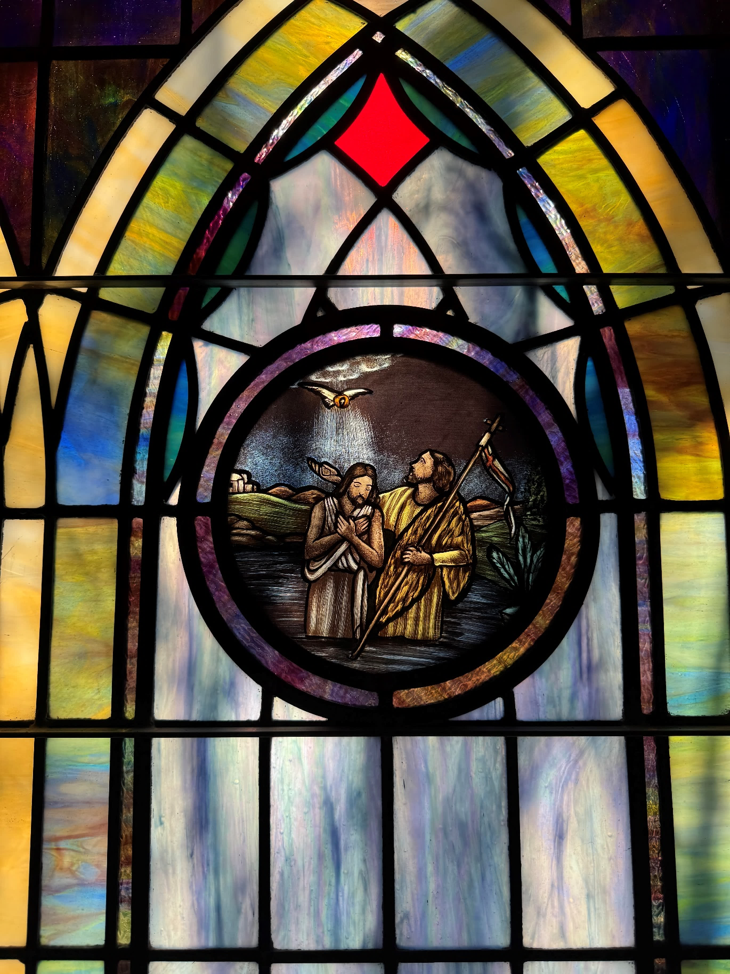
Holy Baptism
Welcome to St. Peter’s!
The liturgy for Baptism is from the Book of Common Prayer (BCP), found in your pew and reprinted in this bulletin.
There is a staffed nursery down the hall for children ages 4 and under. Toys are welcome in the service, as are the wiggles and joyful noise God put in children. Ushers are available near the doors if you need help. We’re glad you’re here on this holy day!
The liturgy is from the Book of Common Prayer (BCP). Our Hymns are from the 1982 Hymnal (Hymn), Wonder Love and Praise (WLP), Lift Every Voice and Sing (LEVAS) and the Red Spiral Book (A). Permission to reprint, podcast, and/or stream the music in this service obtained from CCLI License #856208 and #20241596.

Service of Holy Baptism
Prelude
Processional Hymn
Celebrant Blessed be God: Father, Son, and Holy Spirit.
People And blessed be his kingdom, now and for ever. Amen.
Celebrant There is one Body and one Spirit;
People There is one hope in God's call to us;
Celebrant One Lord, one Faith, one Baptism;
People One God and Father of all.
Celebrant The Lord be with you.
People And also with you.
Celebrant Let us pray. Almighty God, by our baptism into the death and
resurrection of your Son Jesus Christ, you turn us from the old life of sin: Grant that
we, being reborn to new life in him, may live in righteousness and holiness all our
days; through Jesus Christ our Lord, who lives and reigns with you and the Holy
Spirit, one God, now and for ever. Amen.
The Collect Insert
Celebrant The Lord be with you.
People And also with you.
Celebrant Let us pray. The collect is found in your insert.
The Lessons Please sit for the Lessons. Insert
After each Reading
Reader The Word of the Lord.
People Thanks be to God.
Sequence Hymn Insert
The Holy Gospel Standing Insert
The Deacon or Priest reads the Gospel, first saying
The Holy Gospel of our Lord Jesus Christ, according to __________.
People Glory to you, Lord Christ.
After the Gospel, the Reader says
The Gospel of the Lord.
People Praise to you, Lord Christ.

Sequence Hymn Insert
Homily
The Baptism: Presentation & Examination of the Candidates
The baptismal candidates, parents and godparents gather around the baptismal font.
Celebrant The Candidates for Holy Baptism will now be presented.
Sponsors We present __________ to receive the Sacrament of Baptism.
The Celebrant asks each candidate old enough to answer when presented
Do you desire to be baptized?
Candidate I do
When all have been presented the Celebrant asks the parents and godparents
Celebrant Will you be responsible for seeing that the children you present is brought up in the Christian faith and life?
Sponsors We will, with God's help.
Celebrant Will you by your prayers and witness help these children to grow the full stature of Christ?
Sponsors We will, with God's help.
Then the Celebrant asks the following questions of the parents and godparents, as well as older children
Question Do you renounce Satan and all the spiritual forces of wickedness that rebel against God?
Answer I renounce them.
Question Do you renounce the evil powers of this world which corrupt and destroy the creatures of God?
Answer I renounce them.
Question Do you renounce all sinful desires that draw you from the love of God?
Answer I renounce them.
Question Do you turn to Jesus Christ and accept him as your Savior?
Answer I do.
Question Do you put your whole trust in his grace and love?
Answer I do.
Question Do you promise to follow and obey him as your Lord?
Answer I do.
The Celebrant addresses the congregation, saying
Celebrant Will you who witness these vows do all in your power to support these persons in their life in Christ?
People We will.
The Baptismal Covenant
Celebrant Let us renew our own baptismal covenant.
Celebrant Do you believe in God the Father?
People I believe in God, the Father almighty, creator of heaven and earth.
Celebrant Do you believe in Jesus Christ, the Son of God?
People I believe in Jesus Christ, his only Son, our Lord.
He was conceived by the power of the Holy Spirit
and born of the Virgin Mary.
He suffered under Pontius Pilate,
was crucified, died, and was buried.
He descended to the dead.
On the third day he rose again.
He ascended into heaven,
and is seated at the right hand of the Father.
He will come again to judge the living and the dead.
Celebrant Do you believe in God the Holy Spirit?
People I believe in the Holy Spirit,
the holy catholic Church,
the communion of saints,
the forgiveness of sins,
the resurrection of the body,
and the life everlasting.
Celebrant Will you continue in the apostles' teaching and fellowship, in the breaking of the bread, and in the prayers?
People I will, with God's help.

Celebrant Will you persevere in resisting evil, and, whenever you fall into sin, repent and return to the Lord?
People I will, with God's help.
Celebrant Will you proclaim by word and example the Good News of God in Christ?
People I will, with God's help.
Celebrant Will you seek and serve Christ in all persons, loving your neighbor as yourself?
People I will, with God's help.
Celebrant Will you strive for justice and peace among all people, and respect the dignity of every human being?
People I will, with God's help.
Prayers for the Candidates
Celebrant Let us now pray for __________, who are to receive the Sacrament of new birth
Leader Deliver them, O Lord, from the way of sin and death.
People Lord, hear our prayer.
Leader Open their hearts to your grace and truth.
People Lord, hear our prayer.
Leader Fill them with your holy and life-giving Spirit.
People Lord, hear our prayer.
Leader Keep them in the faith and communion of your holy Church.
People Lord, hear our prayer.
Leader Teach them to love others in the power of the Spirit.
People Lord, hear our prayer.
Leader Send them into the world in witness to your love.
People Lord, hear our prayer.
Leader Bring them to the fullness of your peace and glory.
People Lord, hear our prayer.
Celebrant Grant, O Lord, that all who are baptized into the death of Jesus Christ your Son may live in the power of his resurrection and look for him to come again in glory; who lives and reigns now and forever. Amen.
Thanksgiving Over the Water
The Celebrant blesses the water, first saying
Celebrant The Lord be with you.
People And also with you.
Celebrant Let us give thanks to the Lord our God.
People It is right to give him thanks and praise.
Celebrant We thank you, Almighty God, for the gift of water. Over it the Holy
Spirit moved in the beginning of creation. Through it you led the children of Israel
out of their bondage in Egypt into the land of promise. In it your Son Jesus received
the baptism of John and was anointed by the Holy Spirit as the Messiah, the Christ,
to lead us, through his death and resurrection, from the bondage of sin into
everlasting life.
We thank you, Father, for the water of Baptism. In it we are buried with Christ in his death. By it we share in his resurrection. Through it we are reborn by the Holy Spirit. Therefore in joyful obedience to your Son, we bring into his fellowship those who come to him in faith, baptizing them in the Name of the Father, and of the Son, and of the Holy Spirit.
At the following words, the Celebrant touches the water
Now sanctify this water, we pray you, by the power of your Holy Spirit, that those who here are cleansed from sin and born again may continue for ever in the risen life of Jesus Christ our Savior.
To him, to you, and to the Holy Spirit, be all honor and glory, now and for ever. Amen.
The Baptism
The candidates are presented by name and the Celebrant then immerses, or pours water upon each of them.
__________ I baptize you in the Name of the Father, and of the Son, and of the Holy Spirit. Amen.
Let us pray. Heavenly Father, we thank you that by water and the Holy Spirit you have bestowed upon these your servants the forgiveness of sin, and have raised them to the new life of grace. Sustain them, O Lord, in your Holy Spirit. Give them an inquiring and discerning heart, the courage to will and to persevere, a spirit to know and to love you, and the gift of joy and wonder in all your works. Amen.
Then the Priest places a hand on the candidates’ heads, marking on the forehead the sign of the cross
__________, you are sealed by the Holy Spirit in Baptism and marked as Christ's own for ever. Amen.
Celebrant Let us welcome the newly baptized.
All We receive you into the household of God. Confess the faith of Christ crucified, proclaim his resurrection, and share with us in his eternal priesthood.
The Peace
Celebrant The peace of the Lord be always with you.
People And also with you.
The people greet one another with a sign of God’s peace. It is a sign of reconciliation, love, and renewed relationships in the Christian community. At baptism, the peace follows the baptism and the welcome for the newly baptized by the celebrant and people.
The Announcements

The Holy Communion: Rite Two
The Offertory At the Offertory, we gratefully return to God some of what God has given us. You may give online (www.saintpetersbythesea.org/donate) or text "BYTHESEA" to 73256.
Presentation of the Offerings Doxology Hymn 380
Please stand as the plates are brought forward to offer our gifts and selves to God.
Praise God from whom all blessings flow.
Praise Him all creatures here below.
Praise Him above ye heavenly hosts.
Praise Father, Son and Holy Ghost.

The Great Thanksgiving Eucharistic Prayer B
Celebrant The Lord be with you.
People And also with you.
Celebrant Lift up your hearts.
People We lift them to the Lord.
Celebrant Let us give thanks to the Lord our God.
People It is right to give God thanks and praise.
Celebrant It is right, and a good and joyful thing, always and everywhere to give
thanks to you, Father Almighty, Creator of heaven and earth. Because in Jesus Christ our Lord you have received us as your sons and daughters, made us citizens of your kingdom, and given us the Holy Spirit to guide us into all truth. Therefore we praise you, joining our voices with Angels and Archangels and with all the company of heaven, who forever sing this hymn to proclaim the glory of your Name:
People Holy, holy, holy Lord, God of power and might, heaven and earth are full of your glory. Hosanna in the highest. Blessed is he who comes in the name of the Lord. Hosanna in the highest.
Here, the people may kneel, sit or stand.
Celebrant We give thanks to you, O God, for the goodness and love which you
have made known to us in creation; in the calling of Israel to be your people; in your Word spoken through the prophets; and above all in the Word made flesh, Jesus, your Son. For in these last days you sent him to be incarnate from the Virgin Mary, to be the Savior and Redeemer of the world. In him, you have delivered us from evil, and made us worthy to stand before you. In him, you have brought us out of error into truth, out of sin into righteousness, out of death into life.
On the night before he died for us, our Lord Jesus Christ took bread; and when he had given thanks to you, he broke it, and gave it to his disciples, and said, “Take, eat: This is my Body, which is given for you. Do this for the remembrance of me.”
After supper he took the cup of wine; and when he had given thanks, he gave it to them, and said, “Drink this, all of you: This is my Blood of the new Covenant, which is shed for you and for many for the forgiveness of sins. Whenever you drink it, do this for the remembrance of me.”
Therefore, according to his command, O Father,
People We remember his death. We proclaim his resurrection. We await his coming in glory;
And we offer our sacrifice of praise and thanksgiving to you, O Lord of all; presenting to you, from your creation, this bread and this wine.
We pray you, gracious God, to send your Holy Spirit upon these gifts that they may be the Sacrament of the Body of Christ and his Blood of the new Covenant. Unite us to your Son in his sacrifice, that we may be acceptable through him, being sanctified by the Holy Spirit. In the fullness of time, put all things in subjection under your Christ, and bring us to that heavenly country where, with blessed Mary and Joseph, Peter and Paul, our patrons, and all your saints, we may enter the everlasting heritage of your sons and daughters; through Jesus Christ our Lord, the firstborn of all creation, the head of the Church, and the author of our salvation.
By him, and with him, and in him, in the unity of the Holy Spirit all honor and glory is yours, Almighty Father, now and forever. Amen.
The Lord’s Prayer
Celebrant And now as our Savior Christ has taught us, we pray
People Our Father, who art in heaven, hallowed be thy Name, thy
kingdom come, thy will be done, on earth as it is in heaven. Give us this day our daily bread. And forgive us our trespasses, as we forgive those who trespass against us. And lead us not into temptation, but deliver us from evil. For thine is the kingdom, and the power, and the glory, for ever and ever. Amen.

The Breaking of the Bread The Priest breaks the consecrated Bread. A period of silence is kept.
Celebrant Alleluia. Christ our Passover is sacrificed for us;
People Therefore let us keep the feast. Alleluia.
Celebrant These are the Gifts of God for the People of God.
Invitation to Holy Communion
Celebrant These are the Gifts of God for the People of God.
Hold out your hands to receive a wafer. Gluten-free wafers and grape juice are available upon request. After receiving the bread, you may sip from the cup or hold up your wafer and the Eucharistic Minister will dip the wafer into the wine for you. Receiving the bread alone is considered full participation in the sacrament. Please cross your arms to receive a blessing.
Communion Hymns See Insert
Post Communion Prayer BCP 365
All Eternal God, heavenly Father, you have graciously accepted us as living members of your Son our Savior Jesus Christ, and you have fed us with spiritual food in the Sacrament of his Body and Blood. Send us now into the world in peace, and grant us strength and courage to love and serve you with gladness and singleness of heart; through Christ our Lord. Amen.
Blessing
Recessional Hymn See Insert
The Dismissal BCP 366
Celebrant Let us go forth in the name of Christ. Alleluia!
People Thanks be to God! Alleluia!

What is baptism in the Episcopal Church?
In the waters of baptism, we are lovingly adopted by God into God’s family, which we call the Church, and given God’s own life to share and reminded that nothing can separate us from God’s love in Christ. Holy Baptism, which can be performed through pouring of water or immersion in it, marks a formal entrance to the congregation and wider Church; the candidates for the sacrament make a series of vows, including an affirmation of the Baptismal Covenant, and are baptized in the Name of the Father, Son, and Holy Spirit. They are marked as Christ’s own for ever, having “clothed [themselves] with Christ” (Galatians 3:27).
All people of any age are welcome to baptized; we believe in one baptism for the forgiveness of sins, as the “bond which God establishes in Baptism is indissoluble” (Book of Common Prayer, p. 298).
From The Episcopal Church’s website: www.episcopalchurch.org/what-we-believe/baptism/
What is a Sponsor and why does the Episcopal Church baptize infants?
Sponsors (godparents) speak on behalf of candidates for baptism who are infants or younger children and cannot speak for themselves... During the baptismal rite the members of the congregation promise to do all they can to support the candidates for baptism in their life in Christ. They join with the candidates by renewing the baptismal covenant. The water of baptism may be administered by immersion or affusion (pouring) (BCP, p. 307). Candidates are baptized “in the Name of the Father, and of the Son, and of the Holy Spirit,” and then marked on the forehead with the sign of the cross. Chrism may be used for this marking. The newly baptized is “sealed by the Holy Spirit in Baptism and marked as Christ’s own for ever.” When all baptisms have been completed, the celebrant and congregation welcome the newly administered within the eucharist as the chief service on a Sunday or another feast.
The Catechism notes that “Infants are baptized so that they can share citizenship in the Covenant, membership in Christ, and redemption by God.” The baptismal promises are made for infants by their parents or sponsors, “who guarantee that the infants will be brought up within the Church, to know Christ and be able to follow him” (BCP, pp. 858-859).
From “An Episcopal Dictionary of the Church, A User Friendly Reference for Episcopalians,” Don S. Armentrout and Robert Boak Slocum, editors.
If you’d like to be baptized, please call the church or talk to our priest.

St. Peter’s by-the-Sea Episcopal Church
An Episcopal Parish in The Diocese of East Carolina
The Most Rev’d. Sean W. Rowe, Presiding Bishop; The Rt. Rev’d. Robert Skirving, Bishop
The Rev’d. Michelle Bullock, Rector
Nick Kohlmann and Sandra Loucks, Seminarians
Catharine Koonce, Musician; Janet Payne, Parish Administrator
John Nash, Sr. Warden; Mike Isabella, Jr. Warden
Glenn Joyner, Clerk; Shonda Asaad, Treasurer
Vestry: Larry Faison, Alexis Garber, Shelly Harrelson, Anne Hume,
David Koonce, Pam Likens, Sue Lynn
Office: (910) 326-4757 Email: churchoffice@saintpetersbythesea.org
Website: saintpetersbythesea.org

