St. Peter’s by-the-Sea Episcopal Church
Holy Eucharist: Rite One
The Season after Pentecost

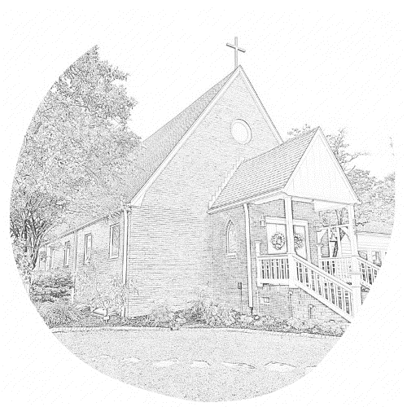

Welcome to St. Peter’s!
The liturgy is from the Book of Common Prayer (BCP). The readings are from the NRSV version of the Bible (Pew Bible) and can be found in your insert, along with the prayer list and announcements.
Ushers are available near the doors if you need help.
We’re glad you’re here!
The Liturgy of the Word
Processional Please stand as you are able.
The Acclamation BCP 323
Gloria BCP 324
The Collect Insert
Celebrant The Lord be with you.
People And also with you.
Celebrant Let us pray. The collect is found in your insert.
The Lessons Please sit for the Lessons. Insert
After each Reading:
Reader The Word of the Lord.
People Thanks be to God.
Homily
The Nicene Creed The people stand as they are able. BCP 326
Prayers of the People BCP 328
The prayer list is found in your insert.
The Confession and Absolution BCP 331
The Peace All Stand BCP 332
Announcements Seated

Holy Communion: Rite One
The Offertory At the Offertory, we gratefully return to God some of what God has given us. You may give online (www.saintpetersbythesea.org/donate) or text "BYTHESEA" to 73256.
The Great Thanksgiving Eucharistic Prayer 1 BCP 333
Sanctus BCP 334
The Lord’s Prayer BCP 336
The Breaking of the Bread BCP 337
Invitation to Holy Communion The usher will invite you to come up the center aisle. Hold out your hands to receive the bread. Wine is received from the cup. Gluten-free wafers and grape juice are available; please make your need known to the minister. Alternatively, you may touch the base of the cup as a sign of receiving the wine. Receiving the bread alone is considered full participation in the sacrament. If you prefer to receive a blessing instead, please indicate your choice by crossing your hands across your chest.
Post Communion Prayer BCP 339
Blessing and Dismissal BCP 339

St. Peter’s by-the-Sea Episcopal Church
The Diocese of East Carolina
The Most Rev’d. Sean W. Rowe, Presiding Bishop; The Rt. Rev’d. Robert Skirving, Bishop
The Rev’d. Michelle Bullock, Rector; Nick Kohlmann and Sandra Loucks, Seminarians
Catharine Koonce, Musician; Janet Payne, Parish Administrator
John Nash, Sr. Warden; Mike Isabella, Jr. Warden; Glenn Joyner, Clerk; Shonda Asaad, Treasurer
Vestry: Larry Faison, Shelly Harrelson, Anne Hume, David Koonce, Pam Likens, Sue Lynn
Office: (910) 326-4757 Email: churchoffice@saintpetersbythesea.org
Website: saintpetersbythesea.org

