St. Peter’s by-the-Sea Episcopal Church
The Season of Creation
Holy Eucharist: Rite One

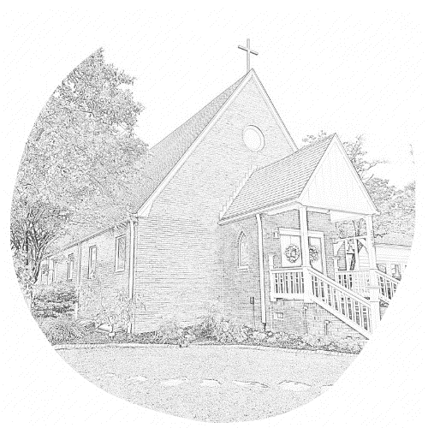

Welcome to St. Peter’s! The liturgy is from the red Book of Common Prayer (BCP), found in your pew. This month, we celebrate the Season of Creation, with creation centered prayers and readings taken from “Season of Creation: An Ecumenical Celebration,” authorized for use by our diocesan bishop.
An usher is available in the back if you need help.
We’re glad you’re here!
THE LITURGY OF THE WORD
Processional Please stand as you are able.
The Acclamation BCP 323
Gloria BCP 324
The Collect Insert
Celebrant The Lord be with you.
People And also with you.
Celebrant Let us pray. The collect is found in your insert.
The Lessons Please sit for the Lessons. Insert
After each Reading:
Reader The Word of the Lord.
People Thanks be to God.
Homily
The Nicene Creed The people stand as they are able. BCP 326
Season of Creation Prayers of the People, Adapted from Form 1
Leader With all our heart and with all our mind, let us pray to the Creator, saying "Creator, renew us."
Leader For the peace of the world, for the welfare of the Holy Church of God, and for the unity of all peoples, let us pray to the Lord.
People Creator, renew us.
Leader For our Bishops Michael and Rob, for Michelle our priest, for our postulants Nick and Sandra, and for all people, let us pray to the Lord.
People Creator, renew us.
Leader For our President Donald, for the leaders of the nations, and for all in authority, let us pray to the Lord.
People Creator, renew us.
Leader For the land, water, and sky of Swansboro, for every city and community, and for those who live in them, let us pray to the Lord.
People Creator, renew us.

Leader For seasonable weather, for abundance of fruits, for the good earth which God has given to all God’s creatures, and for the wisdom and will to conserve it, let us pray to the Lord.
People Creator, renew us.
Leader For those who travel on land, on water, or in the air or through outer space, let us pray to the Lord.
People Creator, renew us.
Leader For the aged and infirm, for the widowed and orphans, and for the sick and the suffering, let us pray to the Lord.
People Creator, renew us.
Leader For peace in the Holy Land and in all areas of conflict around the world.
People Creator, renew us.
Leader For the poor and the oppressed, for the unemployed and the destitute, for prisoners and captives, and for all who remember and care for them, let us pray to the Lord.
People Creator, renew us.
Leader For all who have died in the hope of the resurrection, and for all the departed, and for all species extinction, let us pray to the Lord.
People Creator, renew us.
Leader For deliverance from all danger, violence, oppression, and degradation, let us pray to the Lord.
People Creator, renew us.
Leader That we may end our lives in faith and hope, without suffering and without reproach, let us pray to the Lord.
People Creator, renew us.
Leader In the communion of Creation and all of the saints, saints, let us commend ourselves, and one another, and all our life, to Christ our God.
People To you, O Lord our God.
The prayer list is found in your insert.
Celebrant Gracious and loving God, guide the hearts and minds of those among us who will search for a new bishop to lead the Diocese of East Carolina, that we may listen carefully to discern your will and call a bishop who will love and serve your people in all the communities of this diocese and lead us forward in new ways in our ministries and service to you, through Jesus Christ our Lord. Amen.
The Confession and Absolution BCP 331
The Peace and Announcements All Stand BCP 332
Holy Communion: Rite One
The Offertory At the Offertory, we gratefully return to God some of what God has given us. You may give online (www.saintpetersbythesea.org/donate) or text "BYTHESEA" to 73256.
The Great Thanksgiving Eucharistic Prayer 1 BCP 333
Sanctus BCP 334
The Lord’s Prayer BCP 336
The Breaking of the Bread BCP 337
Invitation to Holy Communion The usher will invite you to come up the center aisle. Hold out your hands to receive the bread. Wine is received from the cup. Gluten-free wafers and grape juice are available; please make your need known to the minister. Alternatively, you may touch the base of the cup as a sign of receiving the wine. Receiving the bread alone is considered full participation in the sacrament. If you prefer to receive a blessing instead, please indicate your choice by crossing your hands across your chest.
Post Communion Prayer BCP 339
Blessing and Dismissal BCP 339

St. Peter’s by-the-Sea Episcopal Church
The Diocese of East Carolina
The Most Rev’d. Sean W. Rowe, Presiding Bishop; The Rt. Rev’d. Robert Skirving, Bishop
The Rev’d. Michelle Bullock, Rector; Nick Kohlmann and Sandra Loucks, Seminarians
Catharine Koonce, Musician; Janet Payne, Parish Administrator
John Nash, Sr. Warden; Mike Isabella, Jr. Warden; Glenn Joyner, Clerk; Shonda Asaad, Treasurer
Vestry: Larry Faison, Shelly Harrelson, Anne Hume, David Koonce, Pam Likens, Sue Lynn
Office: (910) 326-4757 Email: churchoffice@saintpetersbythesea.org
Website: saintpetersbythesea.org

