St. Peter’s by-the-Sea Episcopal Church
An Episcopal Church in the Diocese of East Carolina
Holy Eucharist
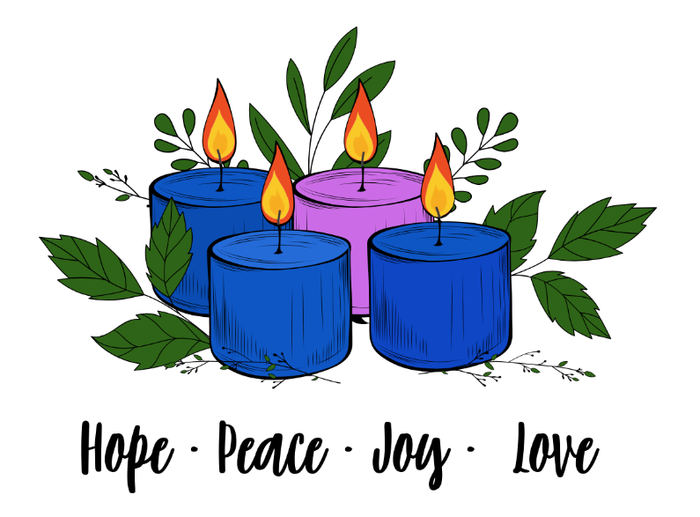
The Season of Advent

Welcome to St. Peter’s! The liturgy is from the Book of Common Prayer (BCP), the Hymnal 1982 (Hymn), both found in your pew. There is a staffed nursery down the hall for children ages 4 and under during the 10am service. Toys are welcome in the service, as are the wiggles and joyful noise God put in children.

Ushers are available near the doors if you need help. We’re glad you’re here!

The liturgy is from the Book of Common Prayer (BCP). Our Hymns are from the 1982 Hymnal (Hymn), Wonder Love and Praise (WLP), Lift Every Voice and Sing (LEVAS) and the Red Spiral Book (A).
Permission to reprint, podcast, and/or stream the music in this service obtained from
CCLI License #856208 and #20241596.

The Liturgy of the Word: Rite 1
Processional Please stand as you are able.
Welcome & Lighting of the Advent Wreath
The Acclamation BCP 323
Kyrie BCP 324
The Collect Insert
Celebrant The Lord be with you.
People And also with you.
The Lessons Please sit for the Lessons. After each Reading, please say: Insert
Reader The Word of the Lord.
People Thanks be to God.
The Holy Gospel Standing. The Deacon or Priest reads the Gospel, first saying Insert
The Holy Gospel of our Lord Jesus Christ, according to ____.
People Glory be to thee, O Lord.
After the Gospel, the Reader says
The Gospel of the Lord.
People Praise be to thee, O Christ.
Homily
The Nicene Creed The people stand as they are able. BCP 326
Prayers of the People Kneeling or standing. The prayer list is found in your insert. BCP 328
The Confession & Absolution BCP 331
The Peace & Announcements All Stand BCP 332
Holy Communion: Rite 1
The Offertory At the Offertory, we gratefully return to God some of what God has given us.
The Great Thanksgiving Eucharistic Prayer 1 BCP 333
The Breaking of the Bread BCP 337
Invitation to Holy Communion The usher will invite you up the center aisle to the altar. Hold out your hands to receive the bread; wine is received from the cup. Gluten-free wafers and grape juice are available; please make your need known to the minister. Alternatively, you may touch the base of the cup as a sign of receiving the wine or receiving bread alone as considered full participation in the sacrament. If you desire a blessing, please cross your hands across your chest.
Post Communion Prayer BCP 339
Blessing and Dismissal BCP 339
The Liturgy of the Word: Rite 2
Welcome & Lighting of the Advent Wreath
Prelude
Processional Hymn or Anthem Insert
The Acclamation Standing BCP 355
Celebrant Blessed be God: Father, Son and Holy Spirit.
People And blessed be his kingdom, now and for ever. Amen.
The Collect For Purity
Celebrant Almighty God, to you all hearts are open, all desires known, and from you no secrets are hid: Cleanse the thoughts of our hearts by the inspiration of your Holy Spirit, that we may perfectly love you, and worthily magnify your holy Name; through Christ our Lord. Amen.
Kyrie Kyrie eleison is a Greek phrase that means, “Lord, have mercy.” Taize
Sung by all Kyrie, Kyrie, eleison. Sung three times.
The Collect of the Day Insert
Celebrant The Lord be with you.
People And also with you.
Celebrant Let us pray. The collect is found in your insert.
The Lessons Please sit for the Lessons. After each Reading, please say: Insert
Reader The Word of the Lord.
People Thanks be to God.
Sequence Hymn Prepare the Way O Zion, Verse 1 Hymn 65
The Holy Gospel Standing. The Deacon or Priest reads the Gospel, first saying Insert
The Holy Gospel of our Lord Jesus Christ, according to ____.
People Glory be to thee, O Lord.
After the Gospel, the Reader says
The Gospel of the Lord.
People Praise be to thee, O Christ.
Sequence Hymn Prepare the Way O Zion, Verse 1 Hymn 65
Homily
The Nicene Creed The people stand as they are able. BCP 358
We believe in one God, the Father, the Almighty, maker of heaven and earth, of all that is, seen and unseen.
We believe in one Lord, Jesus Christ, the only Son of God, eternally begotten of the Father, God from God, Light from Light, true God from true God, begotten, not made, of one Being with the Father. Through him all things were made. For us and for our salvation he came down from heaven: by the power of the Holy Spirit he became incarnate from the Virgin Mary, and was made man. For our sake he was crucified under Pontius Pilate; he suffered death and was buried. On the third day he rose again in accordance with the Scriptures; he ascended into heaven and is seated at the right hand of the Father.
He will come again in glory to judge the living and the dead, and his kingdom will have no end.
We believe in the Holy Spirit, the Lord, the giver of life, who proceeds from the Father and the Son. With the Father and the Son he is worshiped and glorified. He has spoken through the Prophets. We believe in one holy catholic and apostolic Church. We acknowledge one baptism for the forgiveness of sins. We look for the resurrection of the dead, and the life of the world to come. Amen.
PRAYERS OF THE PEOPLE, FORM 2 You may kneel, sit or stand. BCP 385
Sung Response of the People Oh, Lord Hear My Prayer Taize
Oh, Lord hear my prayer. Oh, Lord hear my prayer. When I call answer me.
Oh, Lord hear my prayer. Oh, Lord hear my prayer. Come and listen to me.
I ask your prayers for God's people throughout the world; for our Bishops, Sean and Rob, our Bishop-elect Sarah; for our priest, Michelle; for our staff, Janet and Catharine; for our vestry; for our postulants, Nick and Sandra; for this gathering; and for all ministers and people. Pray for the Church. Silence
I ask your prayers for peace; for goodwill among nations; for our leaders, Donald and Josh; for peace in the Holy Land; and for the well-being of all people. Pray for justice and peace. Silence
I ask your prayers for the poor, the sick, the hungry, the oppressed, and those in prison. Pray for those in any need or trouble. Silence
I ask your prayers for all who seek God, or a deeper knowledge of him. Pray that they may find and be found by him. Silence
I ask your prayers for the departed. Pray for those who have died. Silence
Praise God for those in every generation in whom Christ has been honored. Pray that we may have grace to glorify Christ in our own day. Silence
We pray for those on our prayer list, as included in your insert. Insert
The prayer list is found in your insert.
Sung Response of the People Oh, Lord Hear My Prayer Taize
Oh, Lord hear my prayer. Oh, Lord hear my prayer. When I call answer me.
Oh, Lord hear my prayer. Oh, Lord hear my prayer. Come and listen to me.
The Celebrant may conclude the prayers of the people with a Collect.
The Confession of Sin and Absolution BCP 360
Celebrant Let us confess our sins against God and our neighbor.
All Most merciful God, we confess that we have sinned against you in thought, word, and deed, by what we have done, and by what we have left undone. We have not loved you with our whole heart; we have not loved our neighbors as ourselves. We are truly sorry and we humbly repent. For the sake of your Son Jesus Christ, have mercy on us and forgive us; that we may delight in your will, and walk in your ways, to the glory of your Name. Amen.
Celebrant Almighty God have mercy on you, forgive you all your sins through our Lord Jesus Christ, strengthen you in all goodness, and by the power of the Holy Spirit keep you in eternal life. Amen.
The Peace & Announcements
Celebrant The peace of the Lord be always with you.
People And also with you.

The Holy Communion: Rite Two
The Offertory At the Offertory, we gratefully return to God some of what God has given us. You may give online (www.saintpetersbythesea.org/donate) or text "BYTHESEA" to 73256.
Offering Presentation O Come O Come Emmanuel, verse 1 Hymn 56
Please stand as the plates are brought forward to offer our gifts and selves to God.
The Great Thanksgiving: Eucharistic Prayer B BCP 367
Celebrant The Lord be with you.
People And also with you.
Celebrant Lift up your hearts.
People We lift them to the Lord.
Celebrant Let us give thanks to the Lord our God.
People It is right to give him thanks and praise.
Celebrant It is right, and a good and joyful thing, always and every- where to give thanks to you, Father Almighty, Creator of heaven and earth. Because you sent your beloved Son to redeem us from sin and death, and to make us heirs in him of everlasting life; that when he shall come again in power and great triumph to judge the world, we may without shame or fear rejoice to behold his appearing. Therefore we praise you, joining our voices with Angels and Archangels and with all the company of heaven, who for ever sing this hymn to proclaim the glory of your Name:
Celebrant and People sing
Holy, Holy, Holy Lord, God of power and might, heaven and earth are full of your glory. Hosanna in the highest. Blessed is he who comes in the name of the Lord. Hosanna in the highest.
We give thanks to you, O God, for the goodness and love which you have made known to us in creation; in the calling of Israel to be your people; in your Word spoken through the prophets; and above all in the Word made flesh, Jesus, your Son. For in these last days you sent him to be incarnate from the Virgin Mary, to be the Savior and Redeemer of the world. In him, you have delivered us from evil, and made us worthy to stand before you. In him, you have brought us out of error into truth, out of sin into righteousness, out of death into life.
On the night before he died for us, our Lord Jesus Christ took bread; and when he had given thanks to you, he broke it, and gave it to his disciples, and said, "Take, eat: This is my Body, which is given for you. Do this for the remembrance of me."
After supper he took the cup of wine; and when he had given thanks, he gave it to them, and said, "Drink this, all of you: This is my Blood of the new Covenant, which is shed for you and for many for the forgiveness of sins. Whenever you drink it, do this for the remembrance of me."
Therefore, according to his command, O Father,
Celebrant and People
We remember his death
We proclaim his resurrection,
We await his coming in glory;
And we offer our sacrifice of praise and thanksgiving to you, O Lord of all; presenting to you, from your creation, this bread and this wine.
We pray you, gracious God, to send your Holy Spirit upon these gifts that they may be the Sacrament of the Body of Christ and his Blood of the new Covenant. Unite us to your Son in his sacrifice, that we may be acceptable through him, being sanctified by the Holy Spirit. In the fullness of time, put all things in subjection under your Christ, and bring us to that heavenly country where, with St. Peter and all your saints, we may enter the everlasting heritage of your sons and daughters; through Jesus Christ our Lord, the firstborn of all, the head of the Church, and the author of our salvation.
By him, and with him, and in him, in the unity of the Holy Spirit all honor and glory is yours, Almighty Father, now and for ever. Amen.
And now as our Savior Christ has taught us, we pray:
Celebrant and People BCP 364
Our Father, who art in heaven, hallowed be thy Name, thy kingdom come, thy will be done, on earth as it is in heaven. Give us this day our daily bread. And forgive us our trespasses, as we forgive those who trespass against us. And lead us not into temptation, but deliver us from evil. For thine is the kingdom, and the power, and the glory, for ever and ever. Amen.

Breaking of the Bread The Priest breaks the consecrated Bread.
Celebrant Alleluia. Christ our Passover is sacrificed for us;
People Therefore let us keep the feast. Alleluia.
Invitation to Holy Communion
Celebrant These are the Gifts of God for the People of God.
The usher will invite you up the center aisle to the altar. Hold out your hands to receive the bread; wine is received from the cup. Gluten-free wafers and grape juice are available; please make your need known to the minister. Alternatively, you may touch the base of the cup as a sign of receiving the wine or receiving bread alone as considered full participation in the sacrament. If you desire a blessing, please cross your hands across your chest.
Communion Hymns Insert
Post Communion Prayer BCP 366
Celebrant and People Almighty and everliving God, we thank you for feeding us
with the spiritual food of the most precious Body and Blood of your Son our
Savior Jesus Christ; and for assuring us in these holy mysteries that we are
living members of the Body of your Son, and heirs of your eternal kingdom.
And now, Father, send us out to do the work you have given us to do, to love
and serve you as faithful witnesses of Christ our Lord. To him, to you, and to
the Holy Spirit, be honor and glory, now and for ever. Amen.
Blessing
Recessional Hymn Insert
The Dismissal BCP 366
Celebrant Go in peace to love and serve the Lord. Alleluia!
People Thanks be to God! Alleluia!

St. Peter’s by-the-Sea Episcopal Church
An Episcopal Parish in the Diocese of East Carolina
The Most Rev’d. Sean W. Rowe, Presiding Bishop
The Rt. Rev’d. Robert Skirving, Bishop; The Rev’d Sarah Fisher, Bishop-Elect
The Rev’d. Michelle Bullock, Rector; Nick Kohlmann and Sandra Loucks, Seminarians
Catharine Koonce, Musician; Janet Payne, Parish Administrator
John Nash, Sr. Warden; Mike Isabella, Jr. Warden; Glenn Joyner, Clerk; Shonda Asaad, Treasurer
Vestry: Larry Faison, Shelly Harrelson, Anne Hume, David Koonce, Pam Likens, Sue Lynn
Office: (910) 326-4757 churchoffice@saintpetersbythesea.org www.saintpetersbythesea.org

