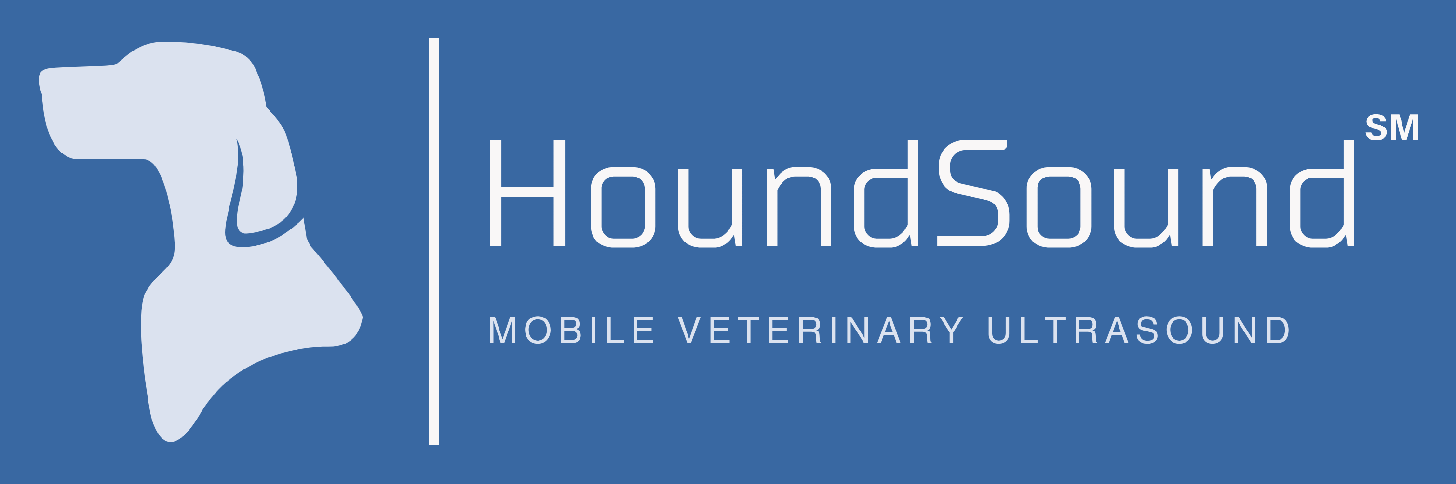

Fine Needle Aspirate and Tissue Biopsy Consent

Additional Procedures
During the ultrasound examination, abnormalities may be detected that could benefit from sampling for microscopic evaluation. These procedures include:
☐ Fine Needle Aspirate (FNA)
- Insertion of a small needle into the organ/mass to collect cells
- Ultrasound-guided for precision
- Minimal discomfort, similar to a vaccination
☐ Tissue Core Biopsy
- Collection of small tissue sample using a larger needle
- Provides more comprehensive tissue architecture
- May require local anesthetic

Additional Risks for Invasive Procedures
I understand the additional risks include but are not limited to:
- Minor bleeding at the sampling site
- Rare risk of organ puncture or damage
- Potential for inadequate sample requiring repeat procedure
- Rare risk of serious complications requiring emergency treatment

Sample Handling
☐ I authorize submission of samples to an external laboratory for analysis
☐ I understand additional fees will apply for laboratory analysis

Additional Consent
I understand that fine needle aspirates and/or tissue biopsies are elective procedures that may provide valuable diagnostic information. I acknowledge that I have been informed of the risks and benefits, and I voluntarily consent to these additional procedures if recommended during the ultrasound examination.
Date: _____________
Print Name:________________________ Owner Signature: _________________________________

