Adina Hotels Accessibility Guide

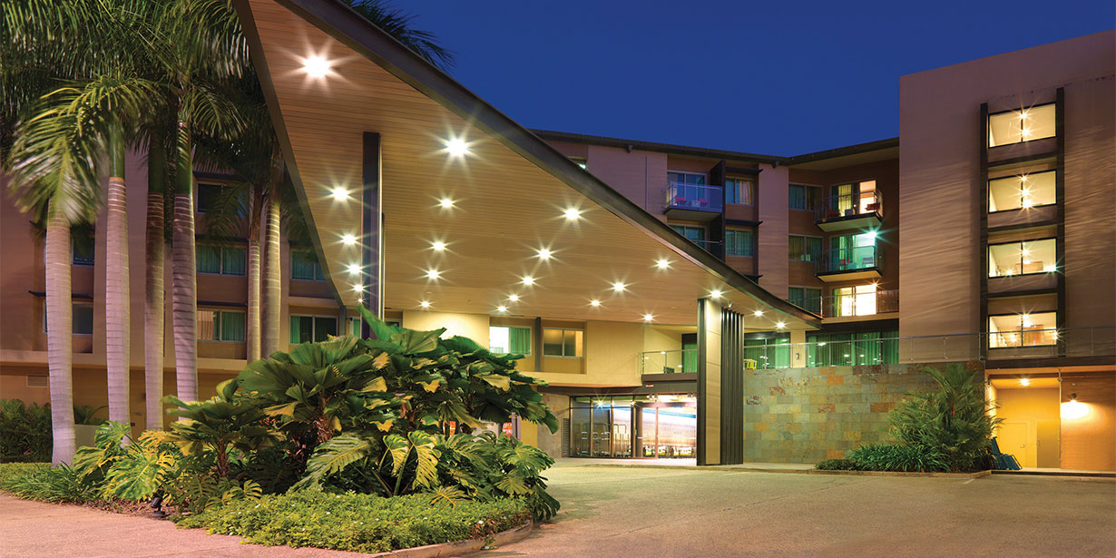

Contact Information:
- Address: 7 Kitchener Drive, Darwin, NT 0800, Australia
- Phone Number: 13 86 42
- Website: https://www.adinahotels.com/en/apartments/darwin-waterfront/

Contents
Welcome 4
Information At A Glance 4
Getting here 4
Travel by Public Transport 5
Bus 5
Free Waterfront Shuttle: 5
Drop-Off 5
Street Parking 6
Kitchener Drive multi-story car park 6
Arrival 6
Communication and Wayfinding 7
Getting Around Inside 8
Foyer 8
The Lift 9
Toilets 9
AccessibleToilets 10
The Pool 10
The Gymnasium 12
Laundry 12
Getting to the Rooms 13
Accessible Apartment 14
Entrance 14
Sounds 14
Lighting 14
Cooling / Heating 15
Power points 15
Other 15
Bedroom 15
Furniture 15
The Kitchenette 16
The Veranda 16
Ensuite 17
The Shower 17
The Toilet 18
The Basin 18
Lighting 18
Scents 18
Power points 18
Standard Apartment 19
Entrance 19
Sounds 19
Emergency Alarm 19
Lighting 19
Cooling / Heating 19
Power points 20
Other 20
Bedroom 20
Furniture 20
The Kitchenette 21
The Veranda 21
Ensuite 22
Lighting 22
Scents 22
The Shower 22
The Toilet 23
The Basin 23
Power Point 23

Acknowledgment of Traditional Owners
Adina Hotel acknowledges the Larrakia people as the Traditional Owners and original custodians of this land and pay our respects to their Elders, past and present.

Acknowledgment of Thanks
Adina Hotel would like to acknowledge the support and assistance provided by Flare Access Pty Ltd in helping to prepare this Accessibility Guide.

Welcome
At Adina Hotels, we strive to make our establishment accessible to all customers. This guide is designed to provide information about the accessibility features of our restaurant or bar, as well as any potential barriers that may exist.

Visiting Australia’s Top End? The Adina Apartment Hotel Darwin Waterfront provides the perfect base for an unforgettable adventure. Positioned amongst waterside restaurants and the family friendly wave pool with a lagoon on Darwin’s seafront promenade. It is only a stone’s throw away from the Darwin Convention Centre and within walking distance of Darwin’s CBD.

Information At A Glance

Accessible Parking | Step Free Access
Accessible Room | Laundry
Pool | Accessible Outdoor Dining
Gym | Accessible Indoor Dining
Sounds | Lift
Scents | Restaurant
Baby Changing Table | Charging Point

Getting here

Travel by Public Transport

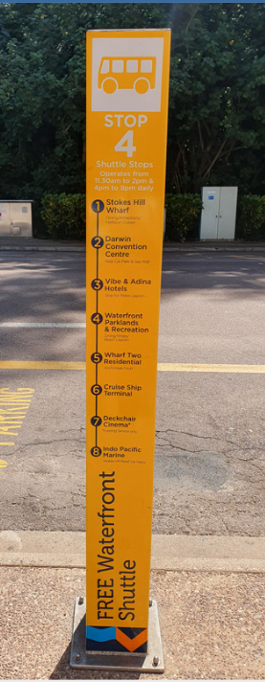
Bus
- The nearest stop is for Bus Route 14C with the major stops of:
  - Darwin Interchange
  - Cullen Bay
  - Darwin Waterfront.
- The Route 14C bus is wheelchair accessible.
- It's approximately 60 m away with a step-free route available.
- Darwin Interchange is approximately 400 m from the restaurant with step-free access to the Waterfront.

Free Waterfront Shuttle:
- The Shuttle bus operates at peak lunch and dinner times; from 11:30am to 2 pm and 4 pm to 9 pm. Linking Stokes Hill Wharf, the Cruise Ship Terminal, residential apartments and hotels. The stop is approximately 50 m from the venue.
- The Shuttle is not wheelchair accessible.

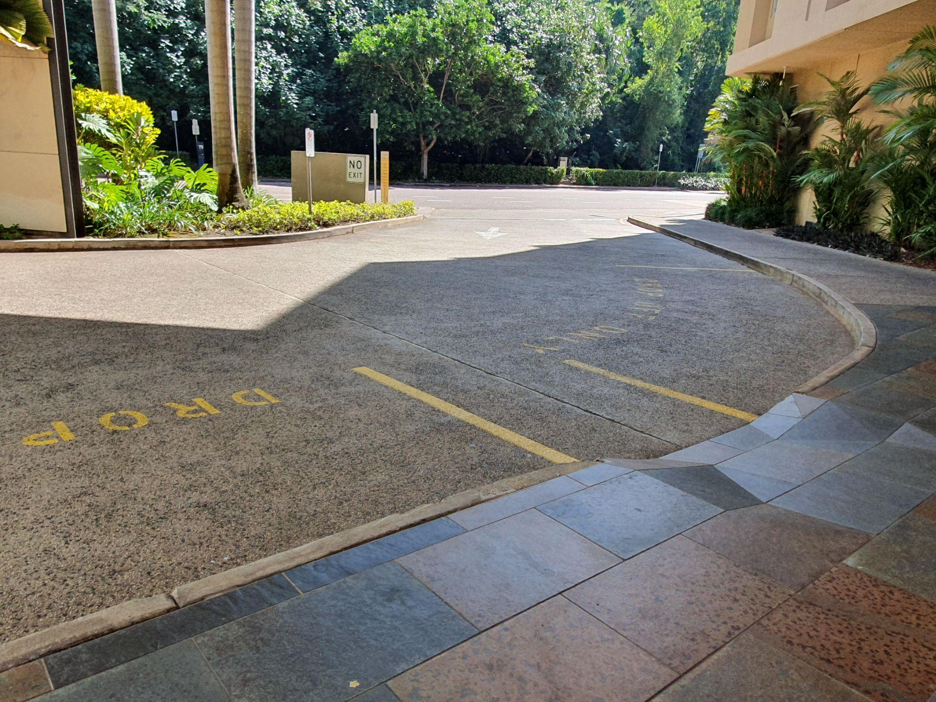
Drop-Off
- There is a drop-off point on Kitchener Drive with a ramped kurb approximately 15m from the entrance.
- The route to the restaurant has a path greater than 1000 mm wide and a level concrete surface.
- There is step-free access to reception.

Street Parking
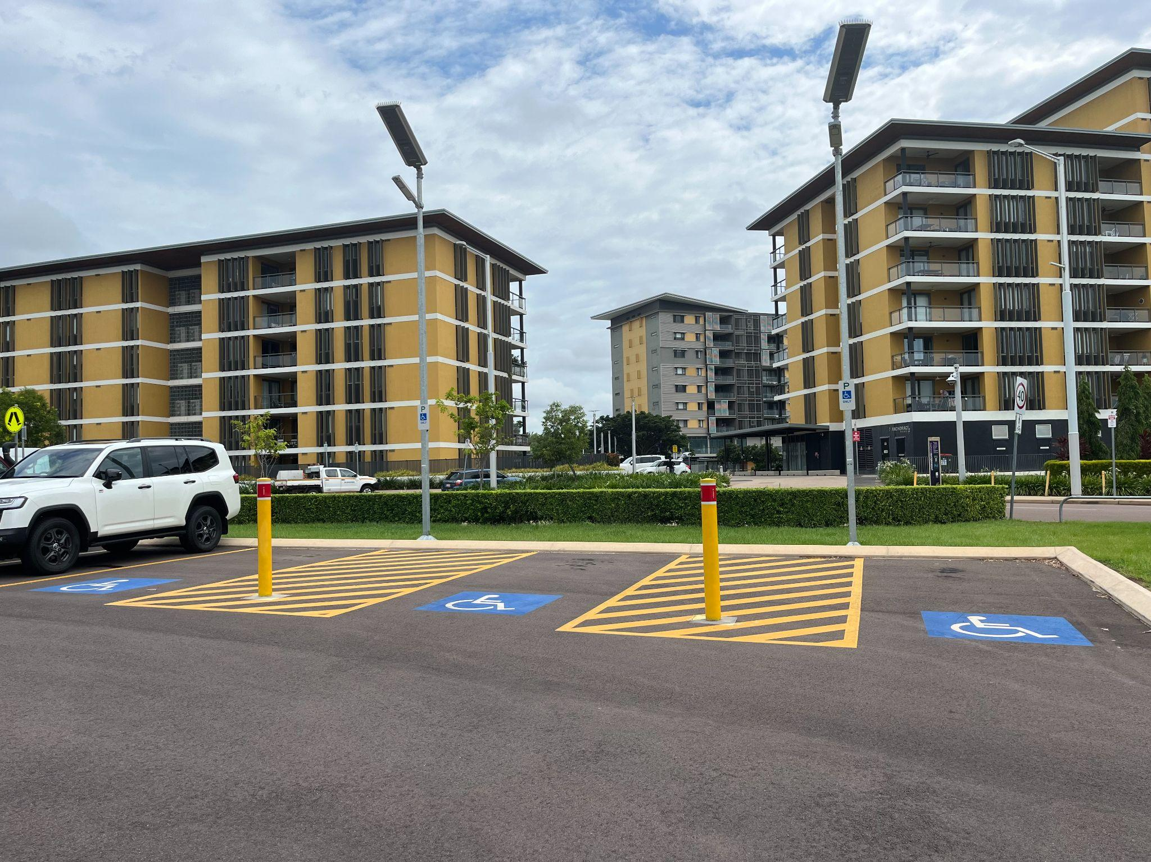
- Parking on Kitchener Drive is $3 per hour for a maximum of 2 hours. Accessible Parking is not available.
- Parking on Anchorage Court is $2.50 per hour.
- Patrons with a valid Accessible Parking permit displayed on their windscreen can park in any car park on-street for double the time as signposted at no cost.
- Anchorage Court has three Accessible parking bays located at Fort Hill near 5 Anchorage Court. The venue is approximately 450 m from these bays.

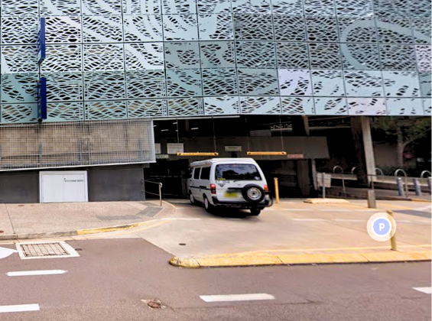
Kitchener Drive multi-story car park
- Accessible parking is located on levels 2 and above, with five spaces close to the lifts. From the car park to the entrance of the restaurant there is step-free access. In use is a ticketless parking system.
- Payment is cashless and can be made by debit or credit card at the pay machines near the lifts or upon exit at the boom gate.
- Parking is free for under two hours.
- The venue is approximately 210 m from this car park.

Arrival
- Path to the main entrance is tiled. From the frontage to the main entrance, there is steps free access. The path is 1000 mm wide, or more.

Main Entrance
- There is a clear path of travel from outdoor to indoor areas.
- Both the entrances from Kitchener Drive and from the Waterfront have automatic sliding doors and a width exceeding 1000 mm.
- There is level access into the venue at both entrances.
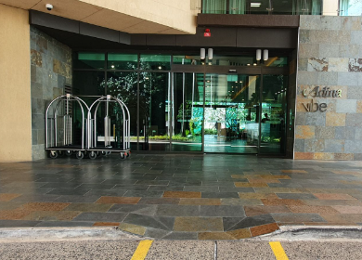
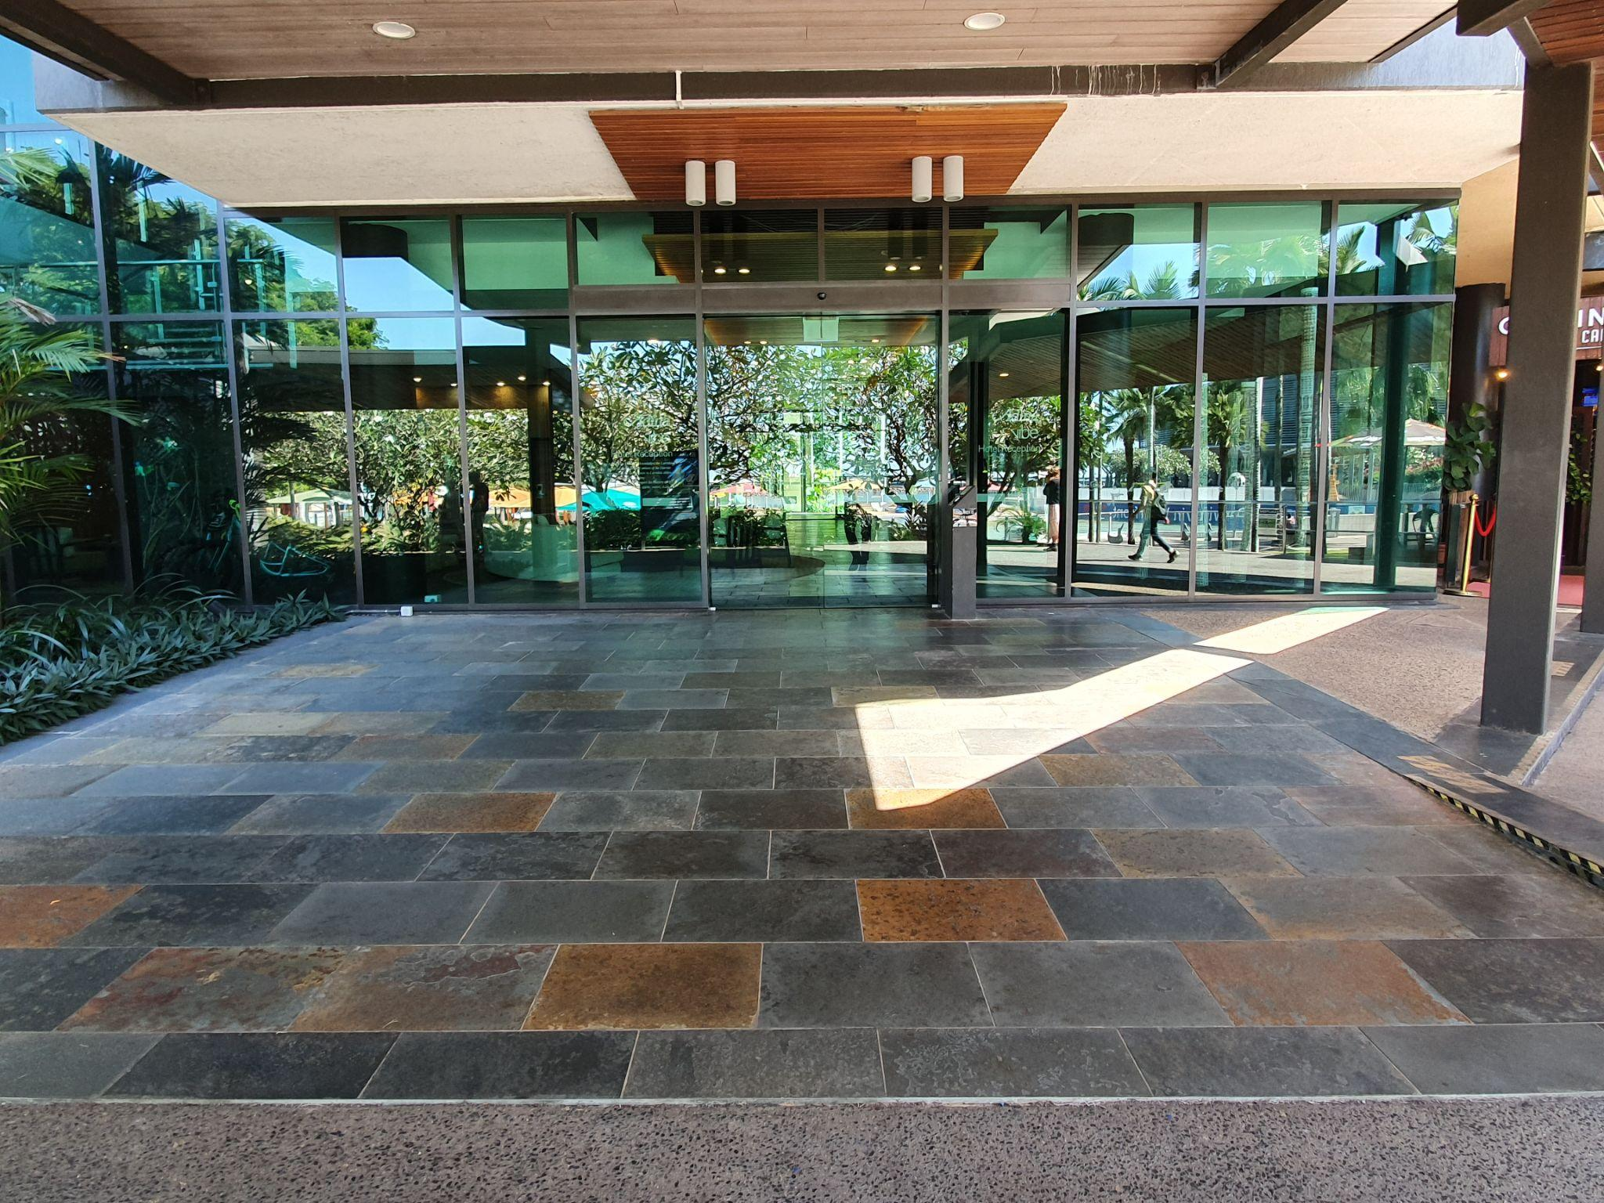
- A free-standing after-hours accessible button is situated 1000 mm from the ground.

Communication and Wayfinding

External Wayfinding
- The hotel is clearly marked with clear signage on the outside of the building.

Internal Wayfinding
- Directional signage throughout the hotel is situated at a height of 1460- 1750 mm from the finished ground surface with overhead lighting in place.
- Pedestal signage in the foyer has a height of 1220 m
- The emergency exits are clearly marked.
- Guest information in the rooms is presented in standard written and printed format.

Getting Around Inside
- There is lift access to all levels.
- On the ground floor there are public male and female toilets and a Unisex accessible toilet.
- A change table is located in the Accessible toilets on the Ground floor.
- All rooms have independent temperature control.
- There is a shared laundry on the Ground floor
- The Pool is located on the ground floor between the Foyer and entry to Curve Restaurant.
- The gym is located on the Ground floor near the pool.
- There is internal and level access to Curve Restaurant from the Foyer.
- Flooring: Ranges from tiles and low pile carpet

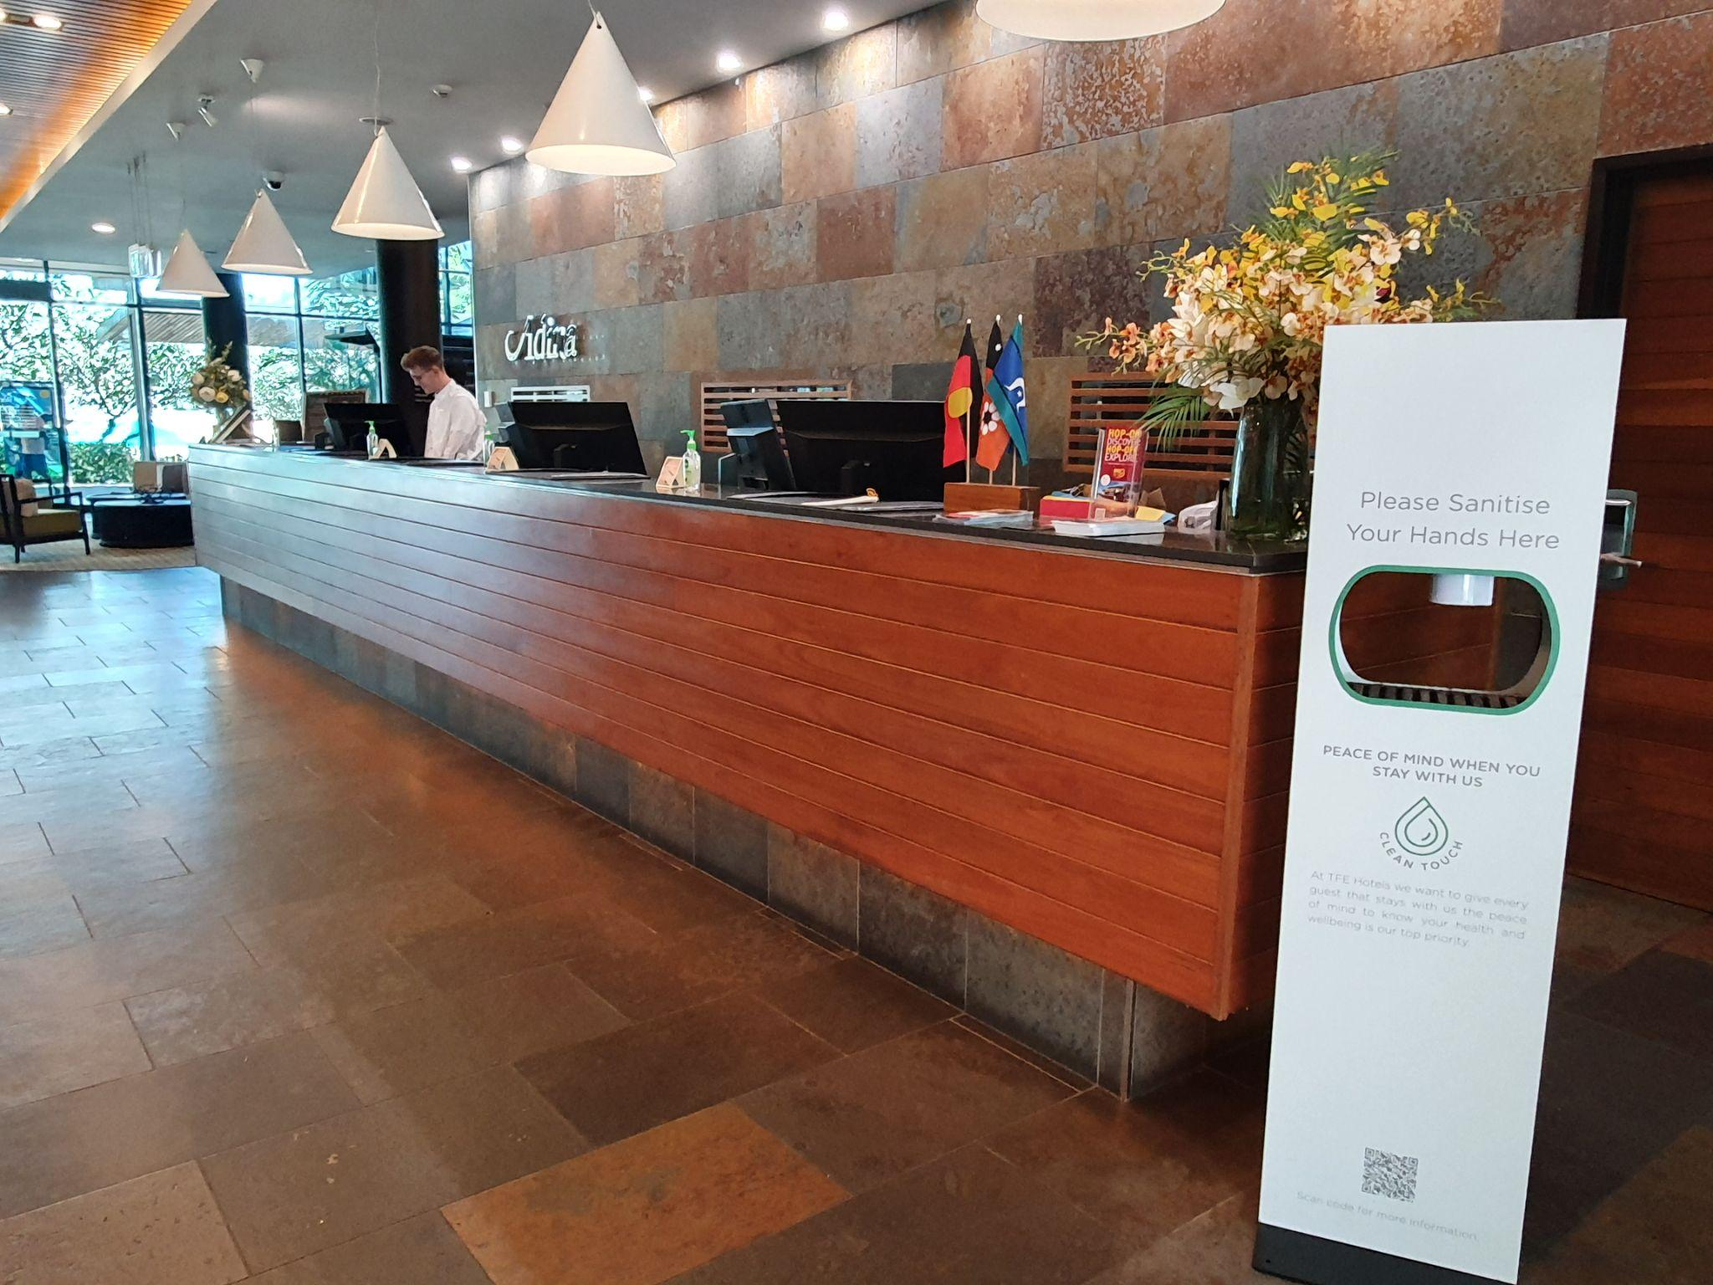
Foyer
- There is a shared Foyer for both Adina and Vibe Hotels.
- The approach to the foyer is level with tiles.
- Front and rear approach to the foyer is possible.
- There is background music playing in the foyer.
- A fragrance is used in the foyer, with a strong scent.
- Lighting is lux at reception, more than 200

The Lift
- The lift is located to the left of the reception area
- Buttons are positioned at a height of 1110 mm with raised elevator buttons.
- Key reader is at a height of 1300 mm.
- Floors are indicated with high contrast signage and Braille.
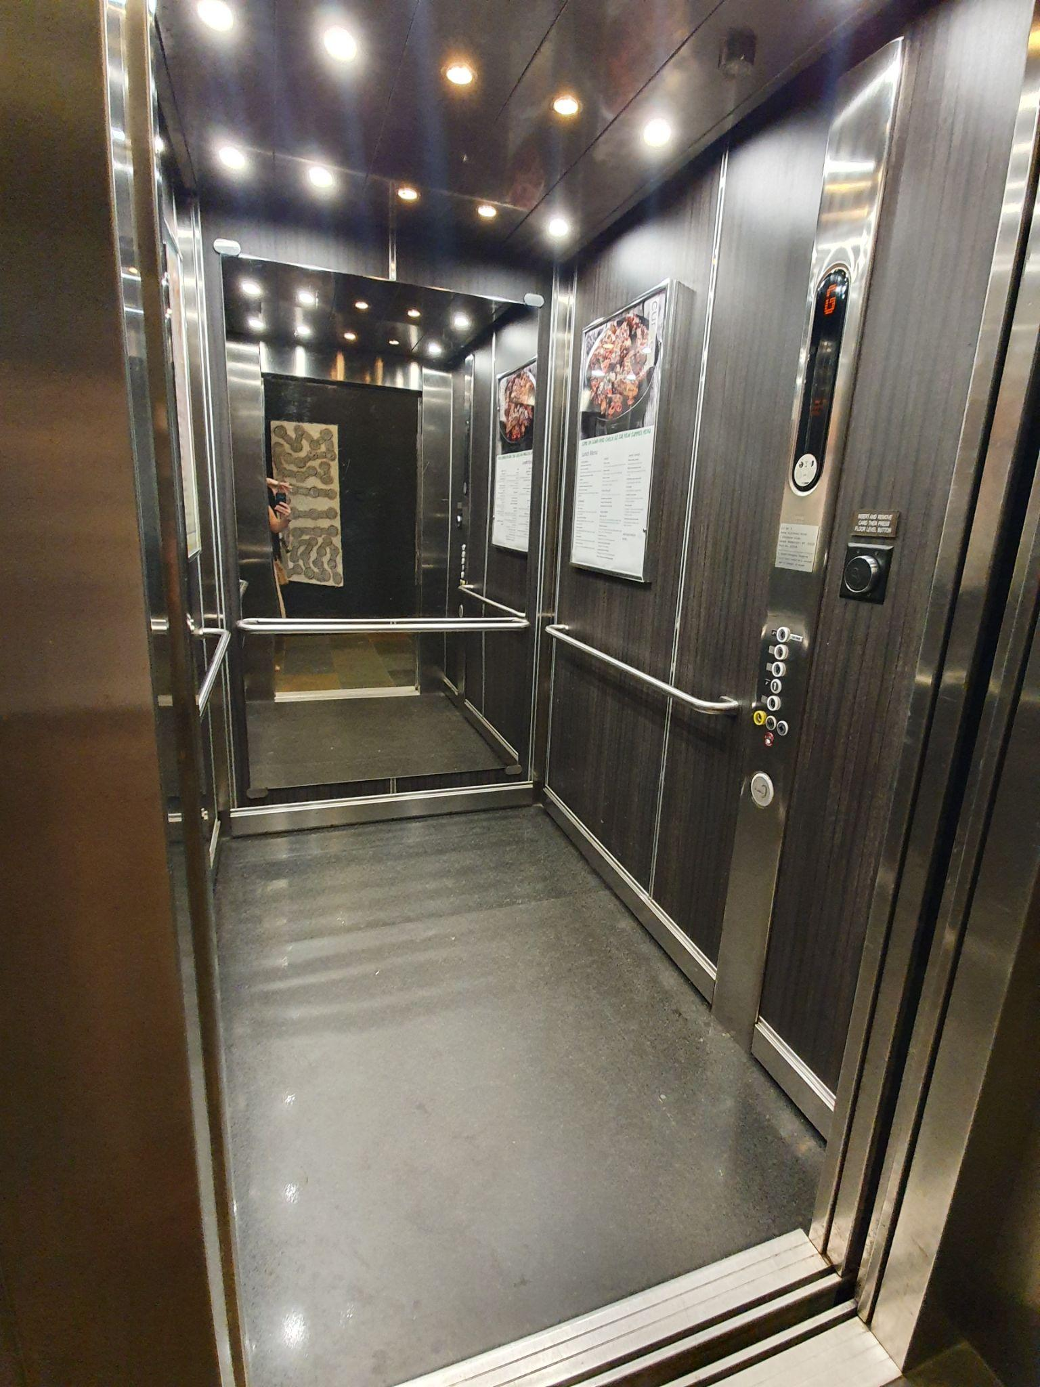
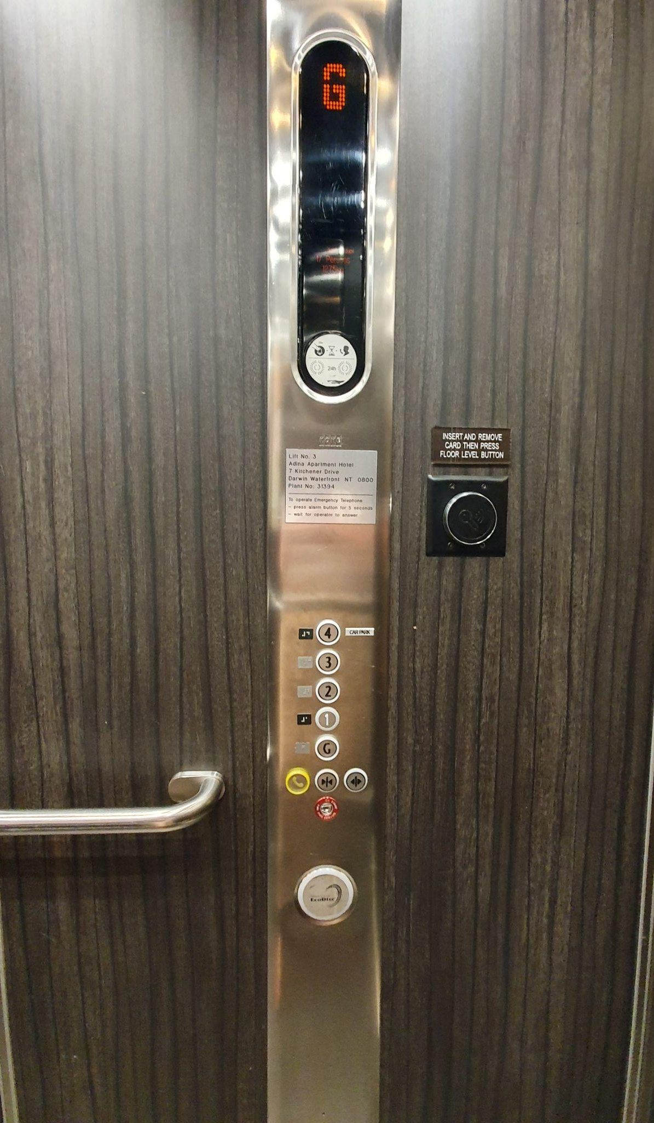
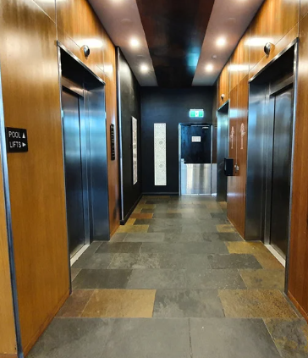
- The external lift button height is 1100 mm.
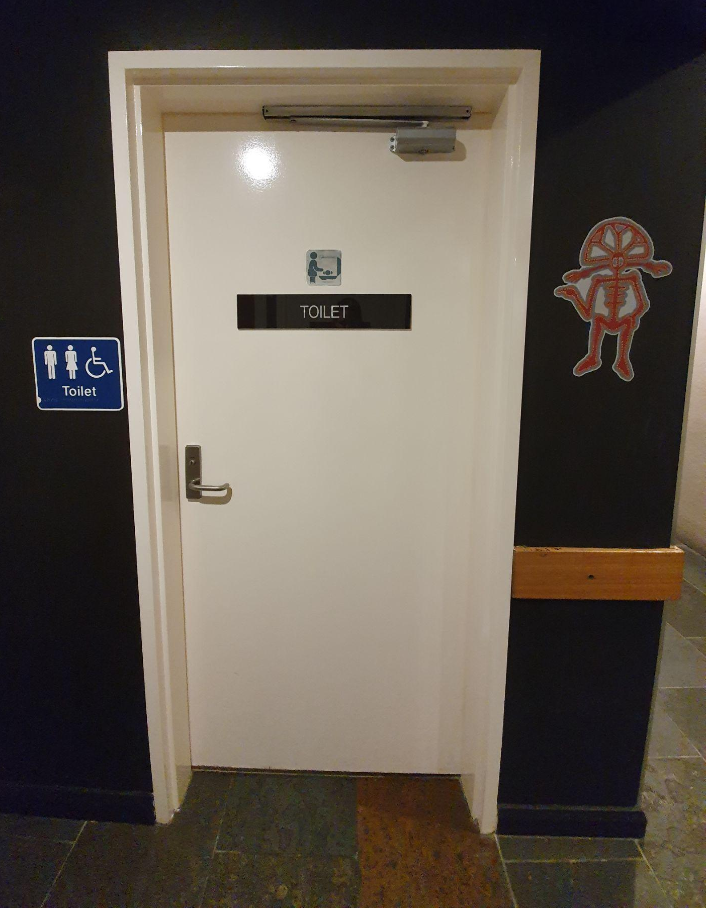

Toilets
- There are accessible toilets as well as standard male/female toilets available for guests.
- The accessible toilet is located on the ground floor near the Foyer of Vibe and Adina Hotels.
- Wayfinding is limited and you may ask staff for directions as needed.
- There is a baby change table in the Accessible Toilet.
- The corridor leading to the toilets area is approximately 1540 mm wide.
- The door width is greater than 850 mm
- There is a lever handle to enter and exit the toilet with a height of 1000 mm.

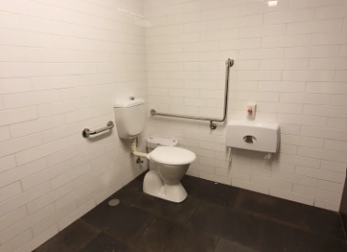
AccessibleToilets
- The toilet height is 460 mm
- Clear floor space to the right of the toilet is 2215 mm and to the left is 275 mm.
- Rails are on the left-hand side and to the rear of the toilet with a height of 800 mm.
- A duress alarm is situated to the left of the toilet at a height of 900 mm.

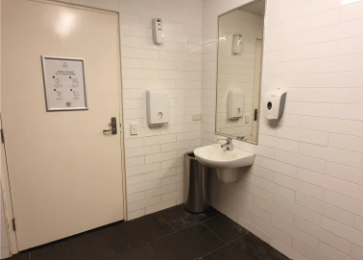
- The basin is located in the cubicle with a lever action tap at a height of 780 mm.
- The soap dispenser is at 1150 mm.
- There is unrestricted knee and foot clearance under the basin.
- There is a paper towel dispenser at 1000 mm.

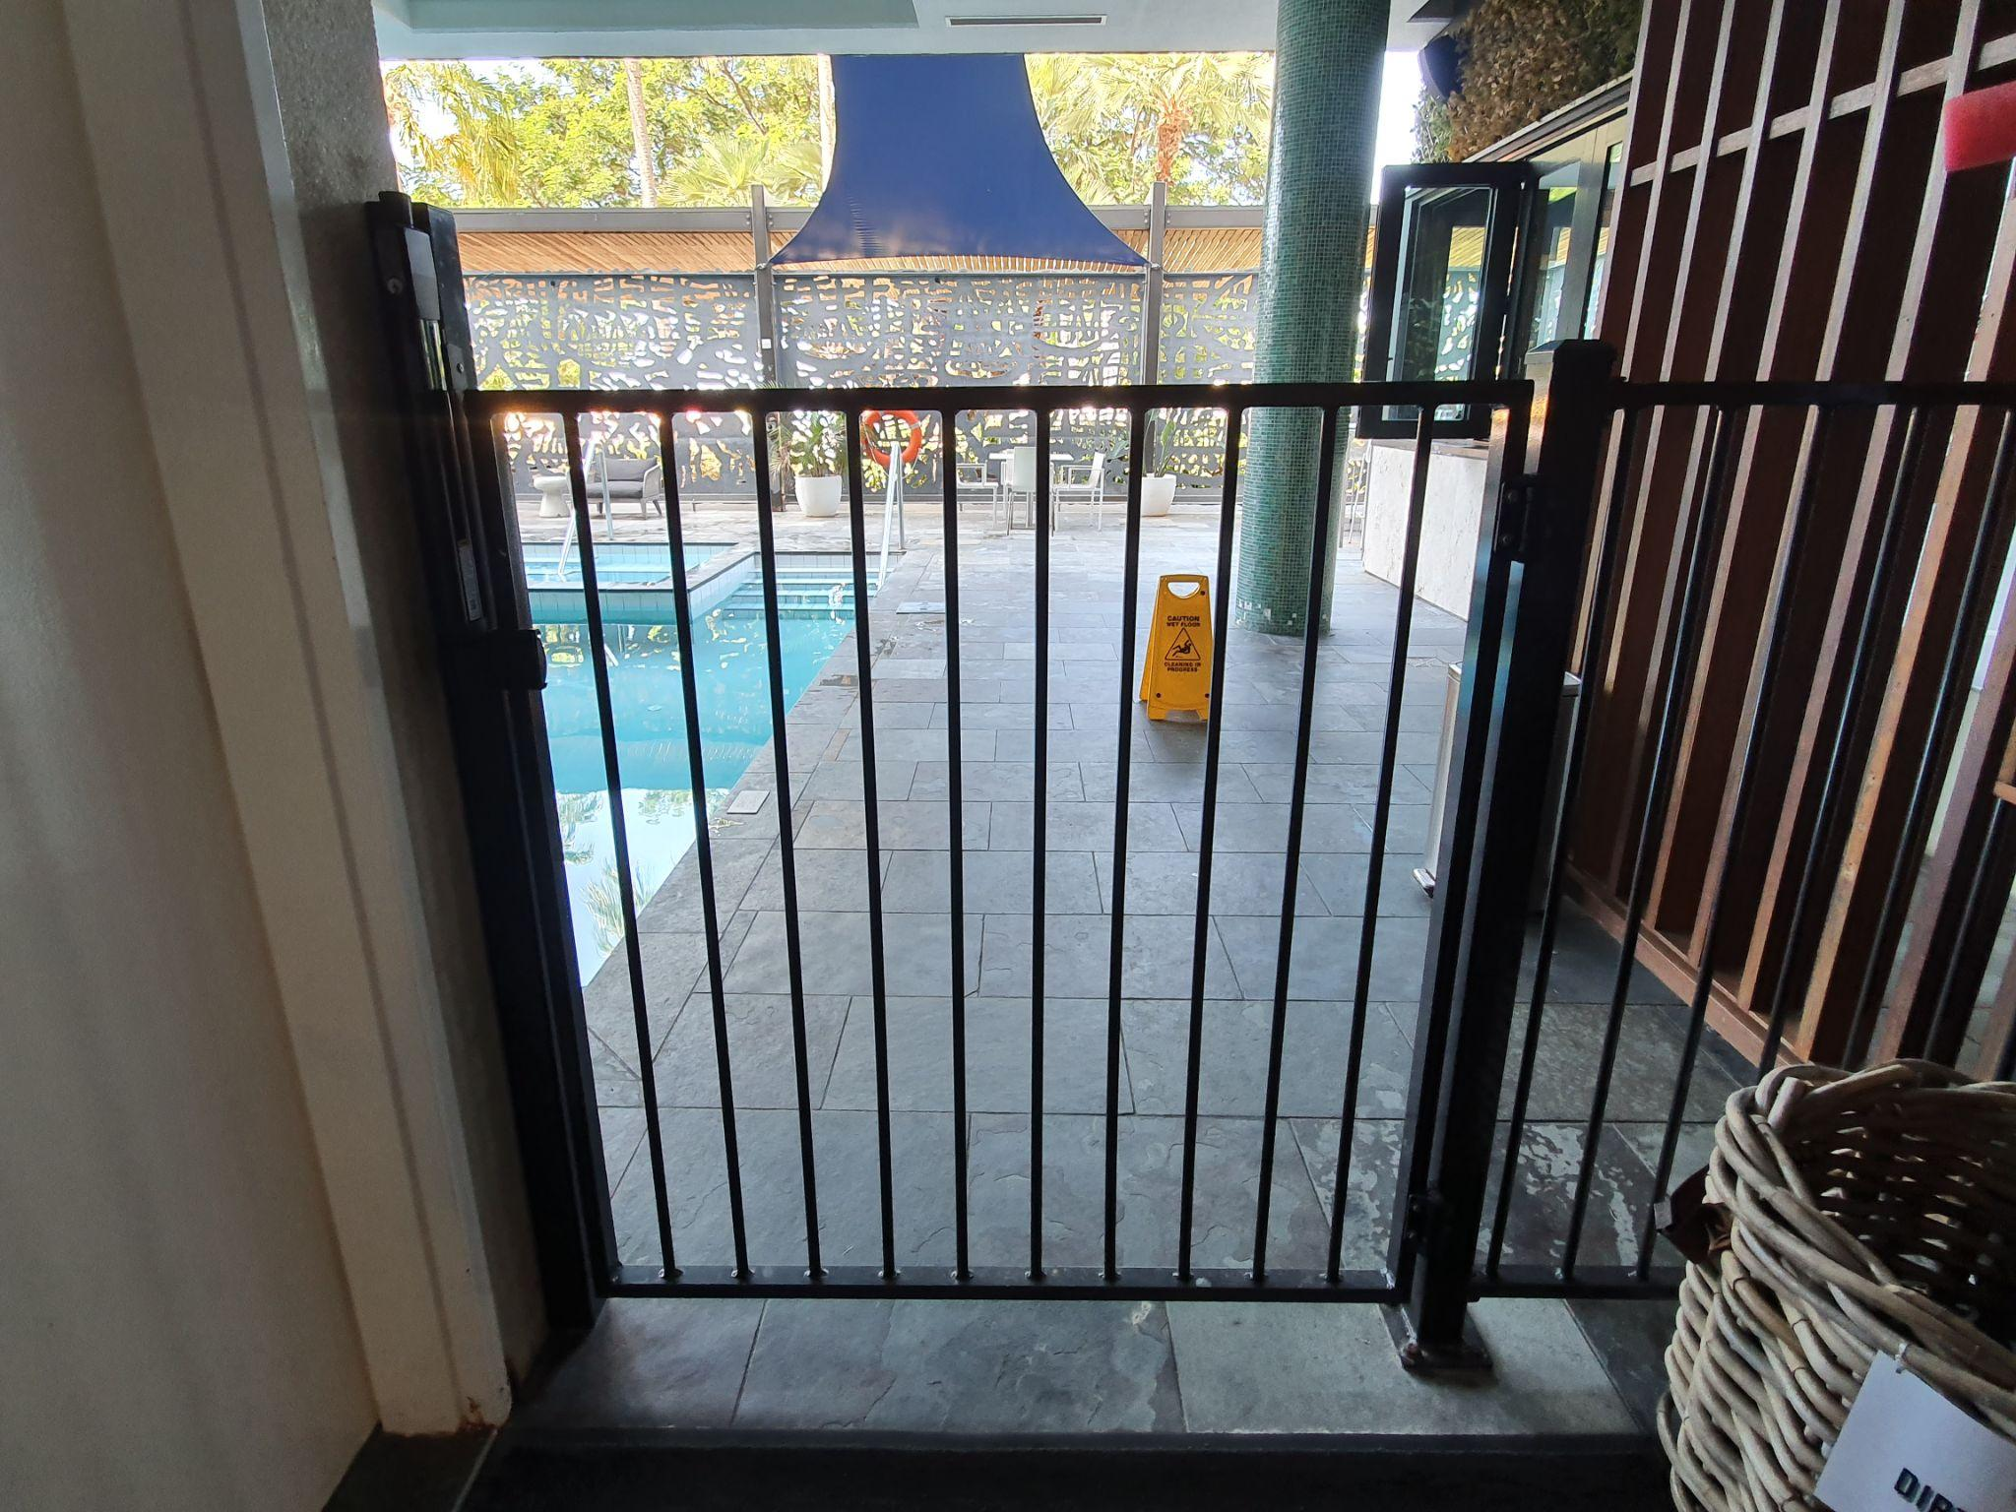
The Pool
- The pool is surrounded by a range of furniture.
- There are standard male and female toilets with a shower cubicle in each and there is a small external shower.
- Access to the pool area can be gained with a swipe key. The swipe pad is at a height of 1100 mm and has a textured indicator.
- There is an outswing door to the pool gate with a height of 945 mm.
- The Child Safety gate has a height of 1500 mm.

- Entrance into the pool is via 5 steps to a depth of 1.2 m.
- There is a handrail installed to the left of the stairs descending into the water at a height of 920 mm.
- Entrance into the spa area is via 4 steps with a handrail to the left, descending to an unspecified depth.
- There is no hoist or adaptive equipment to access the pool or spa.
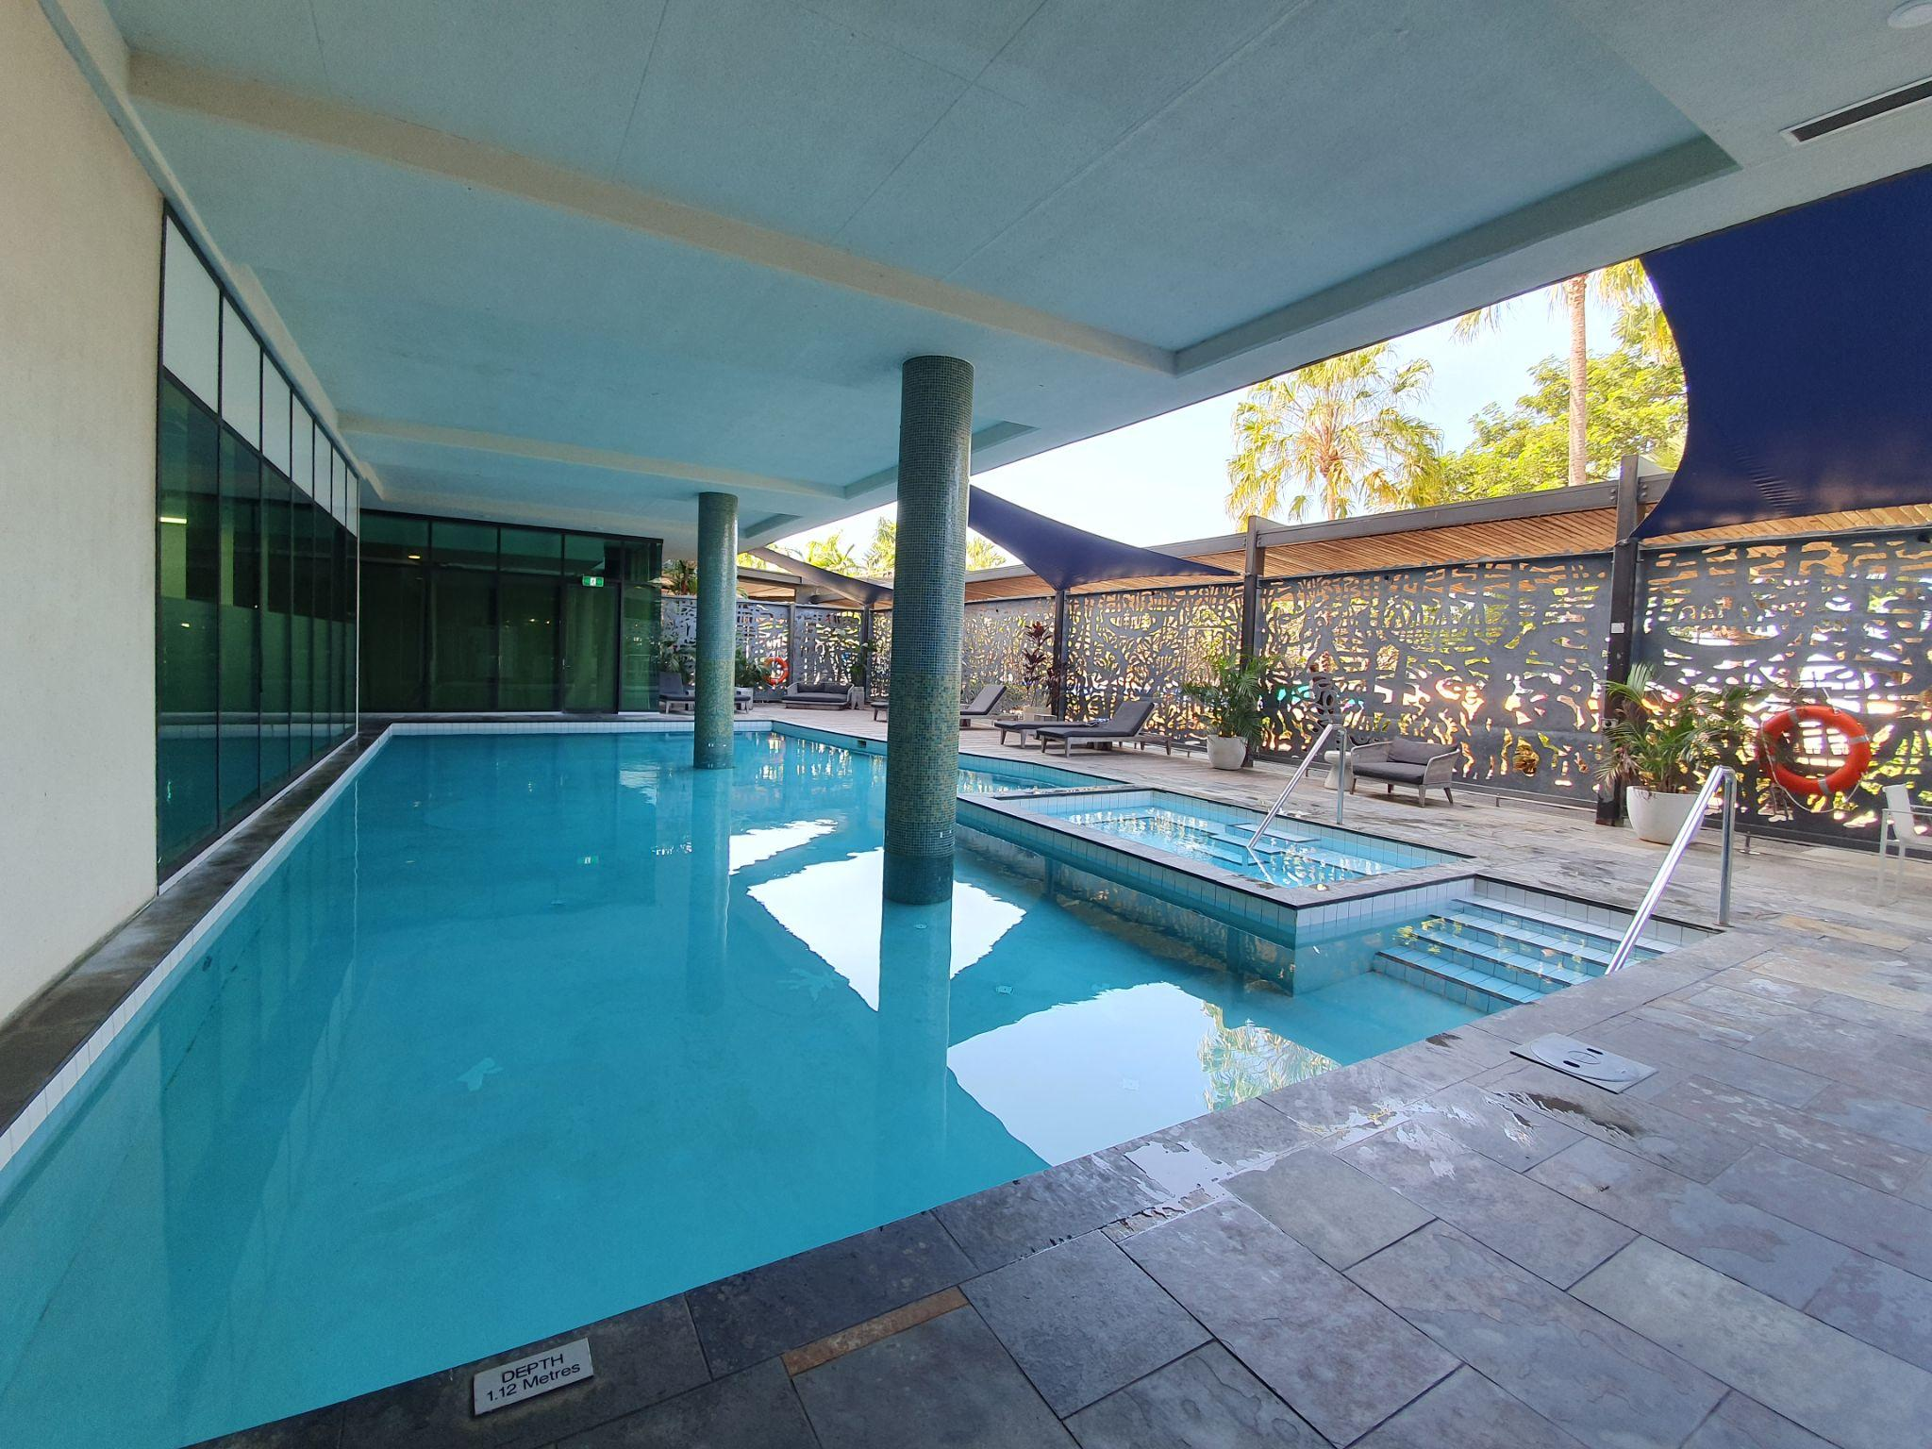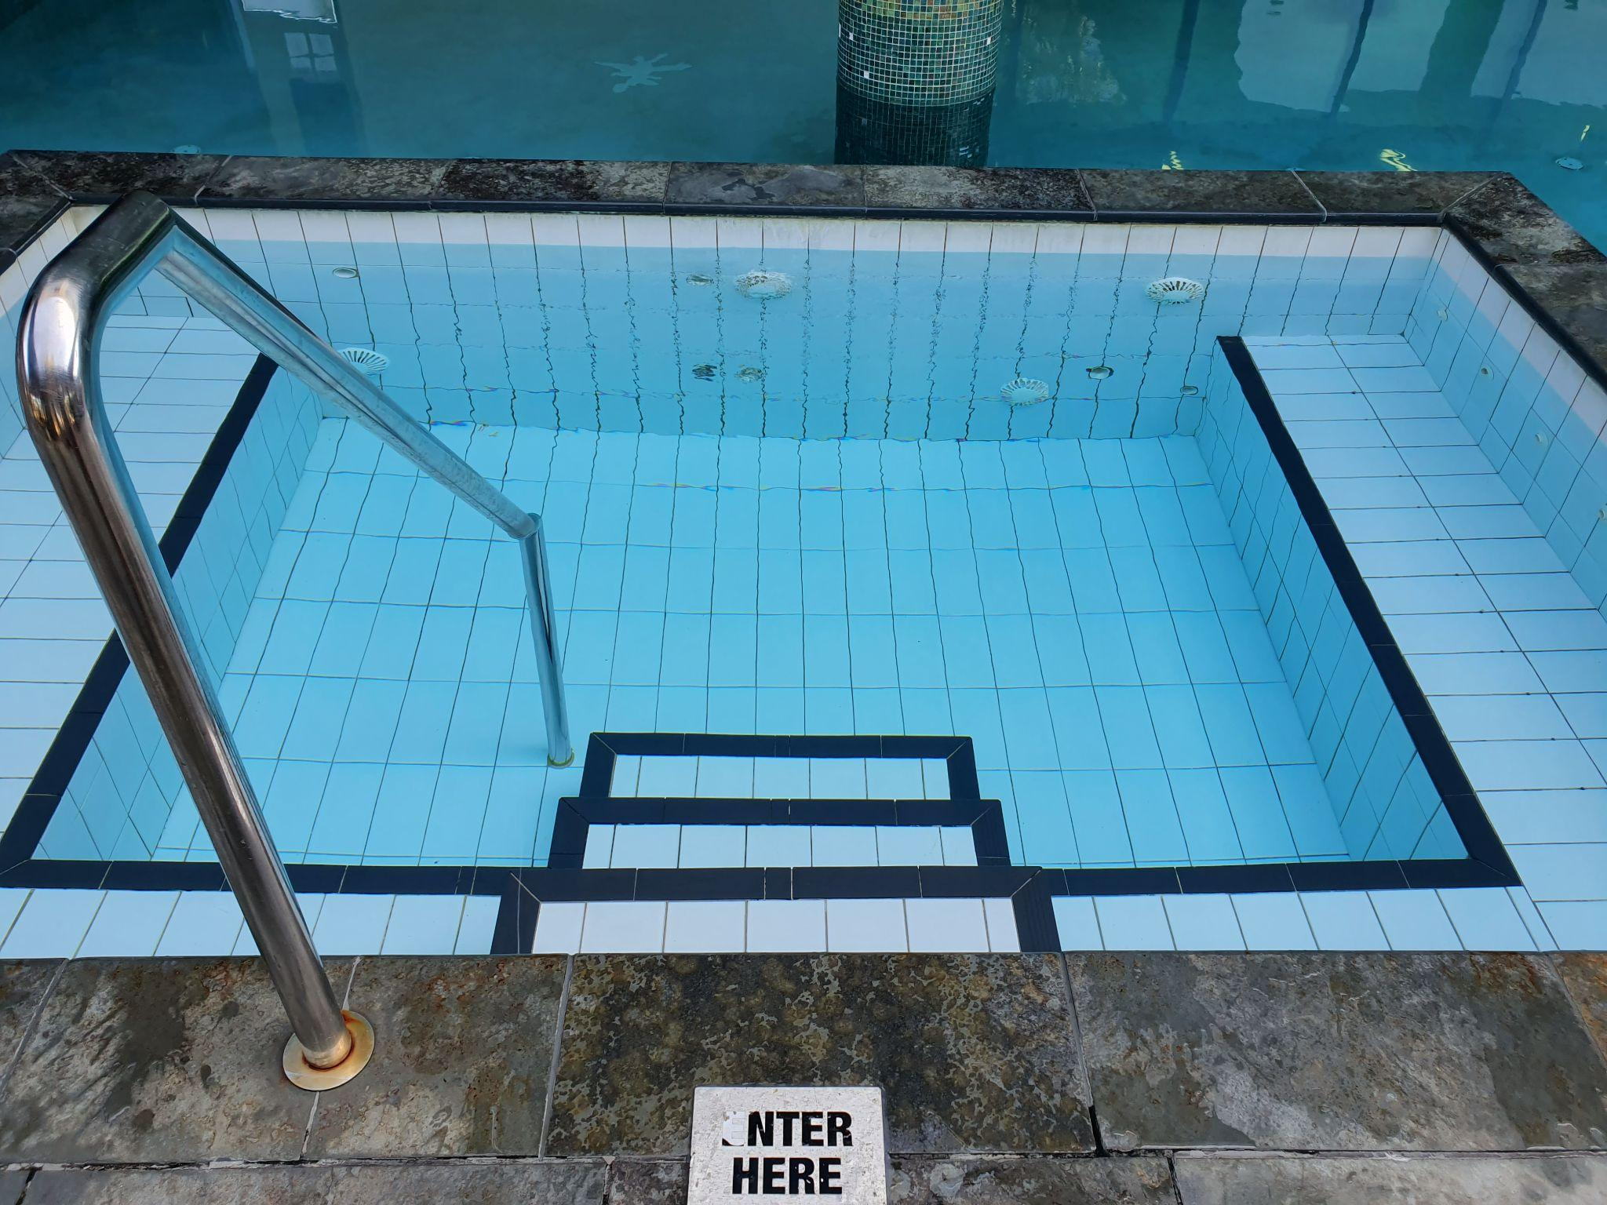

Furniture
- Sun loungers: are low with a height of 370 mm.
- Standard Height Tables: The pedestal table height is 740mm and the height of the clearance underneath is 725 mm.
- Seating: Firm chairs without armrests have a seat height of 460 mm.
- Tall table: Has a height of 1050 mm and the clearance underneath is 1020 mm
- Seating: High stools with backrests have a height of 750 mm.
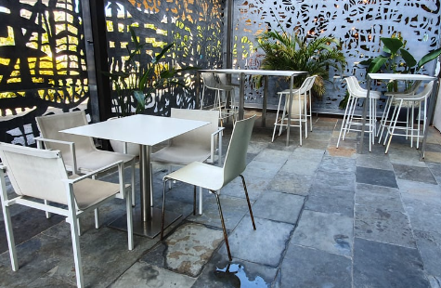
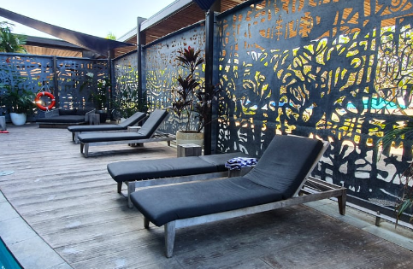

The Gymnasium
- Access to the gym is through an in-swinging door with swipe key access.
- The door has a width of 870 mm and the handle is situated at a height of 990 mm.
- The light switch has a height of 930 mm.
- Flooring: Low pile carpet
- A water fountain and sanitiser is available.
- There is restricted clear floor space between equipment.
- Background music is adjustable.
- The lighting is approx 300 Lux
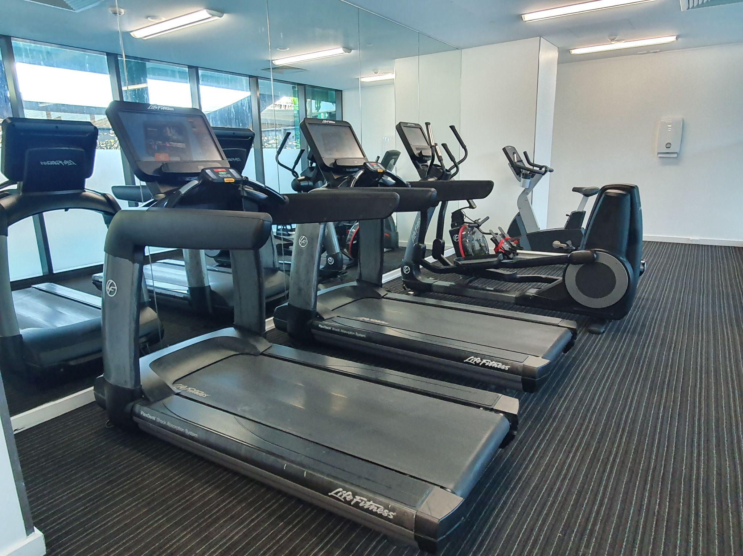
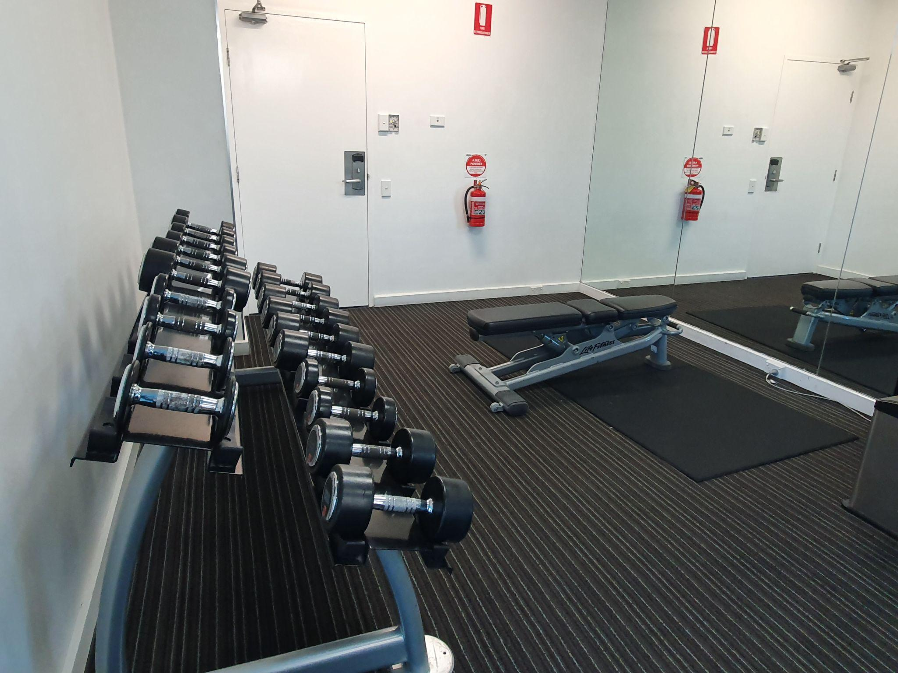
- There is a mild fragrance present

Laundry
- There is level access with a concrete surface.
- The door has a width of 865 mm.
- The narrowest point throughout the space is 1000 mm.
- The top loader washing machine has a height of 915 mm.
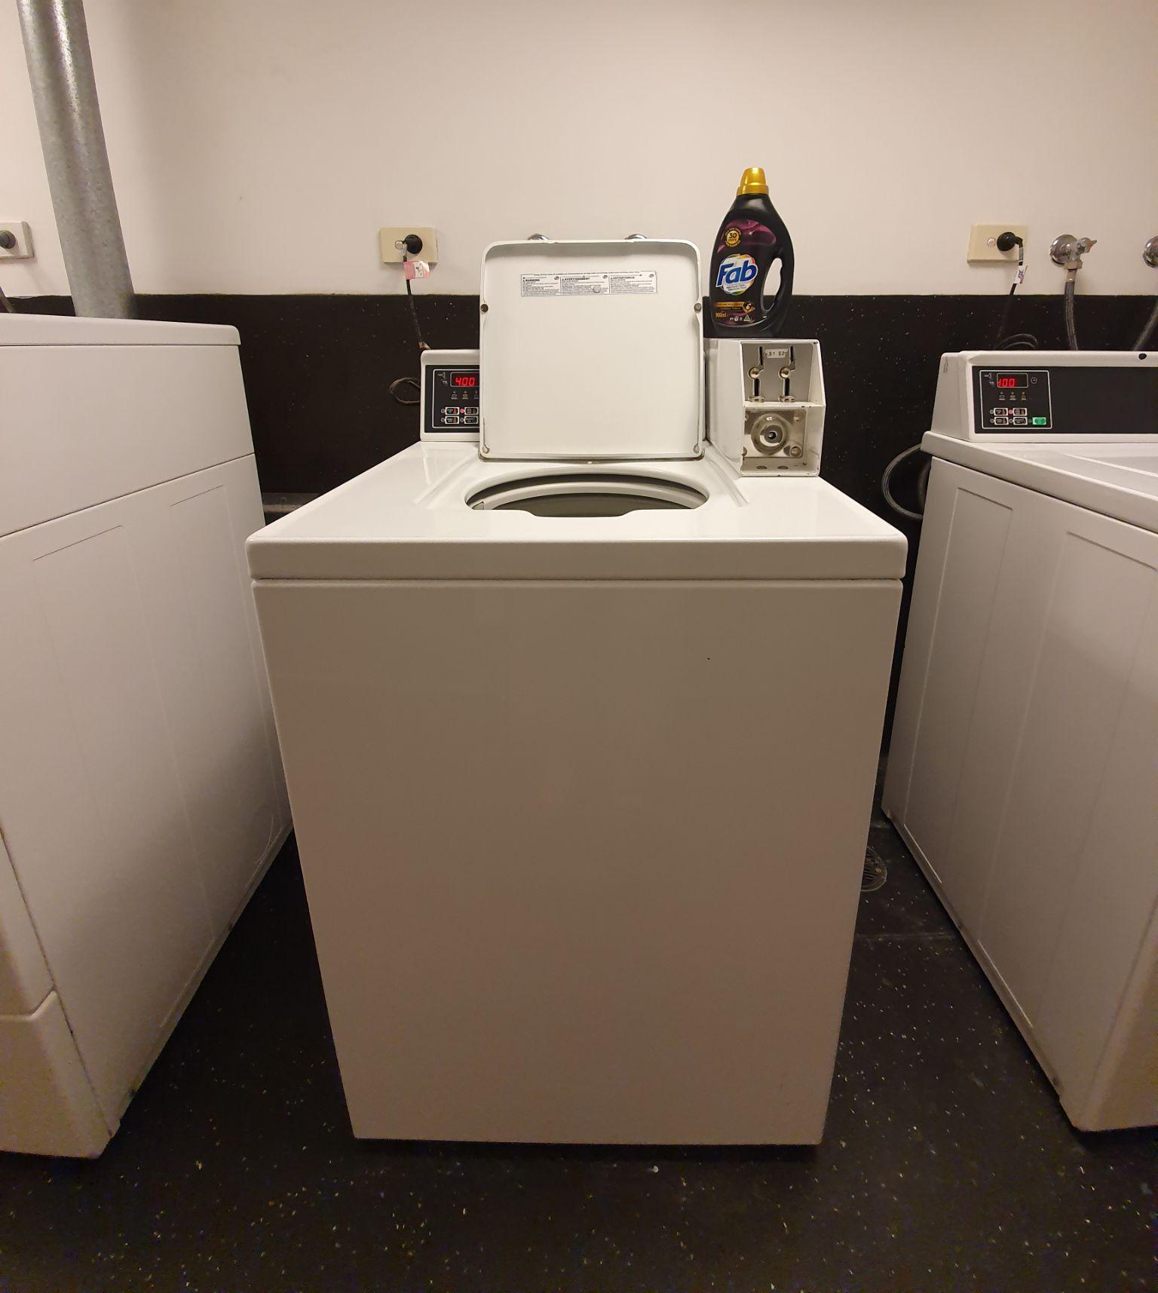
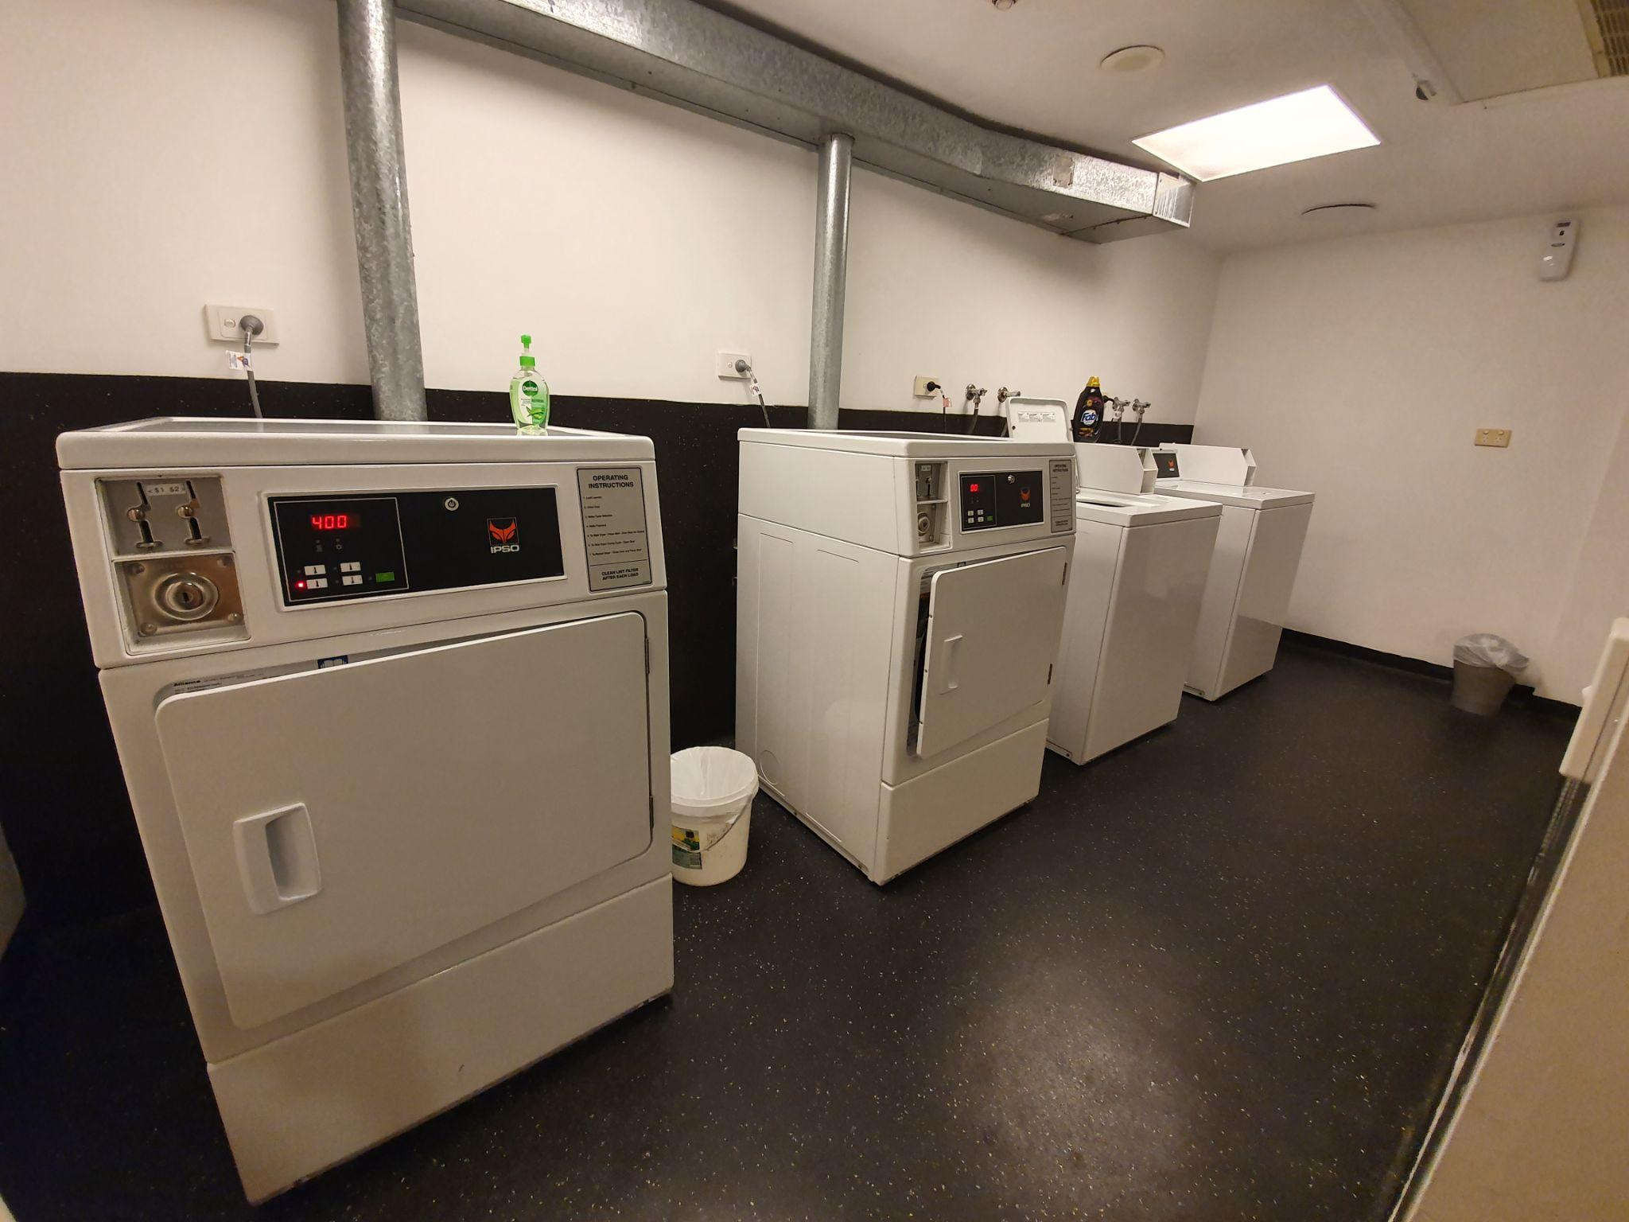
- The dryer is a front loader, with a handle height of 1000 mm.

Getting to the Rooms
- There is lift access to all levels.
- Lighting varies throughout the corridors and can be adjusted.
- There is low pile carpet or tiles throughout.
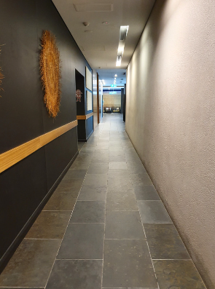
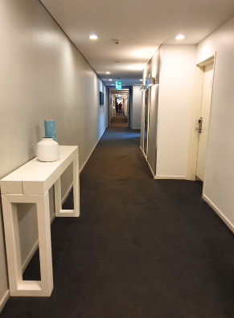
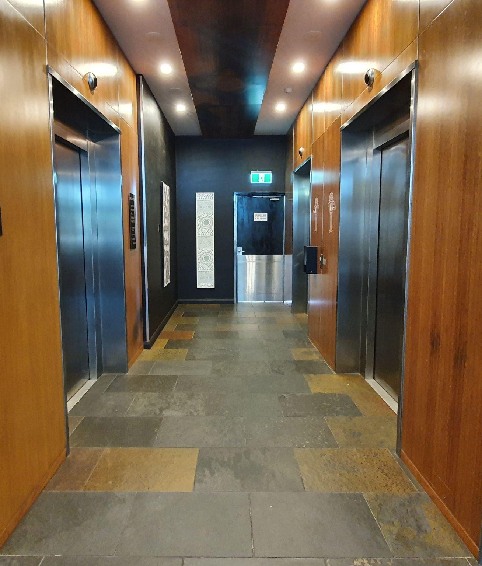
- Staff can accompany you to your room as required.

Accessible Apartment
- The room used in this example is Room 343.

Entrance
- The lighting in the corridor approaching the room is between 30 and 130 Lux depending on the position under lighting.
- The inswing manual door has a width of 855 mm.
- The door handle is 990 mm from the finished floor and the key swipe height is 1125 mm.
- Clearance at entry is greater than 800 mm.
- There is level access throughout
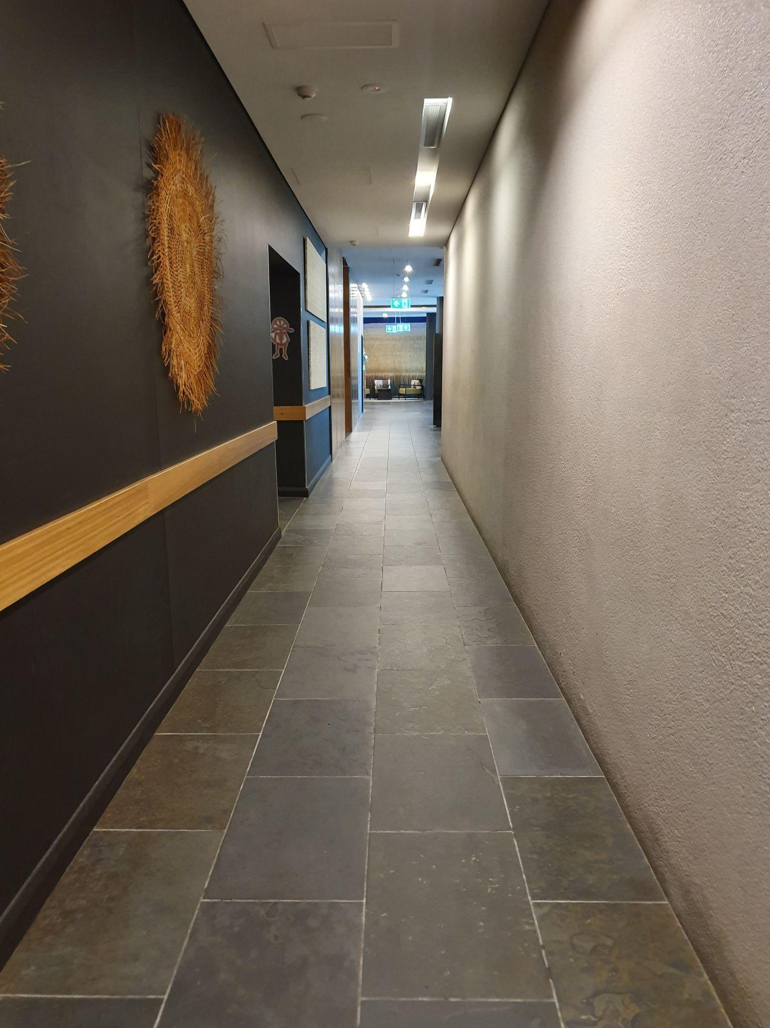
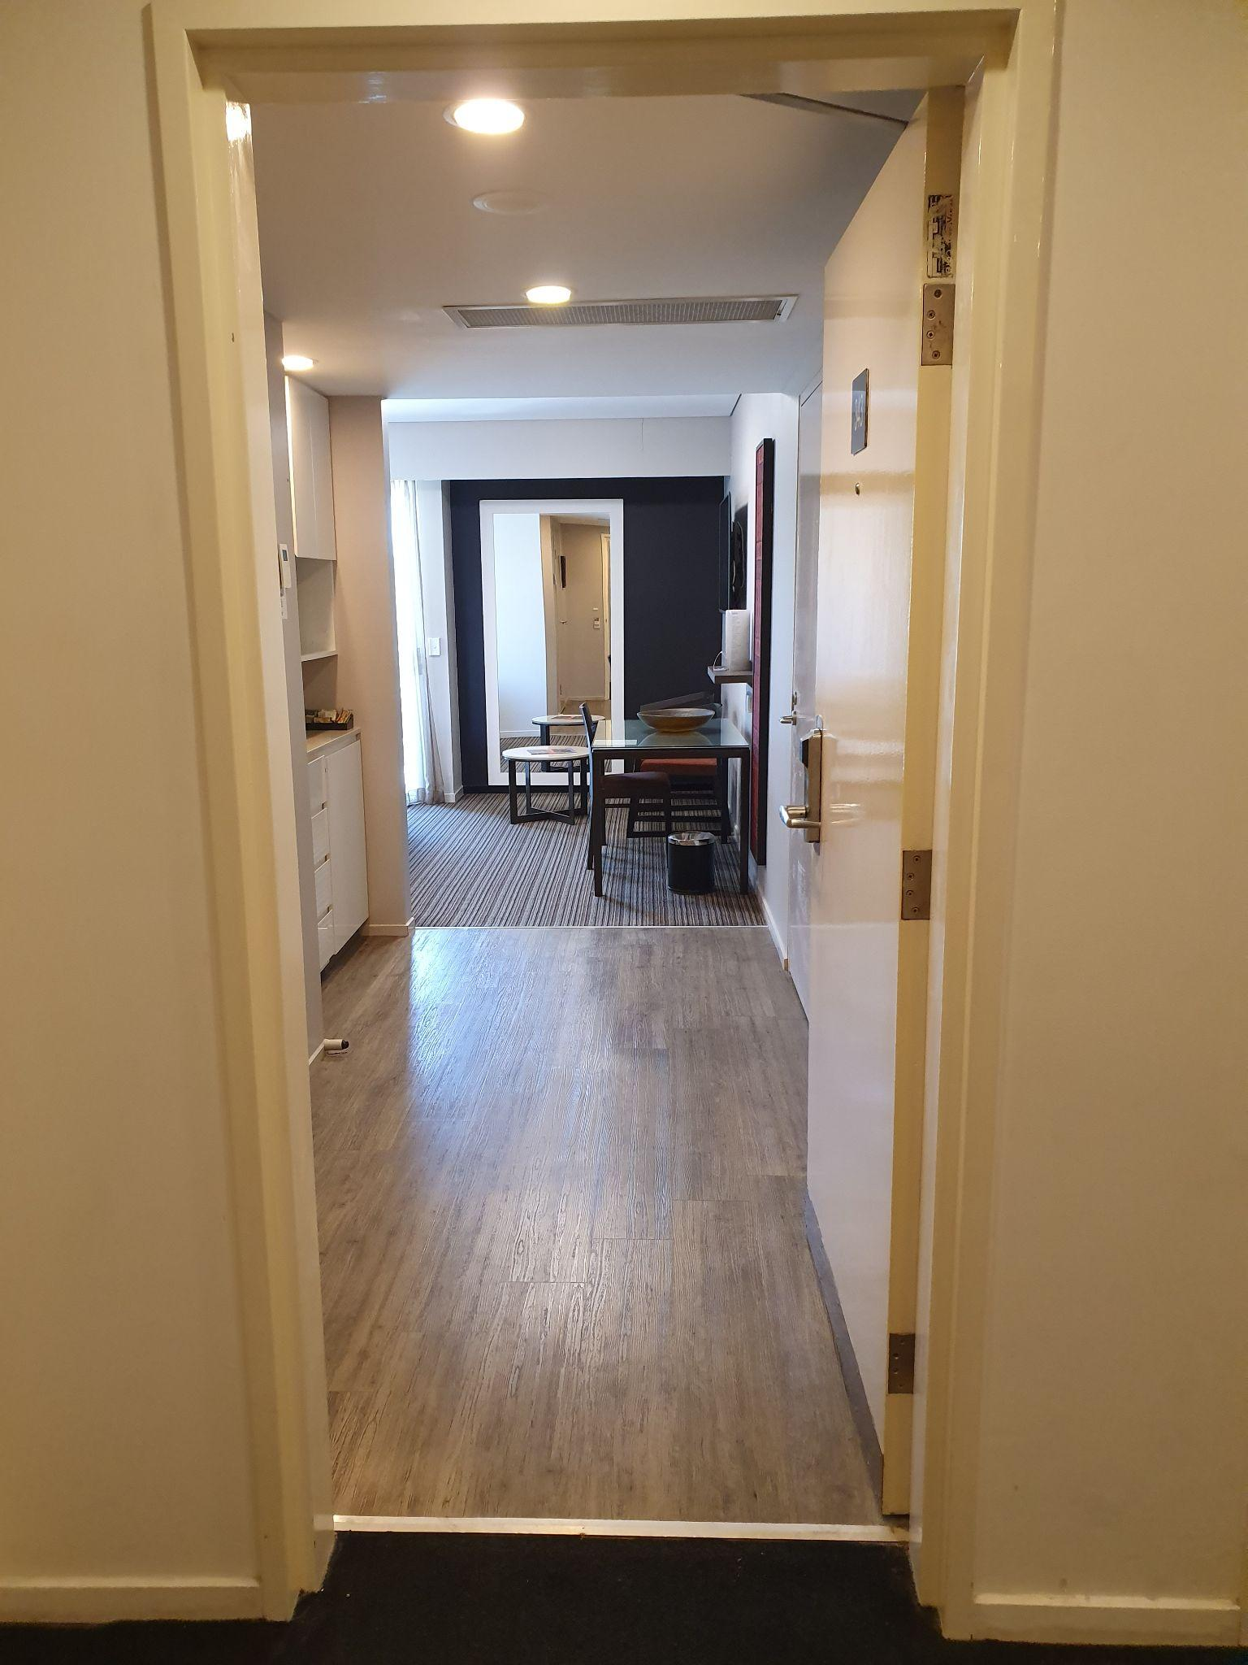
- Flooring: Floorboards and low pile carpet.

Sounds
- This room may be impacted by the sounds of movement of other guests nearby.

Lighting
- Lighting switches are installed at a height of 1000 mm.
- There are bedside lamps and a main light switch at the bedside.

Cooling / Heating
- Air conditioning is available in this room.
- The air conditioner controller is positioned 1620 mm from the finished floor.

Power points
- Power points are installed at various heights around the room and are also located on the bedside table.

Other
- The phone on the bedside table is within reach.
- There is a safe in the room situated at a height of 1960 mm.
- The door viewer peephole is positioned above 1500 mm from the finished flooring.
- This room is fitted with a standard audio emergency alarm.

Bedroom
- The bed has a compressed height of 560 mm and has an under-bed clearance of 85 mm.
- The clear floor space to the left of the bed is 885 mm and to the right of the bed is 765 mm. There is a clearance of 1265 mm at the foot of the bed.

Furniture
- The table has a height of 730 mm and a clearance underneath of 670 mm.
- The chair without armrests has a height of 460 mm.
- The chair with armrests has a height of 400 mm.
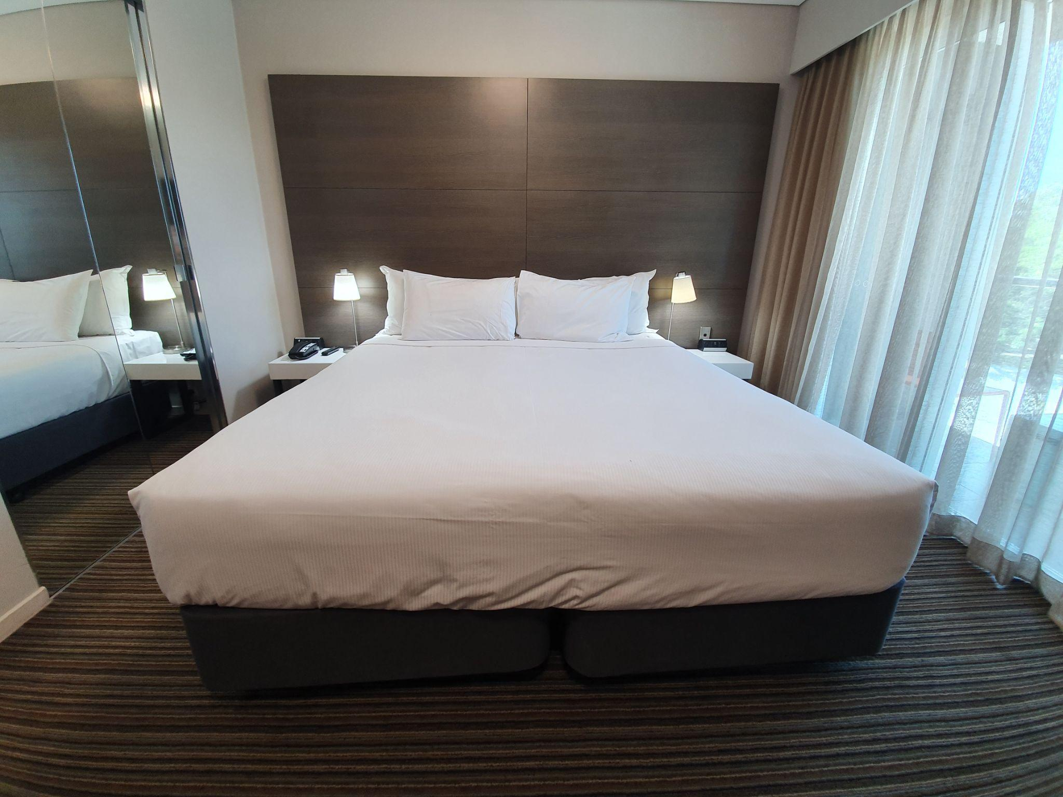
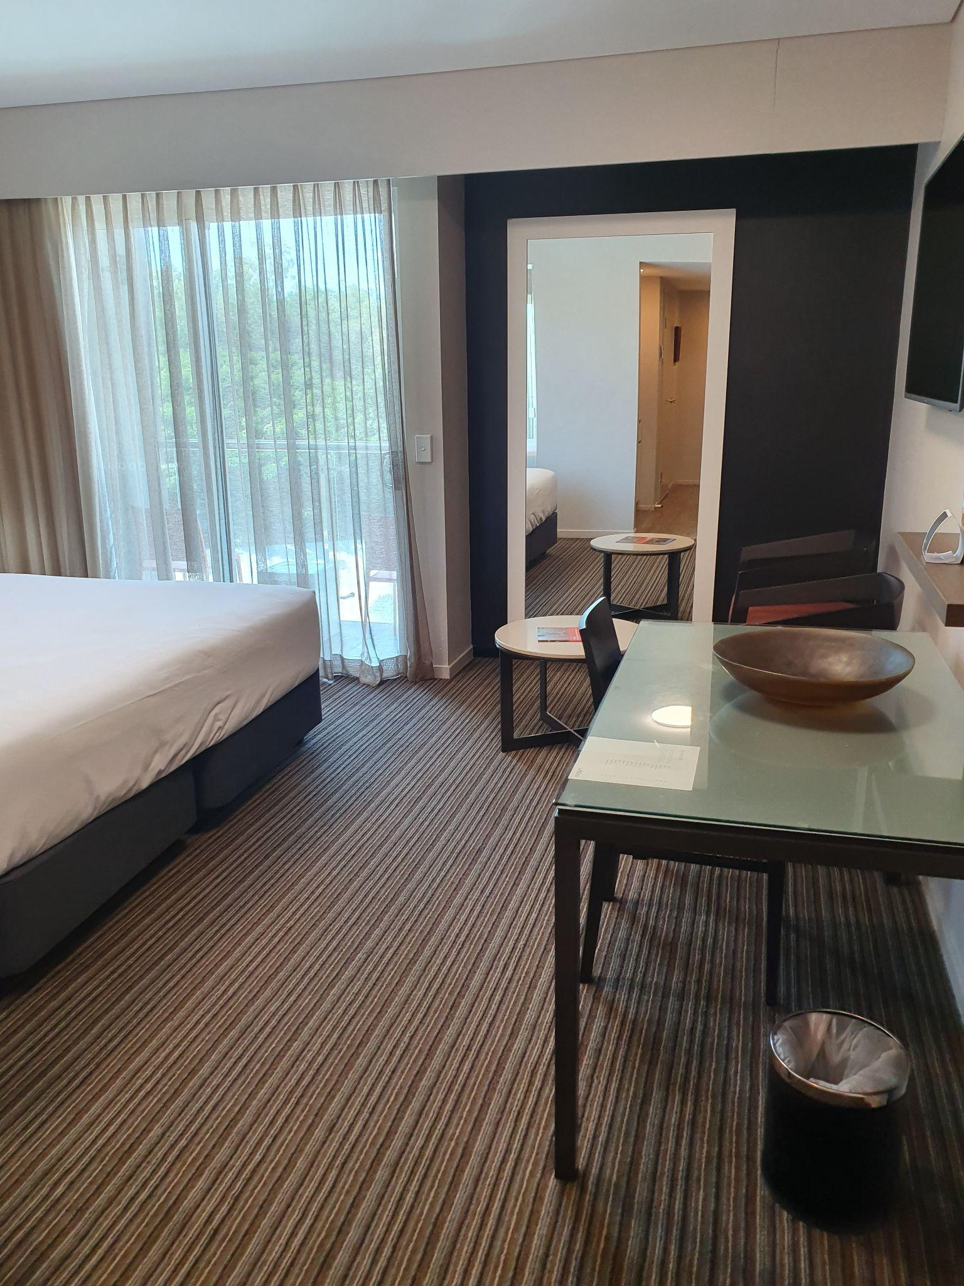
- There is a wardrobe with a full-length mirror next to the bed.

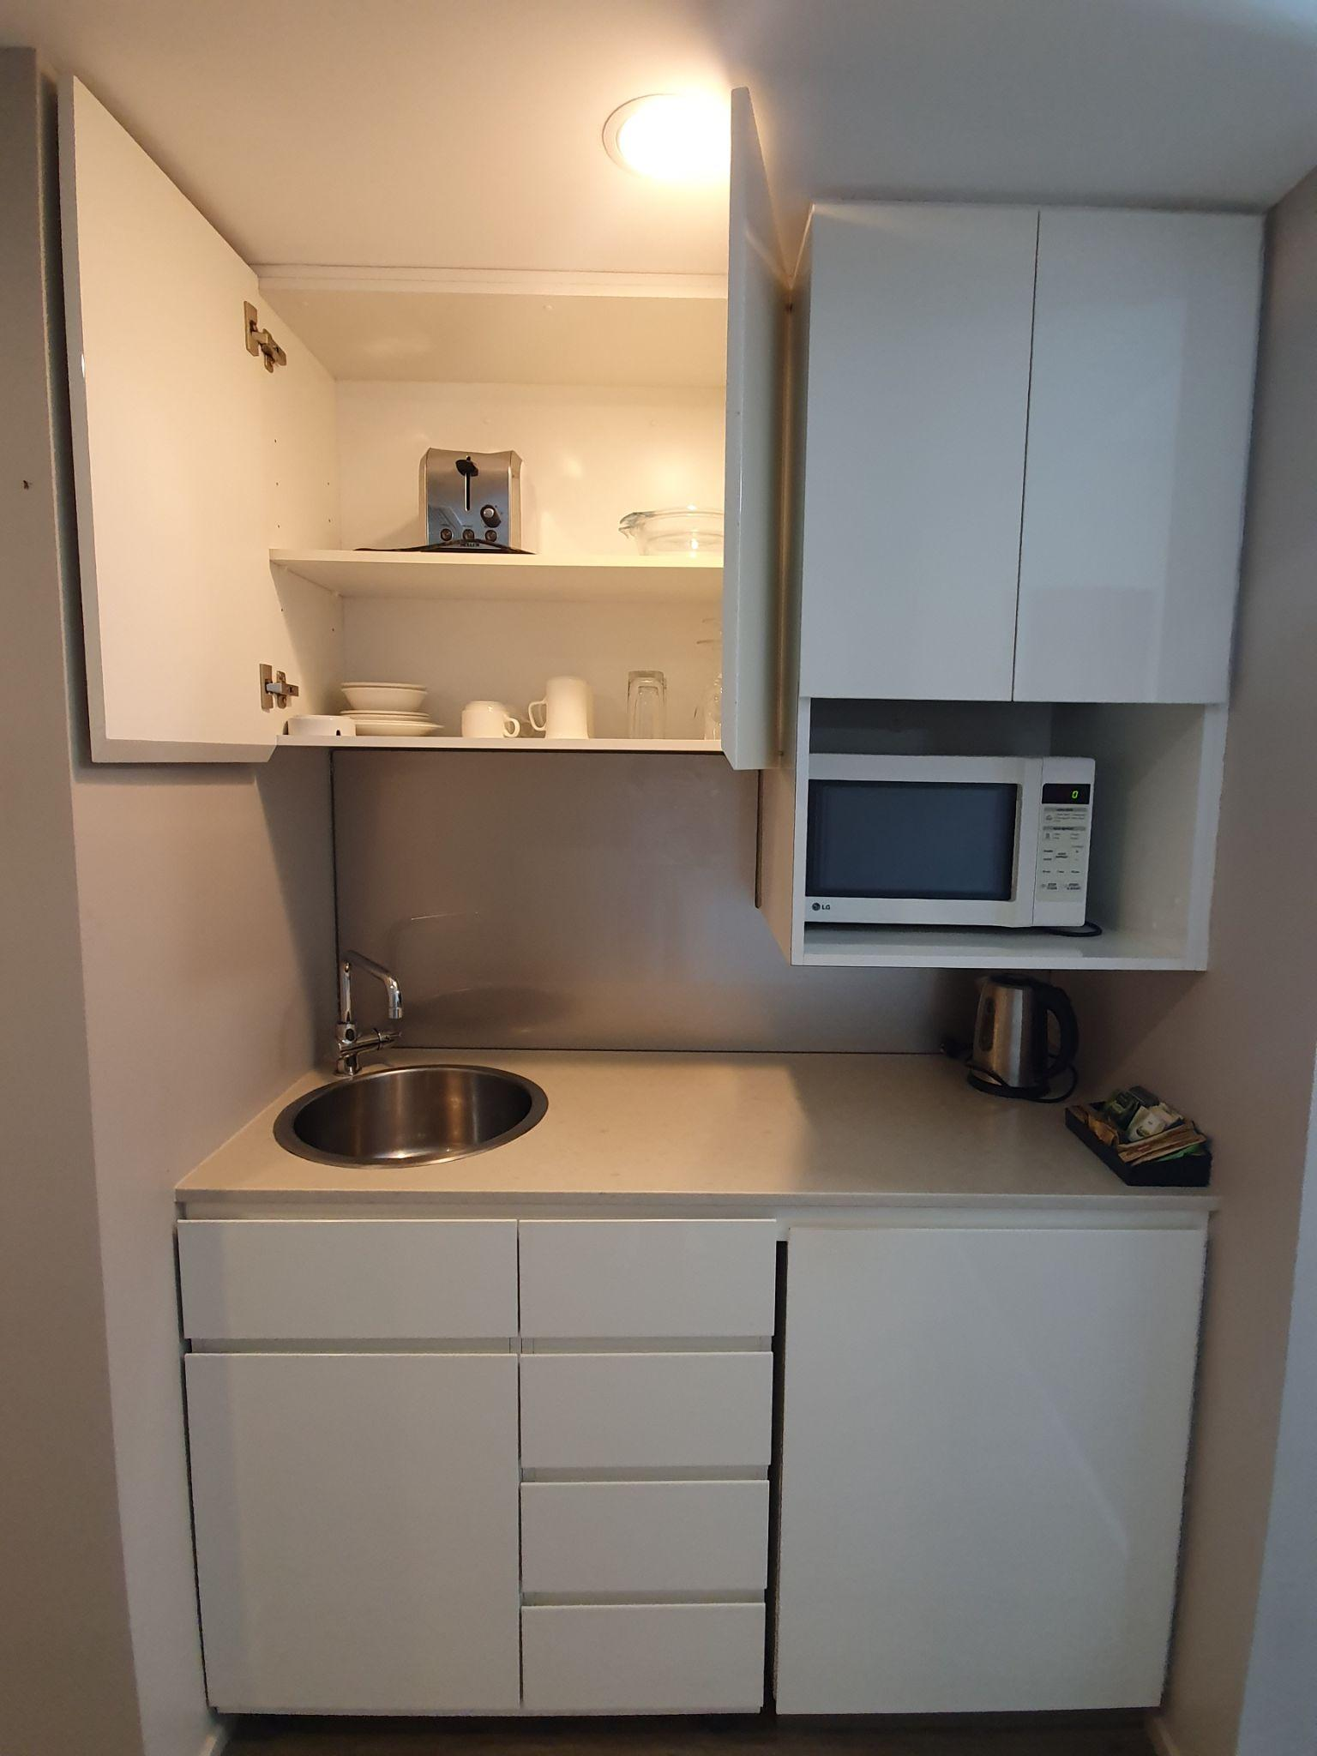
The Kitchenette
- The bench height is 890 mm.
- The tap of the sink is set back 480 mm from the edge of the bench.
- The microwave is situated at 1200 mm high.
- The bottom shelf of the cabinet above the sink has a height of 1500 mm.
- Toaster, stove, fridge and dishwasher are available.

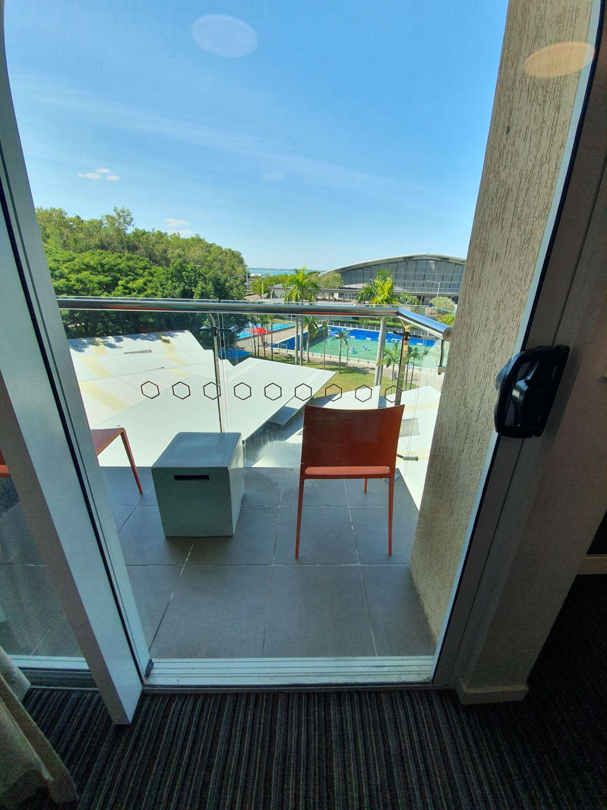
The Veranda
- A heavy sliding door leads out onto the veranda. The door has a width of 860 mm.
- There are glass safety markings on the door.
- The Veranda is 2135 x 1075 mm in size.
- The rail installed has a height of 1100 mm.
- There is a step down to the verandah of 120 mm.
- There are plastic, movable chairs without armrests.

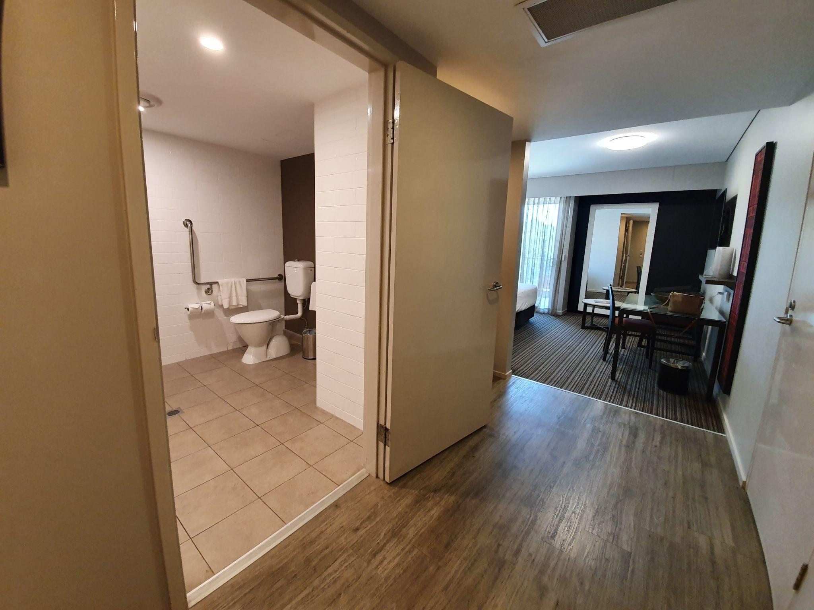
Ensuite
- There is an out-swinging door with a width of 900 mm.
- The height to the top of the handle is 1000 mm
- There is a threshold ramp.

The Shower
- The walk-in shower is 1170 mm x 1100 mm in size and the shower recess has level access.
- There is a hand-held shower hose with a high hook.
- Horizontal rails are installed at a height of 800 mm.
- The soap pump is installed at a height of 1170 mm.
- There is a fold-down seat installed with a depth of 500 mm and a width of 400 mm.
- The tap handle is at 1000 mm.
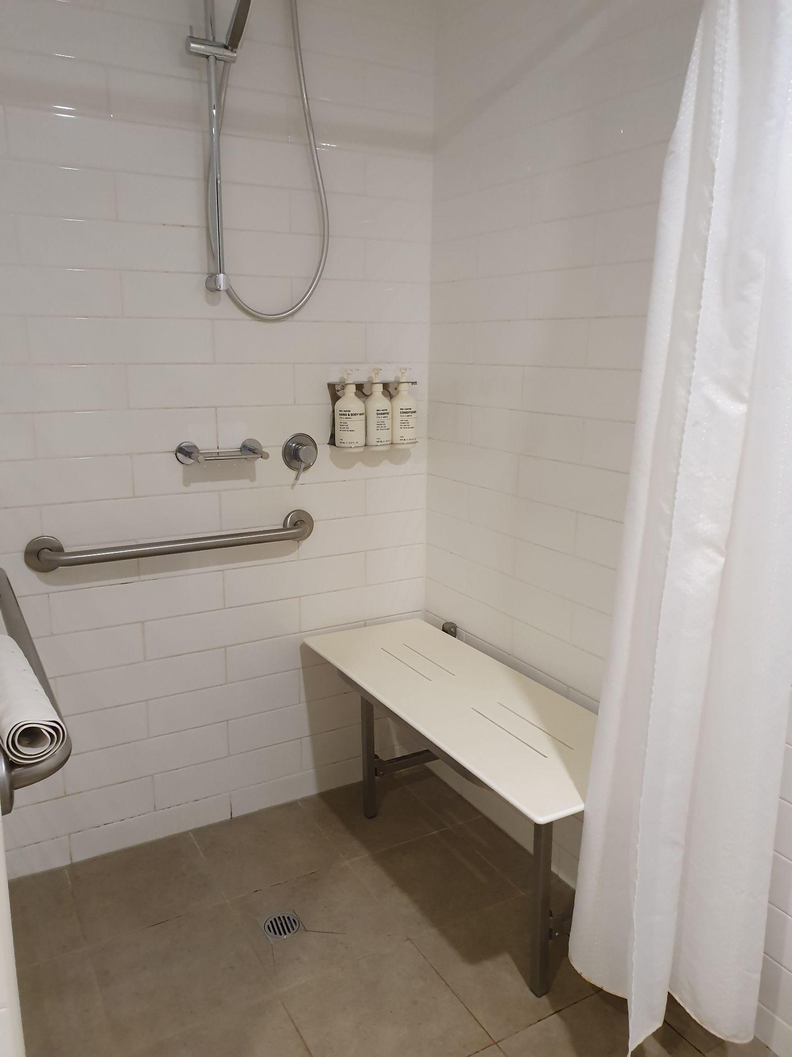
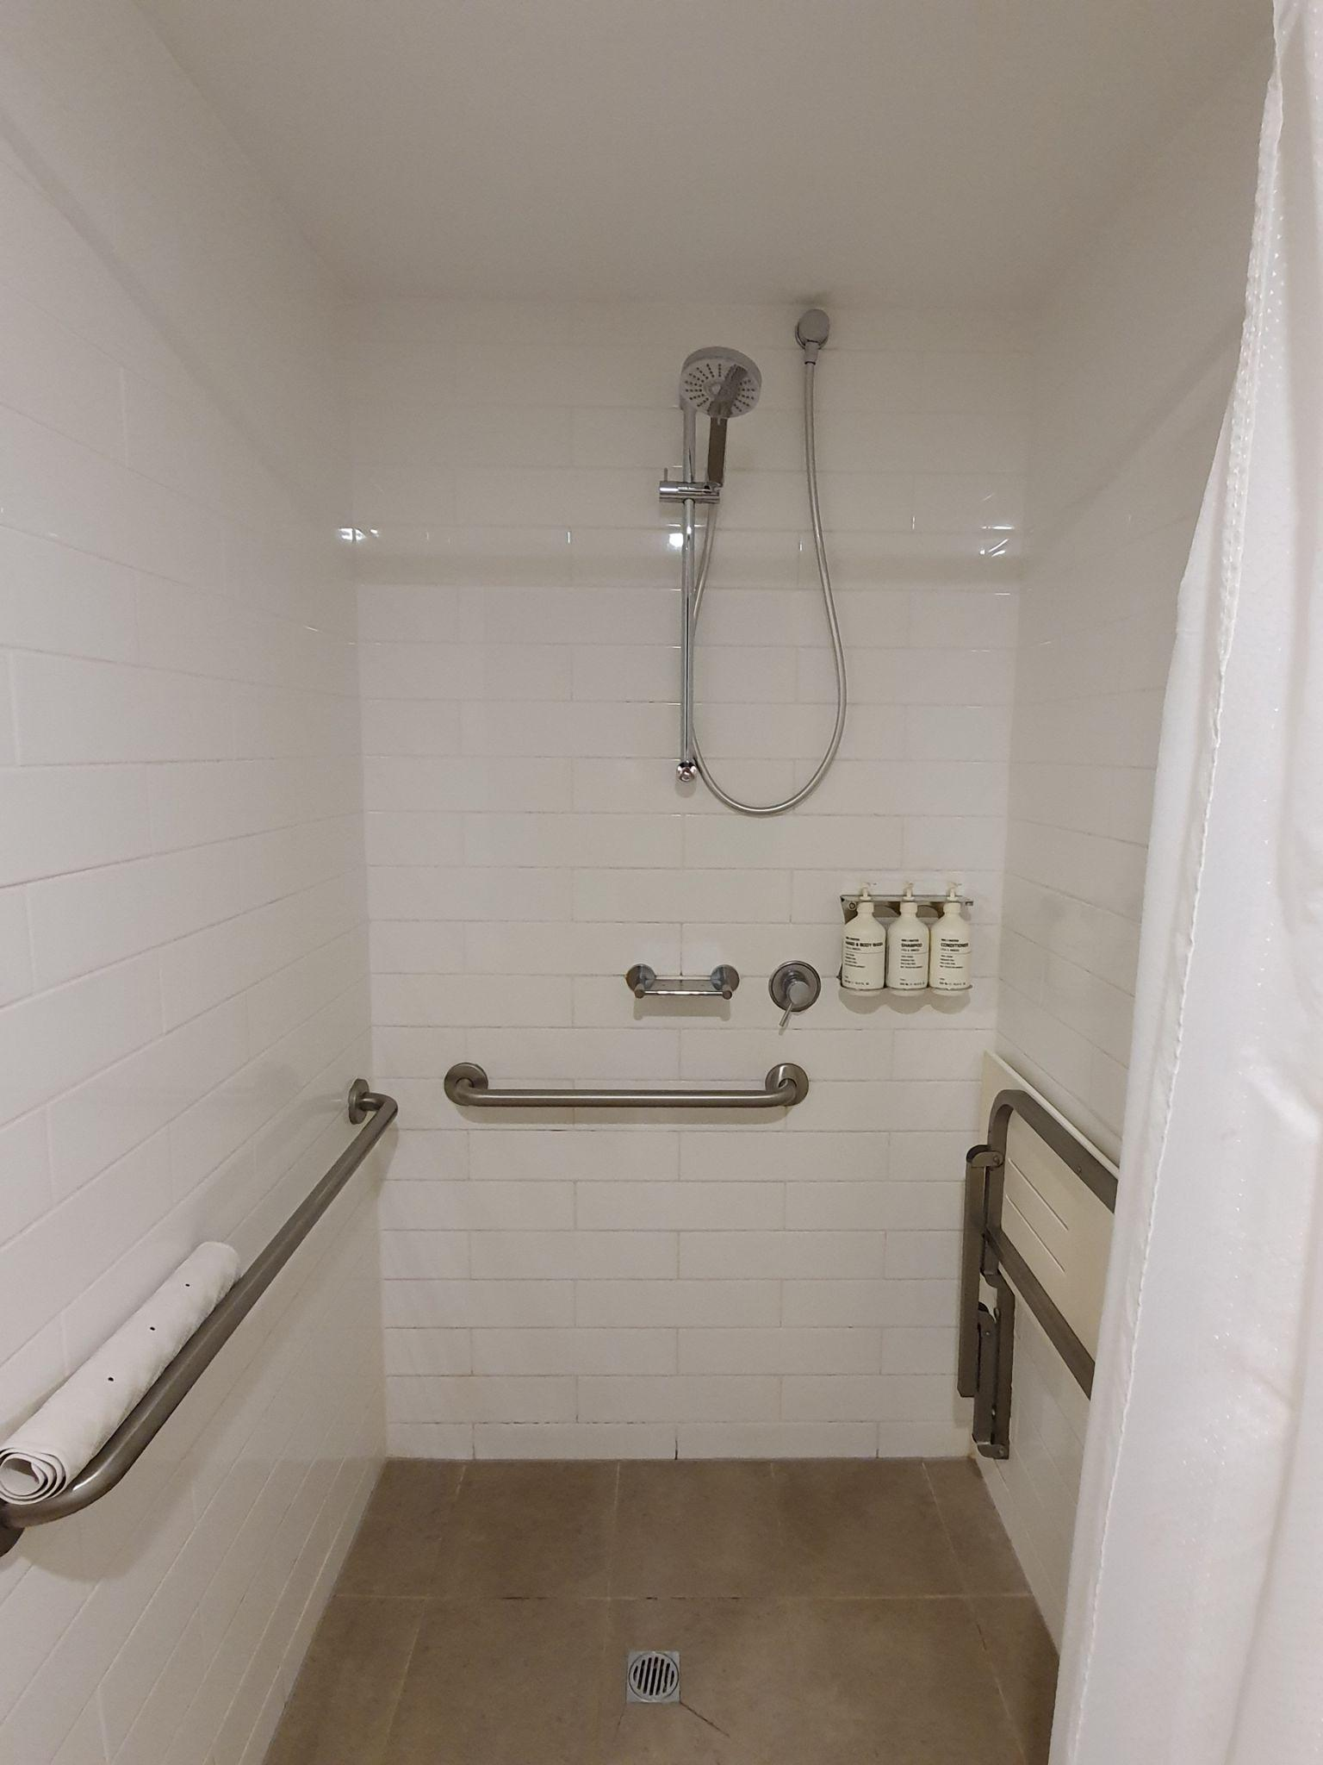
- There is a non-slip mat and shower curtain.

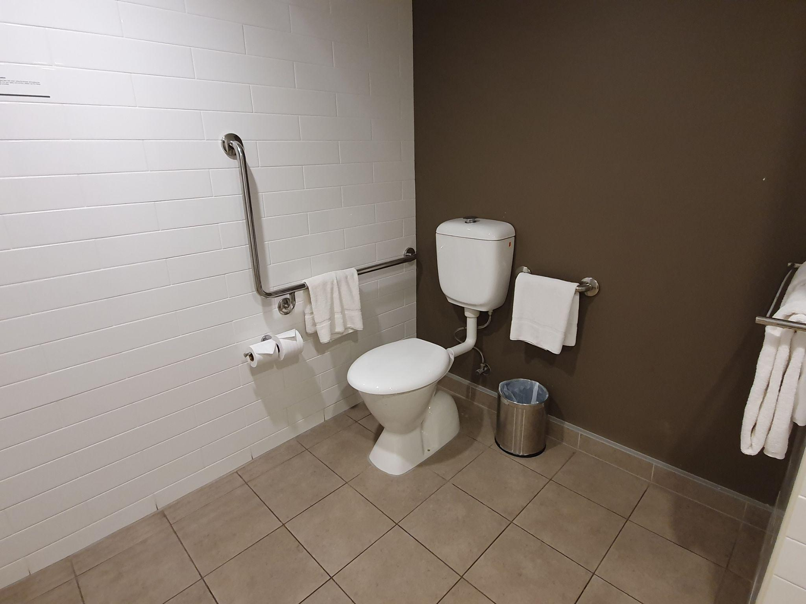
The Toilet
- The toilet is located in the bathroom and has a seat height of 460 mm.
- The space between the toilet and the wall to the right is 270 mm and the space between the toilet and the wall to the left is 1060 mm.
- There is a rail installed on the Right Hand side at a height of 800 mm.
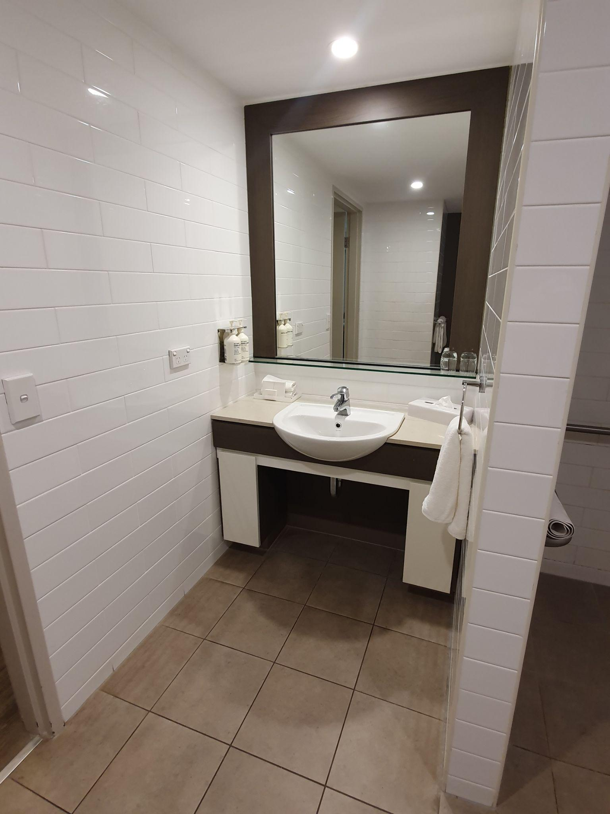
- There is adequate space for equipment such as a raised toilet seat or over-the-toilet aid.

The Basin
- The basin has a mixer lever tap and is located in the bathroom with a height of 770 mm.
- The knee and foot clearance under the basin is 540 mm, restricted by by piping.
- There is adequate circulation space in the bathroom for guests using mobility aids for assisted walking.
- The hand towel is at a height of 900 mm.
- The mirror is installed at a height of 980 mm above the basin.

Lighting
- The light switch is positioned 1000 mm from the finished flooring.

Scents
- There are fragranced products including hand soap, body wash, and shampoo/ conditioner.

Power points
- A power point is installed at 1000 mm from the finished floor.

Standard Apartment
- The room used in this example is Room 358.

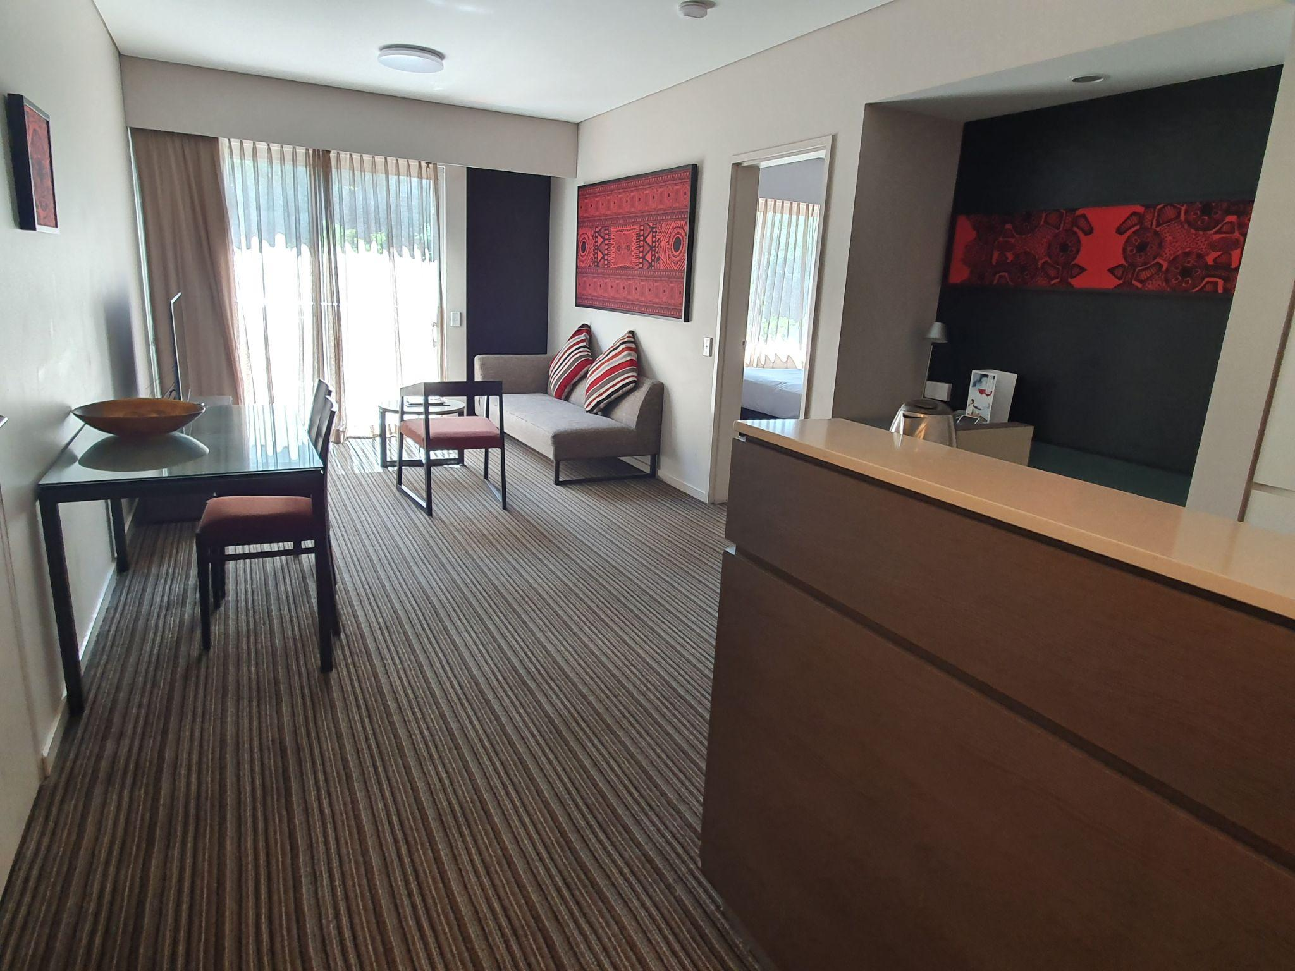
Entrance
- The lighting in the corridor approaching the room is between 30 and 130 Lux depending on the position under lighting.
- The light switch has a height of 1000 mm.
- The inswing manual door has a width of 840 mm.
- The door handle is 1000 mm from the finished floor and the key swipe height is 1130 mm.
- Clearance at the entry is greater than 800 mm.
- There is level access throughout
- Flooring: Floorboards and low pile carpet.

Sounds
- This room may be impacted by the sounds of movement of other guests nearby.

Emergency Alarm
- This room is fitted with a standard audio emergency alarm.

Lighting
- Lighting switches are installed at a height of 1000 mm.
- There are bedside lamps and a main light switch at the bedside.

Cooling / Heating
- Air conditioning is available in this room.
- The air conditioner controller is positioned 1500 mm from the finished floor.

Power points
- Power points are installed at various heights around the room and are also located on the bedside table.

Other
- The phone on the bedside table is within reach.
- There is a safe in the room situated at a height of 530 mm.
- The door viewer peephole is positioned above 1500 mm from the finished flooring.

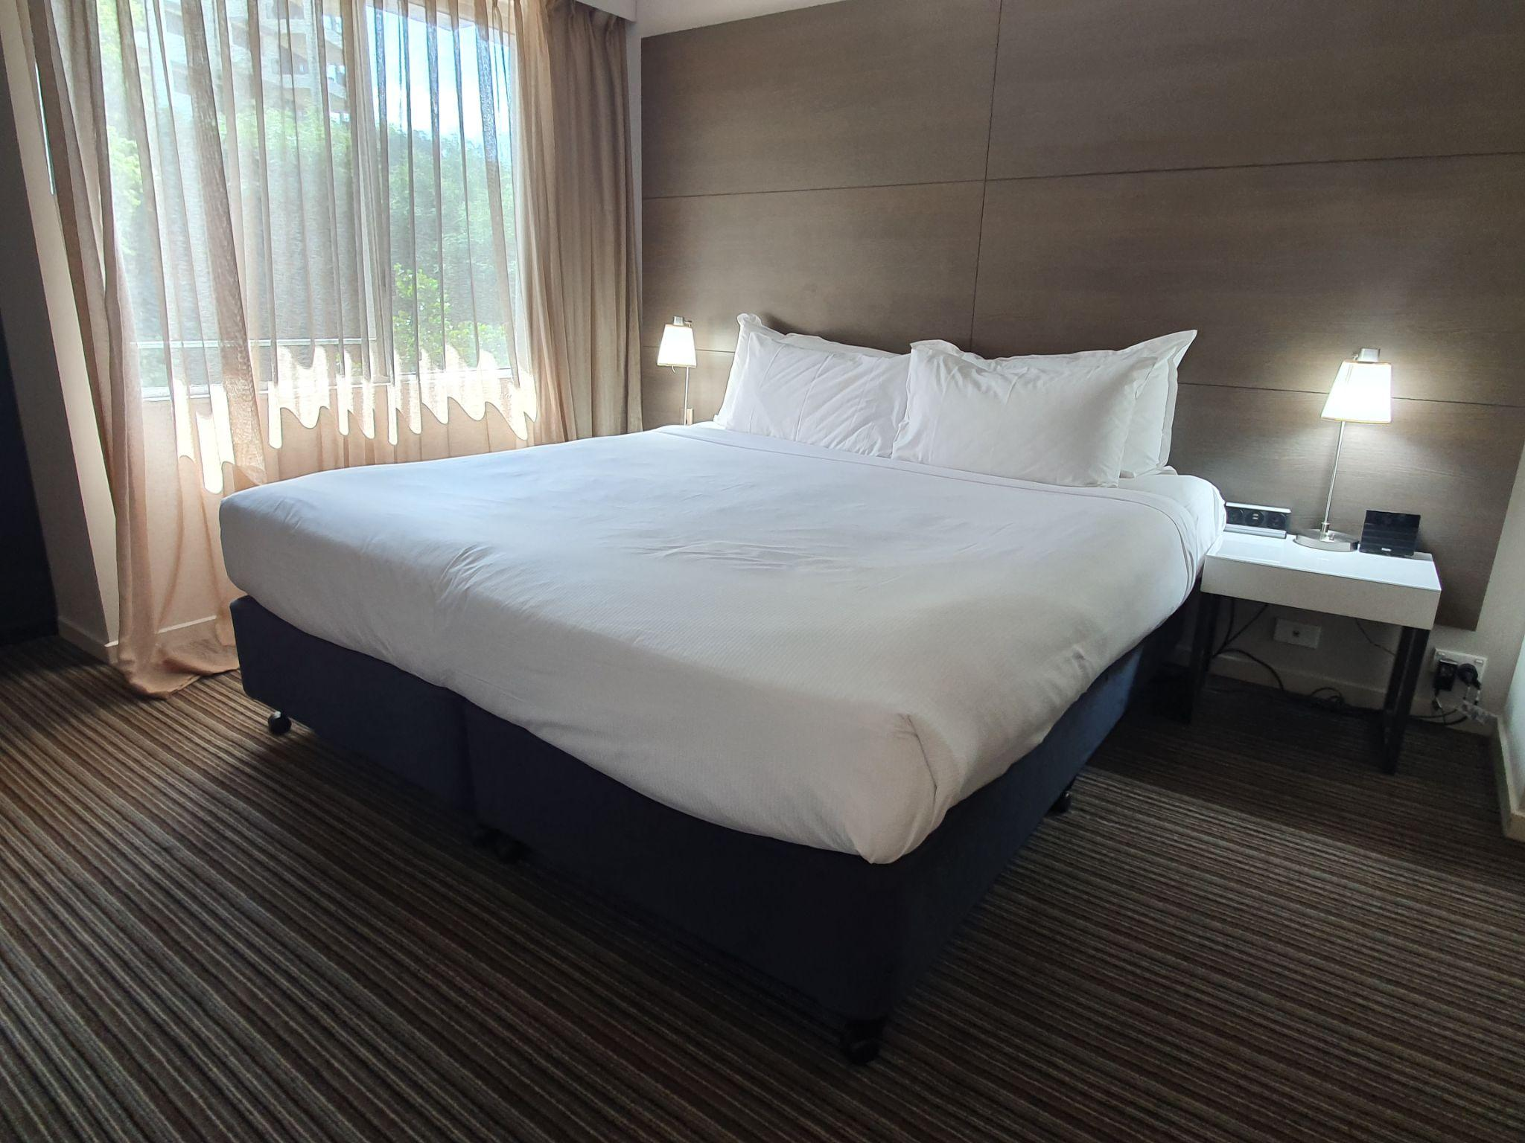
Bedroom
- The bed has a compressed height of 530 mm and has an under-bed clearance of 120 mm.
- The clear floor space to the left of the bed is 1700 mm and to the right of the bed is 610 mm. There is a clearance of 810 mm at the foot of the bed.

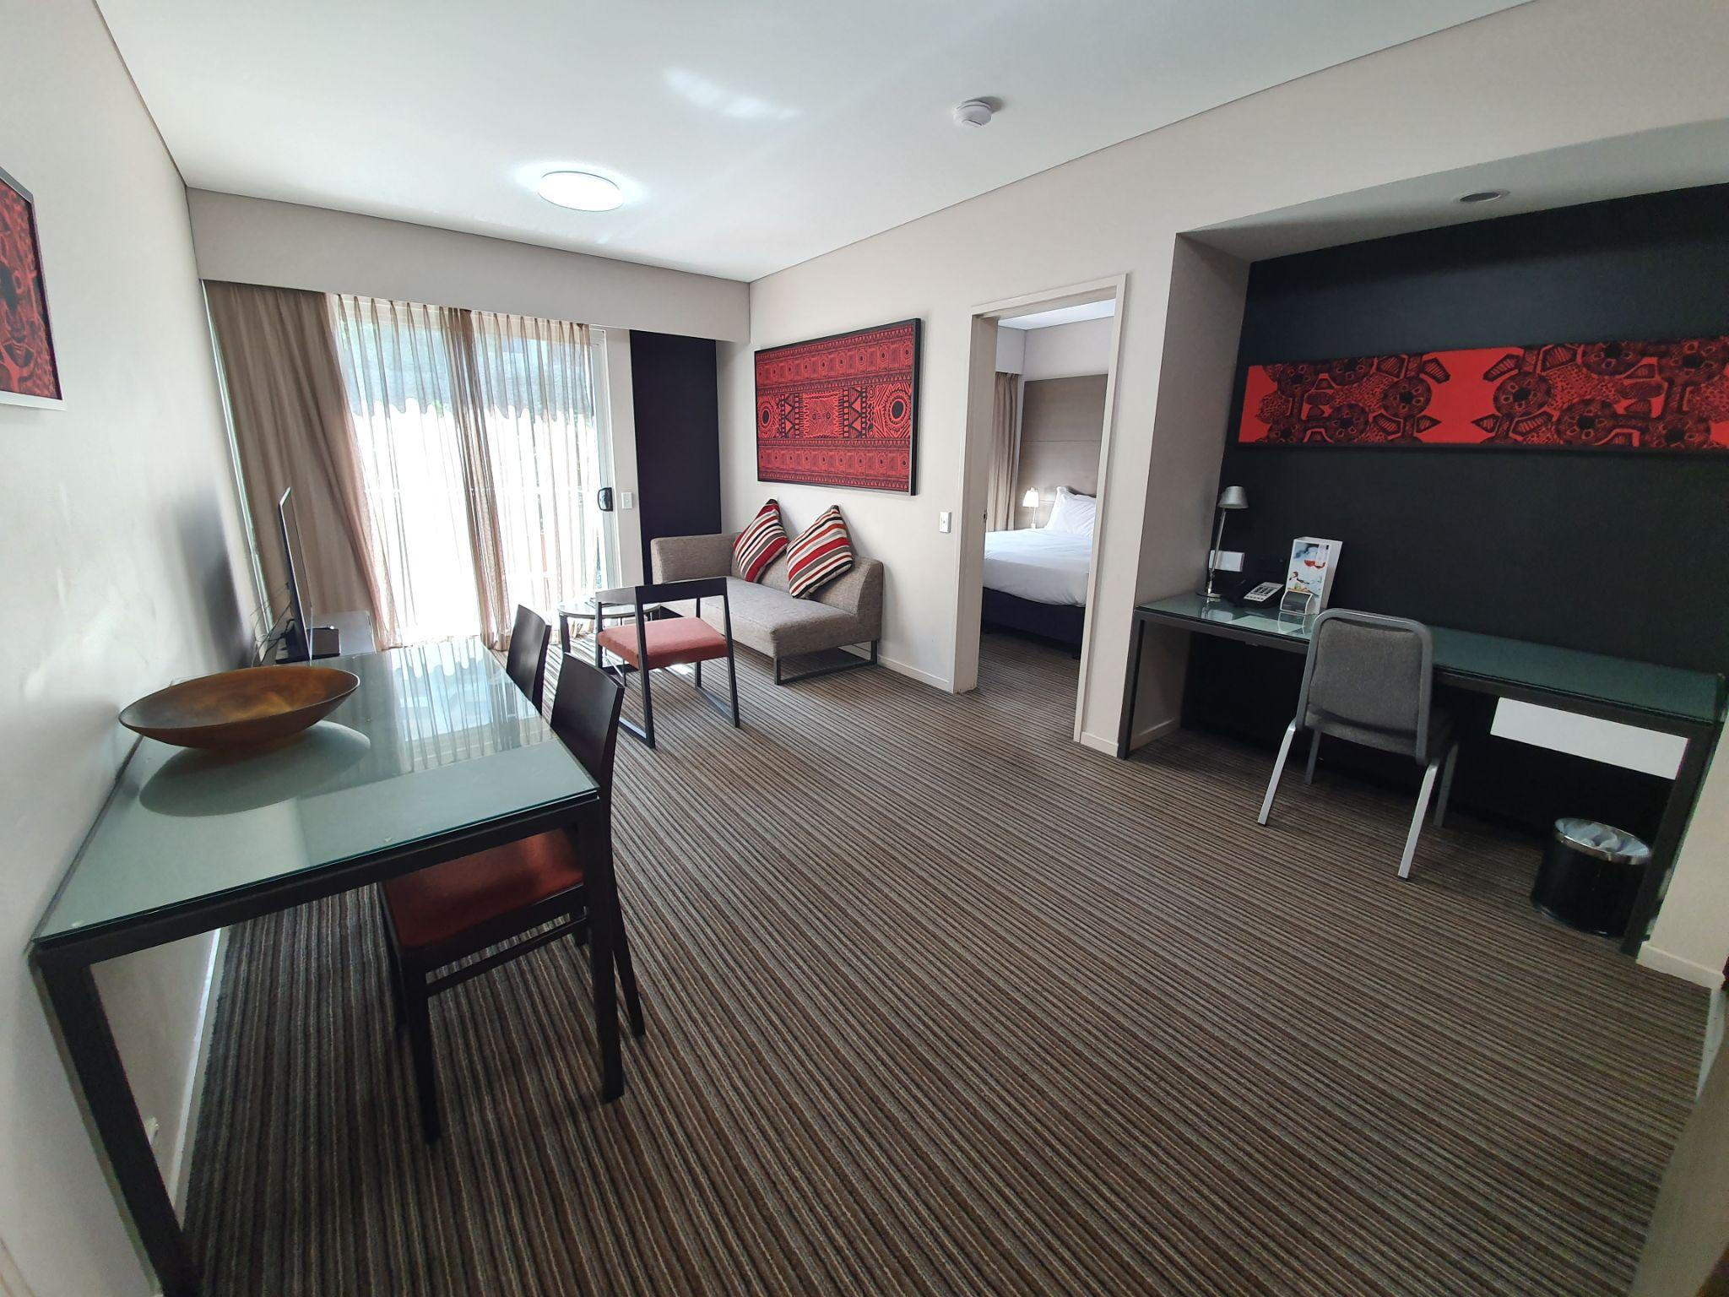
Furniture
- The table has a height of 730 mm and a clearance underneath of 670 mm.
- The chair without armrests has a height of 460 mm.
- The chair with armrests has a seat height of 460 mm.
- There is a wardrobe with a full-length mirror next to the bed.

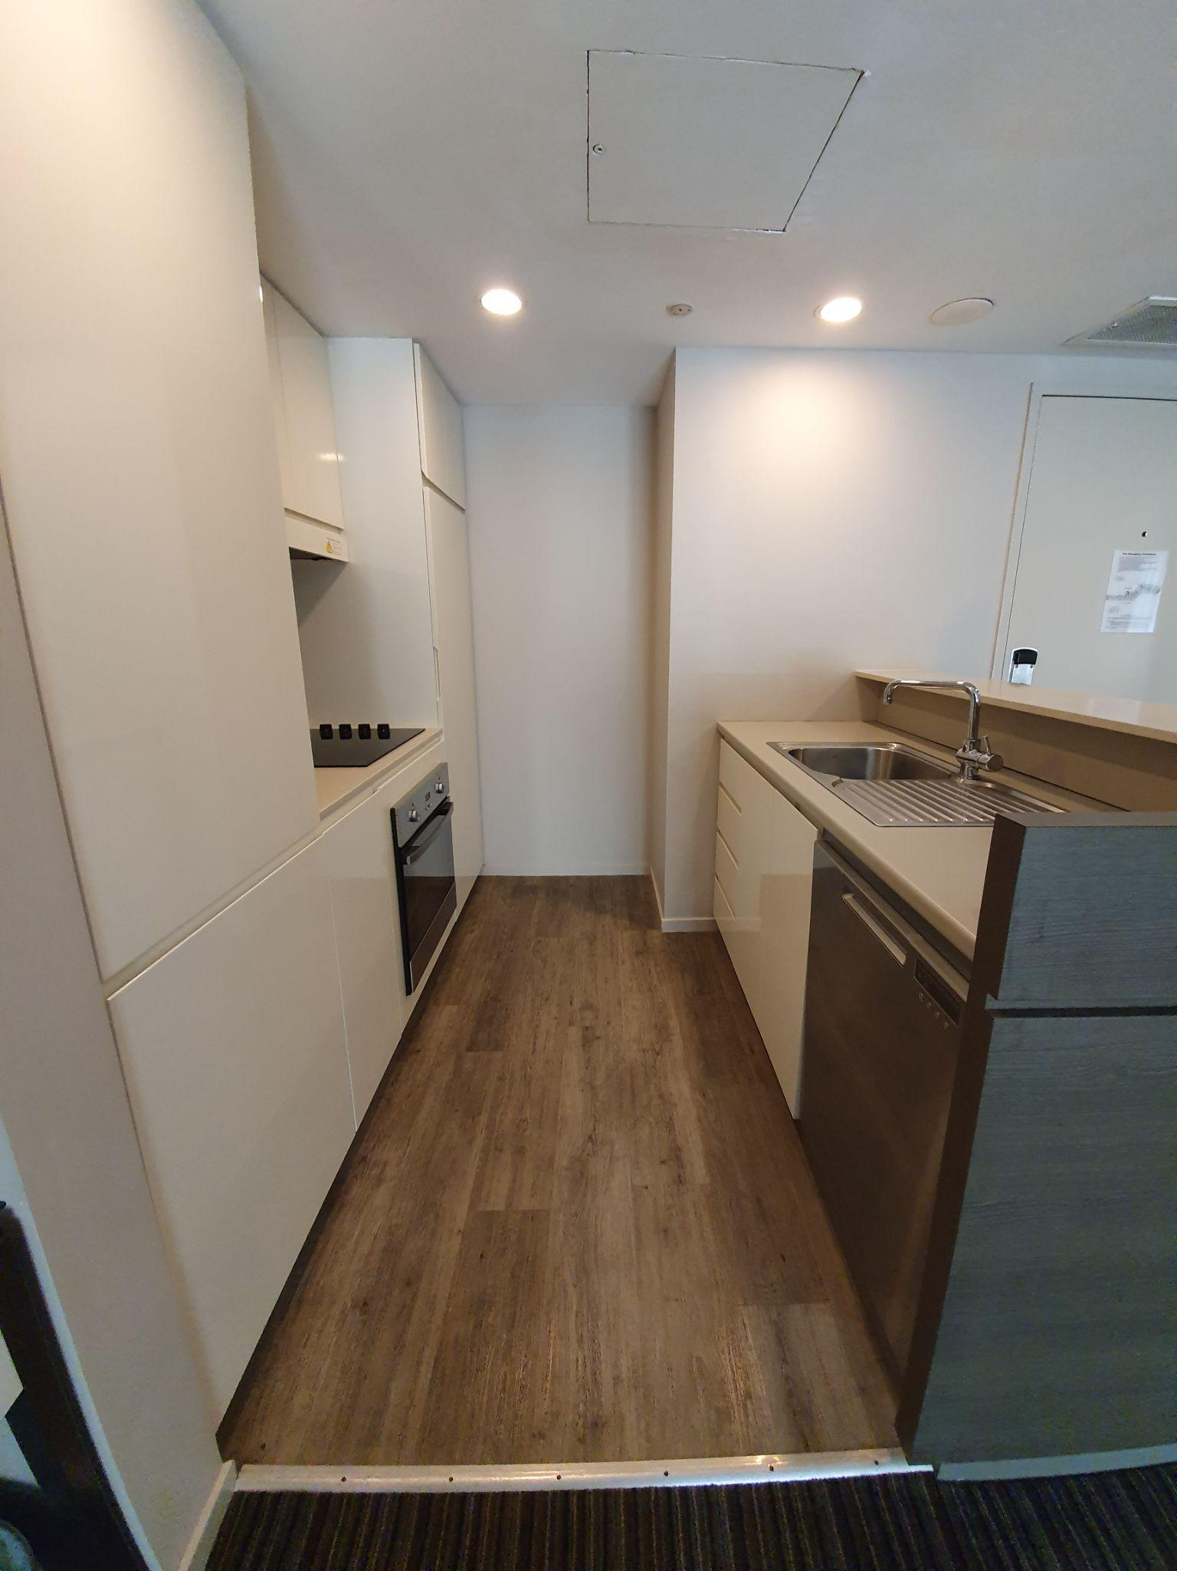
The Kitchenette
- The bench height is 900 mm.
- The microwave is situated at 1250 mm high.
- The bottom shelf of the cabinet above the sink has a height of 1200 mm.
- Toaster, oven, stove, fridge and dishwasher are available.

The Veranda
- A heavy sliding door leads out onto the veranda. The door has a width of 860 mm.
- There are glass safety markings on the door.
- The Veranda is 2135 x 1075 mm in size.
- The rail installed has a height of 1100 mm.
- There is a step down to the verandah of 120 mm.
- There are plastic, movable chairs without armrests.

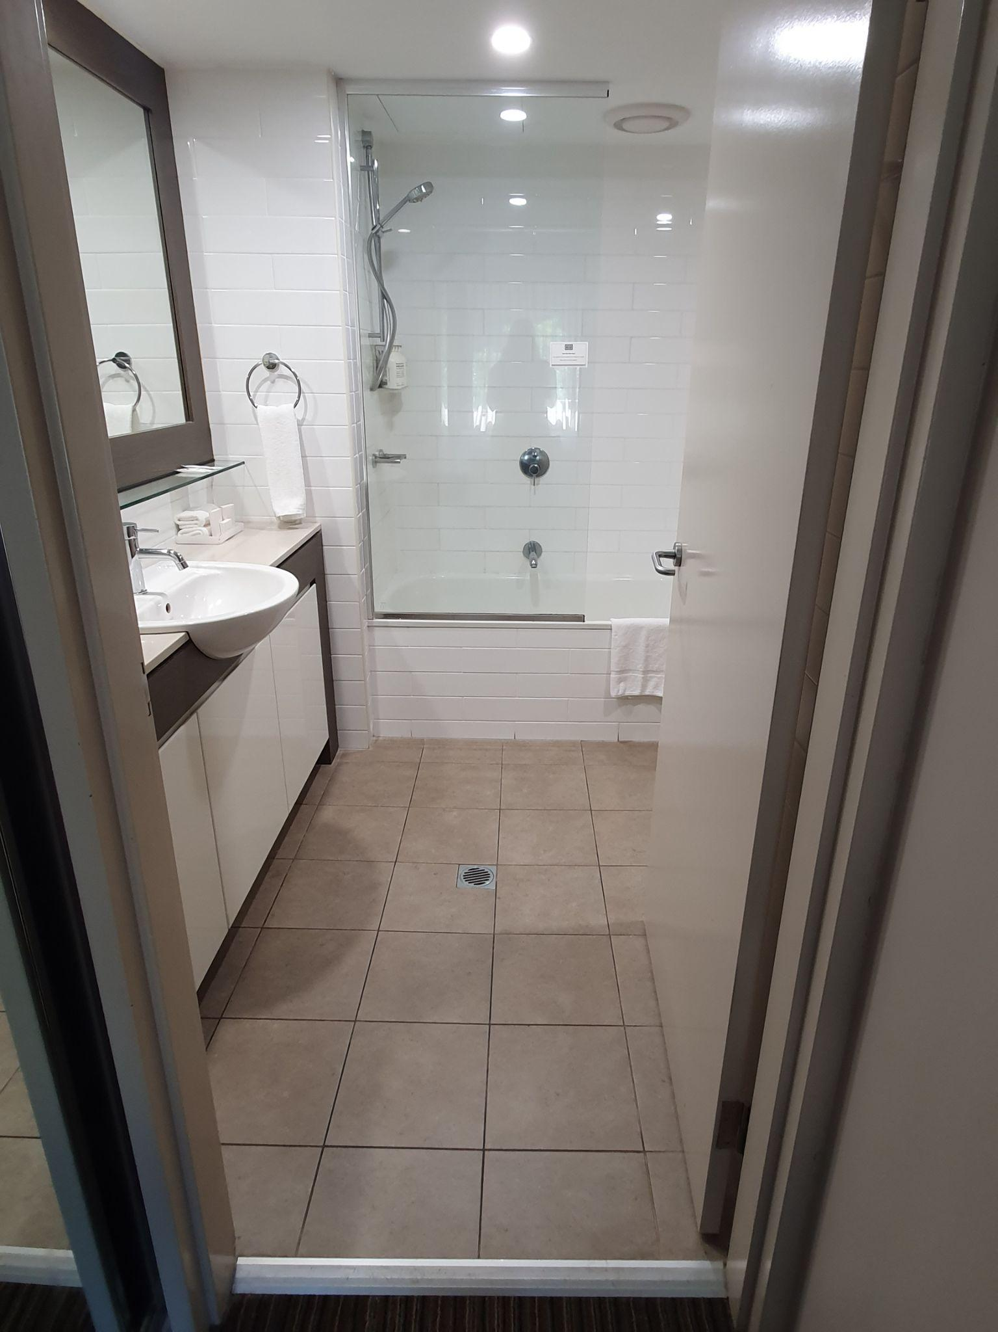
Ensuite
- There is an inswinging door with a width of 760 mm.
- The height to the top of the handle is 1000 mm
- There is a threshold ramp.

Lighting
- The light switch is positioned 1000 mm from the finished flooring.

Scents
- There are fragranced products including hand soap, body wash, shampoo/ conditioner.

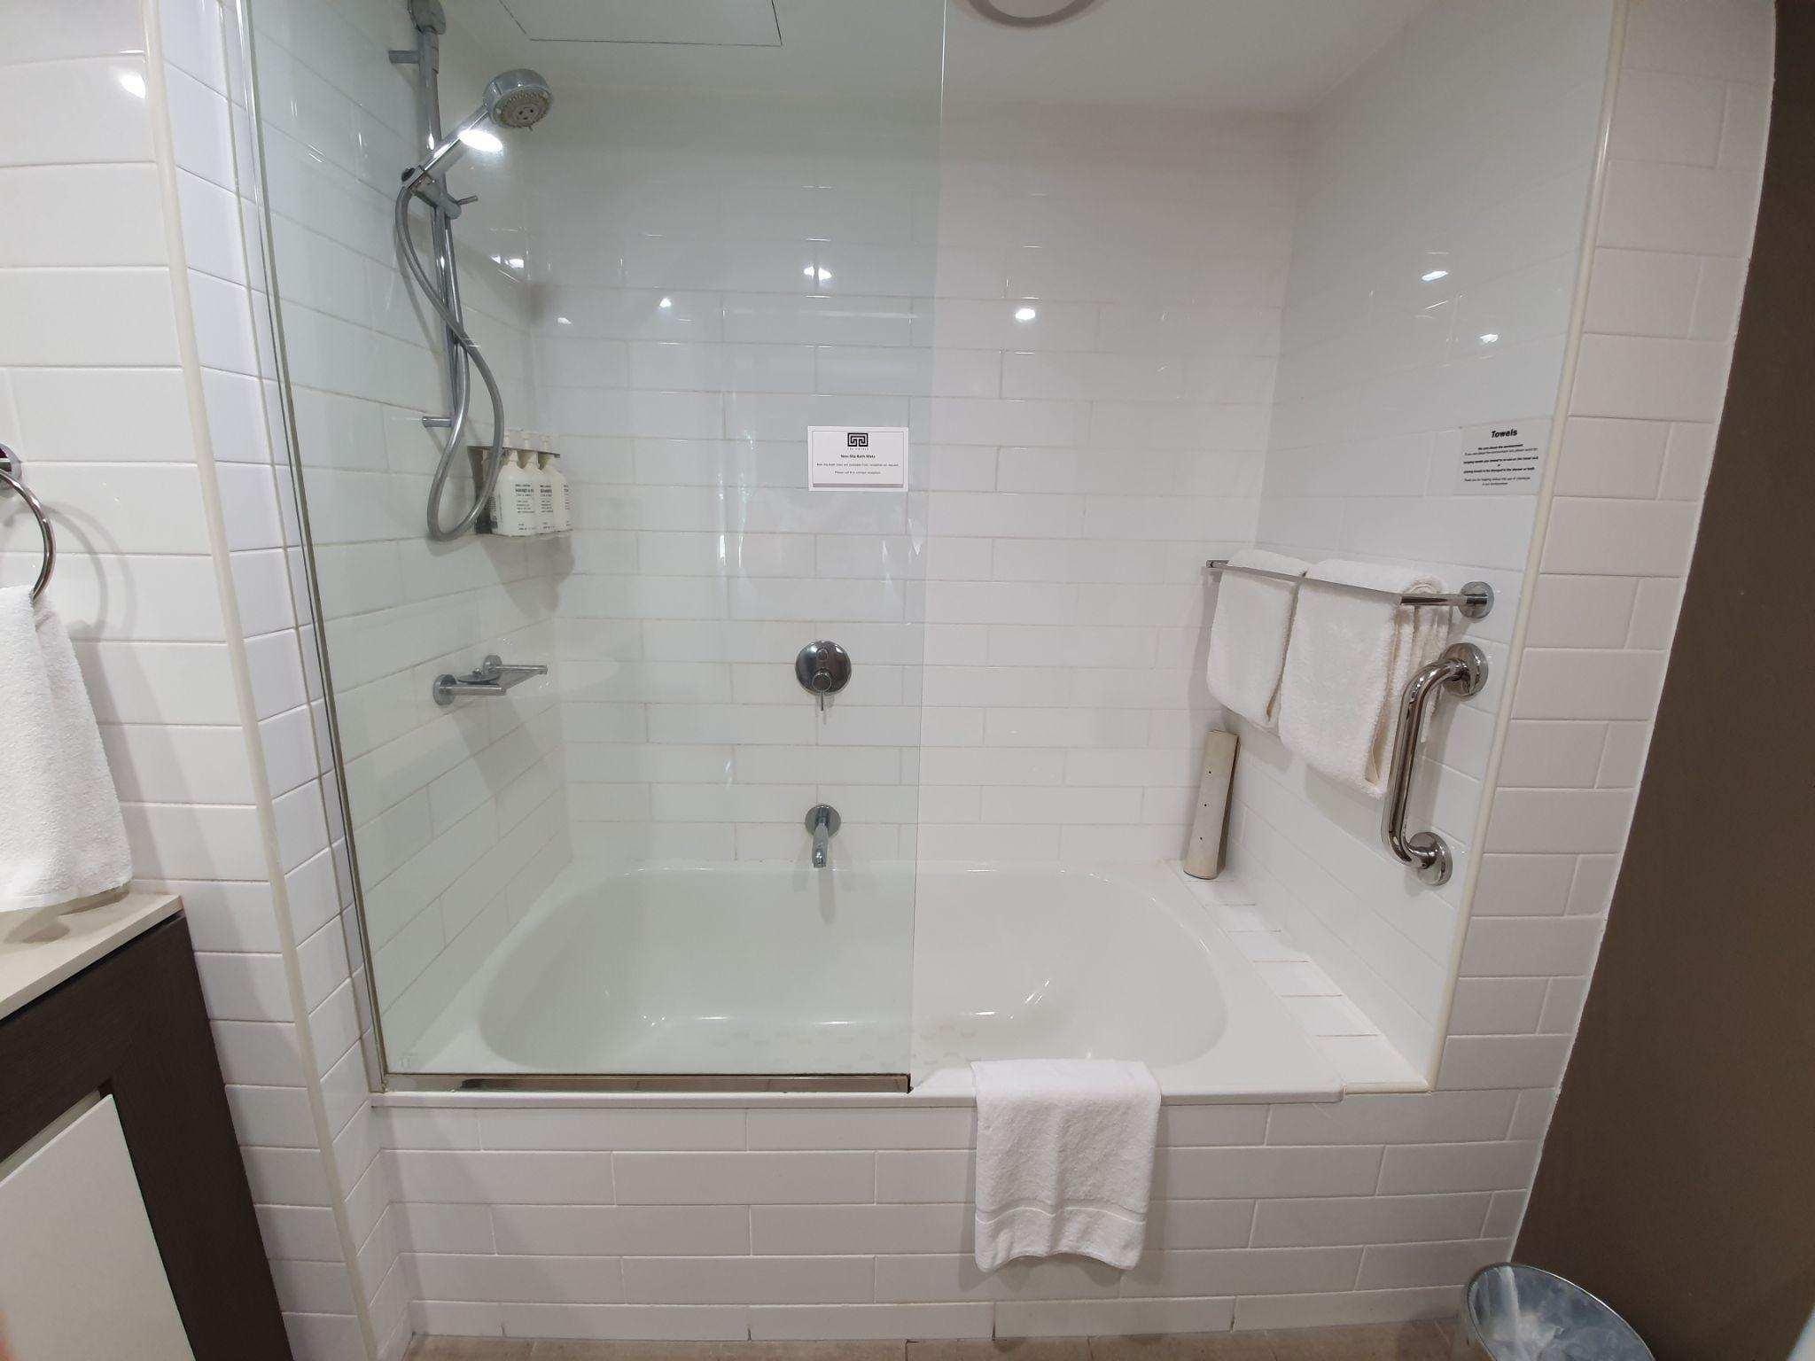
The Shower
- The shower over the bath has a height of 490 mm and a width of 610 mm.
- There is a fixed glass screen with an entry width of 740 mm.
- The vertical rail on the right is 1150 mm from the top.
- There is a hand-held shower hose with a high hook.
- The soap pump is installed at a height of 1400 mm.
- The tap handle is at 880 mm.
- There is a non-slip mat.

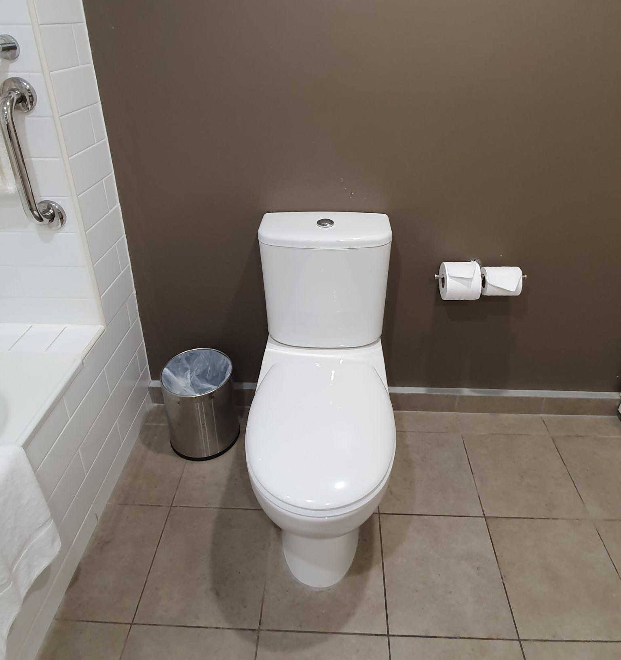
The Toilet
- The toilet height is 400mm
- The space between the toilet and the wall to the right is 450mm and the space between the toilet and the wall to the left is 830 mm.
- There is restricted clear floor space in front of the toilet.
- There is adequate space for equipment such as a raised toilet seat or over-the-toilet aid.

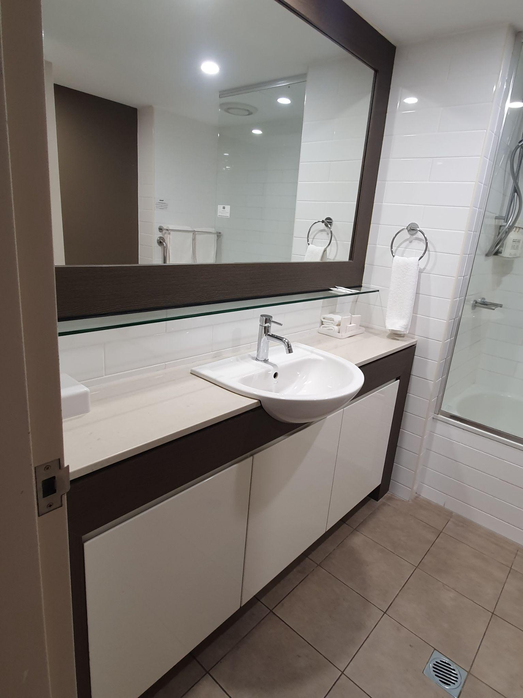
The Basin
- The basin with a mixed tap lever is located in the bathroom with a height of 900 mm.
- There is restricted knee and foot clearance under the basin.
- Soap is installed at a height of 1200 mm.
- There is adequate circulation space in the bathroom for guests using mobility aids for assisted walking.
- The hand towel is at a height of 1250 mm.
- The mirror is installed at a height of 1120 mm.

Power Point
- Power point is installed at 1000 mm from the finished floor.

We welcome your feedback on how we can continue to improve our accessibility. Please contact us with any questions, comments, or concerns. Thank you for choosing Adina Hotel.

Guide last updated: 1 June 2023

This Accessibility Guide was designed and developed in collaboration with Flare Access Pty Ltd. For feedback on the Guide please contact Adina Hotel.
Please note that these guides were developed using observations during the Dry season, information such as peak periods, noise levels and entrance setup may vary in the Wet Season.

© Flare Access, All Rights Reserved. 2024 DISCLAIMER: Accessibility Guide developed by Flare Access. Observations made by Flare Access and additional information provided by Adina Hotel. All materials have been compiled from information available at the time of production. They are not intended to replace professional advice including; but not limited to, access audits. All necessary care has been taken to design and produce Work(s). All measurements provided are within an approximate range. Full implementation guidelines are supplied in accordance with Work(s) in its entirety. You acknowledge and agree that you are using all services and facilities provided by Adina Hotel at your own risk and you agree to defend, indemnify, save and hold Adina Hotel and Flare Access Pty Ltd harmless from any and all demands, liabilities, costs, losses and claims, howsoever suffered, including but not limited to legal fees that may arise directly or indirectly from any service provided or agreed to be provided by Adina Hotel and Flare Access Pty Ltd. You agree that this indemnification extends to all aspects of the Work(s), including but not limited to implementation and usage. Adina Hotel and Flare Access Pty Ltd are indemnified of all claims, liability, and expenses that may arise from use of Work(s) as per usage and acceptance of these terms and conditions.

