Darwin Waterfront
Accessible Destination Guide

Assistance

Speak My Language – Darwin Waterfront in Language
Darwin Waterfront precinct is part of the ‘Speak My Language’ program which involves hundreds of people from culturally diverse communities talking about living well with a disability.
It has also developed a podcast and radio program for Darwin Waterfront with accessible information in up to 24 languages, sharing personal experiences, skills and talents of people living with a disability. Learn about Darwin Waterfront and some of its accessible options in Mandarin, Spanish, Indonesian, Hindi by visiting www.speakmylanguage.com.au.

Darwin Waterfront Office
The office can be contacted Monday to Friday from 8am to 4.30pm to assist with any inquires you may have. Visit www.waterfront.nt.gov.au, call 08 8999 5155 or email darwinwaterfront@nt.gov.au.

Wave Lagoon Kiosk
The friendly staff located at the kiosk can also assist with inquires from 10am to 6pm, 7 days a week. Contact 08 8941 7260.

Getting there – from Darwin International Airport

City Shuttle Bus
Operated by Blue Taxi Company, the Darwin CBD shuttle bus operates 7 days a week. The shuttle provides a convenient and reliable service to and from Darwin Airport and all city accommodation locations. Operating from the terminal door, you can purchase your ticket from the shuttle booth at the baggage carousels. Pricing to the CBD is approximately $15 per person, or $35 for a family of four (subject to change).
Bookings (08) 8980 3755 Email shuttlebus@bluetaxi.com.au

Taxi
The taxi rank is located directly in front of the airport terminal. Taxi pricing is charged by meter. You can expect to pay around $30.00 to $35.00 for a trip between the airport and the CBD district.

Darwin Radio Taxi
Cater for wheelchair passengers with trained and friendly staff to move you in comfort
+61 13 10 08 or darwinradiotaxi.com.au

Blue Taxi Company
+61 13 82 94 or bluetaxi.com.au

Uber
Riders at Darwin Airport can request Uber when travelling to or leaving the airport. Uber has a designated driver-partner waiting area and pick-up zone at Darwin International Airport.

Public Transport – bus
Route 14 is a service that connects the Darwin Bus Interchange to Cullen Bay and Darwin Waterfront Precinct including Convention Centre (this service also connects with the Mandorah Ferry)

The schedule and other connections can be found by googling ‘Darwin Bus Service’ or www.nt.gov.au/driving/public-transport-cycling/public-buses/darwin-and-palmerston-timetables-and-maps

Arriving to Darwin Waterfront

Vibe Hotel & Adina Apartment Hotel
You can be dropped off directly in front of Hotel reception undercover from the weather. Access to reception is via a ramp through glass sliding doors in to an air-conditioned waiting area with seating.

Short Stay Apartments
If you have booked an independently owned apartment at Darwin Waterfront, it may be located within one of six residential buildings located at the precinct. It is important to understand the address before arriving and the nearest drop off point (ie. closest restaurant or café) to advise your transport provider. It is also suggested to have a contact number to ring by the accommodation provider at the time that you arrive, in case needed.

Day Visit
The best location to arrive depends on the type of attraction or experience you are visiting. You can call Darwin Waterfront Corporation on 08 8999 5155 during hours Monday to Friday in order to seek guidance.

Kitchener Drive Pedestrian Crossing – main entry
There is a drop off and pick up point adjacent to the crossing to arrive. A low gradient ramp (with no handrail) is also alongside in order to enter from the road and up onto the curb.

Parking
Disability permit holders with a valid permit displayed the correct side up on dash can park as per the conditions signposted – however for free and double the time allocated in the following locations:

Off-street
- Stokes Hill Road Carpark A
- Darwin Convention Centre Rear Carpark
- Stokes Hill Wharf Main Carpark
- Fort Hill Parklands Carpark
- Jervois Carpark

On-street
- Kitchener Drive
- Anchorage Court

Designated accessible parking spaces are located in all off-street and some on-street parking locations at Darwin Waterfront.

Payment for parking is via the PayStay App which is suggested to be downloaded and credit applied before you arrive (for convenience). Visit paystay.com.au for more information. Typically there is a cost for parking in these locations from Monday to Friday between 8am and 5pm, free on weekends and public holidays.

Multi Storey Carpark – on Kitchener Drive
This carpark is free for the first 2 hours per day, then fees apply dependant on the total time spent in the carpark per day.

Accessible parking spaces are located from levels 2 and above to ensure clear access to the lift, via ramps and into the precinct – with the avoidance of all steps/stairs. Disability permits must be displayed if parking within the bays.

The car park has a ticketless parking system which uses number plate recognition technology to manage parking. A benefit of this technology is that it allows users to skip the pay station queues and go straight to the exit boom gate with their credit card. This is a cashless facility.

Darwin Convention Centre Basement Carpark
The Darwin Convention Centre has parking spaces available underneath the Centre, including seven accessible parking spaces. The cost of basement car parking is $5.00 per car, per day or part thereof (subject to change).

The car park has a ticketless parking system which uses number plate recognition technology to manage parking. A benefit of this technology is that it allows users to skip the pay station queues and go straight to the exit boom gate with their credit card. Cash payments need to be made at the pay station where the vehicle’s registration will need to be entered.

This carpark is the responsibility of Darwin Convention Centre, not the Darwin Waterfront Corporation.

Getting Around

Free Waterfront Shuttle
A 20 seater coaster bus operates on a 20 minute loop service around the Darwin Waterfront with eight different stops at nearby carparks. The vehicle requires three steps in order to access inside the vehicle. The driver can assist with mobility equipment if asked at the time of entry or exit. There is no music played inside the vehicle.
The service operates during lunch from 11.30am to 2pm and for dinner from 4pm to 9pm daily.

Pathways
The Waterfront precinct is connected by wide pathways with various slopes and low gradients throughout. All elevations to other areas have stairs and alternate ramp access nearby in order to connect the precinct attractions. There are many locations to stop and sit for a rest in shade or undercover areas.

Scooters/e-bikes
Neuron e-scooters and e-bikes are permitted to travel through many locations of the Waterfront Precinct, some locations are slow travel areas or not permitted for safety reasons. Use of the equipment available for anyone over 18 years of age through the Neuron App with credit card payment options.

Mobility Equipment Hire
There is no equipment for hire at Darwin Waterfront, only free use of the Water Wheelchair at the Wave & Recreation Lagoons.
Mobility equipment can be hired (or purchased) from suppliers located in Darwin.
Limitless NT Australia
Located at Shop 8, 14 Winnellie Central, Hickman Street ,Winnellie, Northern Territory 0820
Phone: 08 7915 4550 Web: www.limitlessaustralia.com.au
Keep Moving
Located at 4/655 Stuart Highway, Berrimah, Northern Territory 0828
Phone 08 8947 5122 Web: www.keepmoving.com.au

Destinations

Safe Swimming

Recreation Lagoon - free
Take a dip in the Recreation Lagoon with a man-made beach at Darwin Waterfront. It's safe from crocodiles as a seawall separates the waterbody from the adjacent Darwin Harbour. The beach is continuously replenished with fresh saltwater, which is filtered through fine mesh screens.
The inner Lagoon area around the main fountain is monitored by lifeguards from 9am to 6pm daily, who can also assist with support or more information. The main fountain can generate a level of constant noise as water flushes through and lands onto the water’s surface. There is no shade over the beach area or water body.
Easier access into the water is from a concrete path, down a short ramp onto the sand which is covered by a mobi mat and into the water from 10am to 6pm daily.
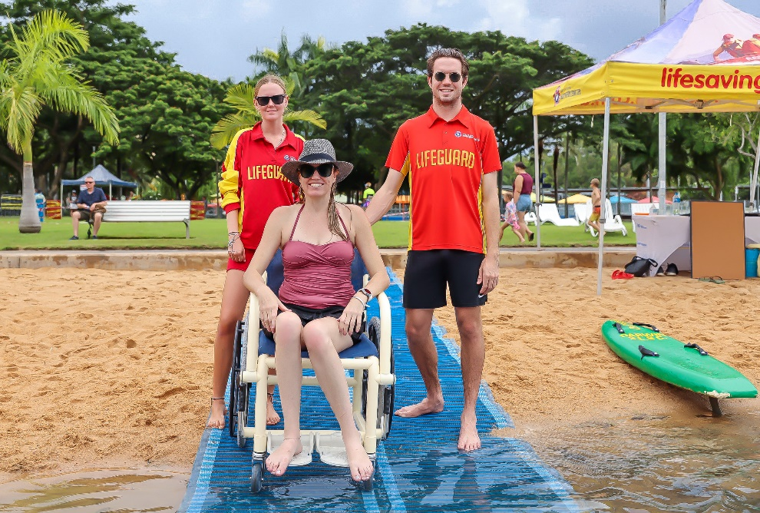
The mat can accommodate a wide range of users, including people with mobility and visual impairments, the elderly, those using wheelchairs, mobility scooters or strollers and other groups with special access needs.
A water wheelchair is also available for free use, simply ask the lifeguards on duty for access.
A fresh water outdoor rinsing shower is also located nearby, with low press in taps in order to turn on.
Assistance animals are not permitted on the beach or in the water to maintain hygiene of the public swimming facility.
There are free plastic sun loungers to enjoy, picnic tables and seating and a table area dedicated to wheelchair users. Some seating areas are located under shade structures for wet weather or heat relief.
Restrooms are approximately 200m away from the Lagoon, in two locations, at the Wave Lagoon kiosk or behind the building nearby closest to restaurants Hot Tamale/Urban Spice & Waterfront Café.

Wave Lagoon – admission fees apply
Open 10am - 6pm daily, the Wave Lagoon is one of Darwin's most popular attractions. This safe wave and swimming lagoon rolls out different wave patterns and includes a shallow water play area for younger children or patrons who prefer to sit shallow and out of the wave environment.

Throughout the day the waves are on in sets for 10 minutes, then there is a 20 minute respite with no waves for patrons to enjoy the calmer water.

The lagoon depth is 2 metres at its deepest point, sloping up to the wet edge. The water is chlorinated salt and the lagoon has a concrete bottom. There are no steps in order to enter the water, only sloping gradients. There is no shade over the water body.

There are some tubes supplied or you can bring your own floatation device.

There is a designated priority seating area under an umbrella for patrons who are elderly or with a disability and a water wheelchair onsite and for free use, simply ask the lifeguards who are always on duty for assistance.
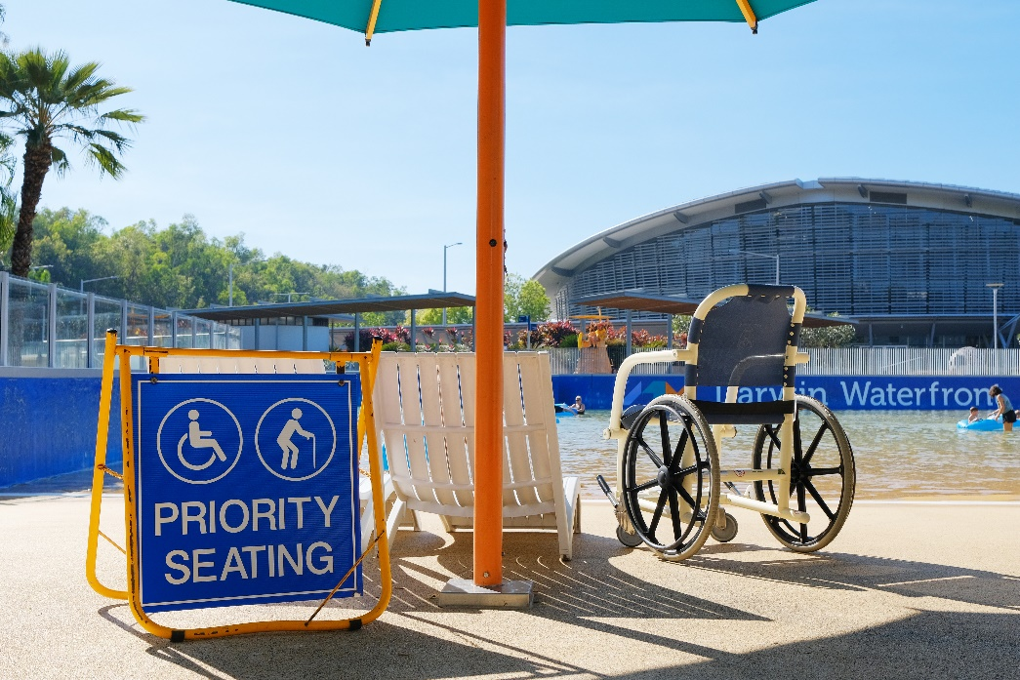
There are sun loungers and shady areas including umbrellas and you are welcome to bring your own temporary, light-weight shade tents, but nothing can be pegged into the ground. There are outdoor rinsing showers with push buttons located low in order to activate and a low drinking fountain accessible with a wheelchair with a push button to activate.

Various sounds can be heard whilst inside the facility, there is an alarm to warn swimmers that the waves will be coming back on. The waves themselves create noise and the shallow play area has water sounds as the fountain water splashes into the pools.

There are no restrooms inside the Wave Lagoon facility, however adjacent to the Kiosk is a disability restroom with access via a MLAK key. Inside is a hoist, shower and enough room to change. There is also a restroom block with showers, change rooms and ambulant cubicles. Nearby is also electronic lockers which can be hired for personal storage of items and USB charging capability.

Tickets can be pre-purchased online to avoid queues by searching ‘Wave Lagoon tickets’ on Google or via the link https://ecom.roller.app/aquaparkdarwin/kiosk/en/products.

Carers who are caring for another person at the time of entry and show their Companion Card are permitted to enter the facility ‘free of charge’. The person they are caring for must purchase an entry ticket. All patrons must wear a wristband as proof of entry inside the facility.

You can bring your own food and drinks into the venue however no glass or alcohol is permitted.

The kiosk also sells water, slushies, soft drinks and snack items as well as sunscreen, goggles, aqua plugs and tube rings.

Aqua Park Inflatable Waterpark
Those with access challenges are encouraged to contact the customer service team in the first instance to ascertain access requirements on a case by case basis. Aqua Park staff will endeavour to accommodate access onto the Aqua Park and assist participants where possible to achieve their individual goals on the park however you must be competent swimmer and able to swim 25 metres freestyle unaided.
www.aqpk.com.au
This attraction is not operated by Darwin Waterfront Corporation.

Deckchair Cinema
The Deckchair Cinema is an open outdoor cinema that is fully accessible, with no steps from the entrance to the exit. Wheelchair seating areas are designated in the cinema area also.
An accessible toilet is available and there are two disabled parking spaces in the carpark located at the front of the cinema entrance.
A Wavecast system is available for those who are Hard of Hearing can link their Bluetooth hearing aids or headphones to the cinema audio to enjoy the films.
There's also one or two Open Captioned movies included specifically in each program released for the Deaf and Hard of hearing.
www.deckchaircinema.com
This attraction is not operated by Darwin Waterfront Corporation.

Darwin Waterfront Playground – Waterfront Park
This unfenced playground is specifically designed for younger children aged two to eight years of age.

The custom rope playground has boardwalks, a slide, a rope course, tunnels, a mini climbing wall, a pod swing and a balance trail. Rope games are mounted on undulating shapes, and children can slide, climb, crawl and swing their way around the play equipment.

There is shaded seating alongside, with free WiFi available and is promoted as a breastfeeding-friendly and smoke free venue.

Adults and guardians are responsible for their own and their children’s wellbeing at all times.

Please obey these playground rules so everyone can play safely:

- Shoes must be worn at all times.
- The playground is suitable for children aged two to eight years only.
- Children must be supervised by an adult at all times.
- No climbing on the coloured poles or roof.
- Play safe and respect others.
- Smoking is strictly prohibited in this area.
- CCTV Cameras are in use.

Table Tennis Tables
The two table tennis tables can be accessed directly from the footpath, although there is an incline without hand rails. Those with accessibility issues may require assistance as they move up/down the incline. There is approximately 2 metres of hard flooring at each end of the table before it converts to grass.

Table tennis equipment can be hired directly from the Wave Lagoon Kiosk approximately 15 metres away however the tables are free to use.

3x3 Basketball Court
The Waterfront basketball arena, is located between the Wave Lagoon kiosk and the Wave Lagoon pool and can be accessed directly from the footpath adjacent to the Kiosk. It is open 24/7 and is free to the public.

The court flooring is MSF pro plastic anti-skidding flooring which has great drainage to prevent water pooling, and cushions to reduce the risk of injury from falls. The product also offers 30% sound reduction to normal courts.

Dining
There are various cafes and restaurants located throughout the Darwin Waterfront, all of which have ramp access to inside the facility.
No matter what time of the day, you can always have a bite to eat or breakfast, lunch or dinner at Darwin Waterfront. Here is a list of restaurants and website in order to contact for further information.

Darwin Waterfront precinct
Wharf One Food & Wine: www.wharfone.com.au
Bella: www.belladarwin.com.au
Hot Tamale Modern Mexican: www.hottamale.net.au
Urban Spice: www.urbanspice.com.au
Oyster Bar: www.oysterbardarwin.com.au
Trampoline Gelato: www.trampolinegelato.com.au
Thirsty Zac: www.thirstyzac.com
Fiddlers Green: www.fiddlersgreendarwin.com.au
Chow!: www.chowdarwin.com.au
Bannsang: www.bannsang.com
Lime Café: www.facebook.com/limecafe
Snapper Rocks: www.snapper.rocks/
Curve Café: www.vibehotels.com/book-accommodation/darwin/hotel-darwin-waterfront/curve-restaurant/
The Precinct Tavern: www.theprecincttavern.com.au
Darwin’s Waterfront Café: (6) Darwin's Waterfront Cafe | Darwin NT | Facebook
Pink Chopstix Waterfront: www.facebook.com/PinkChopstixWaterfront

Stokes Hill Wharf
Stokes Hill Wharf is an iconic tourist attraction in Darwin where you can also enjoy a bite to eat for lunch or dinner either from Port & Starboard Arcades with various food court outlets for casual sea-side alfresco dining or restaurant dining at:

Crustaceans Steak & Seafood Restaurant: www.crustaceans.net.au
The Jetty Restaurant: www.thejettyrestaurantdarwin.com

Access is available with no steps to most parts of Stokes Hill Wharf, except where a ramp is provided. Live entertainment (solo or duo) is played outdoors on Wednesdays and Sundays from 6pm to 9pm from May to September.

Parking at the Wharf
Parking tickets
A valid ticket must be displayed at all times on your vehicle dash.
Tickets are free from the parking station (at each end of the carpark) and valid for a maximum of 3 hours only, per visit.
Please ensure the ticket is placed the correct side up, and check the ticket after you close the door to ensure it remains visible from outside the vehicle.
Disabled parking
There are 3 disabled parking bays in the SHW Carpark.
Disabled customers are entitled to 6 hours free parking (instead of 3) in any car parking bays providing the valid disabled parking permit is placed the correct way up and it is completely visible from outside the vehicle.
Parking within a marked bay
You must ensure your vehicle is parked completely within a marked bay.
Large coaches visit the Wharf and require adequate clearance to manoeuvre.
If you have an extra-large vehicle/motorhome that protrudes outside the standard parking bay, you must reconsider parking at Stokes Hill Wharf, or park in an area that does not impede coach access.
Infringements may be issued for vehicles overhanging too far into the vehicle access lane.
Busier times
There are fewer car parks available during dinner, so try the Stokes Hill Road Off Street Carparks (500m from the Wharf) which are also perfect for stays longer than 3 hours.
The Free Waterfront Shuttle Bus operates from 11.30am to 2pm and 4pm to 9pm daily and connects Stokes Hill Wharf and various parking locations around Darwin Waterfront.

Royal Flying Doctor Service & Bombing of Darwin Tourist Facility
The first iconic story is the Royal Flying Doctor Service, affectionately known throughout Australia as the RFDS. Founded by the Reverend John Flynn, it began its aero medical operations in the Northern Territory in 1939.

The second iconic story featured is the Bombing of Darwin on 19th February 1942. The bombing of the harbour brought destruction to the city of Darwin, and many of the experiences and stories of what happened that day are featured in this facility.

The attraction is fully accessible, air-conditioned with an accessible restroom. Optional virtual reality goggles can be experienced which may over stimulate, and there are loud planes and bombing noises that are activated periodically throughout the facility.

For more information or tickets, visit www.rfdsdarwin.com.au.

This attraction is not operated by Darwin Waterfront Corporation.

Fishing Platform
Land based fishing from Stokes Hill Wharf is popular year-round, especially for those eager to catch a fish without having to travel long distances from Darwin.

The dedicated fishing platform half way along the wharf viaduct provides opportunity for all ages to fish amongst 15 artificial reefs submerged in front of the platform which is undercover. This platform is undercover, has no steps, has access via a pedestrian crossing and parking is available on the Wharf.

Fishing tour operators also depart year round with the option to fish wrecks and reefs in the harbour for jewfish or various reef species, and nearby estuaries for saltwater barramundi or mangrove jack.

Harbour Cruises & Tours
Various boat cruises and tours depart from three locations at Stokes Hill Wharf known as Docks 1, 2 & 3 which have gangways/access ramps down to floating pontoons.

Darwin tides can vary up to heights of 8m which means that the access ramps from the Wharf deck down to the pontoons can be very steep at low tide. Appropriate footwear and clothing is encouraged and extra care is required for those with special needs and the vulnerable.

It is important to note that sometimes these pontoons can bounce around in the water making it unstable for some users, so assistance is always encouraged.

Each tourist vessel has different capability for providing for those with special needs. It is best to contact the operator directly to discuss capabilities, the access arrangements and floorplan and facilities of the vessel.

Dock 1 (1 pontoon with gangway)
As you enter via the road, Dock 1 is located first on the right at Stokes Hill Wharf. This departure point has the narrowest access ramp to the pontoon and has some steps in order to access. There are no close amenities nearby or parking.
Sail Darwin: www.saildarwin.com.au
00Seven Jet Ski Adventures: www.00seven.com.au

Dock 2 (3 pontoons with gangway)
Located behind the Royal Flying Doctor Service Tourist Facility this location does not have steps in order to access the ramp. The gangway has a wider ramp wheelchair users who must be assisted. It is located closest to the accessible toilet out of all three departure points. There is seating and umbrellas for shade nearby.
As there are a series of 3 pontoons, patrons are required to crossover pontoons via a ramp with basic handrails between in order to access vessels.
Spirit of Darwin: www.spiritofdarwin.com.au
Darwin Harbour Fishing Charters: www.darwinharbourfishingcharters.com.au
Sea Darwin: www.seadarwin.com
Streeter Cruises: www.streetercruisers.com.au

Dock 3 (2 pontoons with a gangway)
Dock 3 is located at the furthest end of the Wharf and does not have steps in order to access the ramp. The gangway is wide for wheelchair users who must be assisted. It is located approximately 100m from the accessible toilet facilities. There is seating and umbrellas for shade nearby.
Darwin Harbour Cruises: www.darwinharbourcruises.com.au
Cape Adieu Harbour Cruises: www.capeadieu.com.au

Disclaimer
This Accessibility Guide was designed and developed by Darwin Waterfront Corporation as a guide only. Information is subject to change at any time and without notice. For feedback on the Guide please contact Darwin Waterfront Corporation via darwinwaterfront@nt.gov.au or call 08 899 5155. Please note that this guide was developed using observations during the Dry season (May to September), information such as peak periods, noise levels and entrance setup may vary in the Wet Season (October to April).

