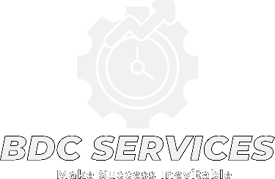
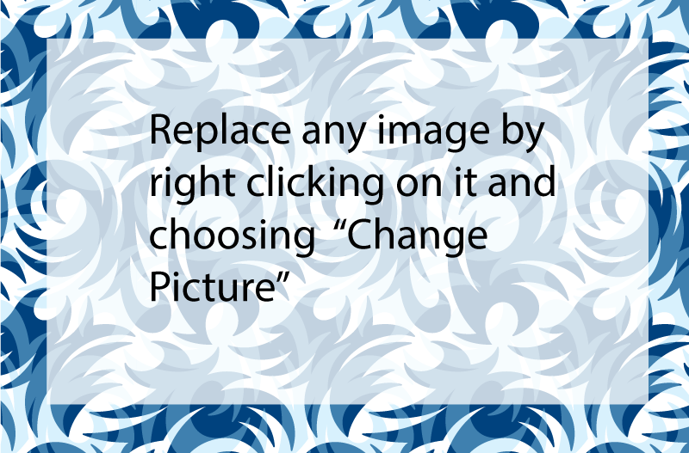
BDC SERVICES LLC

Company Snapshot
Established: 8/2024
CAGE: 9ZBB7
UEI: XCQ9BVUP4BL1
CalEProcure Bidder #BID0112041
We accept: Visa, Mastercard, Check, Cash, Crypto: BTC, XRP, USDC.
Service area: United States of America

NAICS Codes (or UNSPSCs)
- (Primary) 541611: Admin. & Gen. Mgmt. Consulting Serv.
- (Secondary) 449110: Furniture Retailer – Office Furniture, Specializing in custom high quality Ergonomic office chairs
- 459410 : Office Supplies and Stationary retailer
- 541219: Other Accounting services.
- 541614: Human Resources Consulting Serv.
- 541618: Other Management Consulting Serv.
- 561210: Facility support services
- 423490: Other professional equipment and merchant wholesaler
- 921190: Other General Gov. Support
- 80101706: MGMT Business Prof & Admin Serv. - Industrial management - Professional procurement serv.

Licenses & Certifications:
City of Santa Rosa BTC # 06533616
Ca. S.O.S. Entity # 202462714598
Seller’s Permit #203771296-00001
DVBE , SB, Certification ID: 2041072
(SDVOSB certified)

)
Capabilities Statement
BDC Services LLC is a Certified Service-Disabled Veteran Owned Small Business providing procurement and professional services, specializing in custom office furniture to optimize comfort and morale, as well as project management to improve efficiencies, and drive organizational growth. We are committed to providing high-quality services that meet the unique needs of both private sector companies and government agencies.

Your Company(If it is not clearly in the logo)

Core Competencies
- Furniture Sales
  - Custom ergonomic/ orthopedic office chairs
  - Custom waiting room chairs
- Management Duties
  - End-to-end project planning and execution
  - Budget, scope, and timeline management
  - Business strategy development and implementation
  - Capital raising and investment strategy
- Separate topics as needed
  - Product Acquisition
  - Equipment Acquisition
  - We customize our services to meet the specific needs of government agencies and private clients, ensuring the best outcomes for every project.

Contact
Michael Reynolds, Owner/ Manager
BDC-CA@outlook.com
707-774-9068
Address: 1118 San Clemente Drive
Santa Rosa, Ca 95404
Visit Our Website: BDC-CA.com
Differentiators
We offer highly customizable office chairs built with excellent quality and outstanding comfort suited for office professionals. Our project planning and management focuses on continuous improvement and adherence to best practices ensures the highest level of service quality and client satisfaction. We prioritize client relationships, working collaboratively to develop solutions that align with each organization’s unique goals and challenges.


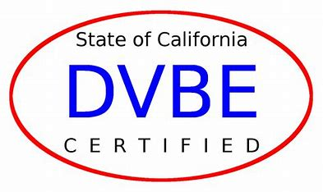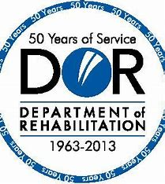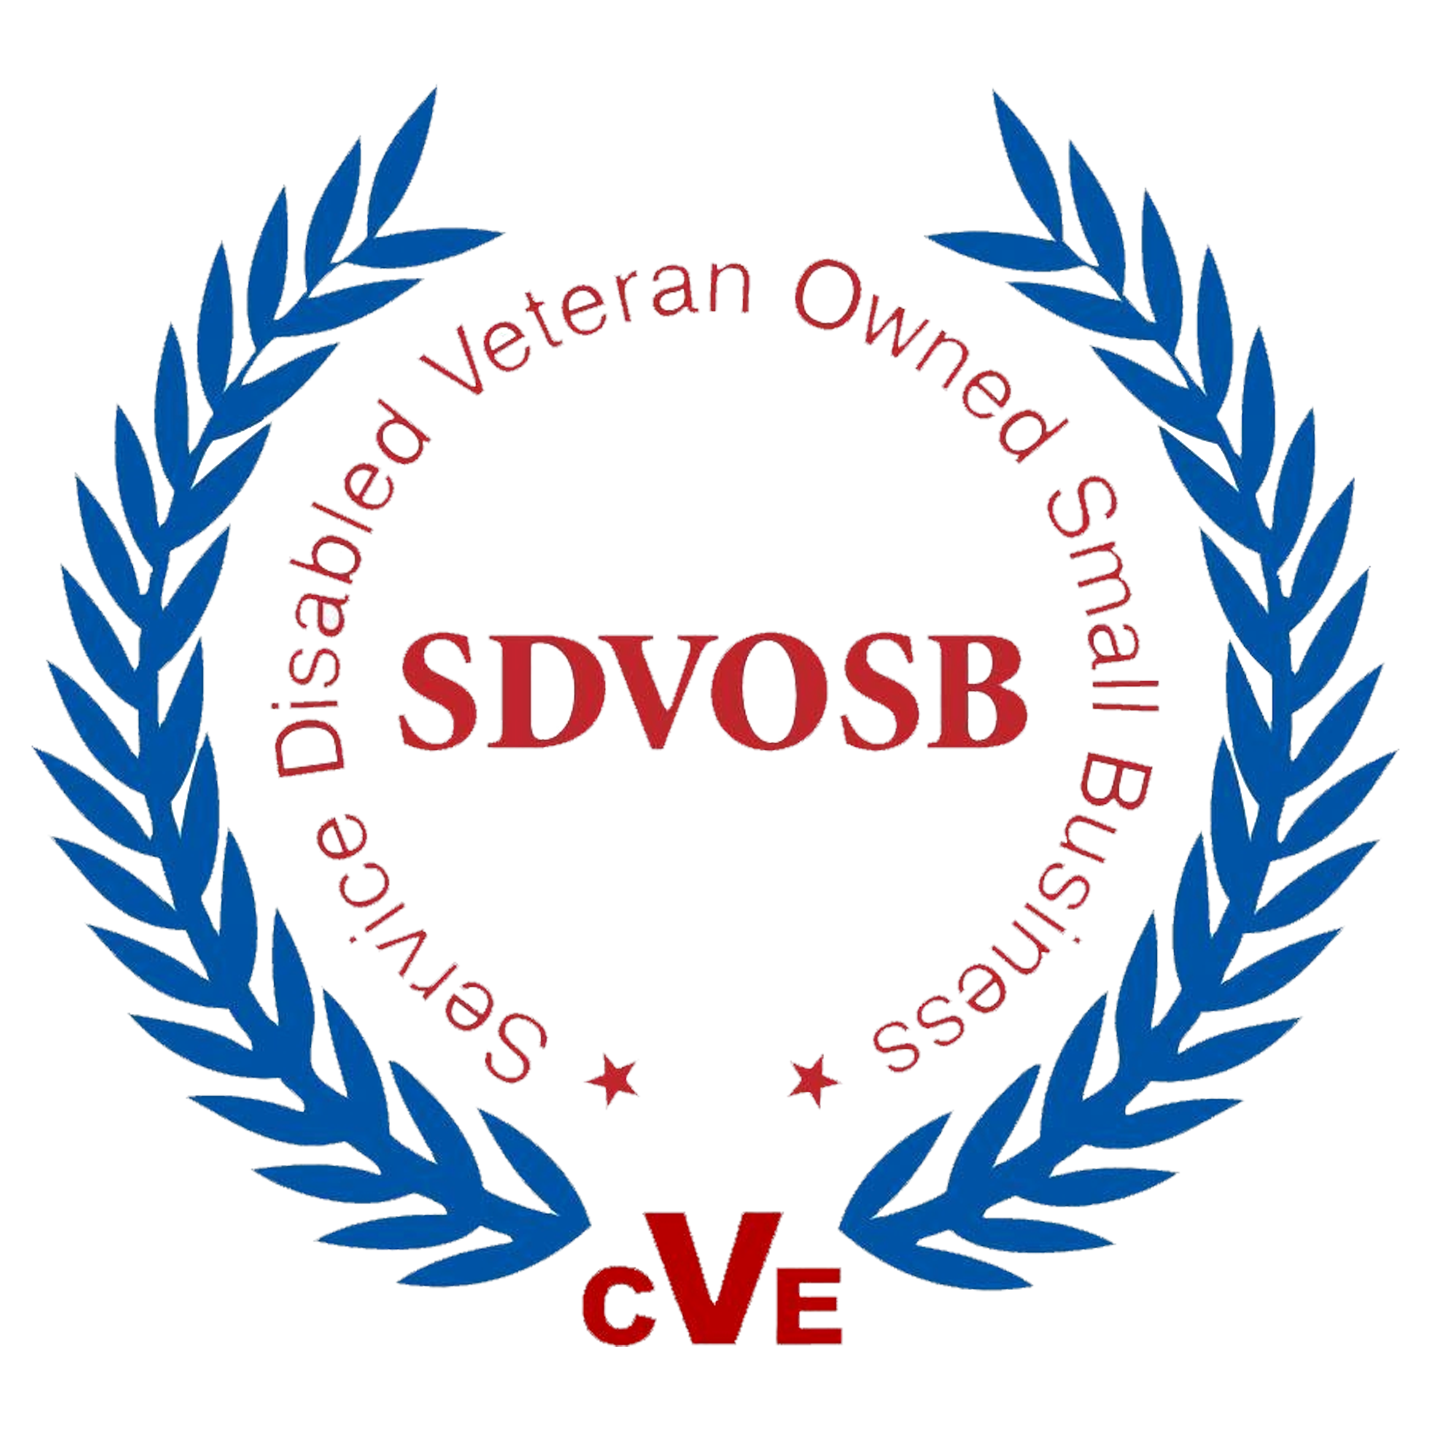
Experience
BDC Services LLC was established June 2024, with the intent of helping the government and private companies build a better future for our country together. Previously: (8/2022 – Current) B- General Construction Contractor, (2015-2020) Diesel Mechanic, (2009-2015) Residential Remodel and repairs/ Tile setter, (2004-2008) US ARMY – 2/75 Ranger Battalion.

