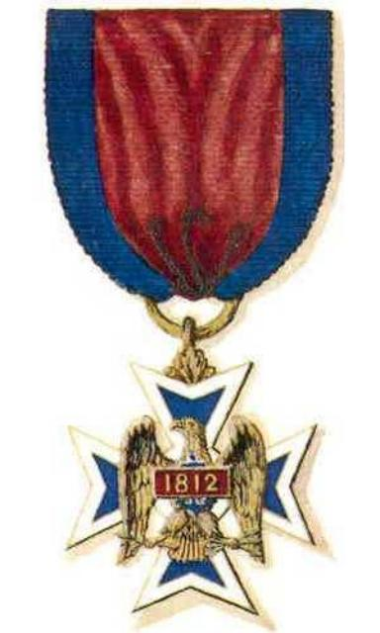
The Veteran Corps of Artillery
Constituting
“The Military Society of the War of 1812”

Proposal Form for Prospective Member

(Full Name)
(Date of Birth)
(Address)
City: State: Zip: Country:
Home Tel # Work Tel #
Email:
(Occupation)
Education (names of institutions, degrees and dates received):

Marital Status (Single, Married, Divorced or Widowed):
If applicable, wife’s full maiden name:
Names of Children, separated by comas:

Other Personal Accomplishments
(For example: Genealogical Societies, Military Service, Community Activities and/or Honors):

Other significant facts that you believe will be of interest to the Membership Committee:

Name of War of 1812 Ancestor:

His grade or rank at the conclusion of his War of 1812 service:
Served in the State of: from: to:

General Society of the War of 1812
(if your application is identical to a previously approved GSW 1812 app)

State(s)_________________ National Number

State Number(s) ________________________________________________

Proposed by, who is a member of the Military Society of the War of 1812:
Proposed by, who is a member of the Military Society of the War of 1812:
Proposer Comments:

If not proposed by a member, please provide a bio and or a resume, plus a picture with this Proposal Form.

Please let us know how you learned of the Society?
- Our Website:
- Genealogy Publications:
- Word of mouth, from existing member(s); please provide name:

The above prospective applicant is requesting that he be considered for membership.

Email to: registrar@militarysocietyofthewarof1812.com

or Mail to:

Darren John Guillot, Registrar
Military Society War of 1812
1550 Hunting Avenue
McLean, VA 22102

