Funeral Planning
and
Memorial Liturgies
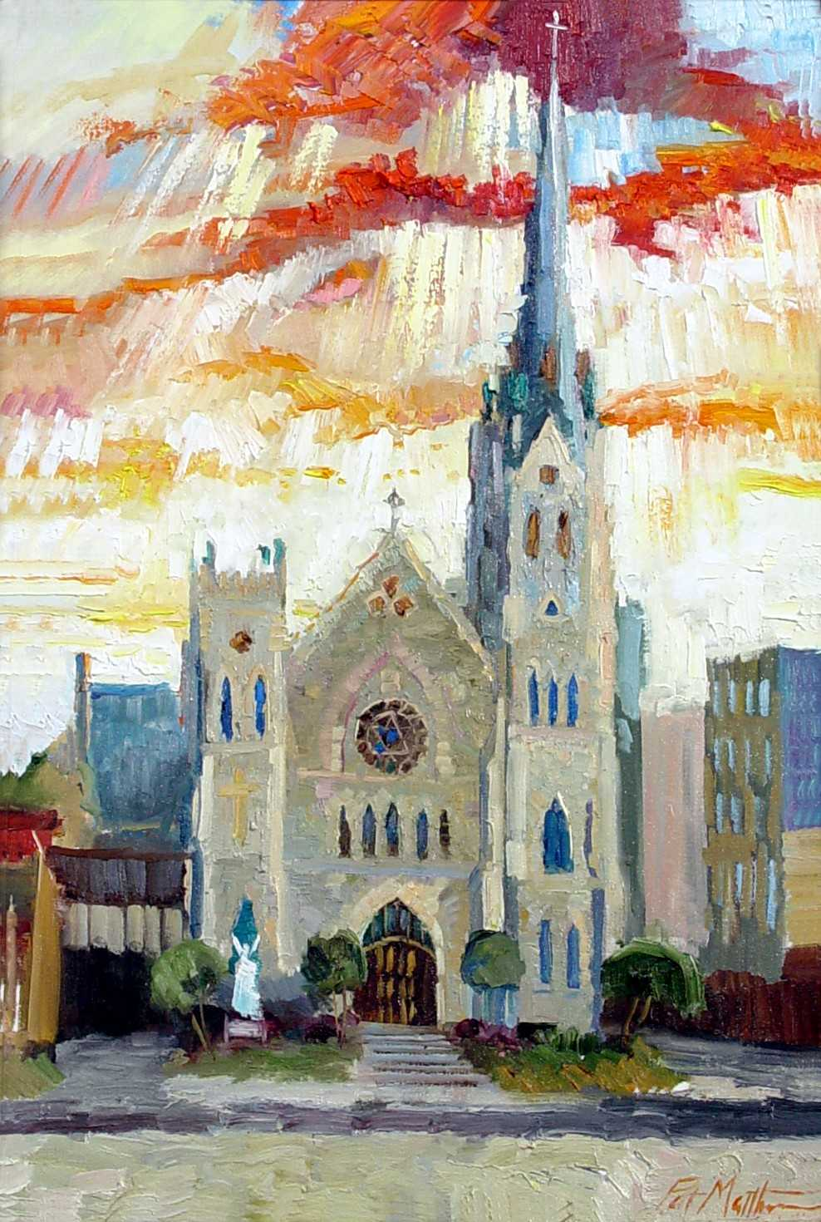

Cathedral of St. Andrew
617 Louisiana Street
Little Rock, Arkansas 72201
501-374-2794
www.csalr.org
Notifying the Parish and Scheduling

To plan a funeral to be celebrated at the Cathedral of St. Andrew, the family of the deceased should contact the Rector/Cathedral office prior to discussing with the Funeral Directors anything regarding funeral liturgy. After that first contact with the Cathedral office, the family will know the available dates and times within a relatively short period. The goal during this process of scheduling will be to work with the family to find a day and time that would work for both the family and for the parish. The Cathedral office is open Monday-Thursday, 8:30 a.m. to 4:00 p.m. and Friday, 8:30 a.m. to 12:00 Noon. The office contact number is 501-374-2794, #221. When the parish office is closed, please call the main office number, 501-374-2794 and chose option #4. Once the ‘emergency’ option is selected, the caller will be routed to a voicemail. Please leave a message with a call-back number and the Rector will return your call. Following the first reception of a death notice the Rector will be notified by the parish office.

Funeral Homes

The following is a list of contact information for a few local funeral homes.

Griffin-Leggett Healey and Roth Smith Family Funeral Homes (various locations)
5800 West 12th Street 8801 Knoedl Court
Little Rock, AR 72204 Little Rock, AR 72205
501-661-9111 501-224-2200
www.Dignitymemorial.com www.smithfamilycares.com

Ruebel Funeral Home Roller Funeral Homes (various locations)
6313 W. Markham Street 13801 Chenal Parkway
Little Rock, AR 72205 Little Rock, AR 72211
501-666-0123 501-225-0818
www.Ruebelfuneralhome.com www.rollerfuneralhomes.com

Cemetery

The local Catholic Cemetery is Calvary. Located at Wright Avenue and South Woodrow Street. The main entrance is off Charles Bussey Avenue. If you are interested in a plot for burial at Calvary for the burial of a casket or cremated remains, please contact Michael Cagle, Superintendent for the cemetery grounds, 501-663-2242 or 501-517-6453. As a note, the cremated remains of two deceased people may be placed in a single cemetery plot space.

Liturgical Services Offered
The most common form of Catholic funeral may have the following elements:
- Vigil service with either the body or cremated remains present. (optional)
- Rosary Prior to funeral.
- Funeral Mass or service with either the body or cremated remains present.
- Graveside service with burial of the body or cremated remains.
If for some reason the remains cannot be present, a memorial Mass or service can still take place close to the time of death or at some convenient time for the gathering of friends and family.

Vigil Services
(optional)

- Prayer service (suitable for congregations of mixed faiths)
- Prayer service with rosary – see below (suitable for congregations of mixed faiths)
- Rosary prior to Mass – usually five decades of the rosary. (suitable where most of the congregation are Catholic).
- Divine Mercy Chaplet suitable for all faiths.
The vigil service may be held at the funeral home or at the Cathedral.
Vigils are often led by a deacon or may be led by a priest.
The vigil is the best time to have memorials, eulogies, as well as secular music and readings, such as poems.

Vigil Service with Rosary

Introductory Rites
This includes prayers and an introduction from the priest or deacon.

Liturgy of the Word
These commonly include short readings, followed by the priest or deacon preaching a suitable homily based on the life of the deceased in relation to the gospel.

Rosary and Reflections
Here the priest or deacon will lead the congregation in praying the five decades of the Rosary. Reflections, other readings and eulogies may follow.

Concluding Prayers
Prayers conclude the vigil service.

Funeral Masses

Funeral Mass with body or cremated remains present

The funeral Mass is held at the church.

In funerals with the body of the deceased, the remains are sprinkled with holy water and covered with a pall, a reminder of baptism, at the entrance of the Church.

An urn of cremated remains may be carried in procession or placed on a table at the front of the church before the service begins. No pall is to be used.

A flag may be placed on a casket before and after the Funeral Mass, but during the Mass it is replaced by the pall.

Immediately following the service, the body or the cremated remains would normally be transferred to the cemetery or columbarium for burial or inurnment.

Memorial Mass

The memorial Mass is held in church just like a funeral Mass, but no remains are present. The opening of Mass is like a more usual Mass with an Opening Song, Greeting and Penitential Act.

Graveside Prayer Service

In cases where a funeral service has already taken place, we offer a simple prayer service for burial of the body or inurnment of the cremated remains at the cemetery.

OUTLINE OF A FUNERAL MASS

Introductory Rites

At the entrance to the church the remains, if in a casket, are sprinkled with holy water and covered with a pall. A pall is a reminder of baptism. After the procession, the priest offers the opening prayer/collect.

The Liturgy of the Word
  - First Reading
  - Responsorial Psalm (usually sung)
  - Second Reading
  - Gospel Reading
  - Homily
  - Universal Prayers

Liturgy of the Eucharist
  - The Offertory (Bread and wine are brought to the altar)
  - The Eucharistic Prayer
  - The Lord’s Prayer and The Peace
  - Communion

Final Commendation and Farewell
  - The remains are honored with incense.
  - The service continues at a cemetery for burial of a casket or inurnment of cremated remains, accompanied by brief prayers.

You may wish to think of people from your family and friends who are trained lectors and can:
  - Read the 1st reading
  - Read the 2nd reading
  - Bring forward the gifts of bread and wine

Readings at Mass

We encourage family and friends to take part in the Liturgy of the Word by reading the First Reading and Second Reading. It is required that those chosen to be trained lectors and conformable with lectoring at funeral Masses. If the family would prefer, the Church will provide a lector to read the readings. Approved readings are included at the back of this booklet, from which you may select the readings. The Gospel should be approved by the Rector or the presiding priest celebrating the funeral.

Music

Music is an important part of ritual, and we encourage families to make full use of the Cathedral’s rich tradition and the parish’s musical resources. The organist and director of Music is available to provide a program (also known as an ‘Order of Service’) for the funeral Mass. Please contact him at least three (3) days prior to the service.

Music before and after the Mass

Music for all liturgies is under the direction of the Director of Music and Organist, Mr. Beau Baldwin. Organ music can provide a quiet and prayerful atmosphere at the beginning of the service, when mourners are likely to be upset and in need of a calming atmosphere. At the end of the Mass, when the cortège leaves the church for the final resting place, it is good to have some uplifting and reassuring music.

Hymns, Psalms and Spiritual Songs

During a liturgy that lasts around 60 minutes, it is good to allow everyone present to participate in the singing. The hymns, psalms and spiritual songs that are chosen should be familiar to the congregation so that the singing is strong. Our hymnal contains many fine items from which you may wish to choose. Appropriate selections of funeral music are available later in this guide to assist you with your planning. Should there be music selections not included in our resources that you wish to use, please contact the Director of Music. All musical selections other than the options listed in this guide must be approved in advance by Mr. Baldwin and/or the presider of the funeral.

Soloists and Choirs

Many families like to have a solo sung. We recommend that one of our skilled cantors lead the singing of the Psalm and the Eucharistic music and sing one or more of the many appropriate solos that you may choose. It is also possible for one of our choirs to sing, or for a group of professional singers to be hired. We can also hire additional instruments if that may be desired (for example, a string quartet or a trumpeter). Mr. Baldwin will be pleased to advise you on this and help with choices.

Recorded Music

We recognize the importance of certain recorded songs. Recorded music may be proper during visitation or at a reception but not during a liturgical service.

OTHER CONSIDERATIONS
Writing Catholic Obituaries

The language or words to be used in writing an obituary notice for the news media referring to a Catholic Church funeral should be written as: “a Funeral Mass will be celebrated…” or “A Mass of Christian Burial will be celebrated…”. The act of burial or entombment of the remains in a cemetery should be worded as “the Rite of Committal and burial will be…” The term “Memorial Mass” is used where the body or cremated remains are not present for the Mass.

Tributes and Eulogies

Normally individual tributes should be reserved for the vigil service the afternoon or evening before the day of the Funeral Mass or for a luncheon/reception following. The homily at Mass is when the priest will preach on the gospel you have chosen and make specific references to the deceased. One short tribute, of less than three (3) minutes, may be read at Mass. This is best read from a script, and should be approved by the priest before the Mass.

Displays and Photographs

We welcome displays of photographs and memorabilia at the entrance to the church or during a luncheon/reception.

Flowers

We welcome flowers and wreaths as part of the funeral celebration. During Lent we do not use flowers on the Altar, but they can be displayed near the casket and at the entrance of the church.

Financial Considerations

There is no fee for the use of the church for a funeral; if you wish to donate to the church, it is certainly welcome. The stipend for a priest and or deacon is at your discretion.

Music Fees: $200 for the organist and $100 for the cantor. Checks should be made payable to the organist and cantor; and delivered to the Cathedral office prior to the funeral Mass.

No one will be denied the services of the Cathedral for financial reasons; if any of the fees are burdensome, please speak with the Rector of the Cathedral. These donations/stipends may be paid through the funeral home or by a family member. They are paid on or before the day of the funeral.

Funeral Luncheon / Reception

Many Catholic families gather after the burial for a meal known as a Mercy Meal or repast. It’s a chance for the community to come together, share stories, and care for the bereaved family. The Cathedral’s Martha’s Meal Ministry may host a lite luncheon/reception in McDonald Hall after a local interment or, when interment will occur later, after the funeral liturgy, if requested by the family.
The luncheon/reception may be planned for family members only or for all who attend the funeral liturgy. The family may choose simple menu option, i.e., sandwiches, chicken tenders, finger foods, etc. All entrees include sides and desserts. There is no charge for the luncheon, though donations to Martha’s Meal Ministry are accepted. If the family prefers to arrange for the luncheon to be catered, the Cathedral can provide names of local caterers. Please note that, due to prior scheduled events in McDonald and other activities, there may be certain days or times when we are unable to offer a funeral luncheon or reception.

Memorial Gifts

You may wish to encourage friends and family to make Memorial Gifts to the Cathedral of St. Andrew. These gifts are received in the name of the deceased. The immediate family is notified of these gifts as well as an acknowledgement to the donor. Memorial gifts may be used for the general needs of the Cathedral, or may be designated for one or more specific purposes, such as the building fund, a current parish project, or the music ministry. If you wish to have Memorial Gifts made to Cathedral of St. Andrew, it may be indicated in the obituary or in the funeral program.
Funeral Reading Selections
Below is a list of suggested readings approved by the Rector and must be used for the Funeral Mass. Please choose one reading from the section of Old Testament readings, one reading from the New Testament readings, and one Gospel reading. These reading may be found in their entirety by visiting www.usccb.org/prayer-and-worship/sacraments-and-sacramentals/bereavement-and-funerals or in the Through Death to Life book that may be obtained from the Cathedral office. If you do not wish to choose the readings, the priest celebrating the funeral will be happy to choose them for you.
Old Testament Readings
- Maccabees 12: 43-46 ~ He acted in an excellent and noble way as he had the resurrection of the dead in view.
- Job 19: 1, 23-27 ~ I know that my Vindicator lives.
- Wisdom 3: 1-9 or 3:1-6, 9 ~ As sacrificial offerings he took them to himself.
- Wisdom 4: 7-14 ~ An unsullied life, the attainment of old age.
- Isaiah 25: 6a, 7-9 ~ He will destroy death forever.
- Lamentations 3: 17-26 ~ It is good to hope in silence for the saving help of the Lord.
- Daniel 12: 1-3 ~ Many of those who sleep in the dust of the earth shall awake.

New Testament Readings
- Acts of the Apostles 10: 34-43 or 10:34-36. 42-43 ~ He is the one appointed by God as judge of the living and the dead.
- Romans 5: 1-11 ~ Since we are now justified by his Blood, we will be saved through him from the wrath.
- Romans 5: 17-21 ~ Where sin increased, grace overflowed all the more.
- Romans 6: 3-9 or 6:3-4. 8-9 ~ We too might live in the newness of life.
- Romans 8: 14-23 ~ We also groan within ourselves as we wait for the redemption of our bodies.
- Romans 8: 31-35. 37-39 ~ What will separate us from the love of Christ.
- Romans 14: 7-9. 10-12 ~ Whether we live or die, we are the Lord’s.
- 1 Corinthians 15: 20-24. 25-28 ~ So too in Christ shall all be brought to life.
- 1 Corinthians 15: 51-57 ~ Death is swallowed up in victory.
- 2 Corinthians 4: 14-5:1 ~ What is seen is transitory, but what is unseen is eternal.
- 2 Corinthians 5:1. 6-10 ~ We have a building from God, eternal in heaven.
- Philippians 3: 20-21 ~ He will change our lowly bodies to conform to his glory.
- 1 Thessalonians 4: 13-18 ~ Thus we shall always be with the Lord.
- 2 Timothy 2: 8-13 ~ If we have died with him, we shall also live with him.
- 1 John 3: 1—2 ~ We shall see him as he is.
- 1 John 3: 14—16 ~ We know that we have passed from death to life because we love our brothers.
- Revelation 14: 13 ~ Blessed are the dead who die in the Lord.
- Revelation 20: 11-21:1 ~ The dead were judged according to their deeds.
- Revelation 21: 1: 1-5. 6-7 ~ There shall be no more death.

Gospel Readings
- Matthew 5: 1-12a ~ Rejoice and be glad, for your reward will be great in heaven.
- Matthew 11: 25-30 ~ Come to me and I will give you rest.
- Matthew 25: 1-13 ~ Behold the bridegroom! Come out to him!
- Matthew 25: 31-46 ~ Come, you who are blessed by my Father.
- Mark 15: 33-39; 16: 1-6 or 15: 33-39 ~ Jesus gave a loud cry and breathed his last.
- Luke 7: 11-17 ~ Young man, I tell you, arise!
- Luke 12: 35-40 ~ You also must be prepared.
- Luke 23: 33, 39-43 ~ Today you will be with me in Paradise.
- Luke 23: 44-49; 24: 1-6 or 23: 44-49 ~ Father, into your hands, I commend my spirit.
- John 6: 37-40 ~ Everyone who sees the Son and believes in him may have eternal life and I shall raise him on the last day.
- John 6: 51-58 ~ Whoever eats this bread will live forever, and I will raise them upon the last day.
- John 11: 17-27 or 11: 21-27 ~ I am the resurrection and the life.
- John 11: 32-45 ~ Lazarus, come out!
- John 12: 23-28 or 12:23-26 ~ If it dies, it produces much fruit.
- John 14: 1-6 ~ I my Father’s house there are many dwellings.
- John 17: 24-26 ~ I wish that where I am they also may be with me.

Music for Funerals and Memorial Masses

This is a list of the most appropriate songs for Mass. Please choose two hymns from the selections for Entrance and Closing Hymns, one Responsorial Psalm, one Offertory Hymn, one Communion Hymn and one Hymn for the Commendation. The titles of these hymns are listed, and many Catholic and non-Catholic Hymnals will have musical examples of these songs. If you do not wish to choose the hymns, Mr. Beau Baldwin, our Director of Music, will be happy to choose them for you. We cannot include secular music at a funeral liturgy.

The Cathedral has one of the finest pipe organs in the State of Arkansas. We do not have a piano in our Cathedral Church. Our Cathedral has a long and proud history of traditional liturgical music. Because of this, some musical selections that might be made at certain parish churches with more contemporary music might not work at the Cathedral. Our Cathedral Organist will advise on music choices related to this.
- Selections for Entrance & Closing Hymns
  - For all the Saints
  - Ye Watchers and Ye Holy Ones
  - Come, You Faithful, Raise the Strain
  - The Strife is O’er
  - Sing with All the Saints in Glory
  - Praise, My Soul, the King of Heaven
  - Joyful, Joyful, We Adore You
  - Holy God, We Praise Thy Name
  - O God beyond All Praising
  - Immortal, Invisible, God Only Wise
  - O God, Our Help in Ages Past
  - I Know that My Redeemer Lives
  - I Want to Walk as a Child of the Light
  - Be Thou My Vision
  - Lord of All Hopefulness
  - I Heard the Voice of Jesus Say
  - How Lovely is Thy Dwelling Place
  - The Living God My Shepherd Is
- Selections for the Sung Responsorial Psalm
  - Psalm 23
  - Psalm 25
  - Psalm 27
  - Psalm 63
  - Psalm 103
- Selections for Offertory and Communion Hymns
  - The King of Love My Shepherd Is
  - Lord of All Hopefulness
  - The Living God My Shepherd Is
  - Jerusalem My Happy Home
  - How Firm a Foundation
  - My Shepherd, You Supply My Need
  - I Am the Bread of Life
  - You Satisfy the Hungry Heart
  - Take and Eat
  - On Eagles’ Wings
  - One Bread, One Body
  - Be Not Afraid
- Sung Solo Music Selections

8/13/2066

