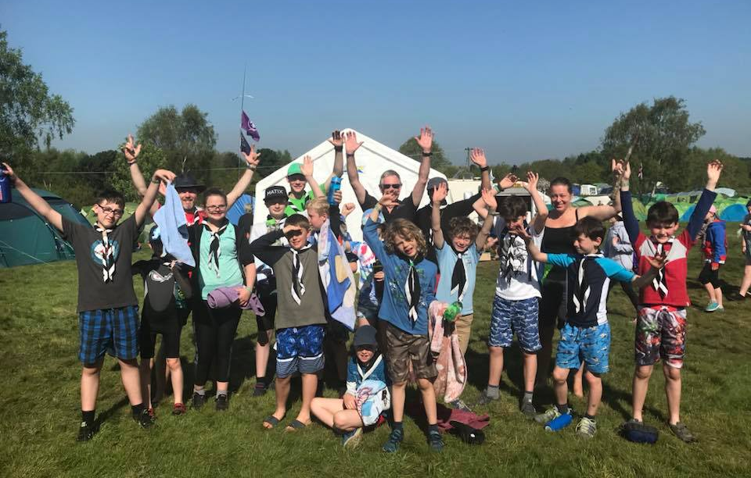

3rd West Bridgford

(Friary) Scout Group
The Scout Hall, 46 Musters Road, NG2 7PR
What3Words: means.common.short

Welcome Pack


Welcome
3rd West Bridgford (Friary) Scout Group celebrated its 90th anniversary in 2017 and is continuing to provide all our members with Skills for Life through an interesting and educational program. As of January 2025, we have just over 100 young people across two Beavers colonies, two Cubs packs and a Scout troop supported by an adult volunteer team numbering over 30.

At the heart of all we do is safeguarding and safety of our members, both young and adult. If at any time you have any concerns regarding this please initially talk to the leaders of your child's section or to the GSL: Alan Hubber – alan.hubber@ntlworld.com

Sections
Beaver Scouts: 6 - 8 Years
We meet weekly on a Thursday and Friday evening to take part in a wide range of activities including games, crafts, singing, visits and good turns, along with plenty of outdoor activities. We also have the opportunity to take part in the fun and excitement of camps and sleepovers. It may be the first time they spend a night away from home, so it’s a real adventure for them

Cub Scouts: 8 – 10½ Years
Our Cub Scout Packs are split into smaller groups called Sixes and meets on a Monday and Wednesday evenings. Cubs take part in a wide range of activities designed to be interesting and challenging. Our Cub Scout meetings consist of games and activities with plenty of time spent outdoors. Camps and holidays are some of the most memorable events of the year for Cubs.

Scouts: 10½ - 14 Years
Our Scout Troop consists of small units of six to eight Scouts called a Patrol, led by Patrol Leaders. We meet on a Thursday evening. Outdoor activities feature prominently, with the highlight being camping. Throughout the year, Scouts learn various skills, such as map reading, camp cooking and first aid in preparation for camp. Rock climbing, potholing, gliding, photography and international experiences are just some of the things we get up to.

Subscription
The annual cost of Scouting membership with 3rd WB is £162 per person. It is the same whether a Beaver, a Cub or a Scout. In the same month that your child joins us, please organise a recurring monthly payment of £13.50 by completing a Standing Order form using the Group's bank details. Please ensure you include your child's name in the reference box.
Barclays Bank Account Name: - 3rd West Bridgford (Friary) Scout Group
Account Number: - 90955817 Sort Code: - 20-63-25

*Trips, camps and external activities are usually charged separately with advance notice. We don’t want young people to miss out through financial hardship. If concerns about finances may prevent your child taking part in some activities, speak to the GSL, as some assistance may be available in confidence.

Gift Aid
Gift Aid is a simple government initiative which allows donors who are taxpayers to increase the value of their donations at no extra cost to them. For every pound given, charities can get an extra 25 pence from HM Revenue & Customs, helping donations go further. Please complete and return the accompanying Gift Aid form at the end of this welcome pack, or use the online form here: https://forms.office.com/e/9ZvcwciiMd

Online Scout Manager (OSM)
OSM is the online tool that we use for section and group administration. In here we store contact details, session plans, badge records and basically everything we need to run our scout group. OSM has a parent portal which your section leader will send you a link to login. Once logged in there is a self-service area for updating contact details and any other information we need to know, plus you can see your child’s badge progress, the programme and events that are planned. We particularly do need to know, in confidence, of any health information regarding your child so we can better understand any needs they have – if we don’t know we cannot make allowances! We also send e-mail communications from OSM so please check your junk mail folder in case they don’t come directly into your in-box to begin with.
Here is the link you need to sign into OSM: - https://www.onlinescoutmanager.co.uk/

Uniform & Scout Shop
During meetings we expect your child to attend in uniform ‘from the waist up’.
· Beavers - Turquoise sweatshirt and Group neckerchief
· Cub Scouts - Dark green sweatshirt and Group neckerchief
· Scouts - Teal green smart shirt and Group neckerchief
For events where the full uniform is required, Scout activity trousers or dark grey / black ‘school’ type trousers / skirt would be more than adequate. Kit lists and other clothing requirements will be provided for events and camps.
A Group Neckerchief and Group Badge is provided when your child is invested. All the additional badges they will attain are also provided by us as part of your subscription.
To purchase the uniform, it is available from a number of sources but the official scout association website, Scout Store | A Scout Shop for all your Scouting essentials. is as good as any other and probably better value.

Go Cardless online payment method via OSM
For events only (camps / activities) we collect payments via OSM rather than bank transfers into the Friary account. Using Go Cardless makes it easy for Parents to pay for events and monitor what is still outstanding.
Please note there is no change to subs, this only effects payments for events and activities.
Step 1 – when you accept the event in OSM it will give the ‘pay now’ option which is a one off payment. It is not a recurring direct debit.
Step 2 – on the first occasion it will ask you to set up a direct debit. Please note this is not a recurring direct debit but Go Cardless will save your details for future payments.

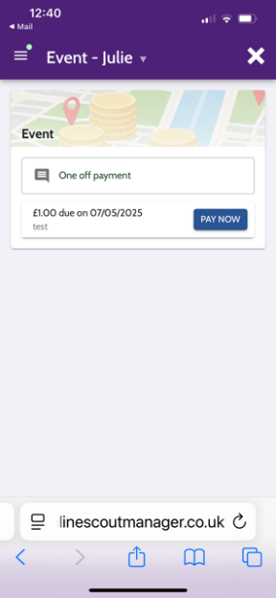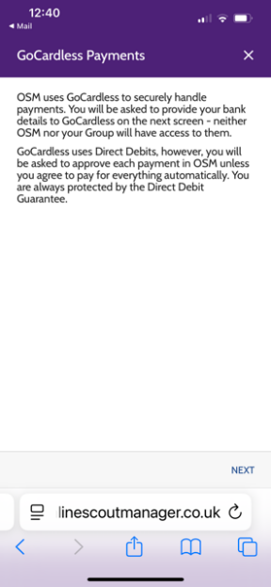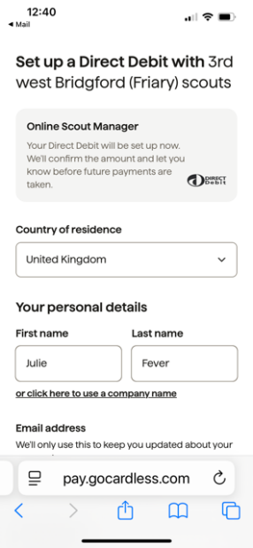

In OSM you will be able to view the Payment screen to see what payments are outstanding or have been paid.

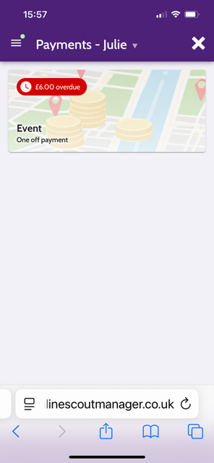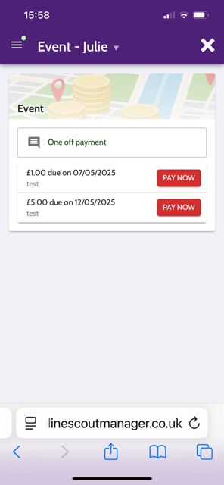

Trustee Board
The Group Trustee Board plays a vital role in the running of a Scout Group. Trustee Boards make decisions and carry out administrative tasks to ensure that the best quality Scouting can be delivered to young people in the Group.

Safeguarding, Data Protection & DBS
The Scout Association and the Group are all committed to the safety and security of our young people. We consider the safety of our Beavers, Cubs & Scouts to be of paramount concern. Disclosure and Barring Service checks (formally CRB checks) are therefore an important part of our approach to safeguarding young people. Adults who help regularly are DBS checked, Parent helpers on our rota do not need to be unless they stay on overnight activities.

- Online Scout Manager: onlinescoutmanager.co.uk
- Our Website: 3rdwbfriaryscouts.org.uk
- Rushcliffe District: rushcliffescouts.org.uk
- Scout Shop: Scout Store | A Scout Shop for all your Scouting essentials.
- Nottinghamshire Scouts: notts-scouts.org.uk
- Scouts UK: scouts.org.uk
- My Badges APP Visit an App Store

Fundraising – 200 Club
A monthly Prize Draw designed to raise extra funds for all sections of the group so that Beavers, Cubs and Scouts can participate in additional events and activities. Membership is entirely voluntary, and members (parents and family members) may join and leave at any time.
Every month we guarantee someone will win a 1st Prize of £25, 2nd Prize of £10 and 3rd Prize of £5. A total of 200 numbers are available but only ‘live’ numbers allocated to members are entered into the draw to guarantee that all prizes are won. Members keep the same allocated number(s) for each prize draw. Each number cost just £1.00 per month payable by Standing Order or Cheque (for the year).
There is no limit on the quantity of numbers held by a member. Since the 200 Club began, over £20,000 has been raised and donated to the Group. Membership is currently less than 100, so your chances of winning are considerably better than you might think.
For more information or to become a member of the 200 Club please contact the name shown below who currently organises the draw, or speak to your Beaver, Cub or Scout Leader.

Malcolm Siddons - E-mail: malcsiddons@hotmail.com - Tel: 0115 923 3769

Online Gift Aid Declaration - https://forms.office.com/e/9ZvcwciiMd

Gift Aid Declaration
Name of charity: 3rd West Bridgford (Friary) Scouts
Please treat as Gift Aid donations: - (please tick the appropriate box)
- The enclosed gift of £ ______________ OR
- All gifts of money that I make today and in the future as Gift Aid donations OR
- All gifts of money that I have made in the past four years and all future gifts of money that I make from the date of this declaration as Gift Aid donations.

Child details:
First Name: ____________________Surname: ____________________

Starting Section: (please circle) - Beavers / Cubs / Scouts / Explorers

Donor details:

Title: _____ First Name: _________________________Surname: _________________________

Home Address: _________________________________________________________________
______________________________________________________________________________
Postcode: _____________
I confirm I have paid or will pay an amount of Income Tax and/or Capital Gains Tax for each tax year (6 April to 5 April) that is at least equal to the amount of tax that all the charities or Community Amateur Sports Clubs (CASCs), that I donate to, will reclaim on my gifts for that tax year. I understand that other taxes such as VAT and Council Tax do not qualify. I understand the charity will reclaim 25p of tax on every £1 that I give.

Date: _______________________ Signature: _______________________
Please notify The Scout Association if you:
- Want to cancel this declaration.
- Change your name or home address.
- No longer pay sufficient tax on your income and/or capital gains.
If you pay income tax at the higher rate, you must include all your Gift Aid donations on your Self-Assessment tax return if you want to receive the additional tax relief due to you.
The Scout Association, Gilwell Park, Chingford, London, E4 7QW. Tel: +44(0)20 8433 7100
Registered Charity numbers 306101 (England and Wales) and SC038437 (Scotland)

