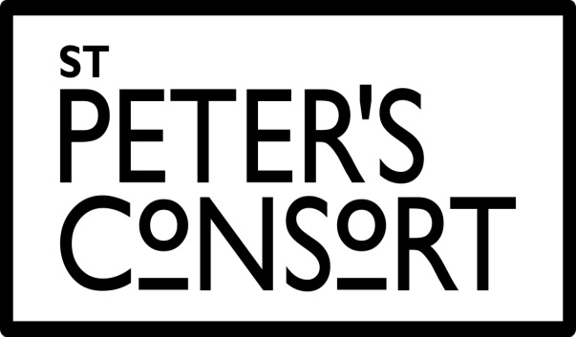
www.stpetersconsort.co.uk

CHAIR: COLIN POWELL MUSICAL DIRECTOR: JAMES BOWSTEAD BA (Oxon) FRCO
PHONE: 07557803869 . EMAIL: colinpowell1002@msn.com PHONE: 07956277359 . EMAIL: jamesbowstead1@gmail.com

28 August 2025

Dear friends,

Our last concert back in May, entitled ‘Fain would I change that note’, was a great success. I think the juxtaposition of Renaissance madrigals and Romantic partsongs made for a really interesting comparison, and the choir sang excellently in both styles. It was also great to have solo songs sung by several members of the choir, and it was particularly wonderful to be accompanied by Peter Cain on guitar for a couple of those. I hope that everyone who was able to come thoroughly enjoyed themselves!

Our next concert will take us into a different sound world entirely – that of jazz. One of the great delights about directing Consort is their versatility, and over the years we’ve included choral arrangements of various jazz standards in our concert programmes alongside more traditional choral works. This concert will give us an opportunity fully to lean into a style we’ve always enjoyed, performing three substantial works with jazz influences.

The main work in this concert will be Will Todd’s Mass in Blue. Todd is a contemporary British composer who also works regularly as a jazz pianist, and this influence of jazz and blues spills over into a lot of his compositions. Mass in Blue is one of his best-known works, composed in 2003, and sets the traditional words of the Latin mass in a jazz idiom. It is at times vibrant and exuberant, at times relaxed or even brooding, always very expressive of the mass texts Todd is setting. Since its première, it has become one of Todd’s most popular works, often performed by large choirs in the full orchestral version. We will be using the small band version, accompanied by piano, bass, drums and saxophone, and I hope that the combination of that with a smaller choir will give a more intimate feel, at once evocative of both a smoky jazz club and a traditional mass – the latter helped of course by the surroundings of Wakefield Cathedral! Our own Lucy Reliņš will be singing the soprano solo part, which weaves in and out of the texture, interacting with the choir and band to great effect.

Mass in Blue will form the second half of the concert, with the first half consisting of two works by well-loved British composers celebrating significant birthdays this year – Bob Chilcott, who turned 70 in April, and John Rutter, who turns 80 in September. Chilcott’s A Little Jazz Mass was written in 2004, and, like Todd’s mass, combines Chilcott’s experience with choral music and jazz, the latter particularly in his time as a member of the King’s Singers. As the name suggests, Chilcott’s setting is on a smaller scale than Todd’s, but its expressive and sensitive setting of the texts of the mass is no less accomplished, and it will hopefully make an effective counterpoint to the larger-scale work.

The final work for this concert, John Rutter’s Birthday Madrigals, harks back to the theme of our May concert, even reusing one of the texts. Rutter wrote the collection in 1995 to celebrate the 75th birthday of the celebrated British jazz pianist, George Shearing. Alongside his work as a pianist, Shearing was also a prolific composer and arranger, including of the classic ‘Lullaby of Birdland’, which has subsequently become a jazz standard. He also composed two collections of choral jazz settings of Shakespeare songs, in 1985 and 1999. Rutter’s tribute has strong influences from lighter jazz styles, as well as from the English madrigal and partsong tradition, particularly in the second and fourth movements. The collection should create a lighter mood and contrast nicely with the two jazz masses, as well as giving a bit of a nod back to our previous concert.

The concert will take place on Saturday 18th October at 19:30, and we will be returning to Wakefield Cathedral. The admission price will be £15 for all (free, of course, for 2025 subscribers), payable on the door with contactless payment facilities available. Via our website (www.stpetersconsort.co.uk) you can also pre-order through Eventbrite for a small booking fee. I hope you’ll be able to join us for what should be a really exciting concert, and something a bit different with the accompaniment of jazz band throughout.

Our final concert of the year will, as ever, be a Christmas concert at St Peter’s and St Leonard’s Horbury on Saturday 20th December. More details about that in due course, but do make sure you have the date in your diary! As a final note, we our currently trying to increase our online presence as a choir, particularly on social media, so please do follow us on Facebook (stpetersconsort) and Instagram (@st_peters_consort) if you use them and encourage friends and family to do the same!

I look forward to seeing you for an evening of Jazz on 18th October!

All the best,



James

