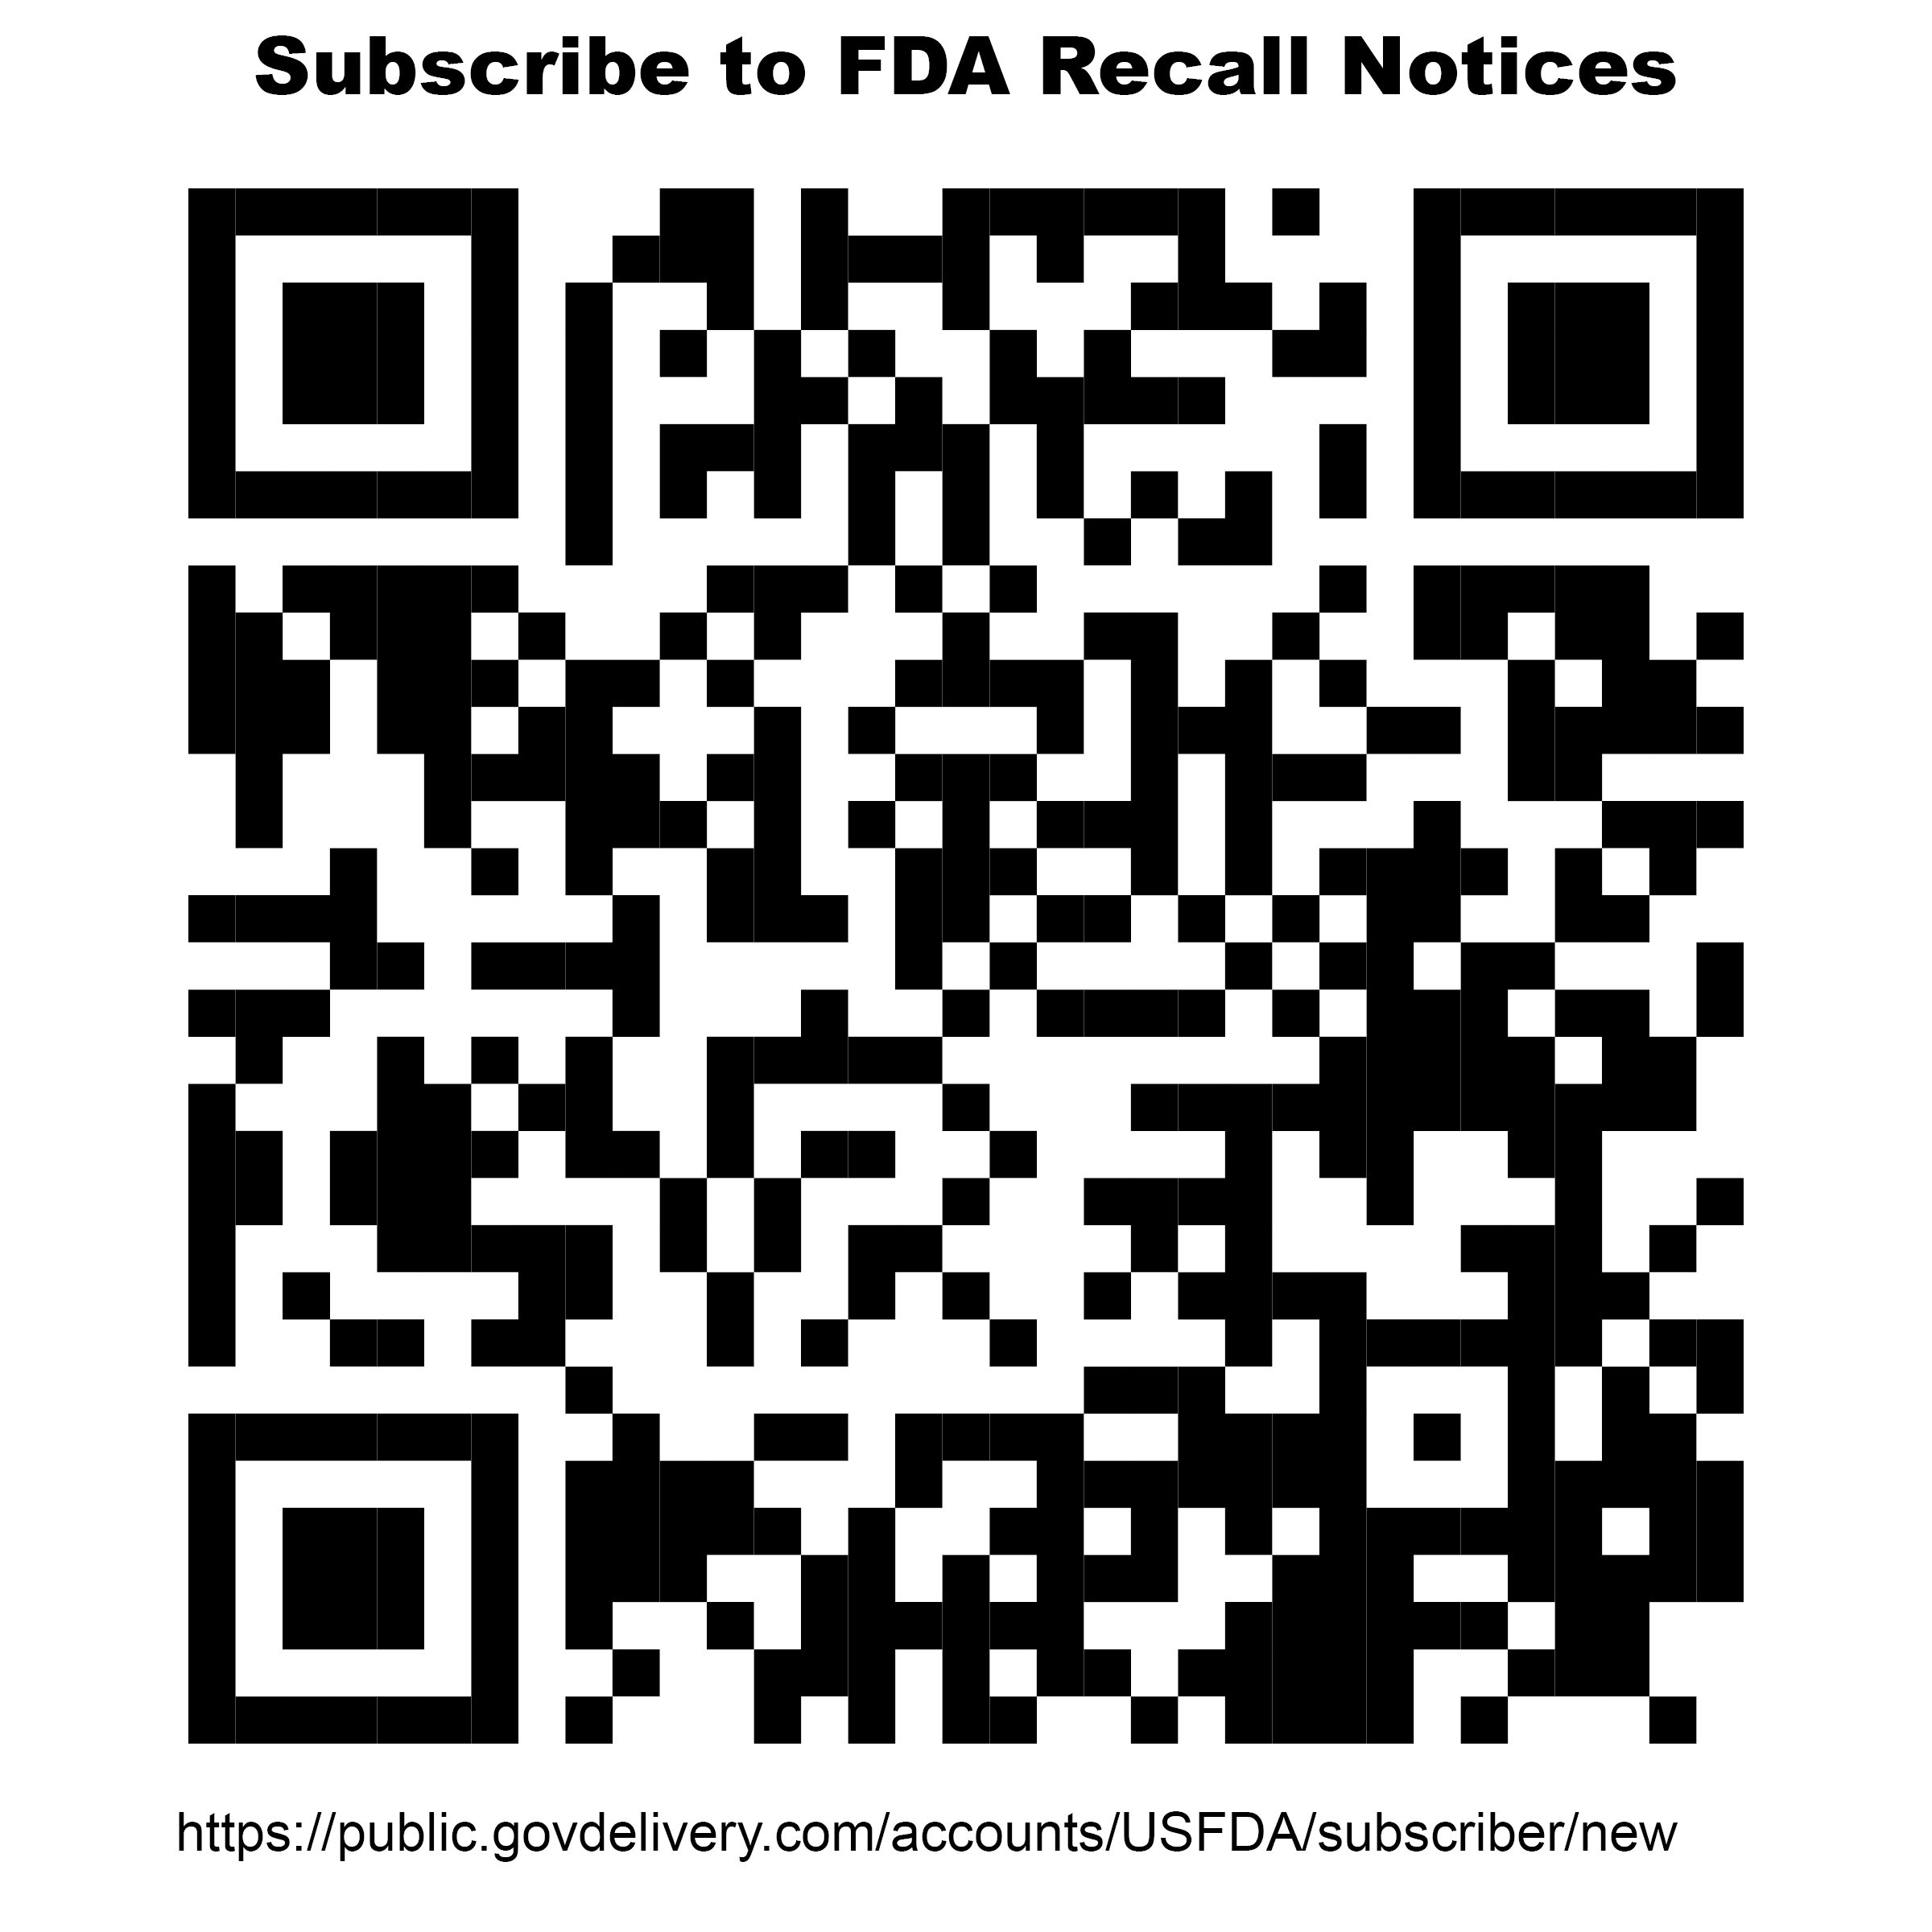 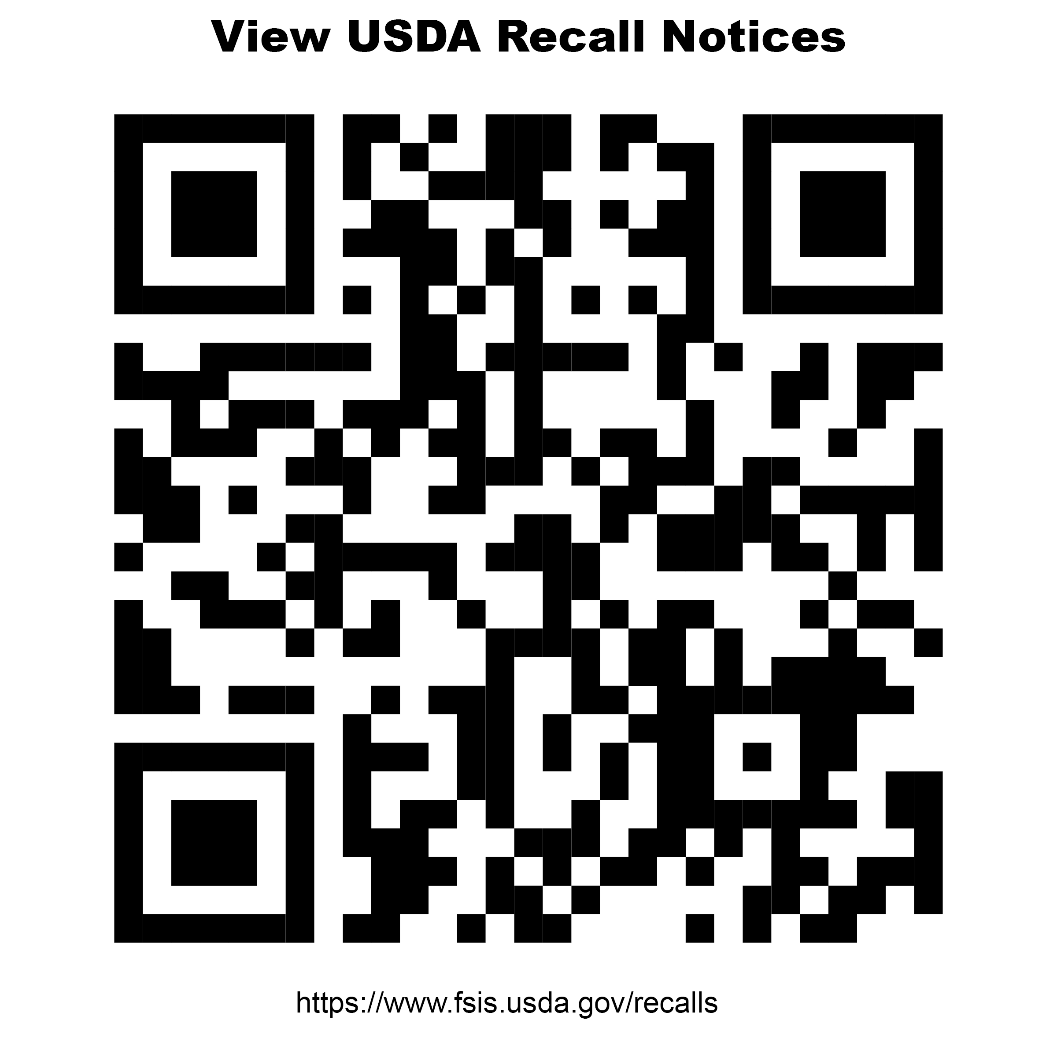

**Recall Procedure for Agency Partners**

**Agency partners must assign at least one person to review recalls regularly as communicated by the FDA and USDA.** This document is an optional tool for agency partners to support internal recall procedures. We recommend sharing this with all staff and volunteers involved in food preparation and distribution.

|  |
| --- |
| **Individual(s) Responsible for Tracking Recalls at this Location**  **Lead Name & Contact Information:**  **_____________________________________________________________________**  **Have they subscribed to recall alerts on the** [**FDA**](https://public.govdelivery.com/accounts/USFDA/subscriber/new) **and** [**USDA**](https://www.fsis.usda.gov/recalls) **websites?**  **Back-Up Name & Contact Information:**  **_____________________________________________________________________**  **Have they subscribed to recall alerts on the** [**FDA**](https://public.govdelivery.com/accounts/USFDA/subscriber/new) **and** [**USDA**](https://www.fsis.usda.gov/recalls) **websites?** |

**Guidance from Connecticut Foodshare**

Connecticut Foodshare only issues recall information to Agency Partners for products we have a record of distributing. Recall notices are emailed to the Main and Secondary contacts at Agency Partners impacted by the recall. The notice includes directions on how to handle the recalled product and any additional information required. Connecticut Foodshare is not able to track recall information for products that are donated in small quantities (such as through community food drives or mixed items from grocery stores) or products that may be received by the Agency Partner from other sources. Therefore, Agency Partners should have one person assigned to review recalls regularly as communicated by the USDA (reports on meat, dairy and egg-related recalls) and FDA (reports on all other food-related recalls).

**Recall information can also be found on Connecticut Foodshare’s website by clicking** [**HERE**](https://www.ctfoodshare.org/food-safety)**.**

**If you suspect you have recalled product in your inventory, first review product receipts/invoices. Then, visually inspect your inventory for the affected product.** **If you find recalled product in your inventory, here are some recommended steps:**

* If you find the recalled product in stock, separate it immediately and do not distribute it.
* Attach HOLD tags to the recalled product in your inventory until you can properly dispose of it.
* Notify relevant staff and volunteers at your program so they can watch for the recalled product in any upcoming food donations you may receive from the community.
* Notify visiting neighbors so they can be made aware of the recall and what to do if they have recalled product at home. This can be done at a minimum by posting a recall notice in a visible area during upcoming distributions, posting on social media, and/or contacting recipients using the information you have on file.
* Save records of any recall notices you issue for the current year (see attached Recall Log)

**HOLD**

**THIS PRODUCT**

**By (name): ____________________________**

**Reason: ____________________________**

**Date: ____________________________**

Do not remove this tag. Do not distribute.

**Recall Log**

|  |  |  |  |  |
| --- | --- | --- | --- | --- |
| **Item Being Recalled** | **Date of Recall** | **Reason** | **Action Taken** | **Signature** |
|  |  |  |  |  |
|  |  |  |  |  |
|  |  |  |  |  |
|  |  |  |  |  |
|  |  |  |  |  |
|  |  |  |  |  |
|  |  |  |  |  |
|  |  |  |  |  |
|  |  |  |  |  |
|  |  |  |  |  |