PICAYUNE SCHOOL DISTRICT



2025-2026
Foster Care Plan
School Board approved: July 10, 2025

This plan is to address the requirement for foster care provisions under Title I of ESSA, which require State Educational Agencies (SDE) and Local Educational Agencies (LEAs) to collaborate with Child Welfare Agencies (CWAs) to ensure educational stability and minimize educational disruptions for children in foster care.

FOSTER CARE PLAN

The Picayune School District is committed to providing students with sound educational experiences. We recognize that foster children are at an increased risk of grade retention, gaps in academic achievement, low high school graduation rates, and postsecondary enrollment. These provisions promote greater stability for children in foster care so that they can continue their education without disruption, maintain meaningful relationships with peers and adults, and have the opportunity to achieve college and career readiness.

The Picayune School District ensures that the educational stability of the child will be met as follows:
- A child in foster care will remain in the child’s school of origin unless it is determined that it is not in the child’s best interest in that school.
- If a determination is made that it is not in the child’s best interest to remain in the school of origin, the child will be immediately enrolled in the school of residence, even if the enrollee cannot produce records usually required for enrollment.
- The new (enrolling) school immediately contacts the school of origin to obtain relevant academic and other records.

SCHOOL DISTRICT ASSURANCES

- Each placement of the child in foster care considers the appropriateness of the current educational setting and the proximity to the school in which the child is enrolled at the time of placement.
- The Mississippi Department of Child Protection Services will coordinate with appropriate local educational agencies to ensure that the child remains in the school where the child is enrolled at the time of placement.
- If it is not in the best interest of the child to return to the resident school, the child will immediately be provided the appropriate enrollment to the Picayune School District.
- The Picayune School District will gather and maintain educational records and promptly send them to any district where the student moves.

FOSTER CARE CHILD LIAISON (POC)

The Picayune School District will assign at least one person as a Foster Care Child Liaison or Point of Contact (POC). The Foster Child Liaison will work in the child's best interest to ensure all educational requirements are met. The liaison assigned to the position will have access to available training and materials to keep them informed of any changes in the Foster Care Regulations. The liaison will work closely with the Mississippi Department of Child Protection Services (MDCPS):

- Coordinating implementation of the Title I, Part A provisions, as it relates to Foster Care provisions outlined in the Every Student Succeeds Act;
- Coordinating with the corresponding child welfare agency,
- Leading the development of a process for making the best interest determination,
- Documenting the best interest determination,
- Facilitating the transfer of records and immediate enrollment,
- Facilitating data sharing with MDCPS, consistent with Family Education Rights to Privacy Act (FERPA) and other privacy protocols,
- Developing and coordinating local transportation procedures,
- Managing best interest determinations and transportation cost disputes,
- Ensuring that children in foster care are enrolled in and regularly attending school,
- Coordinating and implementing the child’s IEP if applicable. If the child is a child with a disability, the school of origin should collaborate with the new school to ensure services begin on day one; and
- Providing professional development and training to school staff on the Title I provisions and educational needs of children in foster care.

FOSTER CARE COMMITTEE

A committee will meet to determine the appropriate placement of each foster care child. (See MDCPS forms in the Appendix.) The committee will be comprised of the school administrator or representative, the Foster Care Liaison, and a member of the CPS. The MDCPS and PSD have five (5) school days from the child’s placement in foster care or change in the child’s living arrangement to finalize the best interest determination, except in emergency removal situations. In emergency circumstances, the CPS has the authority to make an immediate decision regarding the school placement and then consult with the PSD and revisit the best interest determination of the child. The child must remain enrolled in their school of origin during this period. The student is to be enrolled within seven days of the change of placement.

A representative from the school of origin should be knowledgeable about the child and be able to provide insight into significant relationships that the child may have formed with staff and peers. In addition, the representative should be able to express how changing schools could affect the student’s academic, social, and emotional well-being. Based on the individual situation, this person could be a teacher, counselor, coach, or other meaningful person in the child’s life.

Picayune School District and MDCPS designee should consult other relevant parties, such as the child dependent upon age, foster parents, biological parents when appropriate, the education decision maker(s), and other relatives for their perspectives on which school the child should attend during their time in foster care, consistent with the child’s case plan. If a child has an IEP or a Section 504 plan, the relevant school staff members must also participate in the best interest decision process. If the child is an EL, this may also affect the appropriate school staff members, who must participate in the best interest decision process.

BEST INTEREST DETERMINATION PROCEDURES

When a school-age child enters foster care, or there is a placement change while in care, the youth's MDCPS case worker shall work with the local. School district to determine whether it is in the child's best interests to remain at the school of origin or enroll in a new school. This determination must be in writing. The school of origin is defined as the school in which a child is enrolled at the time of initial foster care placement or when a change in foster placement is made. The PSD will use the MDCPS forms for documenting foster care placements and decisions.

Foster care children shall not be withdrawn or enrolled until a BID is completed.

The custodial agency (CPS) must have the following before a BID meeting.
- Grades, attendance logs, and any behavior reports/logs(suspension or expulsions)from the youth's current school
- Copy of youth's IEP/504 plan with current eligibility and supports/services(if applicable)
- Youth's current grade
- Youth's school of origin(the school they are currently attending)
- Distance between the school of origin and the youth's new placement
- The foster care provider's willingness to assist with transportation

STEPS TO CONDUCT A BID

- The CPS worker should phone the school district's POC to schedule a BID conference/meeting. The school of origin and the potential new school district POC should be a part of the BID process. The BID may occur in person, via Zoom, or by conference call. The BID meeting can NOT be done via email. BIDs must occur within five (5) business days of the youth entering foster care or changing placement. The student must be enrolled within seven days.
- Determine what is in the youth's best interest for educational success by engaging in a dialogue using the guiding questions in the BID packet. The district's POC should ask the guiding questions. See the consideration under “Student Placement Decisions” and the appendix for “Discussion of Student’s Best Interest” questions. The BID discussion/meeting must include the district's Special Education Department representative(s) if the student has an IEP or is being evaluated.
  - Youth's current supports and services, behavior concerns, safety concerns, and the youth's-input (when appropriate) should be considered when making a BID.
  - Transportation shall NOT be a factor in determining what school is in the child's best interest unless the distance will take away from instructional time or is too far and unrealistic for the youth to ride a bus or receive private transportation (typically 50 miles).
- If a transportation plan is needed, discuss options, and finalize the plan with the CPS worker. Document the decision and have all parties sign the agreement.
- The POC, MDCPS worker, and all BID participants must sign the BID form. Keep a copy of the BID form for the district records.
- If the child remains in the school of origin, the CPS worker should complete the Notification of Placement (Change) Form. The district must keep a copy of the form.

ENROLLMENT

- MDCPS policy allows the foster parent to enroll a student. PSD requires the MDCPS worker to register the student.
- The Notification of Placement (Change) Form must be provided at the time of enrollment.
- A BID from the school of origin should be provided when a foster child is newly enrolled.
- Each year, the school district should receive an updated enrollment authorization form.
- If the necessary paperwork (birth certificates, shot records, academic records, special education records, etc.) is not immediately available, the school district will enroll the student.
- If the school was not provided with the foster student’s records from the school of origin, the enrolling school would request records on the same day as the student’s arrival. The school of origin is expected to provide the student records to the new school within one (1) school day of request.
- After enrollment, the foster family or CPS shall provide the following guardianship or legal custody documents for verification:
  - Power of attorney
  - Affidavit
  - Court Order

The local MDCPS is responsible for providing pertinent information regarding the child’s age, grade, and academic history (e.g., current Individualized Education Program) to aid the PSD in placing the student in an appropriate classroom setting until the PSD receives the student’s records. The Picayune School District will share education records with CPS that the Family Educational Rights and Privacy Act (FERPA) allows. This allows educational agencies to disclose academic records, including IDEA, of students in foster care to State agencies without parental consent.

WITHDRAWALS

- An MDCPS worker MUST withdraw a student from the school. The foster parent CANNOT withdraw a child.
- Foster children cannot be withdrawn and enrolled in an educational setting of “home school.” Foster children must be in a public school setting. A private school setting may be an option if a foster parent wishes to be financially responsible for a private school.
- Foster children CANNOT be withdrawn until a BID has taken place.
- The school should respond to an enrolling school’s request for records within twenty-four hours.

STUDENT PLACEMENT DECISIONS

The district is responsible for ensuring that a child in foster care remains in their school of origin unless a determination is made that it is not in the child’s best interest to do so. The Foster Care Committee will consider several factors when making a best interest determination. The determining factors that may be evaluated include the following.
- The proximity of the resource family home to the child’s present school.
- Safety considerations.
- Age and grade level of the child as it relates to the other best interest factors.
- Length of time the student has attended current school.
- Needs of the child, including social adjustment and well-being.
- Child’s performance, continuity of education, and engagement in the school the child presently attends.
- Child’s special educational programming if the child is classified.
- Point of time in the year; consider academic calendars of current school and new school; consider timing the transfer so that it coincides with the end of the quarter/semester/school year or following an event that is significant to the student.
- Child’s permanency goal and the likelihood of reunification.
- Anticipated duration of the placement.
- Preferences of the child.
- Preferences of the child’s parent(s) or educational decision maker(s).
- The child’s attachment to the school, including meaningful relationships with staff and peers.
- Placement of the child’s sibling(s).
- Influence of the school climate on the child, including safety.
- Availability and quality of the services in the school to meet the child’s educational and socioemotional needs.
- The child’s participation in specialized instruction (e.g., gifted programming, career technical education program, advanced placement classes) and availability at the new school.
- The student’s ability to earn full academic credit, receive an industry credit, the ability to proceed to the next grade, the ability to graduate on time, and the child’s educational and career goals.
- History of school transfers and how they have impacted the child;
- How the length of the commute would affect the child, based on the child’s developmental stage.
- Whether the child is a student with a disability under the IDEA who is receiving special education and related services or a student with a disability under Section 504 who is receiving special education or related aids and services and, if so, the availability of those required services in a school other than the school of origin.
- Whether the child is an EL and is receiving language services, and if so, the availability of those required services in a school other than the school of origin.

*Transportation costs should not be considered when determining a child’s best interests.

In the event of a disagreement regarding school placement for a child in foster care, the child welfare agency should be considered the final decision maker in making the best interest determination. The child welfare agency is uniquely positioned to assess vital non-educational factors such as safety, sibling placements, the child’s permanency goal, and other components of the case plan. The child welfare agency also has the authority, capacity, and responsibility to collaborate with and gain information from multiple parties, including parents, children, schools, and the court, in making these decisions.

IDEA STUDENTS

The IDEA, Part B directs school districts must make a Free Appropriate Public Education
(FAPE) available to all eligible children with disabilities in the Least Restrictive Environment (LRE). FAPE under IDEA includes the provision of special education and related services at no cost to the parents in accordance with a properly developed Individualized Education Program (IEP). A group of knowledgeable persons must make each child’s placement decision. The Picayune School District will operate in accordance with all state and federal laws regarding special education students. Special education services will be provided to foster care students as they are to all students, following the guidelines below.
- Educational placement will be determined annually and will be based on the child’s IEP in accordance with the child’s individual needs.
- The child will be placed in the least restrictive environment, and unless they require some other arrangement, they will attend the school they would attend if not disabled.
- Timely and expedited evaluations and eligibility determinations for highly mobile children with disabilities will be made when possible.
- Children in foster care will have access to related aids and services designed to meet their educational needs.
- Children can access comparable services, including summer and extended school-year services if applicable.
- Children in foster care will not be discriminated against and are considered a protected group.

EL STUDENTS

The Picayune School District will ensure that EL students in foster care will participate meaningfully and equally in educational programs by doing the following:
- Identifying and assessing all potential EL students in a timely, valid, and reliable manner;
- Provide EL students with a language assistance program that is educationally sound and proven successful;
- Sufficiently staff and support the language assistance programs for EL students;
- Ensure that EL students have equal opportunities to participate in all curricular and extra-curricular activities meaningfully;
- Avoid unnecessary segregation of EL students;
- Ensure that EL students with disabilities are evaluated in a timely and appropriate manner for special education and disability-related services and that their language needs are considered in these evaluations and delivery of services;
- Meet the needs of EL students who opt out of language assistance programs;
- Monitor and evaluate EL students in language assistance programs following federal guidelines;
- Continue to evaluate the effectiveness of the school district’s language assistance program and the progress of each student;
- Ensure meaningful communication with the parents of the students.

TRANSPORTATION PROCEDURES

Students in foster care will immediately be enrolled in school even without the required documents. Transportation for students in foster care will be provided in the same manner as for other students. Should it be determined that it is in the best interest of the child in foster care to remain in their school of origin that is outside the attendance boundaries of the Picayune School District (PSD), transportation will be coordinated among MDCPS, the PSD, and the school district of residency to determine the best possible means of transportation.

The Picayune School District will collaborate with the CPS to develop and implement clear written procedures governing how transportation is provided to maintain children in foster care in their schools of origin. The Picayune School District will also work with the CPS to agree on covering the transportation costs. The agreement will cover how the transportation will be provided, arranged, and funded for the child’s time in foster care. Each agreement may vary significantly because the needs of each child should be considered in deciding on transportation. (See Transportation to Ensure School Stability procedures in the Appendix.)

In the event of a dispute between the PSD and MDCPS concerning the cost of transportation, the two entities must consider what is in the student's best interest. If the disagreement continues, the cost will be divided equally between the PSD and the MDCPS. The dispute shall be brought before the state-appointed POCs using the Foster Care Transportation Dispute Form in the Appendix. Current transportation expenses shall remain in effect until a decision is rendered to maintain the student’s status quo.

The standard transportation policies approved by the Picayune School District will be followed in transporting foster care students. Drivers will be appropriately licensed and certified with the required DMV and background checks. Depending on the circumstances, various public school vehicles may be used to transport students. Students that must be transported out of state will be school board-approved as required by Mississippi law.

DISPUTE RESOLUTION PROCESS
TRANSPORTATION

If the foster care dispute cannot be resolved at the local level, the dispute must be forwarded to the Mississippi Department of Education (MDE). Disputes between Picayune School District (PSD) and Mississippi Department of Child Protective Services (MDCPS) regarding implementing the local transportation procedures, calculating, and paying for additional costs of transportation to the school of origin for children in foster care, or other transportation disputes will be resolved by a three-person panel. PSD or MDCPS can bring a transportation payment dispute to the MDE by submitting a dispute resolution request to the MDE foster care point of contact via an email titled “Foster Child Dispute Appeal.” The dispute resolution request must include the following:

- A complete explanation of the basis of the dispute, with all pertinent facts.
- The name and contact information of the people who have been addressing the dispute thus far on behalf of the PSD and the local child welfare agency (phone, email, and mailing address).
- Details of how the agencies have attempted to resolve the local dispute before appealing to the state.
- Within ten (10) days of receipt of the dispute resolution request, the MDE foster care point of contact will contact the party that did not submit the request (either the PSD or MDCPS), identifying the subject matter of the dispute and inviting that party to submit any information pertinent to the dispute.
- The party will have ten (10) days to submit its explanation of the dispute, with all pertinent facts.
- Documents submitted by either party after the applicable deadlines will not be considered.
- The panel shall make a final decision within thirty (30) days of receiving all information related to the dispute.
- The MDE foster care contact will forward the written decision and an explanation of that decision to the appropriate parties at both the PSD and MDCPS. The district of origin must ensure that a child in foster care receives transportation to and from the school of origin in a cost-effective manner until disputes are resolved.
- The decision shall be the final resolution.

DISPUTE RESOLUTION
PLACEMENT DISPUTE

If the Picayune School District seeks to place a homeless, migrant, immigrant, limited English proficient, or foster care child in a school other than the school of origin or the school requested by the educational decision-maker, the educational decision-maker shall be provided written notice of their right to appeal the decision (see Dispute Forms in the Appendix.). The parent notification will include the following:

- The contact information for the Picayune School District’s appropriate point of contact and the Mississippi Department of Education's appropriate point of contact.
- An explanation of the reasons for the PSD’s decision.
- A detailed description of how to dispute the PSD’s decision follows.
- The student shall remain in the school of origin, receiving all appropriate educational services, until the dispute is resolved.
- Timelines for resolution of the dispute at each level.
- Notice of the right to appeal to the MDE if the local-level resolution is not satisfactory.

LEVEL I: PICAYUNE SCHOOL DISTRICT
Initiating Dispute Level I

To dispute the Picayune School District’s (PSD) placement decision related to school selection (best interest) or enrollment, an educational decision-maker (parent, guardian, foster care caregiver, etc.) must request dispute resolution in writing by submitting a dated appeal letter specifying the school in which enrollment is sought and the basis for seeking enrollment in that school. The appeal letter must include the educational decision-maker's name and contact information (phone, email, and mailing address).

The educational decision-maker must submit the appeal letter within five (5) school days of receiving written notice of the right to dispute the decision from the PSD. The letter may be submitted via an email with the subject Foster Child Appeal or delivered to any school to the superintendent's attention. Regardless of how the appeal letter is submitted, the school or District shall ensure the District’s superintendent or designee receives it immediately.

Submitting the appeal letter by email or delivery to any school initiates the dispute. From that point, the student shall remain in the school of origin until the dispute is resolved. The student shall be provided with all appropriate educational services for which the student is eligible during the pending of the dispute. Students attending their school of origin while the dispute is pending will be entitled to receive transportation. The District will provide or arrange transportation during the dispute. Once the dispute is resolved, transportation will be provided according to the local transportation procedures.

PSD Decision
The superintendent, or superintendent’s designee, will arrange for a personal conference with the educational decision-maker, the student (if appropriate), and in foster care situations, with at least one representative from the local child welfare agency. The personal conference will be arranged within five (5) business days of the District’s receipt of the appeal letter and will occur as expeditiously as possible.

Within five (5) business days of the personal conference, the superintendent, or superintendent’s designee, will inform the educational decision-maker of the decision in writing, using the contact information in the appeal letter. The superintendent or designee may consult with the District’s appropriate point of contact in making the decision. The written decision provided to the educational decision-maker must include the following:
- A copy of the complete Level I appeal packet.
- The decision rendered at Level I by the superintendent or designee and an explanation for that decision.
- Instructions regarding how to file a Level II Dispute Resolution to State Level Point of Contact(See appendix.) including the name, phone number, and email address of the MDE appropriate point of contact.

If the educational decision-maker disagrees with the Level I decision and wishes to appeal to Level II, the educational decision-maker shall inform the Picayune School District Superintendent or designee of the intent to appeal to Level II within five (5) school days of receipt of the District’s Level I decision. If the educational decision-maker does not appeal within five (5) school days, the child shall be enrolled and provided all appropriate educational services in the school determined by the District. If that school is not the school the child had been attending during the timeframe the dispute was pending, the District will prioritize minimizing the disruption to the child’s education in effecting the transition to the new school.

LEVEL II: MISSISSIPPI DEPARTMENT OF EDUCATION
Initiating Dispute Level II

If the student’s educational decision-maker disagrees with the decision rendered by the Picayune School District’s Superintendent or designee at Level I, they may appeal the decision to the Mississippi Department of Education (Level II). To appeal to Level II, an educational decision-maker must request an appeal in writing by following the instructions on the Dispute Resolution to State Level Point of Contact Form in the Appendix.

The student shall remain in the school of origin until the dispute is resolved. The student shall be provided with all of the appropriate educational services for which the student is eligible during the pending of the dispute. Students attending their school of origin while the dispute is pending will be entitled to receive transportation. The District will provide or arrange transportation during the dispute. Once the dispute is resolved, transportation will be provided according to the local transportation procedures.

Once a decision is received from the MDE Level II appeal, the Picayune School District must implement the MDE’s decision in full immediately.

Appendix
Foster Care Plan Forms
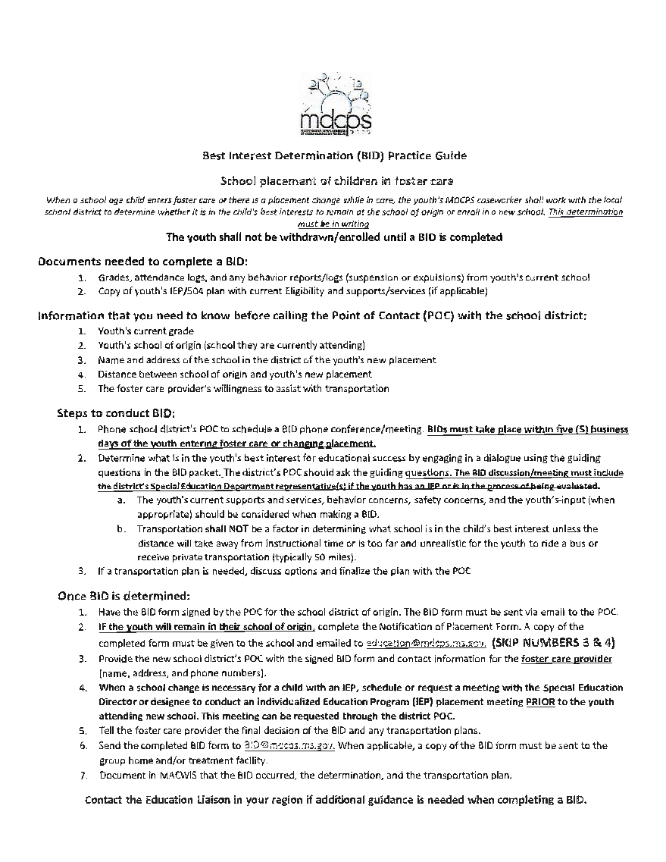
This is the MDCPS Practice Guide for CPS Workers to follow when arranging BIDS.

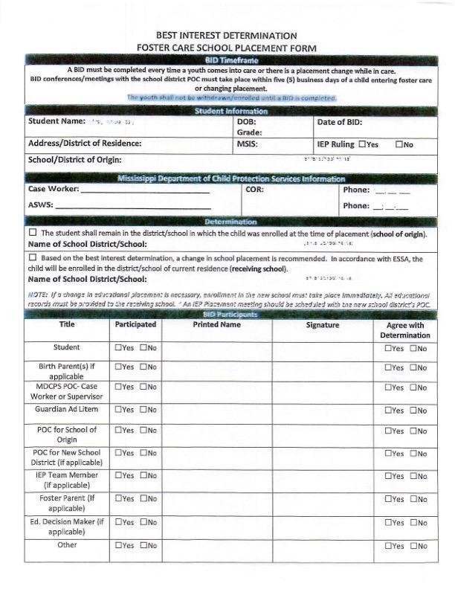
This is the Best Interest Determination Form the CPS Worker is to provide when conducting BIDS.
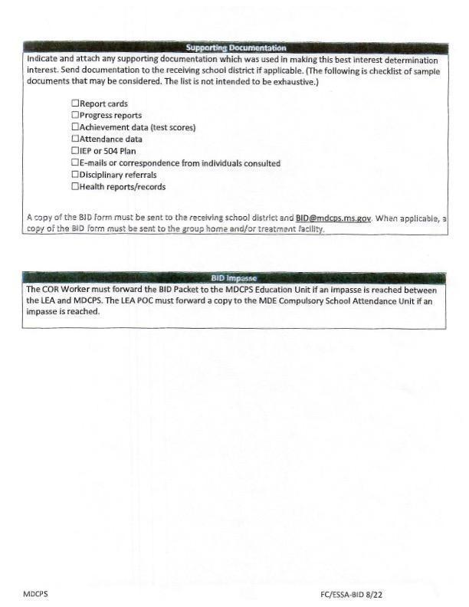

DISCUSSIONOFSTUDENT'SBESTINTEREST

- Howlonghasthestudentattendedthisschool?

- Howwellisthestudentperformingacademically?

- How manyschoolshas thestudentattendedoverthepastfew years?Thisyear?

- Howhavepastschooltransfersimpactedthestudent?

- How is the current school serving the student's academic needs, including gifted or specialeducation, vocational opportunities,andotherinterests? How can thenew school serve these needs?

- Whatisthestudent'sacademicandcareergoals?

- How would changing schools affect thestudent's abilitytoearnfull academic credit, proceed to the next grade, graduate on time, or receive an industry credential?

- Howisthecurrentschool servingthestudent'ssocial,emotional,andculturalneeds?

- Does thestudent accessschool-basedsupportive servicesinthecurrent school? Howcan the new school serve these needs?

- Describe the nature, quality, and duration of the student's relationships in the current school.Consider whether thestudent has ameaningful andsupportive relationship with anadult atthecurrent school. Does thestudenthave anyfamily members at theschool? Is he or she involved in extracurricularor other activities?

- Is thestudent's newlivingarrangementexpected tobeshort-or longterm? What impact will this have on the student?

- How would thecommute tothecurrentschool impact thestudent? Consider thechild's ageand developmental functioning as well as the length of the commute with various modesof transportation. The costoftransportationcannotbeafactorwhen determiningbest interest.

- What otherfactors didtheteamconsider when makingthisdecision (How did you address the unique needs of the student?).

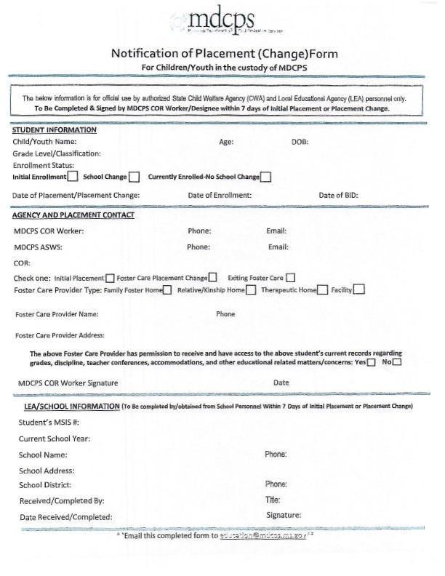
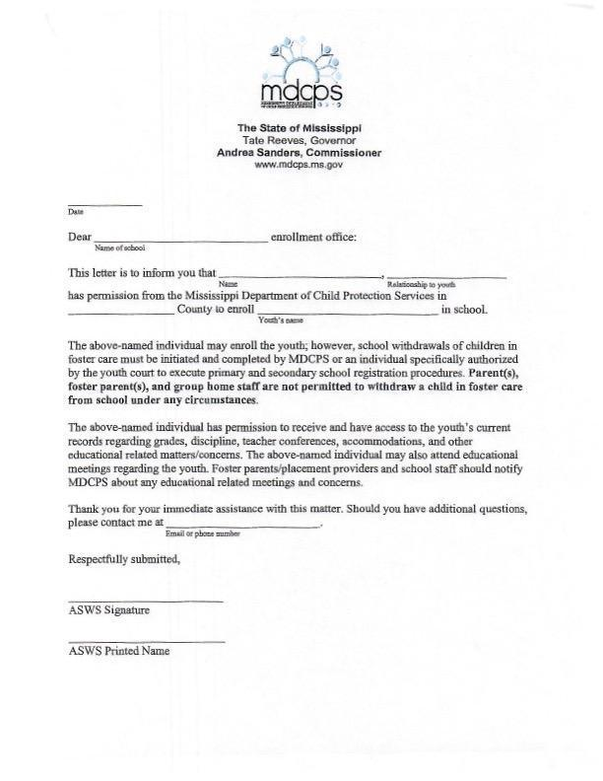
PICAYUNE SCHOOL DISTRICT DISPUTE RESOLUTION PLAN FOR
FOSTER CARE TRANSPORTATION DISPUTE

If all avenues to resolve a foster care dispute have taken place at the local level, the dispute must be forwarded to the Mississippi Department of Education. Disputes between the Picayune School District and the MDCPS regarding implementing the local transportation procedures, calculating, and paying for additional transportation costs to the school of origin for children in foster care, or other transportation disputes will be resolved by a three-person panel on the state level. ThePSD or the MDCPS can bring a transportation payment dispute to the MDE by submitting a dispute resolution request to the MDE foster care point of contact.
MDE Foster Child Point of Contact
Terissa Williams
twilliams@mdek12.org

The transportation dispute will be submitted to MDE via email in the following format:
- A complete explanation of the basis of the dispute, with all pertinent facts.
- The name and contact information of the people who have been addressing the dispute thus far on behalf of the District and the MDCPS (phone, email, and mailing address).
- Details of how the agencies have attempted to resolve the dispute at the local level prior to appealing to the state.
- Within ten (10) days of receipt of the dispute resolution request, the MDE foster care point of contact will contact the party that did not submit the request (either the PSD or MDCPS), identifying the subject matter of the dispute and inviting that party to submit any information pertinent to the dispute.
- The party will have ten (10) days to submit its explanation of the dispute, with all pertinent facts.

The district of origin must ensure that a child in foster care receives transportation to and from the school of origin in a cost-effective manner until disputes are resolved.

LEVEL I DISPUTE RESOLUTION FORM TO
PICAYUNE SCHOOL DISTRICT

To appeal the Picayune School District’s decision, please complete this form and submit it by the date indicated on the Written Notice you received from the district. You may submit this form by any of the following methods:

- Scan and email it to INSERT EMAILwith the subject (choose one: Homeless, Migrant, Immigrant, Limited English Proficient, or Foster) Child Appeal.
- Return the paper form to any school in this school district; or
- Submit the paper form directly to the superintendent's office at 706 Goodyear Blvd., Picayune, MS 39466.

Student Name: ___________________________________________________________

School in which enrollment is sought: _________________________________________

I am the educational decision-maker for this student, and I believe the school in which we are seeking enrollment is in the student’s best interest because:

I believe the student has a right to attend this school because:

If you would like to provide additional information, please attach it to this form. The student shall remain in the school of origin, receiving all appropriate educational services, including transportation, until the dispute is resolved.

Educational decision-maker name: ___________________________________________
Email: __________________________________________________________________
Phone: _________________________________________________________________
LEVEL II DISPUTE RESOLUTION TO STATE-LEVEL POINT OF CONTACT

To appeal the Picayune School District’s decision to the Mississippi Department of Education and Mississippi Department of Child Protection Services, please complete this form and submit it by the date indicated on the Written Notice you received from the school. You may submit this form by any of the following methods:

- Scan and email it to twilliams@mdek12.org with the subject “Foster Child Dispute Appeal” to Terissa Williams, Mississippi Department of Education, Foster Care Point of Contact;
OR
- Return the paper form to Terissa Williams, Mississippi Department of Education, Foster Care Point of Contact at 359 N. West Street, Jackson, MS 39201

Student Name: ___________________________________________________________

School in which enrollment is sought: _________________________________________

School District in which enrollment is sought: __________________________________

I am the educational decision-maker for this student, and I believe the school in which we are seeking enrollment is in the student’s best interest because:

I believe the student has a right to attend this school because:

If you would like to provide additional information, please attach it to this form. The student shall remain in the school of origin, receiving all appropriate educational services, including transportation, until the dispute is resolved.

Educational decision-maker name: ___________________________________________
Email: __________________________________________________________________
Phone: _________________________________________________________________
SOURCES:

Mississippi Department of Education and Mississippi Department of Child Protection Services Joint Guidance. Educational Stability for Children in Foster Care. December 2016. x
MDE Foster Care Guidance

National Association for the Education of Homeless Children and Youth website.
http://www.naehcy.org/essa-and-children-foster-care

