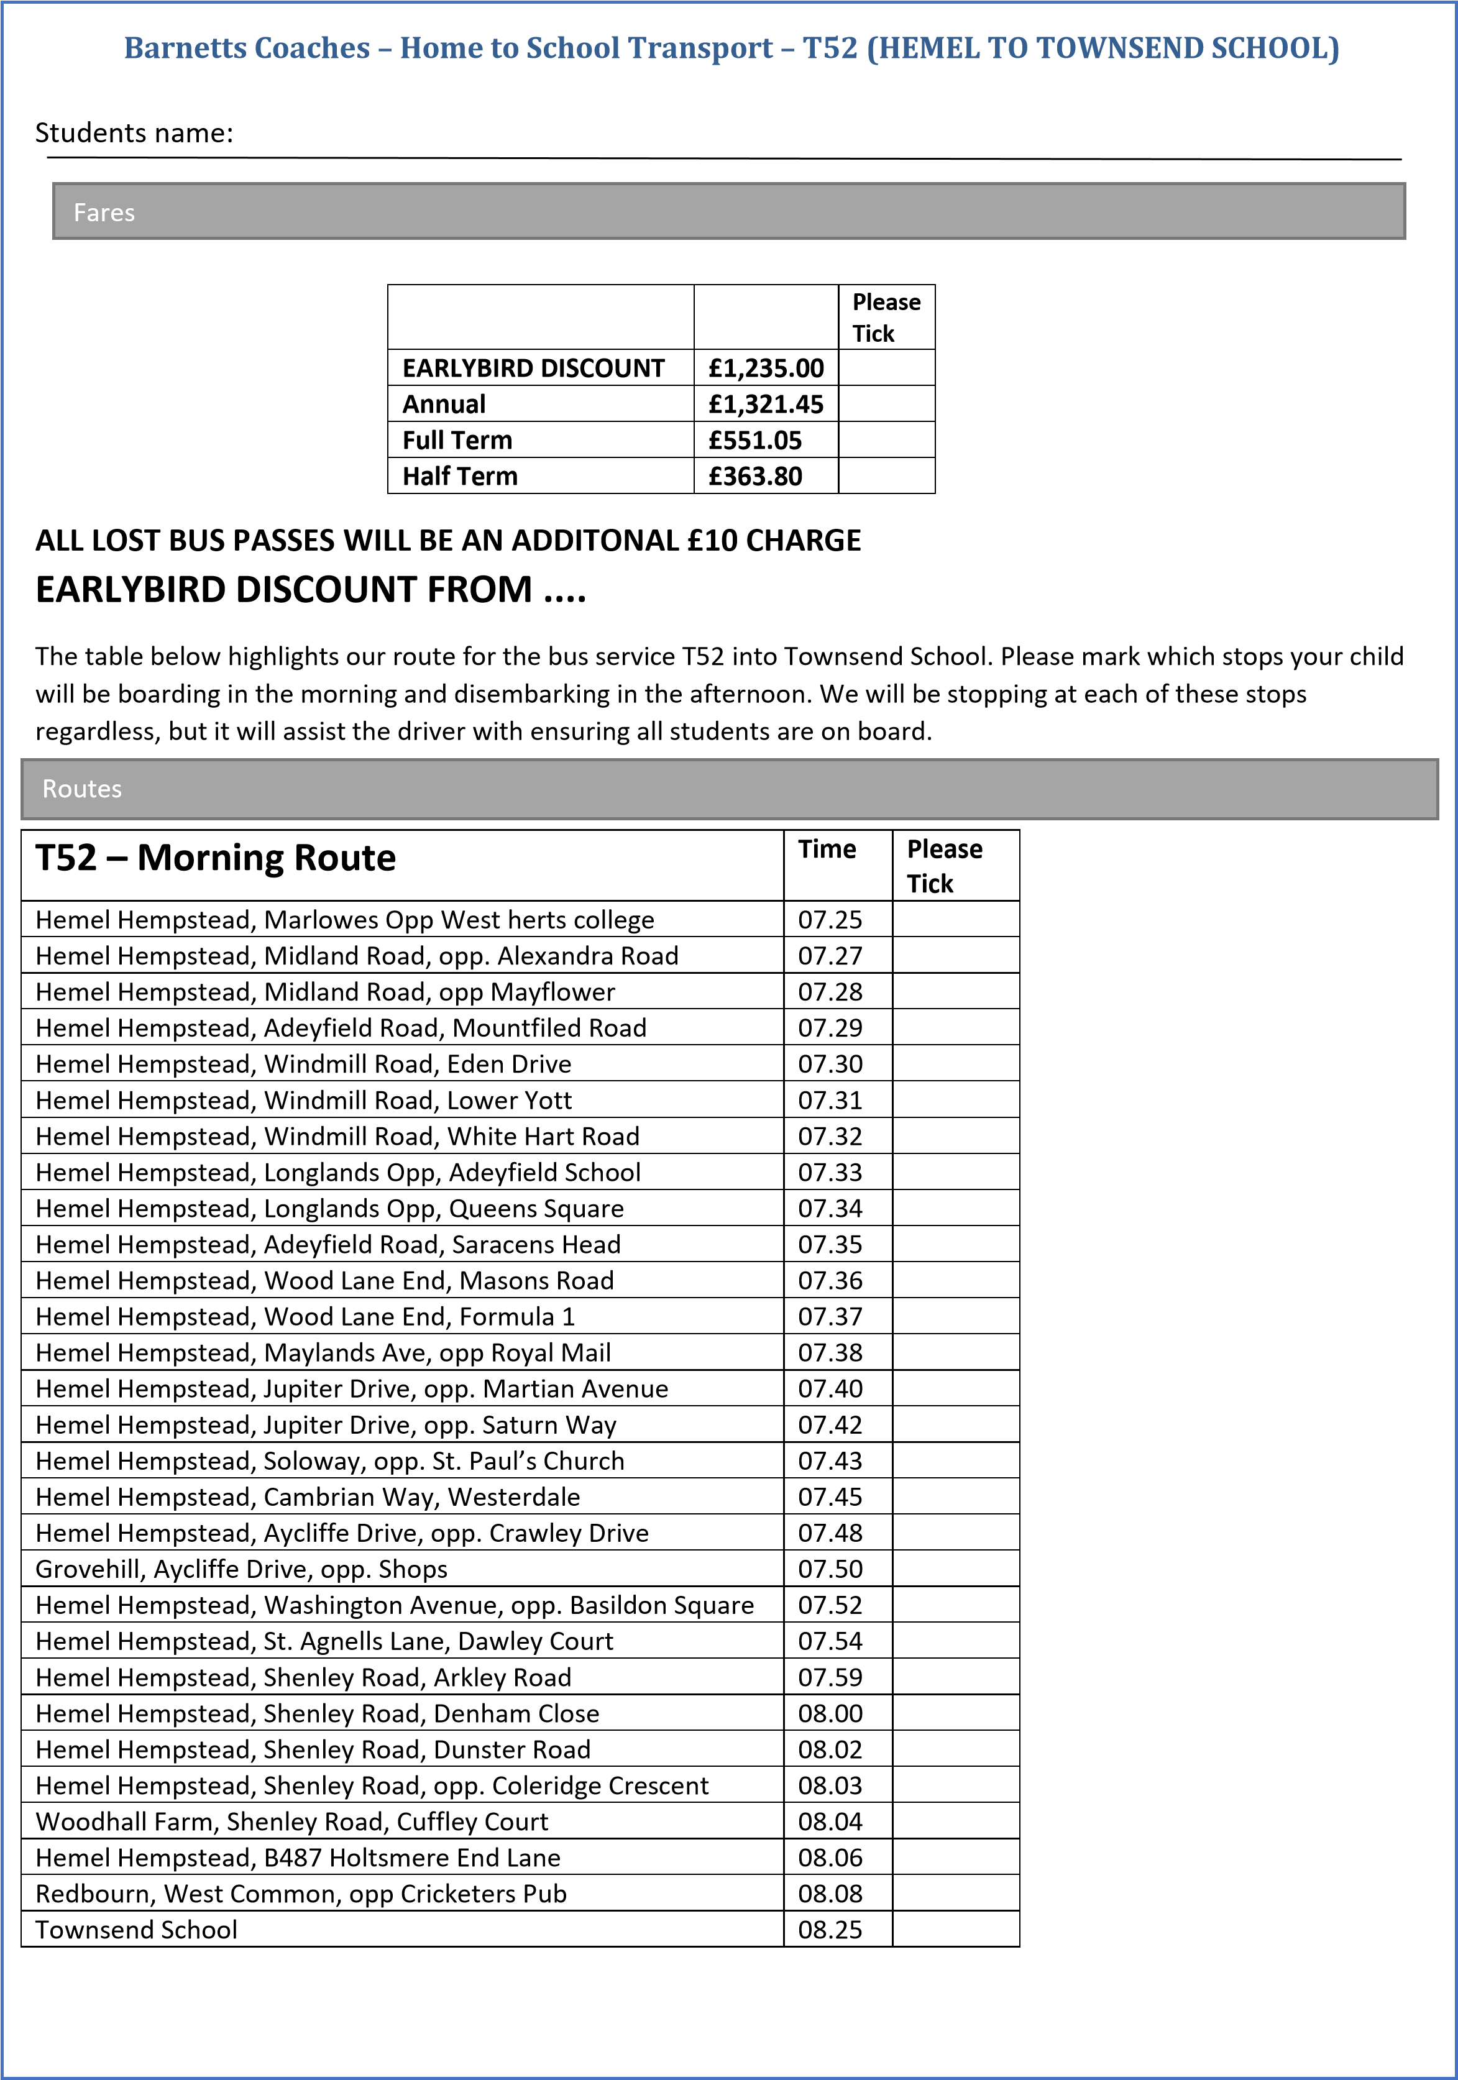

**1st July 25 – 8th August 25**

|  |  |
| --- | --- |
| **T52 – Afternoon Route** | **Time** |
| Townsend School | 15.40 |
| Redbourn, West Common, Cricketers Pub | 15.56 |
| Hemel Hempstead, B487 Cherry Tree Lane | 16.00 |
| Woodhall Farm, Shenley Road, Cuffley Court | 16.02 |
| Hemel Hempstead, Shenley Road, opp. Coleridge Crescent | 16.04 |
| Hemel Hempstead, Shenley Road, Duster | 16.06 |
| Hemel Hempstead, Shenley Road, Denham Close | 16.08 |
| Hemel Hempstead, Shenley Road, Arkley Road | 16.10 |
| Hemel Hempstead, St. Agnells Lane, Dawley Court | 16.12 |
| Hemel Hempstead, Washington Avenue, opp. Basildon Square | 16.13 |
| Grovehill, Aycliffe Drive, opp. Shops | 16.15 |
| Hemel Hempstead, Aycliffe Drive, opp. Crawley Drive | 16.16 |
| Hemel Hempstead, Cambrian Way, Westerdale | 16.18 |
| Hemel Hempstead, Solway, opp. St Paul’s Church | 16.19 |
| Hemel Hempstead, Jupiter Drive, opp. Saturn Way | 16.20 |
| Hemel Hempstead, Jupiter Drive, opp. Martian Avenue | 16.22 |
| Hemel Hempstead, Maylands Ave, outside Royal Mail | 16.24 |
| Hemel Hempstead, Wood Lane End, Formula 1 | 16.25 |
| Hemel Hempstead, Wood Lane End, Masons Road | 16.26 |
| Hemel Hempstead, Adeyfield Road, Saracens Head | 16.27 |
| Hemel Hempstead, Longlands, Queens Square | 16.28 |
| Hemel Hempstead, Longlands, Adeyfield School | 16.29 |
| Hemel Hempstead, Windmill Road, White Hart Road | 16.30 |
| Hemel Hempstead, Windmill Road, Lower Yott | 16.31 |
| Hemel Hempstead, Windmill Raod, opp. Eden Drive | 16.32 |
| Hemel Hempstead, Adeyfield Road, Mountfield Road | 16.33 |
| Hemel Hempstead, Midland Road, Mayflower | 16.34 |
| Hemel Hempstead, Midland Road, Alexandra Road | 16.35 |
| Hemel Hempstead, Marlowes, Outside West Herts College | 16.37 |

**Please include a passport sized photograph of each student.**

If you are going to pay by bank transfer, please make sure that you email the office adding your son / Daughter’s name and how much you have paid. Please state your chosen payment method:

Card payments call us on ***01442 254944*** Bank transfer; Barnett’s Coaches Ltd

Sort code; 60-10-33 Account Number; 12068691

Please state childs name and route number.

Return form address; 54 Duxons Turn, Hemel Hempstead, Herts, HP2 4SB or email us on [barnetts@voyage2000.co.uk](mailto:barnetts@voyage2000.co.uk)

Contact details

Emergency Contact Name; Telephone Number;

Alternative Contact Name; Telephone Number;

Email;

Address;