
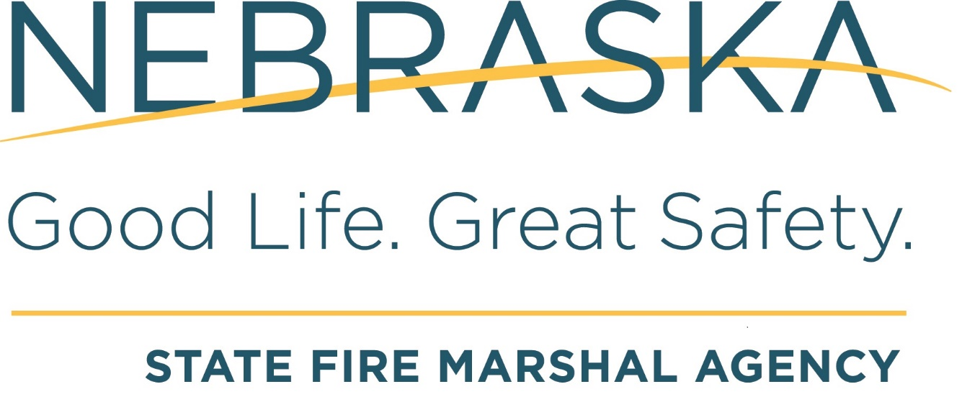

Jim Pillen, Governor
Kitchen Fire-Extinguishing System
Quick Check

NFPA 17A includes a new requirement in the 2009 edition for the Owner to conduct a “quick check” of the kitchen fire suppression system Monthly. It doesn’t require the person conducting the quick check to be certified but they must keep documentation of the check and must include all eight points listed in the code.

7.2.1 On a monthly basis, inspection shall be conducted in accordance with the manufacturer’s listed installation and maintenance manual or the owner’s manual.
7.2.2 At a minimum, this “quick check” or inspection shall include verification of the following:
(1) The extinguishing system is in its proper location.
(2) The manual actuators are unobstructed.
(3) The tamper indicators and seals are intact.
(4) The maintenance tag or certificate is in place.
(5) No obvious physical damage or condition exists that might prevent operation.
(6) The pressure gauge(s), if provided, shall be inspected physically or electronically to ensure it is in the operable range.
(7) The nozzle blowoff caps, where provided, are intact and undamaged.
(8) Neither the protected equipment nor the hazard has not been replaced, modified, or relocated.
7.2.3 If any deficiencies are found, appropriate corrective action shall be taken immediately.
7.2.3.1 Where the corrective action involves maintenance, it shall be conducted by a service technician as outlined in 7.3.1.
7.2.4 Personnel making inspections shall keep records for those extinguishing systems that were found to require corrective actions.
7.2.5 At least monthly, the date the inspection is performed and the initials of the person performing the inspection shall be recorded.
7.2.6 The records shall be retained for the period between the semiannual maintenance inspections.

