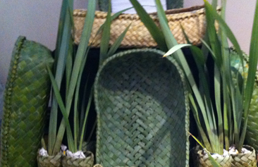
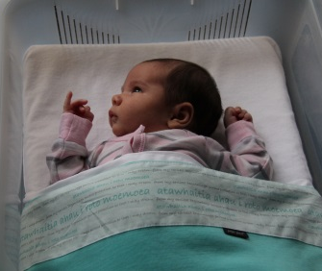
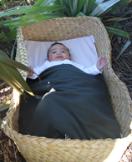
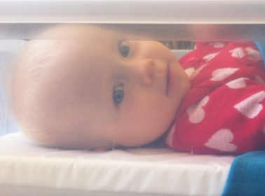
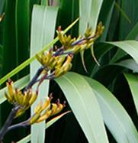

In-bed Sleeper Data Record (2026)
Change for our Children values data monitoring to keep programmes on track, support equitable use of resources, and maximise impact for communities. This form was updated in June 2026 in response to emerging evidence about infant risk and programme targeting (Reference).
INSTRUCTIONS: Collect distribution data. Then when pēpi is 6-8 weeks collect impact data. Once both distribution and impact data have been collected, please transfer information from this paper form to the online e-form at https://www.pepipod.co.nz/forms/in-bed_sleeper_data_record/2026

CONTACT DETAILS (not required on the electronic version of this form)
Name of parent/carer:
Name of pēpi:
Street address:
Suburb: | Postcode:
City/Town:
Telephone | Mobile: Landline:
Back-up contact:
Email:

RECORD OF PROGRESS (not required on the electronic version of this form)
- Referral received on ____ / ____ / ______ from ____________________________________
- Contact details for the referrer _________________________________________________
- Distribution scheduled for ____ / ____ / ______ and completed on ____ / ____ / ______
- Follow-up planned for ____ / ____ / ______
- Data entered on ____ / ____ / ______
- File closed

PROGRAMME INFORMATION FOR WHĀNAU

Easy to breathe - safe to sleep.
Pēpi-Pod® and wahakura offer babies a zone of protection for easy breathing when they sleep. They protect more vulnerable babies from accidental suffocation when sleeping in, or on, adult beds, on couches, in the same bed as others, or when away from home.
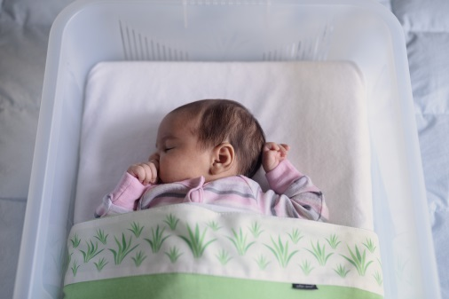
Babies who need this extra protection are aged less than 5 months, exposed to nicotine in pregnancy (smokes or vapes), born premature or low birth weight. Such babies have weakened breathing. Their ‘wake-up’ responses may fail to protect them when they meet breathing hazards during sleep.
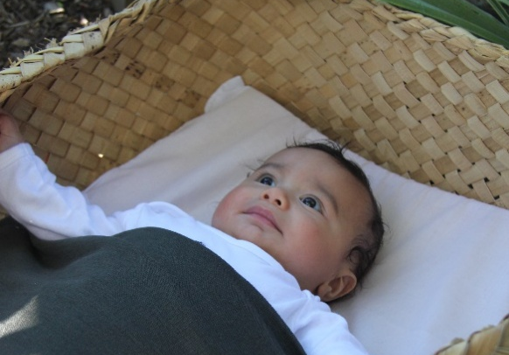
In-bed sleepers do not guarantee that babies will not die.
- They must be used every time there is bedsharing. Sadly, too many babies have died, where an in-bed sleeper was in the house, but not used that sleep.
- Babies also need care that makes them strong. A strong baby is one who is breastfed, nicotine-free, immunised on time and handled gently. Such care sets babies up to survive and thrive.
protection = safe space + strong baby

Share your knowledge - protect more babies
You have influence. People notice what you say and do. In exchange for this bed for your pēpi, we ask that you share what you have learned with others in your networks. We invite you to use the ‘Your Tube’ resource to show others how to protect a baby’s breathing. By doing this, you will help grow knowledge, and protect the lives of many more babies.
REPORTING
Part 1. Service reporting (Distributor to respond.)
1a. Health New Zealand REGION:
1b. Distribution AGENCY:
1c. Referral CRITERIA met: | Nicotine-exposed in pregnancy  Born <37wks/<2500gms Both criteria Neither
1d. TYPE of in-bed sleeper offered: | Pēpi-Pod® Wahakura made by recipient  Pre-made Wahakura Other
1e. Pēpi-Pod ID number: |  | n/a
1f. Date in-bed sleeper was provided to family/whānau: | ___ / ___ / ______(d/m/y)
Part 2. Distribution reporting (A main carer to respond.)
Prioritisation: Who received in-bed sleepers?
2a. Current AGE of MOTHER | ____________ years
2b. AGE of PĒPI at distribution (completed weeks) | ____________ weeks
2c. During this pregnancy, what NICOTINE products did PĒPI’s mother use? | smoking only vaping only NRT only  a mix of products no nicotine use by mother
2d. During this pregnancy, did pēpi’s mother live with a PARTNER who smoked or vaped? | yes, for all or most of the pregnancy  yes, for part of the pregnancy no
2e. Was pēpi born <37 weeks or weighing <2500grams? | yes no not born yet
2f. Pēpi’s ETHNICITY includes:  (more than one option can be selected) | Māori Pacific Asian Other
2g. Does pēpi have an INFANT BED? | yes (cot, bassinet, Moses basket …)  no
Fidelity: How were key parts of the SAFETY BRIEFING delivered and understood?
2h. Was a SAFETY BRIEFING completed with you? | yes, using the picture card supplied  yes, but did not use the picture card no
2i. Was it made clear to you why YOUR pēpi needs extra protection when sharing your bed? | yes no
2j. How was ‘Your Tube’ used to DEMONSTRATE airway safety for pēpi?  (Tubing is for education and not clinical use.) | demo only demo + practice only  demo + encouragement only  demo + practice + encouragement to teach others  not used
2k. Can you now see how your pēpi + bedsharing + using an in-bed sleeper all CONNECT? | not really sort of yes
2l. Do you think using an in-bed sleeper will help protect YOUR PĒPI when bedsharing? | yes no not sure
2m. How CONFIDENT do you now feel about protecting your pēpi wherever they sleep? | not confident quite confident very confident not sure
SCHEDULE FOLLOW-UP (when pēpi is 6-8 weeks) | ___ / ___ / ______(d/m/y)

3. Impact Reporting at follow-up. (A main carer to respond when pēpi is 6-8 weeks old.)
In-bed sleeper use: How are in-bed sleepers used by whānau/families?
3a. How many people have you SPOKEN with so far about protecting the breathing of pēpi? | 0 1 2 3 4 5 5+  (please circle to indicate)
3b. Has your pēpi EVER slept in their in-bed sleeper? | yes no
3c. Is your pēpi in their in-bed sleeper when BEDSHARING? | always usually sometimes never  do not bedshare
3d. This past week, how OFTEN did your pēpi sleep in their in-bed sleeper? | all sleeps most sleeps some sleeps no sleeps
3e. This past week, if the in-bed sleeper was not used what was the main REASON? | ☐ pēpi has outgrown it  ☐ pēpi slept in a cot, bassinet, Moses basket …  ☐ prefer direct bedsharing – without Pēpi-Pod or wahakura  ☐ other ________________________________________________
3f. Where did your pēpi sleep for all or most of LAST NIGHT when you were also asleep? | ☐ in the in-bed sleeper and in bed with me/us (carer)  ☐ in the in-bed sleeper and not in bed with anyone  ☐ not in the in-bed sleeper, but in an infant bed such as cot, bassinet, port-a-cot or Moses basket  ☐ not in the in-bed sleeper, but directly in bed with me/us  ☐ other ________________________________________________
Infant care: How are infant care principles applied in whānau/families?
 | always | usually | sometimes | never
3g. Do you place your pēpi on the BACK for sleeping? | ☐ | ☐ | ☐ | ☐
3h. Do you check that pēpi's sleep area is hazard-free before each sleep (no pillows or soft/loose items? | ☐ | ☐ | ☐ | ☐
3i. Does your pēpi sleep in the same ROOM as a main carer at night? | ☐ | ☐ | ☐ | ☐
3j. Is your pēpi BREASTFED?  (Use standard definitions for the past 48 hours) | ☐ Exclusively or fully (only breastmilk)  ☐ Partially (mainly breastmilk)  ☐ Sometimes (mainly formula)  ☐ Not at all (no breastmilk)  ☐ Has never breastfed (no breastmilk ever)
3k. Has your pēpi started IMMUNISATIONS yet? | ☐ Yes ☐ Not yet, but intend to ☐ No and don’t intend to
3l. What AGE is your pēpi NOW? | ________ (in completed weeks)
3m. Were there any accidents, incidents or safety CONCERNS when pēpi was in an in-bed sleeper? | yes no
If ‘yes’, please describe:
3n. Where will your pēpi usually sleep NEXT when too big for the in-bed sleeper or bassinet? | in a cot or portacot  will directly bedshare (share same sleep surface)  no usual place  not sure  other ________________________________________________
3o. Would you RECOMMEND an in-bed sleeper to other parents of young pēpi? | ☐ definitely ☐ probably ☐ maybe ☐ probably not ☐ no
3p. How will you pass on your in-bed sleeper for another pēpi to use? | ☐ keep for next baby ☐ pass to whānau or friend ☐ return it to health service ☐ sell it ☐ not sure
Free Comment
What is one thing WORTH sharing with other parents about this programme?
THANK YOU
Please enter data from this form for reporting to your service by opening the link below.
https://www.pepipod.co.nz/forms/in-bed_sleeper_data_record/2026

