Please join us for the Serve, Inc
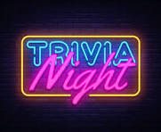

Saturday July 25, 7 pm
Callaway Electric Community Room
1313 Cooperative Dr. Fulton
$120 per team – Teams of 4 – 6
Food and beverage (non-alcohol) available (NO alcohol allowed on property)
Prizes! 50/50! Side games!
All proceeds benefit Serve’s
Capital Campaign/Feeding Callaway!
CONTACT DON SOPH AT DONSOPH@HOTMAIL.COM
OR 314-304-5054 TO RESERVE or FOR QUESTIONS

