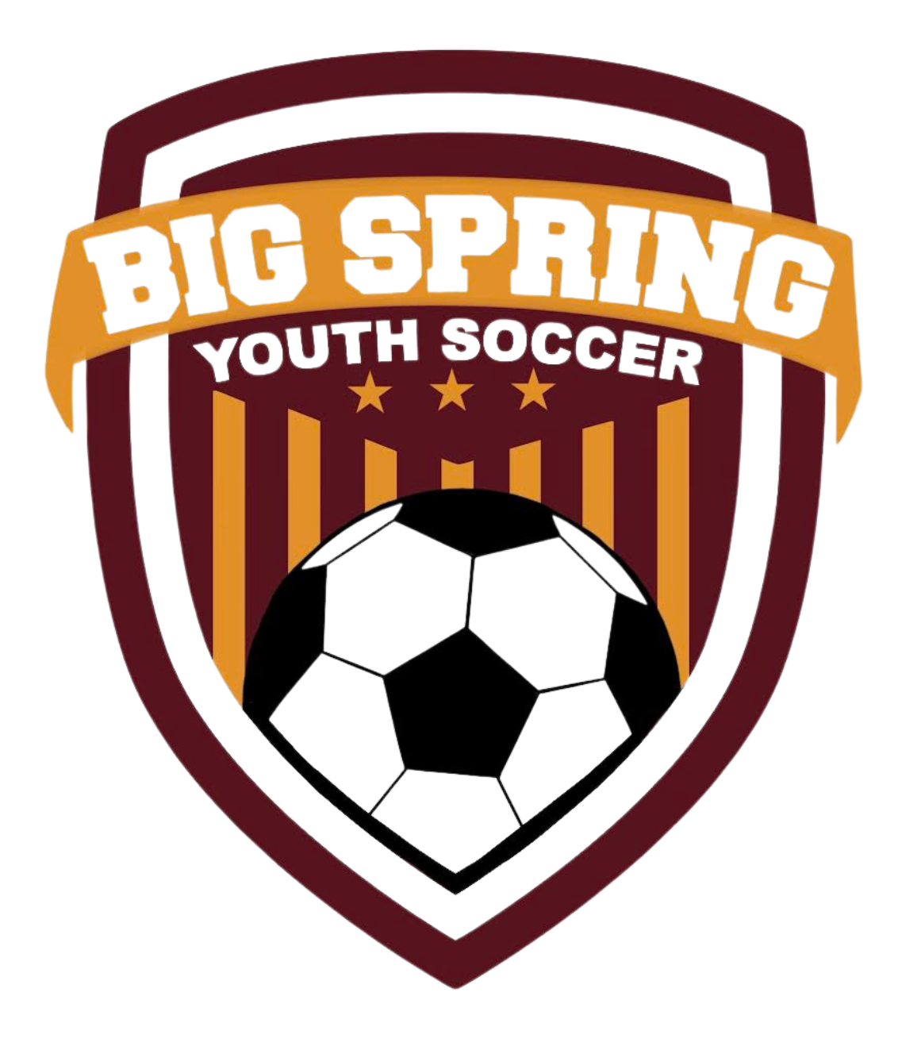

BSYSA Sponsorship Commitment Form 2025-26 Seasons

We thank you for choosing to sponsor Big Spring Youth Soccer. Our program cannot operate without community support. Your sponsorship will aid in purchases such as new equipment, uniforms, tournament entries and much more.

Sponsorship Commitment Levels & Benefits
Sponsor a Child - $250  (covers player registration per season) | Business name (logo provided by you) featured on the club website/social media
Bronze $250 | Business name (logo provided by you) featured on the club website/social media
Silver $500 | Business name (logo provided by you) featured on the club website/social media & Rec Program shirts
Gold $1000+ | Business name (logo provided by you) featured on the club website/social media & Rec Program shirts plus business banner (also provided by you) displayed at the soccer park

I, __________________________________, am committing on behalf of my organization to
(business/business owner name)
sponsor the 2024-25 Big Spring Soccer Association through selecting the noted sponsor levels below. I understand the terms of my sponsorship level and agree to submit the appropriate funds to the Big Spring Soccer Association no later than the specified registration date.
By signing below, I understand that this sponsorship/payment will last for the 2024-25 seasons (both Fall and Spring) apart from the “Sponsor a Child” program.
Please select sponsorship level:

Club Sponsorship | Team Sponsorship | Sponsor a Child
Bronze $250 | Bronze $250 | $250 Season __________
Silver $500 | Silver $500 | Child’s Name _______________
Gold $1000 | Gold $1000 | Team Name ________________

______________________________________________________________________
Organization/Print Name

______________________________________________________________________
Signature/Date

______________________________________________________________________
Email/Contact number

