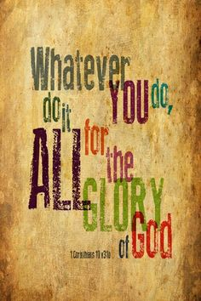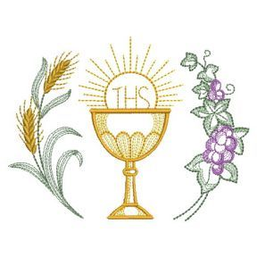

July 2026

To the ministers of Christ the King Parish,

Thanks to everyone for serving our parish. We are truly blessed to have so many dedicated people who are willing to give graciously of their time and talent.
As I was making out the schedule I noticed the biggest change is in the servers’ section. We had 3 wonderful seniors who had served us so faithfully that will not be returning, as they are moving on to college. We wish them all the best and our prayers for success go with them. In their place we have 13 new up-and-coming parishioners who are taking their place. You have probably noticed some of these new faces as many have already started serving. However, this big change means that there are many adjustments to the schedule which created some changes. I tried to balance each team with some experienced servers as well as novices. Sacristans, please keep in mind that the newer servers may need a little help with your expertise.
Another change for SF sacristans is the process by which you begin to livestream the masses. Brian created a new instruction sheet for you to follow.
Again we are very grateful for all our talented ministers. If you are unable to keep your scheduled time, please switch with someone or find a substitute.

Judy 

