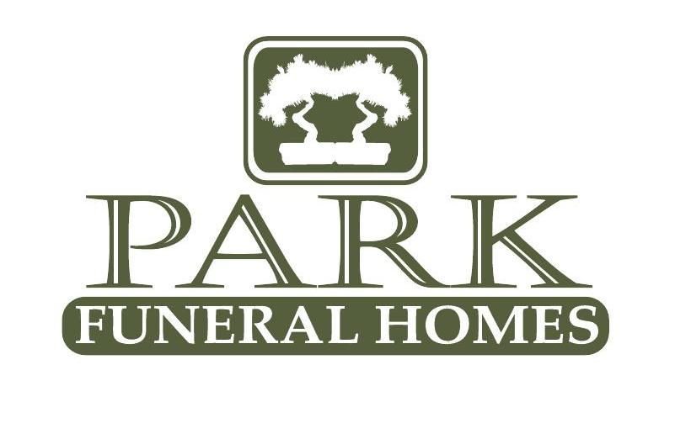
Park Funeral Home of Rochester
200 East Main St. Rochester, IL. 62563
P: 217-498-7161
F: 217-498-7348
Fullenwider-Park Funeral Home of Mechanicsburg
200 S. Church St.
Mechanicsburg, IL 62545.
P 217-498-7161
F: 217-498-7348
Fullenwider-Park Funeral Home of Illiopolis
432 7th Street
Illiopolis, IL 62539
217-498-7161
F: 217-498-7348

What to do
when death occurs

Home
When a death occurs at home and your loved one is not under hospice care, please call 911 and a police officer will respond to the home.
If your loved one is under hospice care, please call the hospice nurse.
Ask the police officer or the nurse to contact

Park Funeral Homes at (217) 498-7161.
The following questions will be asked:
- Caller’s name and phone number
- Name of the deceased
- Address and directions to the home
Our staff will respond to the location of passing and receive your loved one into our care.
We will contact you and schedule a time that is convenient for you to meet with one of our funeral directors.
Cremation will only occur after the necessary written authorizations have been obtained.

Coroner's Office













When death occurs and your loved one is in the care of the coroner, you will need to authorize them to release your loved one into our care.
We will contact you and schedule a time that is convenient for you to meet with one of our funeral directors.
Cremation will only occur after the necessary written authorizations have been obtained.
PARKFUNERALHOMESINC.COM

Hospitals, Hospices, Nursing Homes
Contact the nurse or physician.
The nurse or physician will come to the room and make the pronouncement of death.
Ask the nurse to contact Branch Funeral Homes at (631) 724-9500. Our staff will respond to the location of passing and receive your loved one into our care.
We will call to schedule a time that is convenient for you to meet with one of our funeral directors.
Cremation will only occur after the necessary written authorizations have been obtained.

Out of Area

Contact Park Funeral Homes at (217) 498-7161
and the Funeral Director will assist you.

It is important to contact us prior to contacting another funeral provider. This may save time and minimize expenses.

