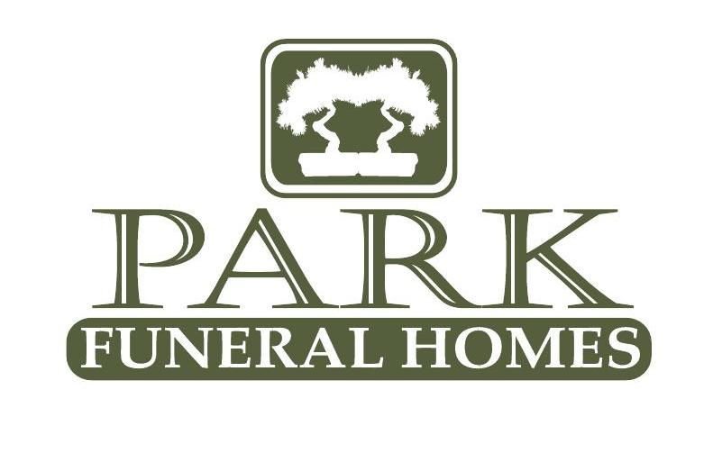
Park Funeral Home of Rochester
200 East Main St. Rochester, IL. 62563
P: 217-498-7161
F: 217-498-7348
Fullenwider-Park Funeral Home of Mechanicsburg
200 S. Church St.
Mechanicsburg, IL 62545.
P 217-498-7161
F: 217-498-7348
Fullenwider-Park Funeral Home of Illiopolis
432 7th Street
Illiopolis, IL 62539
217-498-7161
F: 217-498-7348

Social Security Benefits

Eligibility
The deceased worker must have credit for work covered by Social Security, ranging from 1-1/2 to 10 years depending on his or her age at death. Those who may receive monthly benefits are:
- A widow or widower age 60 (50 if disabled) or older or at any age if caring for an entitled child who is under 16 or disabled
- A divorced widow or widower age 60 (50 if disabled) or older if the marriage lasted 10 years or if caring for an entitled child who is under 16 or disabled
- Unmarried children up to 18 (19 if they are attending a primary or secondary school full-time)
- Children who were disabled before reaching 22, as long as they remained disabled
- Dependent parent or parents 62 or older

We hope this information is helpful to you. We will be assisting you in ensuring you receive all of the benefits available to you at the time of death.














Lump-Sum Death Payment
Parkfuneralhomesinc.com
A one-time payment of $255 is paid in addition to the monthly cash benefits described above. The lump-sum death payment (LSDP) is paid in the following
priority order:
- A surviving spouse who lived in the same household as the deceased person at the time of death
- A surviving spouse eligible for or entitled to benefits for the month of death
- A child or children eligible for or entitled to benefits for the month of death

Why Choose Us
  - Local ownership since 1904
  - 3 modern and convenient locations
  - Higher standards than required by law
  - Certified cremation with care provider
  - Cemetery, cremation, and burial services available at all of our locations
For additional information call
Social Security 800-772-1213

