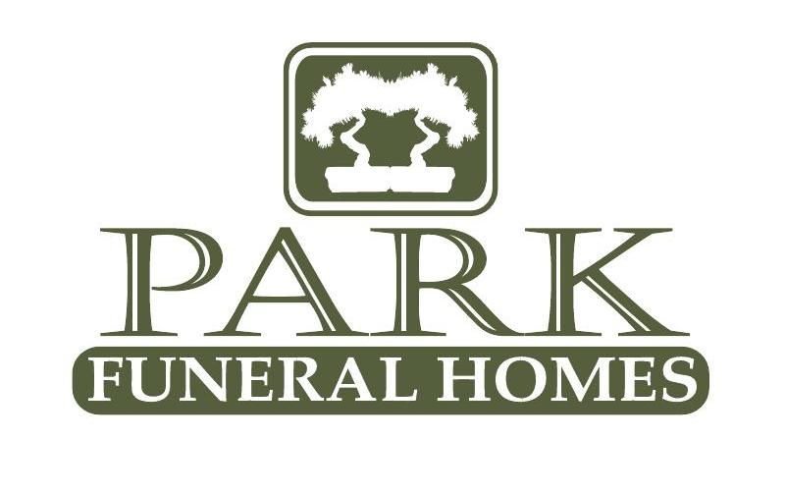
Park Funeral Home of Rochester
200 East Main St. Rochester, IL. 62563
P: 217-498-7161
F: 217-498-7348
Fullenwider-Park Funeral Home of Mechanicsburg
200 S. Church St.
Mechanicsburg, IL 62545.
P 217-498-7161
F: 217-498-7348
Fullenwider-Park Funeral Home of Illiopolis
432 7th Street
Illiopolis, IL 62539
217-498-7161
F: 217-498-7348















Veterans Administration Benefits
BRANCHFH.COM
For comprehensive information on Veterans Administration benefits, visit va.gov.

You will find information regarding:
- Who is eligible to receive benefits
- How to apply
- Required application materials
- Obtaining burial flags
- Burial in national and VA cemeteries
- Headstones, medallions, and markers
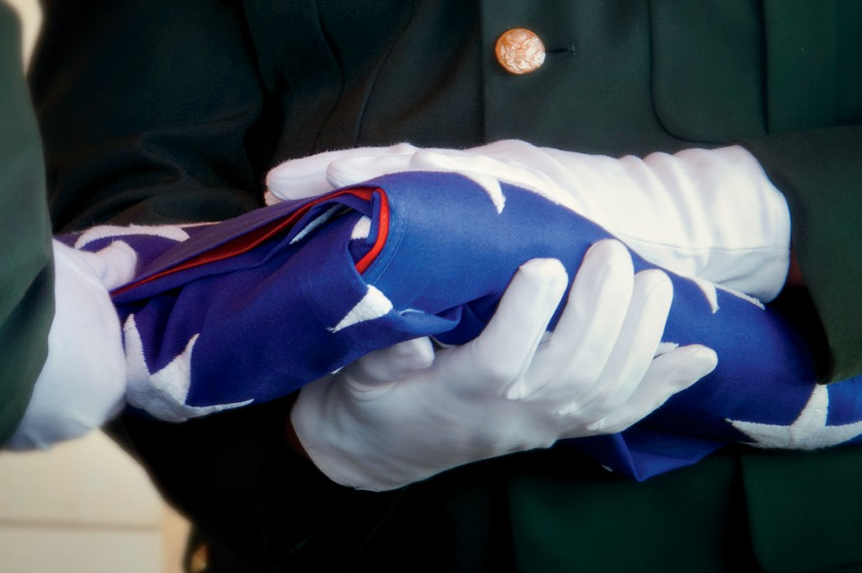

Veteran’s Benefits Administration 800-827-1000

At the Time of Death
Complimentary with services provided for an honorably discharged veteran.
- Assistance in securing all applicable benefits (including Presidential Memorial Certificate, Governor’s Memorial Certificate).
- Military honors, including “Taps” and American Flag presentation at ceremony location

Funeral Services
Eligible veterans will be provided funeral services and charged amounts covered by the government.

Special Note
If a veteran is eligible for these benefits and pre-planned, 100% of all proceeds will be refunded to their family.
We work closely with the National Cemetery of the Alleghenies. Our staff is able to explain your valuable earned benefits and help families claim them for eligible veterans and their spouses. Call us with your questions 217-498-7161.

