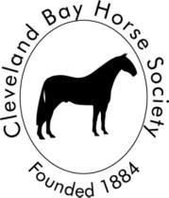 | Cleveland Bay Horse Society  Registered Charity No. 293872  PO Box 298 Crook DL14 4GT Telephone: 07895 535147 Email: clevelandbayoffice@gmail.com Website: www.clevelandbay.com

Voting Instructions for October 18, 2025 AGM
Council has authorised Postal Voting for this year’s elections, and you will find the necessary ballot(s) in your AGM pack. Following Charity Commission guidance, we have an independent scrutineer who will manage receipt and counting of ballots received by mail and email and prepare a report of results for presentation at the AGM.
Completed ballots must be returned by 1700 GMT on October 11th to
cbhsagm2025@gmail.com or by post within UK to:
CBHS Scrutineer
C/O 11 Mount Pleasant
Rawtenstall
Lancashire
BB4 6RT
ELECTION AND VOTING CRITERIA:
Successful candidates are those who receive 50% of the total votes cast plus 1. So, if 100 votes are cast, those receiving at least 51 votes are elected.
The total votes cast is defined as total valid ballots, any ballots deemed invalid, such as a blank ballot, would not be included in the total count.

