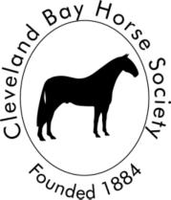 | Cleveland Bay Horse Society  Registered Charity No. 293872  PO Box 298 Crook DL14 4GT Telephone: 07895 535147 Email: info@clevelandbays.co.uk Website: www.clevelandbay.com

Cleveland Bay Horse Society
Annual General Meeting
Saturday, 18 October 2025, 1330 GMT
Agenda
Welcome To the Membership by the President-
Introduction by the Chair of Council-
Apologies
Resolution to approve AGM 2024 Minutes
Elections to Council- Scrutineer Report
Treasurer’s Report
Resolution to accept accounts
Breed Committee Report
Show Committee Report
P&P Committee Report
Resolutions from Members
Election of President-Elect
Any Other Business
Questions and Comments from the Membership
Presentation of Awards
Date of Next AGM- Saturday, October 17, 2026
Tea and biscuits will be served from 11 a.m., and Carvery lunch (reserved and paid in advance)
will be served at 12 noon.

