**CLEVELAND BAY HORSE SOCIETY**

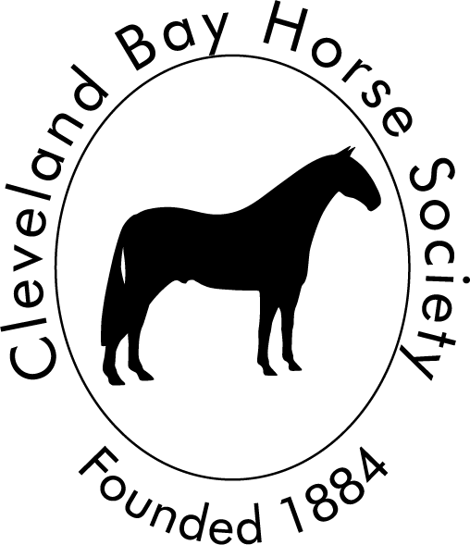

**2025 ELECTION OF TRUSTEES**

VOTE FOR **UP TO 7 CANDIDATES** BY PLACING A  IN THE BOX NEXT TO YOUR CHOICE(S)

(if returning by Royal Mail, place your completed ballot paper in a ***blank*** envelope , seal the envelope and then place into another envelope addressed to CBHS Scrutineer)

If returning via email, scan and send to [cbhsagm2025@gmail.com](mailto:cbhsagm2025@gmail.com)

Please send as a pdf or jpeg file.

Completed ballots must be returned by 1700 GMT on October 11th 2025.

|  |  |  |
| --- | --- | --- |
| 1 | **Beverley Heffernan**  Having served on council from 2020 to 2024 I have enjoyed a year off which included becoming a pure breeder with a filly born this past June, and starting my ¾ bred filly under saddle. I am willing to serve on council once again to help council increase its numbers and spread the work load. |  |
| 2 | **Tierney Hill**  I am a passionate Cleveland Bay owner and breeder. Having recently joined council, I am thoroughly enjoying the opportunity to contribute, and gaining traction in supporting the society’s aims. I bring fresh energy and enthusiasm with many ideas for strengthening our breeds profile, supporting members and promoting the future of the Cleveland Bay. I am committed to the horses, listening to members and making a positive difference from within with your support I look forward to building on the progress already made and helping to secure a strong future for our breed. |  |
| 3 | **Elaine Keith**  I have served on council since October 2022 as show committee Co-chair and Chief officer although I have been involved in all aspects of council work. Together with colleagues I would like to continue with projects started within my first term such as Cleveland Bay camp, judges assessments and fundraising whilst continuing to breed from, and show the progeny of, my pure mares |  |
| 4 | **Catherine Lea**  I have had the privilege and honour of serving on council for the last three years during this time I have worked on the breed committee and now hold the position as treasurer I am very passionate about preserving the breed and I would like to continue to work on council to help preserve and promote Cleveland bays. |  |
| 5 | **Jessica Odgers**  My interest in Clevelands started when my mother brought home a 5 year old gelding Braithwaite Bentley when I was a teenager.  These horses are a pleasure to work with and I hope that by standing for Council I can help promote and preserve these fantastic animals so they are here to enjoy for many years to come.  I aim to provide another enthusiastic voice to the council as well as providing a different perspective with my background in farm and equine veterinary medicine and pedigree livestock breeding under the Quarrydale prefix. |  |
| 6 | **Michelle Snooks**  I have owned horses for over 30 years over this time I have taken part in a range of equestrian activities including hunting driving dressage show jumping and riding club activities I have also bred 3 foals by my own stallion. Since owning a Cleveland Bay I have realized how important seeing them out showing and doing activities is and hope to help promote this I have a keen interest in promoting the Cleveland bay breed particularly as an all-round riding club horse for an amateur. |  |
| 7 | **Matthew Stonehouse**  I am a willing and enthusiastic member of the society. I believe in the preeminence of the breed. I continue to actively breed and expand my bloodlines. I would like to help the society prosper in the future and feel I can contribute to the development of a healthy, active organization. |  |