SANIBEL CAPTIVA LIONS CLUB ANNOUNCES
FRANCIS BAILEY SCHOLARSHIP WINNERS FOR 2025-26

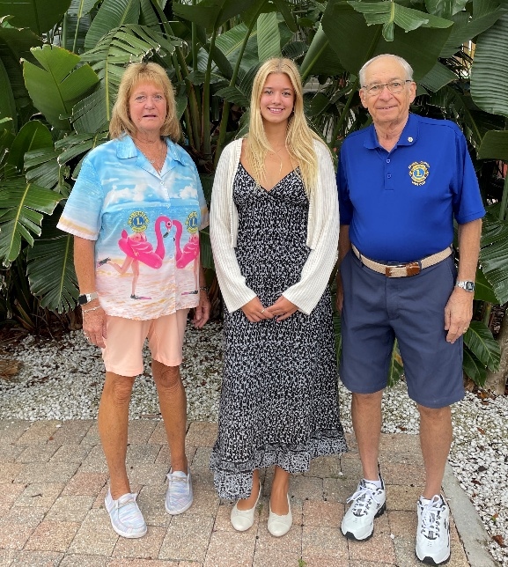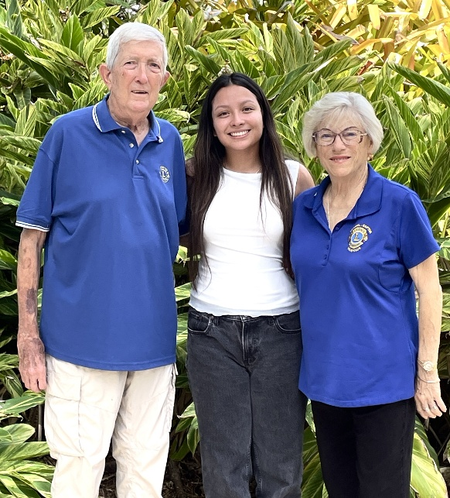

Lori Schulz, Olympia DeCosta and Bill Sartoris Jerry Miller, Madison Chinchilla and Sharon Miller

The Sanibel Captiva Lions Club annually awards two Francis Bailey Scholarships. The endowment fund supporting the scholarships was originally created by Francis Bailey, one of the founders of the Sanibel Captiva Lions Club. The scholarships are awarded for post-secondary education to qualified Lee County students with a preference for those who either live or work on Sanibel or Captiva. Awardees are selected based upon their academic achievement in high school, leadership in extracurricular activities, and financial need.

We are proud to announce the 2025-26 recipients are Olympia De Costa and Madison Chinchilla, both graduates of Fort Myers High School. We wish all the best for these two outstanding students in furthering their education.

Olympia will be attending Florida State University and majoring in Biomedical Science with a goal of becoming a Dermatology PA. She said, “I am incredibly grateful to receive this scholarship from my local Lion’s Club. This scholarship will not only help me pursue my education further but also motivate me to work harder towards my goal of making a difference in the medical field.”

Madison Chinchilla is also attending Florida State University, in fact she started this summer, and is majoring in Finance. She said, “As a first-generation college student, this scholarship lifts a weight off my shoulders and reminds me that my hard work is paying off. It brings me one step closer to a future in finance and law, where I hope to help others overcome the challenges I’ve faced.”
The Johnson/Bailey family commented on the importance of Francis Bailey and the scholarship in his name to the Sanibel Community. Richard and Mead Johnson said, “When Mead and I made the decision to relocate our family to join the family business we knew there was more to being a part of our new community beyond being the island's grocery store. The Johnson/Bailey Family is proud to see the family legacy created by Lion Francis P. Bailey continue. Our thanks to the Sanibel Captiva Lions Club for their help.” Callie, one of the 4th generation of Baileys, said, “Bailie, Dane, and I are proud to be part of a legacy started by our grandfather, Francis P. Bailey, and stewarded by our local Sanibel Captiva Lions Club. We look forward to seeing the future successes of Olympia and Madison further enhanced by earning this scholarship. Congratulations to them from all of us at The Island Store and Bailey’s.”

The Sanibel Captiva Lions Club has been serving the Sanibel and Captiva Communities and Greater Lee County for over 50 years. For more information on the Club please visit our website: sanibelcaptivalionsclub.com.

