
Championship Ring Order Form
IWCOA – Hall of Fame Ring

Name:

Address:
Phone: Email:
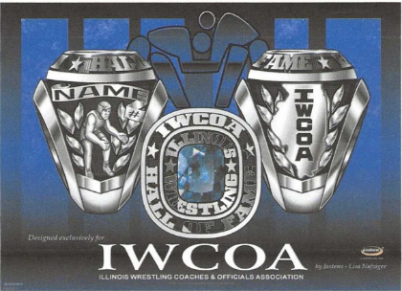

Step 1 Metal Quality:
White Lustrium (non-precious metal) $ 209
______ Suncast (non-precious gold toned metal) $ 249
______ 10 kt white gold $1479
______ 10 kt yellow gold $1479

Step 2 Personalize: Ring Design: 8519X

Name on Side of Ring:

(14 characters max. including spaces)

Year Inducted:
(3 characters max. including spaces)

Inside Engraving:

________________________________
(two lines of 18 characters max. each including spaces)

Step 3 Select Ring Size & Stone Color:
Size
Stone ___________
(choice of simulated birthstone in garnet, amethyst, aquamarine, white spinel, shamrock, alexandrite, ruby, peridot, fire blue spinel, rose zircon, topaz, or blue zircon)

Step 4 Check Out:
Ring Price
Delivery $14.95
Tax (6.25%)
TOTAL

Check #

Debit/Credit Card Number
Expiration Date CVV Code
Name on Card

Signature & Date

Pricing valid until 12/31/22. We accept all major credit cards, debit cards, checks and money orders. Make checks payable to Jostens.

Step 5 Mail or Email by Dec. 31st to: JOSTENS Email:
PO Box 231 jan.slade@jostens.com
Bettendorf, IA 52722

