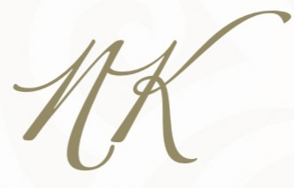

***Starters***

Soup of the Day Served with a Bread Roll **£4.95**

(VE)Wild Mushroom Pate, Crisp Sourdough Bread, Roasted Walnut Vinaigrette, Blackberry Gel **£8.95**

Pan Seared Scallops, Beetroot Purée, Pickled Apple & Radish Salad, Pancetta Crisp **£15.95**

(VE)Carrot Schnitzel, Butterbean Purée, Green Chilli & Herb Dressing **£8.95**

Pan Fried Halloumi, Smoked Red Pepper & Courgette, Pickled Red Onion, Basil Dressing **£8.95**

Pulled Gammon with Peppered Pineapple, Grain Mustard Dressing **£8.95**

White Crab, Bacon & Avocado, Lemon Marinated Heritage Tomatoes, Bloody Mary Dressing **£13.95**

***Main Courses***

Fillet of Blackgate Beef, Potato Terrine, Garlic Portobello Mushroom, Wilted Baby Spinach, Teryaki Sauce **£36.95**

Pan Seared Seafood Chowder *(Salmon, Scallops, Crab Meat, Mussels, King Prawns, Crushed New Potatoes, White Wine & Chive Fish Cream*) **£29.95**

Parmesan Crusted Loin of Venison, Creamed Mash, Roasted Squash, Squash Purée, Steamed Kale, Red Wine Jus & Truffle Oil **£30.95**

Dill Marinated Fillet of Halibut, Roasted Sweetheart Cabbage, Crispy Potato Wedges, Green Herb & Cashew Sauce **£29.95**

Baked Supreme of Chicken, Roasted New Potatoes, Caramelized Red Onion & Red Pepper, Chimichurri Dressing **£25.95**

(VE) Braised Parsnip, Miso Pumpkin Seed Sauce, Crispy Capers, Pickled Pears, Toasted Hazelnuts, Parsnip Crisps **£19.95**

(V)Roasted Broccoli Steaks, Braised Raddichio, Fried Paneer, Lemon & Roasted Garlic Dressing **£18.95**

Blackgate Sirloin Steak, Onion Rings, Mushrooms, Roast Tomatoes & Chunky Chips **£30.95**

**ADD:** Pepper Sauce, Diane Sauce, Whisky & Mushroom Sauce **£3.95**

Battered King Prawns, with Tartare Sauce, Salad & Chunky Chips **£19.95**

Beer Battered Haddock, with Mushy Peas, Tartare Sauce & Chunky Chips **£19.95**

Breaded Chicken Fillets, Coleslaw, Salad, Peas & Chunky Chips **£18.95**

Kessock Hamful *(Sliced Honey Roast Ham cooked in our kitchen*

*Wrapped around Prawns bound in a Marie Rose Sauce)* served with Salad & Chunky Chips **£19.95**

**SIDE DISHES @ £3.95:** Chunky Chips, Onion Rings, Garlic Bread

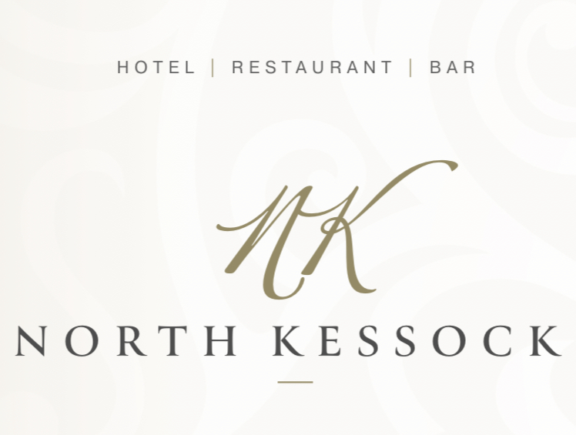

***Desserts***

Sticky Toffee Pudding drizzled with a butterscotch sauce and Served with Vanilla Ice Cream **£8.50**

Locally Sourced Selection of Cheese *(Gruth Dhu, Apple Smoked Cheddar, Strathdon Blue, Caboc)* with Apple & Raisin Chutney & Biscuits **£10.95**

(VE)Roasted Rhubarb, Rhubarb & Ginger Coulis, Lemon Sorbet, Cinnamon Crumble **£8.50**

Double Chocolate Tartlet, Raspberry Compote, Sesame Tuille **£8.50**

Banana & Rum Parfait, Salted Caramel, Caramel Biscuit Crumb

**£8.50**

Mint Aero Cheesecake, on a Hobnob Base, Chocolate Syrup, Lime Gel **£8.50**