

**September 7, 2025**

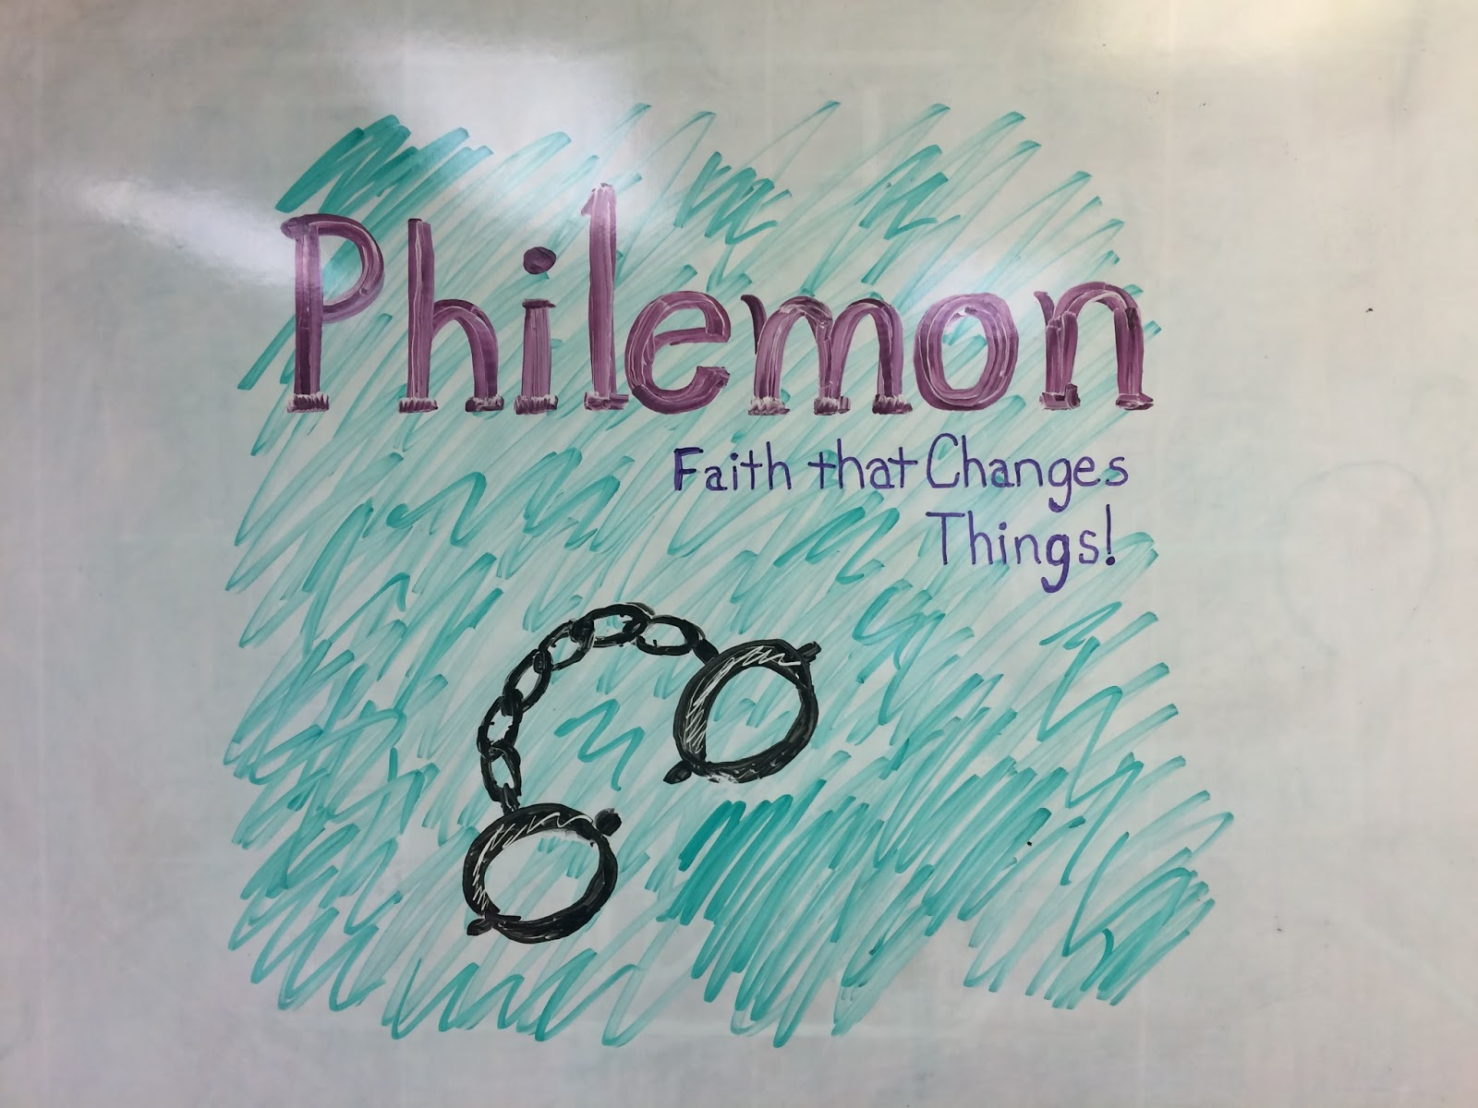

**5812 Ford Rd. N. Mt. Vernon, IN 47620 (812) 985-3115**

**Facebook:** Immanuel United Church of Christ **Church Website:** [www.immanueluccmv.com](http://www.immanueluccmv.com)

**Church Email:** [info@immanueluccmv.com](mailto:info@immanueluccmv.com) **Administrative** **Assistant:** Janie Meinschein

**Our Vision? *“To grow a vibrant church by sharing Christ with the community . . .”***

**Our Mission? *“To invite, inspire, involve, increase . . .”***

**Thirteenth Sunday after Pentecost ~ Holy Communion**

September 7, 2025

**RINGING OF THE BELL** Keith Deig

**WELCOME AND WORDS OF GREETING** Jennifer Willett

**PRELUDE**

**\*CALL TO WORSHIP** Jennifer Willett

Leader: Joy comes to those who follow God’s ways.

**All: We will follow the Lord with joyful hearts.**

Leader: Those who follow the Lord are like trees planted by the river, bearing fruit each season.

**All: May our lives be fruitful and blessed by God.**

Leader: Worship the Lord who leads us to joy and abundance.

**All: Let us worship God now and throughout all our days!**

**\*OPENING HYMN #161 *“Breathe On Me, Breath of God”***

**\*PRAYER OF CONFESSION (Unison)** Jennifer Willett

**God of justice and mercy, we offer you our love and loyalty in worship yet we admit we do not live out that love and loyalty. We don’t always act on our good Intentions, we fail to keep our promises, we hurt each other while thinking we did not , and then refuse to seek or offer forgiveness. Forgive us, we pray, and help us to do better, for we ask this in Jesus’ name. Amen.**

**\*WORDS OF ASSURANCE** Rev. Robert B. Walker

**\*GLORIA PATRI**

***Glory be to the Father, and to the Son, and to the Holy Ghost;***

***As it was in the beginning, is now, and ever shall be,***

***world without end. Amen.***

**TIME FOR THE YOUNG AT HEART** Rev. Robert B. Walker

**PASTORAL PRAYER – THE LORD’S PRAYER** Rev. Robert B. Walker

**SERVICE OF GIVING**

**Invitation** Rev. Robert B. Walker

**Offertory**

**\*Response No. 382**

***Praise God, from whom all blessings flow;***

***Praise Him, all creatures here below;***

***Praise Him above, ye heavenly host;***

***Praise Father, Son, and Holy Ghost. Amen.***

**\*Prayer of Dedication** (Unison) Jennifer Willett

**Abundant God, we bring you our gifts in gratitude for your generosity. Bless and multiply these gifts in Jesus’ name, so that they can spread your goodness in the world and touch lives of those in need, in Christ’s name. Amen.**

**SCRIPTURE – Philemon 1-10** Rev. Robert B. Walker

1 Paul, a prisoner of Christ Jesus, and Timothy our brother,

To Philemon our dear friend and fellow worker— 2 also to Apphia our sister and Archippus our fellow soldier—and to the church that meets in your home:

3 Grace and peace to you from God our Father and the Lord Jesus Christ.

4 I always thank my God as I remember you in my prayers, 5 because I hear about your love for all his holy people and your faith in the Lord Jesus. 6 I pray that your partnership with us in the faith may be effective in deepening your understanding of every good thing we share for the sake of Christ. 7 Your love has given me great joy and encouragement, because you, brother, have refreshed the hearts of the Lord’s people.

8 Therefore, although in Christ I could be bold and order you to do what you ought to do, 9 yet I prefer to appeal to you on the basis of love. It is as none other than Paul—an old man and now also a prisoner of Christ Jesus— 10 that I appeal to you for my son Onesimus, who became my son while I was in chains. 11 Formerly he was useless to you, but now he has become useful both to you and to me.

**SERMON “On the Basis of Love”** Rev. Robert B. Walker

**\*HYMN #166 *“Let All Mortal Flesh Keep Silence”***

**THE LORD INVITES US TO HIS TABLE**

**Invitation to Communion**

**Prayer of Consecration**

**Sharing The Bread and Cup**

**Prayer of Thanksgiving** (Unison)

**Eternal God, we thank you for your presence in this holy feast. May we know the presence of Jesus among us. Take us from this table, raised and restored, ready not to be served but to serve, in the power of the Spirit. Amen.**

**\*CLOSING HYMN #458 *“Take My Life, and Let It Be Consecrated”***

**\*PASTORAL BENEDICTION** Rev. Robert B. Walker

**\*BENEDICTION SONG** ***“Let There Be Peace on Earth”***

***Let there be peace on earth and let it begin with me;***

***let there be peace on earth, the peace that was meant to be.***

***With God our Maker, family all are we.***

***Let us walk with each other, in perfect harmony.***

***Let peace begin with me, let this be the moment now.***

***With every step I take, may this be my solemn vow:***

***To take each moment and live each moment***

***in peace eternally.***

***Let there be peace on earth, and let it begin with me.***

**POSTLUDE**

Used by Permission. CCLI License # 20658309, Streaming # 20658316

**+++++++++++++++++++++++++++++++++++++++++++++++++++++++++++++++++++++++++++++**

**Today** **September 14**

|  |  |  |
| --- | --- | --- |
| Lay Leader  Ushers/Greeters:  Pianist/Organist:  Children’s Moments: | Jennifer Willett  Janie Meinschein  Beth Folz  Rev. Robert Walker | Bobbie Hoebeke  OPEN  Beth Folz  Adam McCloud |

|  |  |
| --- | --- |
| **ATTENDANCE** | LAST WEEK: 40 LAST YEAR: 50 |



**OUR IMMANUEL UCC PRAYER LIST**



***\*Charles Behrick*** ***\*David Behrick******\*Cherry Chase******\*Janice Jones***

***Ken Willett******David Frye Kenny Meinschein***

***Teresa Topper*** *(Friend of Chris Moers)* ***Tom Howard*** *(Brother of Angela Clark)*

***Kiersten Ferguson-Cremin*** *(Niece of Paula Boarman)*



**VISITORS: We invite you to sign our Guest Book, located in the Narthex., as well as the attendance book in the pews.**

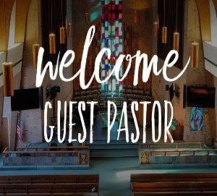

Today we welcome **Rev. Robert B. Walker**.

Lay Leader will be Jennifer Willett.

Robert Walker is a native of Evansville and a graduate of the University of Southern Indiana, Eden Theological Seminary, and St. Louis University. Ordained by the Evansville/Tri-State Association, he served churches in Illinois, St. Louis, Evansville, and Ohio., as well as being on the Board of Directors of different Conferences and the German Partnership of the Indiana-Kentucky Conference. He and his wife Janet live in Evansville, Indiana where Robert has served a UCC church in Evansville from 2021-2024. His hobbies include writing Lenten and Advent devotional booklets, church bulletin liturgy (calls to worship, prayers of invocation, pastoral prayers), electronic vintage stereo repair, playing electric bass in different bands and church music, jogging, and even car repair “just because!”



Next Sunday, September 14th, we welcome **Adam McCloud.**

Lay Leader will be Bobbie Hoebeke.



|  |
| --- |
| **Dorcas Women’s Fellowship Meeting**  Thursday, September 18 at 1 pm in the Church Parlor  Pam Robinson will be leading the program and discussion.  This is our first meeting of the year and we will be planning future meetings and activities.  All women are invited to attend. |
| trail clean up - Protecting the New Jersey Pinelands and Pine Barrens ...  **TRAIL CLEAN UP WORK DAY**  September 20th at 8:00 a.m.  Sign up sheet in the Narthex  Coffee & Donuts will be provided |
| St. Peter’s UCC (Highland)  Fall Festival Kuchen Sale  St. Peter’s UCC is accepting preorders for our famous Kuchen.  Preorders accepted  September 7th through September 28th  Call 812-424-5922 or 812-909-4391 to place an order.  All Kuchen are baked fresh daily and are only $8 each.  Flavors include: Cinnamon, Peach, Apple, Cherry and Pineapple.  Preordered Kuchen will be available for pickup at St. Peter’s Drive-Thru  Tuesday, October 7th through Friday, October 10th  Between 1 pm and 6pm.  Our Kuchen will also be available at our Booth 100 during the  Westside Nut Club Fall Festival. |

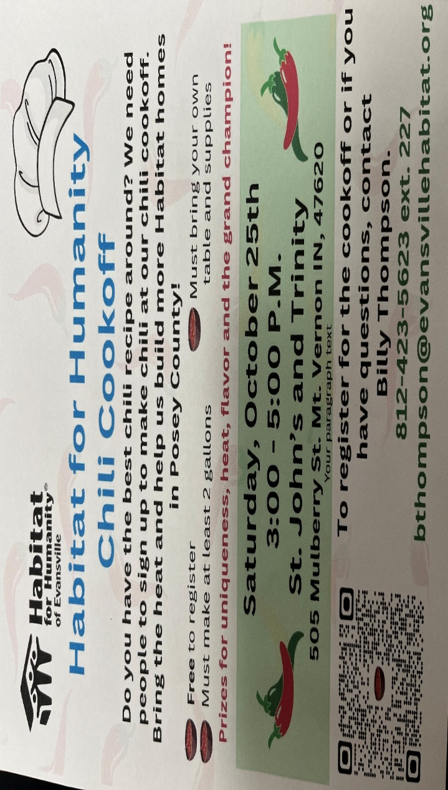



**SUNDAY** **7th** **THIRTEENTH SUNDAY AFTER PENTECOST**

9:00 a.m. Adult Sunday School

10:00 a.m. Worship & Communion

5:30 p.m. – 6:30 p.m. AA Meeting

**MONDAY 8th** 8:30 a.m. God’s Storehouse

**TUESDAY** **9th**

**WEDNESDAY** **10th**

**THURSDAY** **11th** 9:30 a.m. Gentle Exercise Class

**FRIDAY** **12th**

**SATURDAY** **13th**

**SUNDAY** **14th FOURTEENTH SUNDAY AFTER PENTECOST**

9:00 a.m. Adult Sunday School

10:00 a.m. Worship

5:30 p.m. – 6:30 p.m. AA Meeting



*September 14 – Paul Williams September 13 – Mark & Becky Brenner*

**Gentle Exercise Class . . . designed for 40+**

Every **Thursday morning at 9:30** **am** in the Fellowship Hall

Breath & Movement 45 mins~

Discussion on creating a positive mindset 15 min~

Led by De Brown, certified Yoga Instructor and Immanuel UCC member!

*Suggested donation: $5-