IMMANUEL UNITED CHURCH OF CHRIST
September 6, 2026

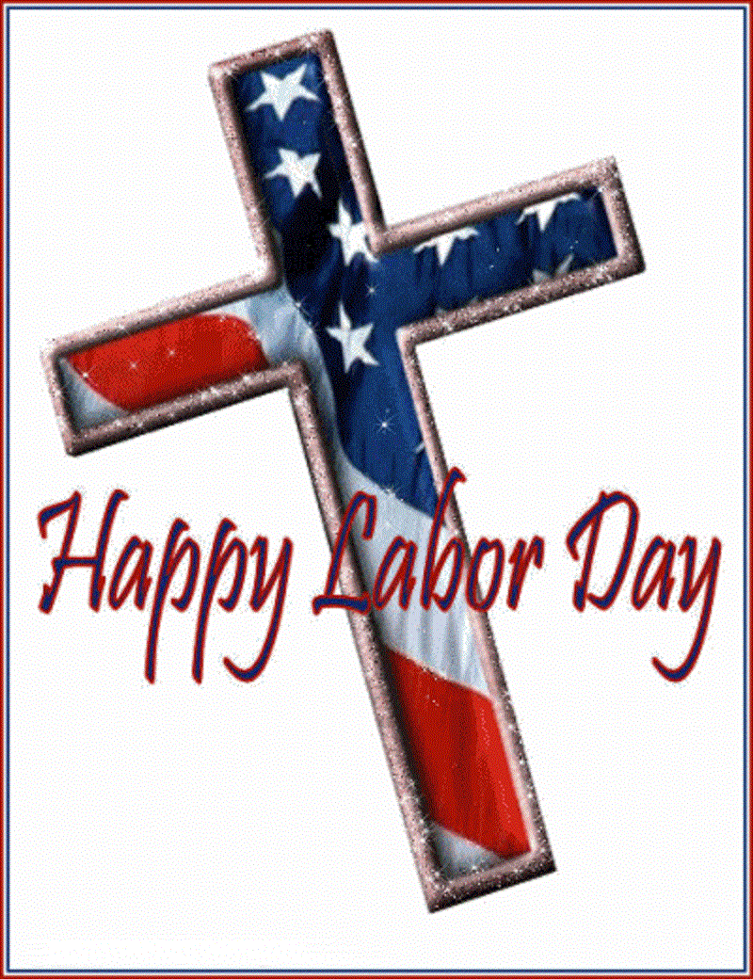

5812 Ford Rd. N. Mt. Vernon, IN 47620 (812) 985-3115
Facebook: Immanuel United Church of Christ Church Website: www.immanueluccmv.com
Church Email: info@immanueluccmv.com Secretary: Janie Meinschein (812)483-3578
Council President: Bret Baldwin (930) 465-5471
Our Vision? “To grow a vibrant church by sharing Christ with the community . . .”
Our Mission? “To invite, inspire, involve, increase . . .”

Fifteenth Sunday after Pentecost ~ Holy Communion
September 6, 2026

RINGING OF THE BELL Keith Deig

WELCOME AND WORDS OF GREETING Bobbie Hoebeke

PRELUDE

*CALL TO WORSHIP Bobbie Hoebeke

Leader: Sing to God a New Song!

All: We will worship God, our Maker!

Leader: Let us praise God with song and dance!

All: For God is gracious and loving!

Leader: Let us bring God glory and honor.

All: Praise the Lord.

Leader: And on this weekend of Labor Day,

All: Let us worship God who provides rest from labor, loneliness, and weariness. Let us
worship God now and throughout all our days!

*OPENING HYMN #347 “All Creatures of Our God and King”

*PRAYER OF CONFESSION (Unison) Bobbie Hoebeke

Gracious God, our sins are too heavy to carry, too real to hide, and too deep to undo.
We look at a world undone by strife, torn by violence, separated by hatred. Yet you call us to walk the way of peace. Forgive us, O Lord, for refusing to follow you on this path because the cost is too high, the direction too confusing, the conditions too harsh.
Grant us clarity of vision to see the light and the strength to walk behind you,
in the power of your Spirit we pray, Amen.

*WORDS OF ASSURANCE Rev. Robert B. Walker

*GLORIA PATRI
Glory be to the Father, and to the Son, and to the Holy Ghost;
As it was in the beginning, is now, and ever shall be,
world without end. Amen.

CHILDREN’S MOMENTS Ashton Wagner

PASTORAL PRAYER – THE LORD’S PRAYER Rev. Robert B. Walker

SERVICE OF GIVING
Invitation Rev. Robert B. Walker
Offertory

*Response No. 382
Praise God, from whom all blessings flow;
Praise Him, all creatures here below;
Praise Him above, ye heavenly host;
Praise Father, Son, and Holy Ghost. Amen.

*Prayer of Dedication (Unison) Bobbie Hoebeke

Gracious God, receive these gifts, offered in a spirit of generosity and humility.
Bless and use them for the work that you long to do in the world you love,
for Jesus’ sake. Amen.

SCRIPTURE – Romans 13:8-14 Bobbie Hoebeke

⁸ Let no debt remain outstanding, except the continuing debt to love one another, for whoever loves others has fulfilled the law. ⁹ The commandments, “You shall not commit adultery,” “You shall not murder,” “You shall not steal,” “You shall not covet,” and whatever other command there may be, are summed up in this one command: “Love your neighbor as yourself.” ¹⁰ Love does no harm to a neighbor. Therefore love is the fulfillment of the law.

¹¹ And do this, understanding the present time: The hour has already come for you to wake up from your slumber, because our salvation is nearer now than when we first believed. ¹² The night is nearly over; the day is almost here. So let us put aside the deeds of darkness and put on the armor of light. ¹³ Let us behave decently, as in the daytime, not in carousing and drunkenness, not in sexual immorality and debauchery, not in dissension and jealousy. ¹⁴ Rather, clothe yourselves with the Lord Jesus Christ, and do not think about how to gratify the desires of the flesh.

SERMON “Who Knows ‘Near’?” Rev. Robert B. Walker

*HYMN #166 “Let All Mortal Flesh Keep Silence”

THE LORD INVITES US TO HIS TABLE

Invitation to Communion
Prayer of Consecration
Sharing The Bread and Cup
Prayer of Thanksgiving (Unison)

Eternal God, we thank you for your presence in this holy feast. May we know the presence of Jesus among us. Take us from this table, raised and restored, ready not to be served but to serve, in the power of the Spirit. Amen.

*CLOSING HYMN #458 “Take My Life, and Let It Be Consecrated”

*PASTORAL BENEDICTION Rev. Robert B. Walker

Go in peace, love and care for one another in the name of Jesus, and may God make safe to you each step may God open to you each door, may God make clear to you each road. And may God enfold you in loving arms, both now and forevermore. Amen.

*BENEDICTION SONG “Let There Be Peace on Earth”

Let there be peace on earth and let it begin with me;
let there be peace on earth, the peace that was meant to be.
With God our Maker, family all are we.
Let us walk with each other, in perfect harmony.

Let peace begin with me, let this be the moment now.
With every step I take, may this be my solemn vow:
To take each moment and live each moment
in peace eternally.
Let there be peace on earth, and let it begin with me.
POSTLUDE

Used by Permission. CCLI License # 20658309, Streaming # 20658316
+++++++++++++++++++++++++++++++++++++++++++++++++++++++++++++++++++++++++++++

Today Sept 13
Lay Leader:  Ushers/Greeters:  Pianist/Organist:  Children’s Moments: | Bobbie Hoebeke  Tina Kissinger  Beth Folz  Ashton Wagner | OPEN  Nelda Hickey  Beth Folz  Ashton Wagner

ATTENDANCE | LAST WEEK:46 LAST YEAR: 40

OUR IMMANUEL UCC PRAYER LIST

*Charles Behrick *David Behrick *Becky Brenner *Cherry Chase

*Janice Jones *Kenny Kuebler *Dan Riddle *Ruth Rueger

David Frye Norma Houghton Tom Howard Denis Lambrech

Kenny Meinschein Teresa Topper Ken Willett Eli Williams

If you have names to be added or deleted from the Prayer List, please obtain permission from the person or a family member for their name to be published.
A phone call or a card will let people know we miss them and we care for them.

OUR PRAYERS go out to the family of Marge Kissinger. Marge passed away on Saturday, August 29th. Marge was a long-time member of Immanuel UCC. The funeral was held Thursday, September 3rd at Immanuel UCC with burial following at Immanuel Cemetery. In lieu of flowers, memorial contributions in memory of Marge may be made to Immanuel UCC Cemetery or to Immanuel United Church of Christ



We wish to welcome all in the name of Christ.
We invite you to worship with us every Sunday...
and to become a part of this faith household.

We invite you to sign our Guest Book, located in the Narthex.

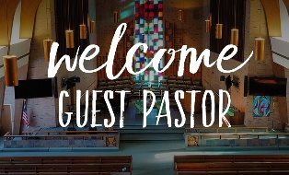


TODAY NEXT SUNDAY
Rev. Bob Walker Adam McCloud

We pray their message will touch our hearts and inspire our faith.
Thank you for blessing our congregation with your time, wisdom and love.



THIS WEEK

SUNDAY 6th FIFTEENTH SUNDAY AFTER PENTECOST
9:00 a.m. Adult Sunday School
10:00 a.m. Worship & Communion
5:30 p.m. – 6:30 p.m. AA Meeting

MONDAY 7th LABOR DAY

TUESDAY 8th

WEDNESDAY 9th

THURSDAY 10th 9:30 a.m. Exercise Class

FRIDAY 11th

SATURDAY 12th

SUNDAY 13th SIXTEENTH SUNDAY AFTER PENTECOST
9:00 a.m. Adult Sunday School
10:00 a.m. Worship Service
5:30 p.m. – 6:30 p.m. AA Meeting



