IMMANUEL UNITED CHURCH OF CHRIST
September 28, 2025

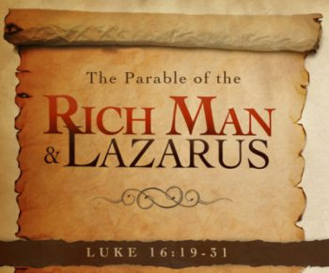

5812 Ford Rd. N. Mt. Vernon, IN 47620 (812) 985-3115
Facebook: Immanuel United Church of Christ Church Website: www.immanueluccmv.com
Church Email: info@immanueluccmv.com Administrative Assistant: Janie Meinschein
Our Vision? “To grow a vibrant church by sharing Christ with the community . . .”
Our Mission? “To invite, inspire, involve, increase . . .”

Sixteenth Sunday after Pentecost
September 28, 2025 – Guest Speaker: Billy Thompson

RINGING OF THE BELL Keith Deig

WELCOME AND WORDS OF GREETING Bret Baldwin

PRELUDE “Wiegenlied” By Carl Bohm

*PRAISE SONG #227 “There’s Something About That Name”

*CALL TO WORSHIP Bret Baldwin

L: See what love has been given to us, that we should be called children of God! Christ said, “This is my commandment: Love one another.”

P: We come to worship God—who loves us and, through Jesus, teaches us to love one another.

L: Let us sing our praises to God, and live in love and friendship.

*OPENING HYMN #630 “There is Sunshine in My Soul Today”

*PRAYER OF CONFESSION (Unison) Bret Baldwin

Almighty God, we thank you that you have not left us alone in our sin and despair. Loving us, you have brought us good news and set before us the way of life. When we fail to see your loving ways, and when we turn away from the call you set before us, forgive us. Grant that we may be fortified in your Spirit. Lead us, we pray into faithful communion with you. Amen.

*WORDS OF ASSURANCE Bret Baldwin

Hear the Good News:
God, every merciful and loving forgives us.
God’s great mercy abounds and renews us each day.
Thanks be to God!

*GLORIA PATRI

Glory be to the Father, and to the Son, and to the Holy Ghost;
As it was in the beginning, is now, and ever shall be,
world without end. Amen.

CHILDREN’S MOMENTS Deb Wells

PRAYERS OF THE PEOPLE Billy Thompson
Silent Prayer ~ Pastoral Prayer ~ Our Lord’s Prayer

SERVICE OF GIVING
Offertory “Footsteps of Jesus” By Asa Everett, arr. A.C. Whitworth
*Response No. 382

Praise God, from whom all blessings flow;
Praise Him, all creatures here below;
Praise Him above, ye heavenly host;
Praise Father, Son, and Holy Ghost. Amen.

*Prayer of Dedication (In Unison) Bret Baldwin

All good gifts come from you, O God. You have given us life, and new life in Christ. As you have given us gifts, we offer these gifts praying that you bless them. May they be used to your glory and for the benefit of your world. Amen.

SCRIPTURE – Luke 16:19-31 Bret Baldwin

¹⁹ “There was a rich man who was dressed in purple and fine linen and lived in luxury every day. ²⁰ At his gate was laid a beggar named Lazarus, covered with sores ²¹ and longing to eat what fell from the rich man’s table. Even the dogs came and licked his sores.

²² “The time came when the beggar died and the angels carried him to Abraham’s side. The rich man also died and was buried. ²³ In Hades, where he was in torment, he looked up and saw Abraham far away, with Lazarus by his side. ²⁴ So he called to him, ‘Father Abraham, have pity on me and send Lazarus to dip the tip of his finger in water and cool my tongue, because I am in agony in this fire.’

²⁵ “But Abraham replied, ‘Son, remember that in your lifetime you received your good things, while Lazarus received bad things, but now he is comforted here and you are in agony. ²⁶ And besides all this, between us and you a great chasm has been set in place, so that those who want to go from here to you cannot, nor can anyone cross over from there to us.’

²⁷ “He answered, ‘Then I beg you, father, send Lazarus to my family, ²⁸ for I have five brothers. Let him warn them, so that they will not also come to this place of torment.’

²⁹ “Abraham replied, ‘They have Moses and the Prophets; let them listen to them.’

³⁰ “‘No, father Abraham,’ he said, ‘but if someone from the dead goes to them, they will repent.’

³¹ “He said to him, ‘If they do not listen to Moses and the Prophets, they will not be convinced even if someone rises from the dead.’”

HYMN #217 “Jesus Walked This Lonesome Valley“

SERMON “A Determining Faith” Billy Thompson

*CLOSING HYMN #619 “I Love to Tell the Story“

*BENEDICTION Billy Thompson

*BENEDICTION SONG “Lord of Life”

Lord, of life, Lord of Love, Walk forever beside us.
Day by Day, Show the Way, With your Vision to guide us,
Striving to Follow Your Will and Way, Nothing can divide us,
Lord of Life, Lord of Love, Walk forever beside us.

POSTLUDE

Used by Permission. CCLI License # 20658309, Streaming # 20658316

+++++++++++++++++++++++++++++++++++++++++++++++++++++++++++++++++++++++++++++
Today October 5
Lay Leader  Ushers/Greeters:  Pianist/Organist:  Children’s Moments: | Bret Baldwin  Chris Moers & Nelda Hickey  Gail Angel  Deb Wells | Bret Baldwin  Justin, Ashton & Rose Wagner  Gail Angel  OPEN

ATTENDANCE | LAST WEEK: 37 LAST YEAR: 55


OUR IMMANUEL UCC PRAYER LIST

*Charles Behrick *David Behrick *Janice Jones *Cindy Woodall

Ken Willett David Frye Kenny Meinschein Justin Russell

Teresa Topper (Friend of Chris Moers) Tom Howard (Brother of Angela Clark)

Kiersten Ferguson-Cremin (Niece of Paula Boarman)

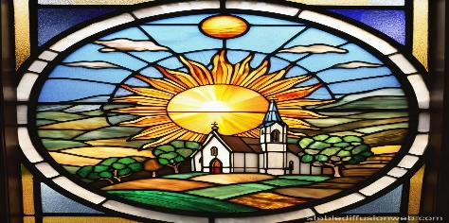
Welcome
to our church

VISITORS: We invite you to sign our Guest Book, located in the Narthex., as well as the attendance book in the pews.

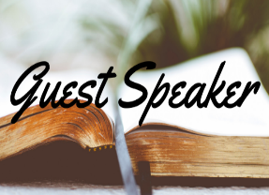

TODAY WE WELCOME Billy Thompson.
Lay Leader will be Bret Baldwin.



NEXT SUNDAY, OCTOBER 5TH
We welcome Rev. Robert Walker.
Lay Leader will be Bret Baldwin.

ANNOUNCEMENTS

BELL CHOIR will practice after worship today. If anyone is interested in joining, please talk to Beth Folz or Debbie Wells.

PLASTIC CAPS are still being collected. Please make sure they are clean and rinsed out if they have any food or liquid on them. This makes it easy for the individuals that are sorting them.

YAY! WE HAVE A WHEELCHAIR – Our prayers were answered!
Email Sent from Bobbie Hoebeke: This morning when I went to yoga class at Zion Lippe UCC, I was passing by the wheelchairs they have in a storage room. I’ve seen these numerous times before. However, this morning the Lord prompted me to ask if they would kindly donate one to Immanuel UCC and told them about the state of the one we have. The women said, “that’s funny, because we were just discussing that we should donate some of this equipment”. This is a God-arranged opportunity and an answer to prayer. So, Zion gave one to our church.

FOOD COLLECTION - BOX AND BAG CEREAL is needed for ATC Mission. There is a basket in the Narthex. Thank you for your donations.

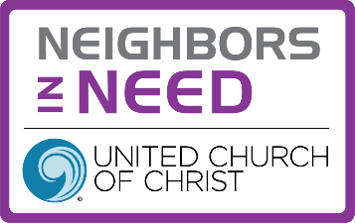
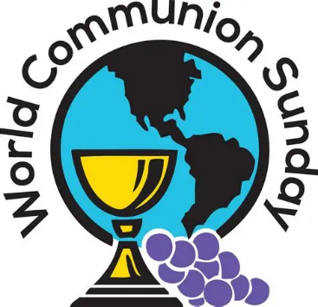

NEXT SUNDAY, OCTOBER 5th
World Communion Sunday

Rev. Robert Walker will be our guest minister
presiding over The Lord’s Supper.

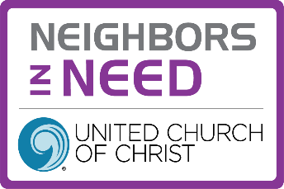
NEIGHBORS IN NEED OFFERING
Next Sunday, October 5th

Neighbors in Need (NIN) is a special mission offering of the United Church of Christ that supports ministries of justice and compassion throughout the United States. One-third of NIN funds support the council for American Indian Ministry (CAIM). Two-thirds of this offering is used by the UCC’s Justice and Witness Ministries (JWM) to support a variety of justice initiatives, advocacy efforts, and direct service projects through grants. Envelopes are on the pew in the Narthex.

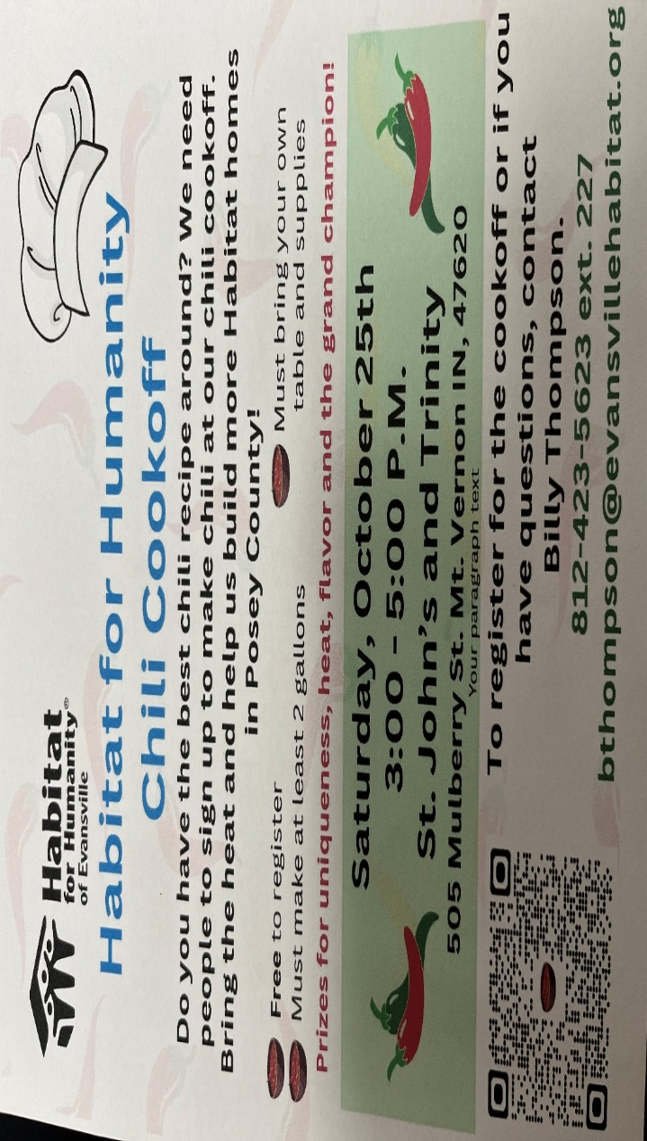


SUNDAY 28th SIXTEENTH SUNDAY AFTER PENTECOST
9:00 a.m. Adult Sunday School
10:00 a.m. Worship
5:30 p.m. – 6:30 p.m. AA Meeting

MONDAY 29th
TUESDAY 30th

WEDNESDAY 1st 9:30 a.m. Exercise Class

THURSDAY 2nd

FRIDAY 3rd

SATURDAY 4th

SUNDAY 5th SEVENTEENTH SUNDAY AFTER PENTECOST
9:00 a.m. Adult Sunday School
10:00 a.m. Worship & Communion
NEIGHBORS IN NEED OFFERING
5:30 p.m. – 6:30 p.m. AA Meeting



October 1 – Emma Lawrence
October 5 – Betty Michael


Gentle Exercise Class . . . designed for 40+
Every Thursday morning at 9:30 am in the Fellowship Hall
Breath & Movement 45 mins~
Discussion on creating a positive mindset 15 min~
Led by De Brown, certified Yoga Instructor and Immanuel UCC member!
*Suggested donation: $5-

