IMMANUEL UNITED CHURCH OF CHRIST
September 27, 2026

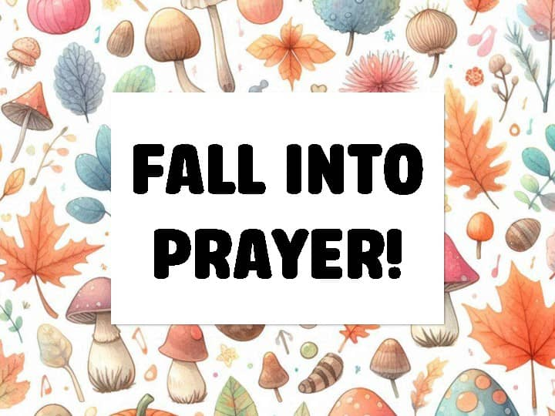

5812 Ford Rd. N. Mt. Vernon, IN 47620 (812) 985-3115
Facebook: Immanuel United Church of Christ Church Website: www.immanueluccmv.com
Church Email: info@immanueluccmv.com IM: Adam McCloud (812) 598-8887
Council President: Bret Baldwin (930) 465-5471 Secretary: Janie Meinschein (812) 483-3578
Our Vision? “To grow a vibrant church by sharing Christ with the community . . .”
Our Mission? “To invite, inspire, involve, increase . . .”

Eighteenth Sunday after Pentecost
September 27, 2026
Adam McCloud, Interim Pastor

RINGING OF THE BELL Keith Deig

WELCOME AND WORDS OF GREETING Debbie Wells

PRELUDE “Verset” By George Blake

*PRAISE HYMN #2061 “Praise Our God Above” (Harvest Song)

*CALL TO WORSHIP Debbie Wells

L: Come, let us celebrate the wondrous gifts that God has given us.

P: Throughout all our lives God has blessed us with love and hope.

L: Praise be to God who provides for us.

P: May our hearts be truly grateful, and may we show our gratitude by the ways in which we live and care for others.

ALL: Amen.

*OPENING HYMN #322 “When Morning Gilds the Skies”

*PRAYER OF CONFESSION (Unison) Debbie Wells

Heavenly Father, when we fail to embrace your love, forgive us. When we fail to follow your Son, Jesus as our Lord and exemplar, forgive us. Lead us, we pray, to become strong witnesses to you and your everlasting love. Amen.

*WORDS OF ASSURANCE Debbie Wells

God renews us and gives us courage to live anew.
With humble hearts, we seek to be ready to receive God’s grace.
We open ourselves to the workings of God’s Holy Spirit.
Thanks be to God!

*GLORIA PATRI
Glory be to the Father, and to the Son, and to the Holy Ghost;
As it was in the beginning, is now, and ever shall be,
world without end. Amen.

CHILDREN’S MOMENTS Ashton Wagner

PRAYERS OF THE PEOPLE Adam McCloud
Silent Prayer ~ Pastoral Prayer ~ Lord’s Prayer

SERVICE OF GIVING
Offertory “Andantino in G” By KH Zollner

*Response No. 382
Praise God, from whom all blessings flow;
Praise Him, all creatures here below;
Praise Him above, ye heavenly host;
Praise Father, Son, and Holy Ghost. Amen.

*Prayer of Dedication (In Unison) Debbie Wells

Almighty God, daily we see your handiwork, and rejoice! With thanksgiving and joy we offer up these gifts, and ask that you use us, our hands, and this body of Christ for the benefit of the world and to your glory. Amen.

SCRIPTURE – Luke 18: 1, 7-8 Debbie Wells

18 Then Jesus told his disciples a parable to show them that they should always pray and not give up.

⁷ And will not God bring about justice for his chosen ones, who cry out to him day and night? Will he keep putting them off? ⁸ I tell you, he will see that they get justice, and quickly. However, when the Son of Man comes, will he find faith on the earth?”

HYMN #432 “Softly & Tenderly”

SERMON “Keep Praying” Adam McCloud

*CLOSING HYMN #677 “They’ll Know We Are Christians by our Love”
Favorite Hymn of Jackson Baldwin

*BENEDICTION

*BENEDICTION SONG “Let There Be Peace on Earth”

Let there be peace on earth and let it begin with me;
let there be peace on earth, the peace that was meant to be.
With God our Maker, family all are we.
Let us walk with each other, in perfect harmony.

Let peace begin with me, let this be the moment now.
With every step I take, may this be my solemn vow:
To take each moment and live each moment
in peace eternally.
Let there be peace on earth, and let it begin with me.

POSTLUDE “A Song of Rejoicing” John Rasley

Used by Permission. CCLI License # 20658309, Streaming # 20658316
+++++++++++++++++++++++++++++++++++++++++++++++++++++++++++++++++++++++++++++

Today October 4
Lay Leader:  Ushers/Greeters:  Pianist/Organist:  Children’s Moments: | Debbie Wells  Chris Moers & Judy Berry  Gail Angel  Ashton Wagner | Bret Baldwin  Terri, Emmerson & Lennox McCormick  Gail Angel  Ashton Wagner

ATTENDANCE | LAST WEEK:48 LAST YEAR: 37

OUR IMMANUEL UCC PRAYER LIST



*Charles Behrick *David Behrick *Becky Brenner *Cherry Chase

*Janice Jones *Kenny Kuebler *Dan Riddle *Ruth Rueger

David Frye Norma Houghton Tom Howard Denis Lambrech

Kenny Meinschein Teresa Topper Ken Willett Eli Williams

Heather Warner, daughter of Sandy Heil

If you have names to be added or deleted from the Prayer List, please obtain permission from the person or a family member for their name to be published.
A phone call or a card will let people know we miss them and we care for them.


We wish to welcome all in the name of Christ.
We invite you to worship with us every Sunday...
and to become a part of this faith household.

We invite you to sign our Guest Book, located in the Narthex.

Interim Minister of Immanuel UCC

Adam McCloud

We pray your message will touch our hearts and inspire our faith.
Thank you for blessing our congregation with your time, wisdom and love.
His contact number is (812) 598-8887.

LUNCH BUNCH  WEDNESDAY, September 30th  12:OO noon    Located at  231 West 2nd Street  Mt. Vernon, IN  EVERYONE IS INVITED! |   Neighbors in Need offering  next Sunday, October 4th  Envelopes are in the Narthex.
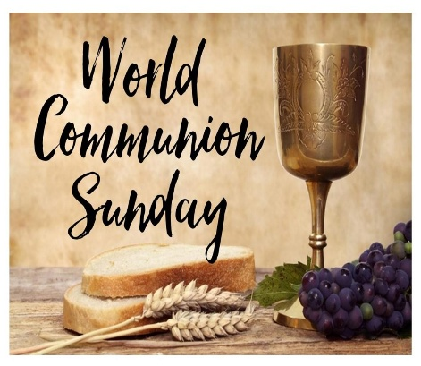  Next Sunday, October 4th  In the UCC, World Communion Sunday is a celebration of global Christian unity,  rooted in shared faith and expressed through worship, scripture, and commitment to  peace and justice across borders.  We welcome to the pulpit  Rev. Jeffrey Howard.  He will present the sermon  and Holy Communion. | 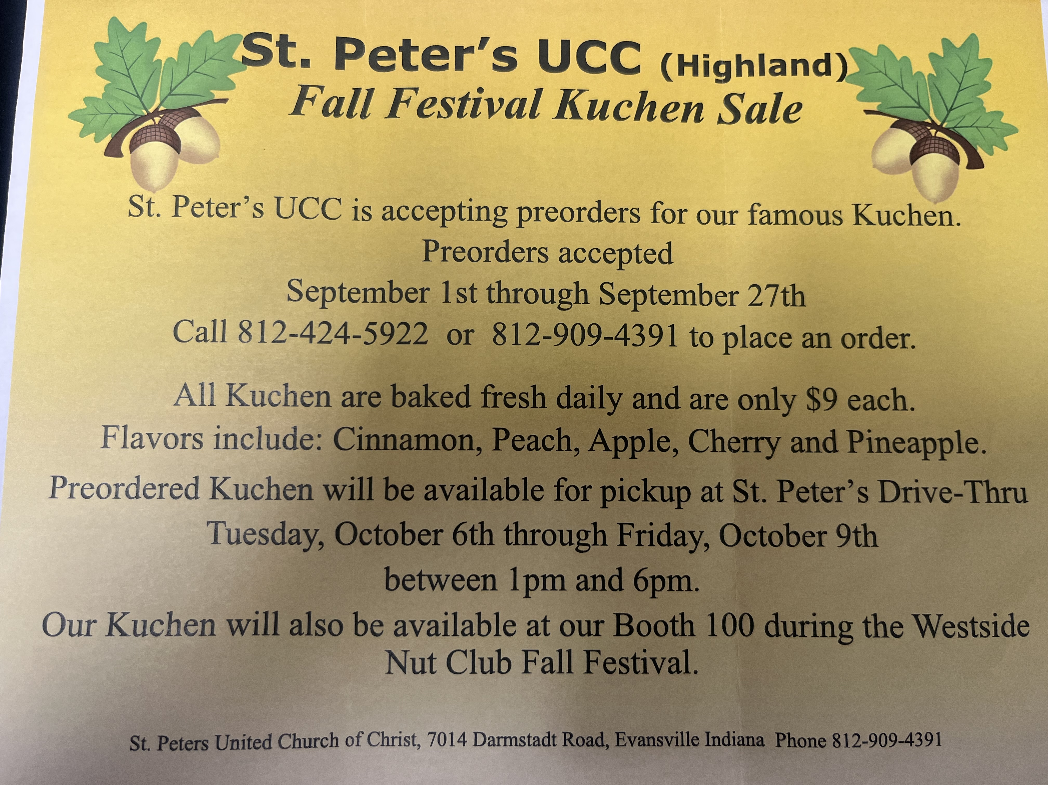

THIS WEEK

SUNDAY 27th EIGHTEENTH SUNDAY AFTER PENTECOST
9:00 a.m. Adult Sunday School
10:00 a.m. Worship
5:30 p.m. – 6:30 p.m. AA Meeting

MONDAY 28^{tht}

TUESDAY 29th

WEDNESDAY 30th 12:00 p.m. Lunch Bunch at Half Moon Saloon

THURSDAY 1st 9:30 a.m. Exercise Class

FRIDAY 2nd

SATURDAY 3rd

SUNDAY 4th NINETEENTH SUNDAY AFTER PENTECOST
WORLD COMMUNION SUNDAY
NEIGHBORS IN NEED OFFERING
9:00 a.m. Adult Sunday School
10:00 a.m. Worship & Communion
5:30 p.m. – 6:30 p.m. AA Meeting



September 27 – Pat Schoonover
October 1 – Emma Lawrence


Gentle Exercise Class . . . designed for 40+
Every Thursday morning at 9:30 am in the Fellowship Hall
Breath & Movement 45 mins~
Discussion on creating a positive mindset 15 min~
Led by De Brown, certified Yoga Instructor and Immanuel UCC member!
*Suggested donation: $5-

