IMMANUEL UNITED CHURCH OF CHRIST
September 21, 2025

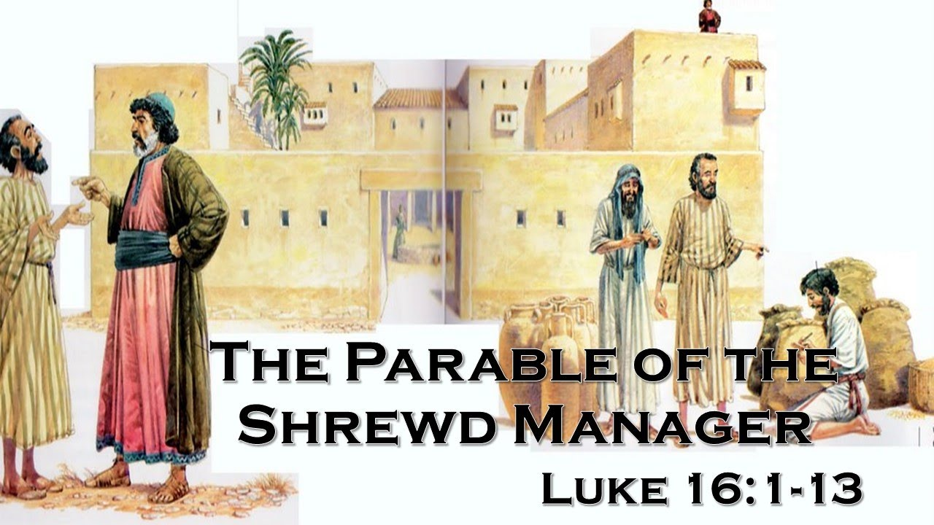

5812 Ford Rd. N. Mt. Vernon, IN 47620 (812) 985-3115
Facebook: Immanuel United Church of Christ Church Website: www.immanueluccmv.com
Church Email: info@immanueluccmv.com Administrative Assistant: Janie Meinschein
Our Vision? “To grow a vibrant church by sharing Christ with the community . . .”
Our Mission? “To invite, inspire, involve, increase . . .”

Fifteenth Sunday after Pentecost
September 21, 2025 – Guest Speaker: Dr. Tom Hickey

RINGING OF THE BELL Keith Deig

WELCOME AND WORDS OF GREETING Jennifer Willett

PRELUDE “Religioso” By Beethoven

*PRAISE HYMN #435 “Spirit Song” (Back of Hymnal)

*CALL TO WORSHIP Jennifer Willett

Lay Leader: God is mighty in word and deed.

People: God’s mercy is everlasting.

Lay Leader: Blessed be the Holy and Living God!

People: Glory to God forever!

*OPENING HYMN #528 “God of Grace and God of Glory”

*PRAYER OF CONFESSION (Unison) Jennifer Willett

Holy God, you call us to boldly proclaim your name. Too often we fail to do so. Forgive us. By the power of your Spirit, give us courage, and lead us away from fear to new life. May we return to faithful living, in Christ’s name we pray. Amen.

*WORDS OF ASSURANCE Jennifer Willett

Listen to the Good News:
God’s grace and mercy are never ending. Our sins are forgiven!
Praise be to God!

*GLORIA PATRI
Glory be to the Father, and to the Son, and to the Holy Ghost;
As it was in the beginning, is now, and ever shall be,
world without end. Amen.

CHILDREN’S MOMENTS OPEN

PRAYERS OF THE PEOPLE Dr. Tom Hickey
Pastoral Prayer ~ Lord’s Prayer

SERVICE OF GIVING Jennifer Willett

Lay Leader: God’s goodness overflows. Let us bear witness to the love of God and present our offerings of thanksgiving to our loving God with generous hearts.

Offertory “Berceuse” By A. Iljinsky
*Response #515 “We Give Thee But Thy Own” (vs 1)

We give Thee but Thine own, What-e’er the gift may be:
All that we have is Thine a-lone, A trust, O Lord, from Thee.

*Prayer of Dedication (In Unison) Jennifer Willett

Gracious God, may we remember that all we have is a gift from you. Pour out your Spirit upon these gifts that they may increase your blessings to others through the grace and mercy of Christ. Amen.

SCRIPTURE – Luke 16:1-13 Jennifer Willett

Jesus told his disciples: “There was a rich man whose manager was accused of wasting his possessions. ² So he called him in and asked him, ‘What is this I hear about you? Give an account of your management, because you cannot be manager any longer.’

³ “The manager said to himself, ‘What shall I do now? My master is taking away my job. I’m not strong enough to dig, and I’m ashamed to beg— ⁴ I know what I’ll do so that, when I lose my job here, people will welcome me into their houses.’

⁵ “So he called in each one of his master’s debtors. He asked the first, ‘How much do you owe my master?’

⁶ “‘Nine hundred gallons^{[a]} of olive oil,’ he replied.

“The manager told him, ‘Take your bill, sit down quickly, and make it four hundred and fifty.’

⁷ “Then he asked the second, ‘And how much do you owe?’

“‘A thousand bushels^{[b]} of wheat,’ he replied.

“He told him, ‘Take your bill and make it eight hundred.’

⁸ “The master commended the dishonest manager because he had acted shrewdly. For the people of this world are more shrewd in dealing with their own kind than are the people of the light. ⁹ I tell you, use worldly wealth to gain friends for yourselves, so that when it is gone, you will be welcomed into eternal dwellings.

¹⁰ “Whoever can be trusted with very little can also be trusted with much, and whoever is dishonest with very little will also be dishonest with much. ¹¹ So if you have not been trustworthy in handling worldly wealth, who will trust you with true riches? ¹² And if you have not been trustworthy with someone else’s property, who will give you property of your own?

¹³ “No one can serve two masters. Either you will hate the one and love the other, or you will be devoted to the one and despise the other. You cannot serve both God and money.”

HYMN #360 “You Servants of God, Your Master Proclaim”

SERMON “The Dishonest Manager” Dr. Tom Hickey

*CLOSING HYMN #402 “O Jesus, I Have Promised”

*BENEDICTION Dr. Tom Hickey

*BENEDICTION RESPONSE #522 “The Lord Bless You and Keep You”

POSTLUDE “Bacarolle” By Frnaz Bendel

Used by Permission. CCLI License # 20658309, Streaming # 20658316

+++++++++++++++++++++++++++++++++++++++++++++++++++++++++++++++++++++++++++++
Today September 28
Lay Leader  Ushers/Greeters:  Pianist/Organist:  Children’s Moments: | Jennifer Willett  Bret & Traci Baldwin  Gail Angel  OPEN | Bret Baldwin  Chris Moers & Nelda Hickey  Gail Angel  OPEN

ATTENDANCE | LAST WEEK: 35 LAST YEAR: 43


OUR IMMANUEL UCC PRAYER LIST

*Charles Behrick *David Behrick *Janice Jones *Cindy Woodall

Ken Willett David Frye Kenny Meinschein Justin Russell

Teresa Topper (Friend of Chris Moers) Tom Howard (Brother of Angela Clark)

Kiersten Ferguson-Cremin (Niece of Paula Boarman)


Welcome
to our church

VISITORS: We invite you to sign our Guest Book, located in the Narthex., as well as the attendance book in the pews.


TODAY WE WELCOME Dr. Tom Hickey
Lay Leader will be Jennifer Willett

NEXT SUNDAY, SEPTEMBER 28st
We welcome Billy Thompson
Lay Leader will be Bret Baldwin.

ANNOUNCEMENTS

BELL CHOIR will practice after worship today. If anyone is interested in joining, please talk to Beth Folz or Debbie Wells.

GENTLE EXERCISE CLASS will NOT meet this Thursday, September 25th, due to the Marrs Field Trip. Exercise Class will resume on Thursday, October 2nd.

OCTOBER NEWSLETTER ARTICLES are due Thursday, September 25th.

PLASTIC CAPS are still being collected. Please make sure they are clean and rinsed out if they have any food or liquid on them. This makes it easy for the individuals that are sorting them.

WHEELCHAIR NEEDED – The church is looking for a gently used wheelchair to be used while at church, not to be taken home. If anyone has a decent wheelchair they would like to donate to the church, it would be appreciated. Ours has started to dry rot.

ATC FOOD COLLECTION FOR SEPTEMBER
We will be collecting BOX & BAG CEREAL.


There is a basket in the Narthex.

Thank you for your donations!!



LUNCH BUNCH AT TEQUILA’S
Wednesday, Sept 24th at 12:00 noon
Co-leaders of Lunch Bunch are Betty Schuessler and Ruth Duckworth.
*Lunch Bunch meets monthly on the last Wednesday of the month.
Mark your calendars!

MARRS FALL FIELD TRIP TO IMMANUEL

THURSDAY, September 25th
Wesselman Woods Nature Center on site
Helpers needed! Sign up sheet in Narthex

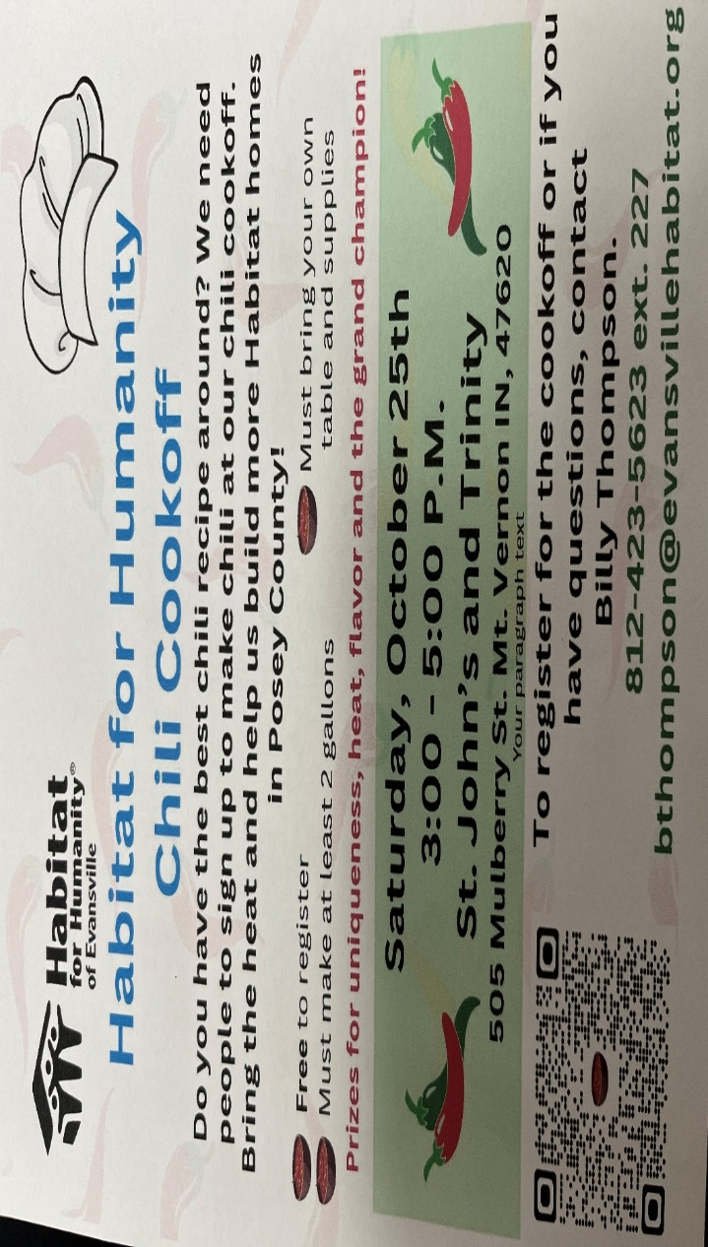


SUNDAY 21st FIFTHEENTH SUNDAY AFTER PENTECOST
9:00 a.m. Adult Sunday School
10:00 a.m. Worship
5:30 p.m. – 6:30 p.m. AA Meeting

MONDAY 22nd First Day of Autumn

TUESDAY 23rd

WEDNESDAY 24th

THURSDAY 25th 9:00 a.m. Marrs Fall Field Trip
October Newsletter articles are due in office

FRIDAY 26th

SATURDAY 27th 1:00 p.m. Fellowship Hall reserved for Frazer Memorial Service

SUNDAY 28th SIXTEENTH SUNDAY AFTER PENTECOST
9:00 a.m. Adult Sunday School
10:00 a.m. Worship
5:30 p.m. – 6:30 p.m. AA Meeting




September 22 – Amy Weiss September 21 – Kevin & Paula Boarman
September 27 – Pat Schoonover September 22 – Destiny & Bo Harris
September 23 – Dan & Terri Riddle
September 23 – Ken & Jennifer Willett
September 23 – Greg & Sheryl Seifert



