IMMANUEL UNITED CHURCH OF CHRIST
September 20, 2026

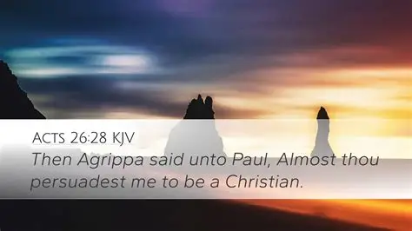

5812 Ford Rd. N. Mt. Vernon, IN 47620 (812) 985-3115
Facebook: Immanuel United Church of Christ Church Website: www.immanueluccmv.com
Church Email: info@immanueluccmv.com Secretary: Janie Meinschein (812)483-3578
Council President: Bret Baldwin (930) 465-5471
Our Vision? “To grow a vibrant church by sharing Christ with the community . . .”
Our Mission? “To invite, inspire, involve, increase . . .”

Seventeenth Sunday after Pentecost
September 20, 2026
Adam McCloud, Interim Pastor

RINGING OF THE BELL Keith Deig

WELCOME AND WORDS OF GREETING Paula Boarman

PRELUDE “Cantilena” By Richard Lloyd

*PRAISE SONG #2025 (Black Hymnal) “As the Deer”

*CALL TO WORSHIP - (based on Psalm 92) Paula Boarman

L: It is good to give thanks to you, O God. To sing praises to your Holy Name.

P: To declare your steadfast love in the morning; and your faithfulness by night.

L: For you, O Lord, have made us glad by your work; at the work of your hands, we sing for joy!

P: How great are your works, O Lord!

*OPENING HYMN #468 “Be Thou My Vision”
Favorite Hymn of Angela Clark

*PRAYER OF CONFESSION (Unison) Paula Boarman

We give thanks, merciful God, that in Christ you seek to unite all things in heaven and on earth. You seek to reconcile all people to one another and to you. When we fail to work toward unity, forgive us. Fill us with your Spirit and call us into reunion with You and our brothers and sisters. Amen.

*WORDS OF ASSURANCE Paula Boarman

The good news in Christ is that God offers us life at every moment,
forgiving us, and inviting us to the freshness of new beginnings.
Let us praise our God of grace!

*GLORIA PATRI

Glory be to the Father, and to the Son, and to the Holy Ghost;
As it was in the beginning, is now, and ever shall be,
world without end. Amen.

CHILDREN’S MOMENTS Ashton Wagner

PASTORAL PRAYER & OUR LORD’S PRAYER Adam McCloud

SERVICE OF GIVING
Offertory “Lyrisch Stuck” By Gustav Merkel

*Response No. 382

Praise God, from whom all blessings flow;
Praise Him, all creatures here below;
Praise Him above, ye heavenly host;
Praise Father, Son, and Holy Ghost. Amen.

*Prayer of Dedication (In Unison) Paula Boarman

Everlasting Father, we respond with joy as we lift up our tithes and offerings unto you. Your blessings touch our lives each and every day. May our lives, and the life of our Church, be a blessing unto you. We pray this in the name of our Savior, Jesus. Amen.

SCRIPTURE: Acts 26: 28 (See front cover) Paula Boarman

SERMON HYMN #417 “Just As I Am, Without One Plea”
Favorite Hymn of Dr. Tom Hickey

SERMON “Almost Persuaded” Adam McCloud

*CLOSING HYMN 2146 (Black Hymnal) “His Eye Is on the Sparrow”
Favorite Hymn of Olivia Reller

*BENEDICTION Adam McCloud

*BENEDICTION SONG “Let There Be Peace on Earth”

Let there be peace on earth and let it begin with me;
let there be peace on earth, the peace that was meant to be.
With God our Maker, family all are we.
Let us walk with each other, in perfect harmony.

Let peace begin with me, let this be the moment now.
With every step I take, may this be my solemn vow:
To take each moment and live each moment
in peace eternally.
Let there be peace on earth, and let it begin with me.

POSTLUDE “Christus der ist mein Leben” By Johann Walter

Used by Permission. CCLI License # 20658309, Streaming # 20658316
+++++++++++++++++++++++++++++++++++++++++++++++++++++++++++++++++++++++++++++
Today September 27
Lay Leader:  Ushers/Greeters:  Pianist/Organist:  Children’s Moments: | Paula Boarman  Bret & Traci Baldwin  Gail Angel  Ashton Wagner | Deb Wells  Chris Moers  Gail Angel  Ashton Wagner

ATTENDANCE | LAST WEEK:54 LAST YEAR: 35

OUR IMMANUEL UCC PRAYER LIST



*Charles Behrick *David Behrick *Becky Brenner *Cherry Chase

*Janice Jones *Kenny Kuebler *Dan Riddle *Ruth Rueger

David Frye Norma Houghton Tom Howard Denis Lambrech

Kenny Meinschein Teresa Topper Ken Willett Eli Williams

Heather, daughter of Sandy Heil

If you have names to be added or deleted from the Prayer List, please obtain permission from the person or a family member for their name to be published.
A phone call or a card will let people know we miss them and we care for them.



We wish to welcome all in the name of Christ.
We invite you to worship with us every Sunday...
and to become a part of this faith household.

We invite you to sign our Guest Book, located in the Narthex.

Interim Minister

Adam McCloud

We pray your message will touch our hearts and inspire our faith.
Thank you for blessing our congregation with your time, wisdom and love.

NEWSLETTER ARTICLES are due in the office by Thursday, September 24th.

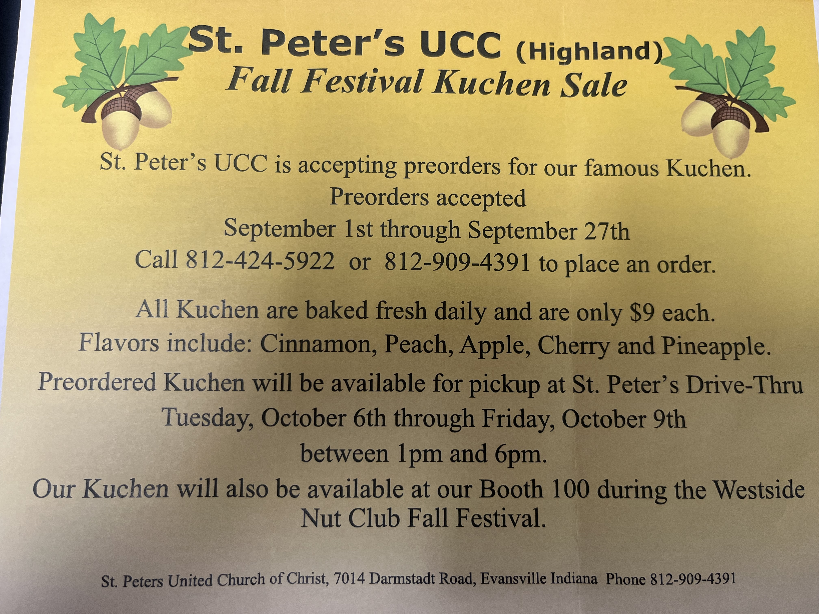



THIS WEEK

SUNDAY 20th SEVENTEENTH SUNDAY AFTER PENTECOST
9:00 a.m. Adult Sunday School
10:00 a.m. Worship
5:30 p.m. – 6:30 p.m. AA Meeting

MONDAY 21st

TUESDAY 22nd First day of Fall

WEDNESDAY 23rd

THURSDAY 24th 9:30 a.m. Exercise Class

FRIDAY 25th

SATURDAY 26th

SUNDAY 27th EIGHTEENTH SUNDAY AFTER PENTECOST
9:00 a.m. Adult Sunday School
10:00 a.m. Worship Service
5:30 p.m. – 6:30 p.m. AA Meeting



September 24 – Duane Lawrence
September 25 – Melody Oeth

Tuesday, September 22, 2026


