IMMANUEL UNITED CHURCH OF CHRIST
September 13, 2026

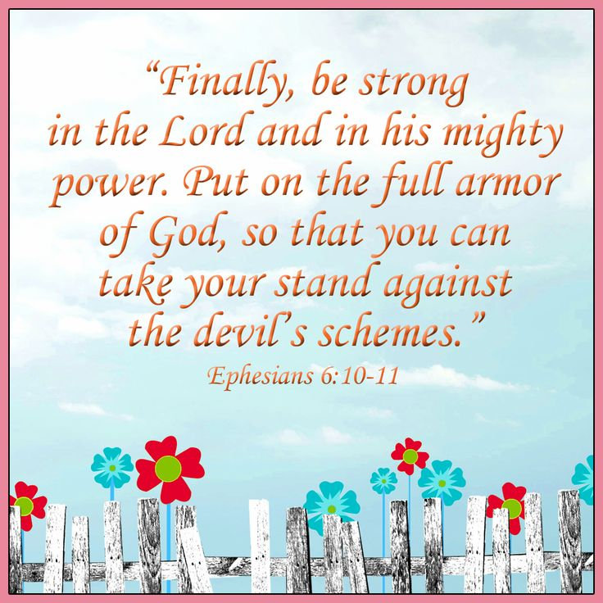

5812 Ford Rd. N. Mt. Vernon, IN 47620 (812) 985-3115
Facebook: Immanuel United Church of Christ Church Website: www.immanueluccmv.com
Church Email: info@immanueluccmv.com Secretary: Janie Meinschein (812)483-3578
Council President: Bret Baldwin (930) 465-5471
Our Vision? “To grow a vibrant church by sharing Christ with the community . . .”
Our Mission? “To invite, inspire, involve, increase . . .”

Sixteenth Sunday after Pentecost
September 13, 2026
Interim Minister – Adam McCloud

RINGING OF THE BELL Keith Deig

WELCOME AND WORDS OF GREETING Dr. Tom Hickey
*Call for Favorite Hymns – Deb Wells

PRELUDE

*PRAISE SONG #227 “There’s Something About That Name”

*CALL TO WORSHIP Dr. Tom Hickey

L: See what love has been given to us, that we should be called children of God! Christ said, “This is my commandment: Love one another.”

P: We come to worship God—who loves us and, through Jesus, teaches us to love one another.

L: Let us sing our praises to God, and live in love and friendship.

*OPENING HYMN #639 “Since Jesus Came Into My Heart”

*PRAYER OF CONFESSION (Unison) Dr. Tom Hickey

Almighty God, we thank you that you have not left us alone in our sin and despair. Loving us, you have brought us good news and set before us the way of life. When we fail to see your loving ways, and when we turn away from the call you set before us, forgive us. Grant that we may be fortified in your Spirit. Lead us, we pray into faithful communion with you. Amen.

*WORDS OF ASSURANCE Dr. Tom Hickey

Hear the Good News:
God, every merciful and loving forgives us.
God’s great mercy abounds and renews us each day.
Thanks be to God!

*GLORIA PATRI

Glory be to the Father, and to the Son, and to the Holy Ghost;
As it was in the beginning, is now, and ever shall be,
world without end. Amen.

CHILDREN’S MOMENTS Ashton Wagner

PRAYERS OF THE PEOPLE Adam McCloud
Silent Prayer ~ Pastoral Prayer ~ Our Lord’s Prayer

SERVICE OF GIVING
Offertory
*Response No. 382

Praise God, from whom all blessings flow;
Praise Him, all creatures here below;
Praise Him above, ye heavenly host;
Praise Father, Son, and Holy Ghost. Amen.

*Prayer of Dedication (In Unison) Dr. Tom Hickey

All good gifts come from you, O God. You have given us life, and new life in Christ. As you have given us gifts, we offer these gifts praying that you bless them. May they be used to your glory and for the benefit of your world. Amen.

SCRIPTURE Ephesians 6: 10-11 (See Front Cover) Dr. Tom Hickey

HYMN #217 “Jesus Walked This Lonesome Valley“

SERMON “His Mighty Power: Adam McCloud

*CLOSING HYMN #619 “I Love to Tell the Story”

*BENEDICTION Adam McCloud
*BENEDICTION SONG “Let There Be Peace on Earth”

Let there be peace on earth and let it begin with me;
let there be peace on earth, the peace that was meant to be.
With God our Maker, family all are we.
Let us walk with each other, in perfect harmony.

Let peace begin with me, let this be the moment now.
With every step I take, may this be my solemn vow:
To take each moment and live each moment
in peace eternally.
Let there be peace on earth, and let it begin with me.
POSTLUDE

Used by Permission. CCLI License # 20658309, Streaming # 20658316
+++++++++++++++++++++++++++++++++++++++++++++++++++++++++++++++++++++++++++++

Today Sept 20
Lay Leader:  Ushers/Greeters:  Pianist/Organist:  Children’s Moments: | Dr. Tom Hickey  Nelda Hickey  Beth Folz  Ashton Wagner | Paula Boarman  Bret & Traci Baldwin  Gail Angel  Ashton Wagner

ATTENDANCE | LAST WEEK:43 LAST YEAR: 49

OUR IMMANUEL UCC PRAYER LIST



*Charles Behrick *David Behrick *Becky Brenner *Cherry Chase

*Janice Jones *Kenny Kuebler *Dan Riddle *Ruth Rueger

David Frye Norma Houghton Tom Howard Denis Lambrech

Kenny Meinschein Teresa Topper Ken Willett Eli Williams

If you have names to be added or deleted from the Prayer List, please obtain permission from the person or a family member for their name to be published.
A phone call or a card will let people know we miss them and we care for them.



We wish to welcome all in the name of Christ.
We invite you to worship with us every Sunday...
and to become a part of this faith household.

We invite you to sign our Guest Book, located in the Narthex.

Interim Minister

Adam McCloud

We pray your message will touch our hearts and inspire our faith.
Thank you for blessing our congregation with your time, wisdom and love.


God’s Storehouse
At St. Peter’s Church in Wadesville
Monday, September 14th at 8:30 a.m.



CHURCH COUNCIL will meet this Thursday, September 17th at 5:30 p.m.

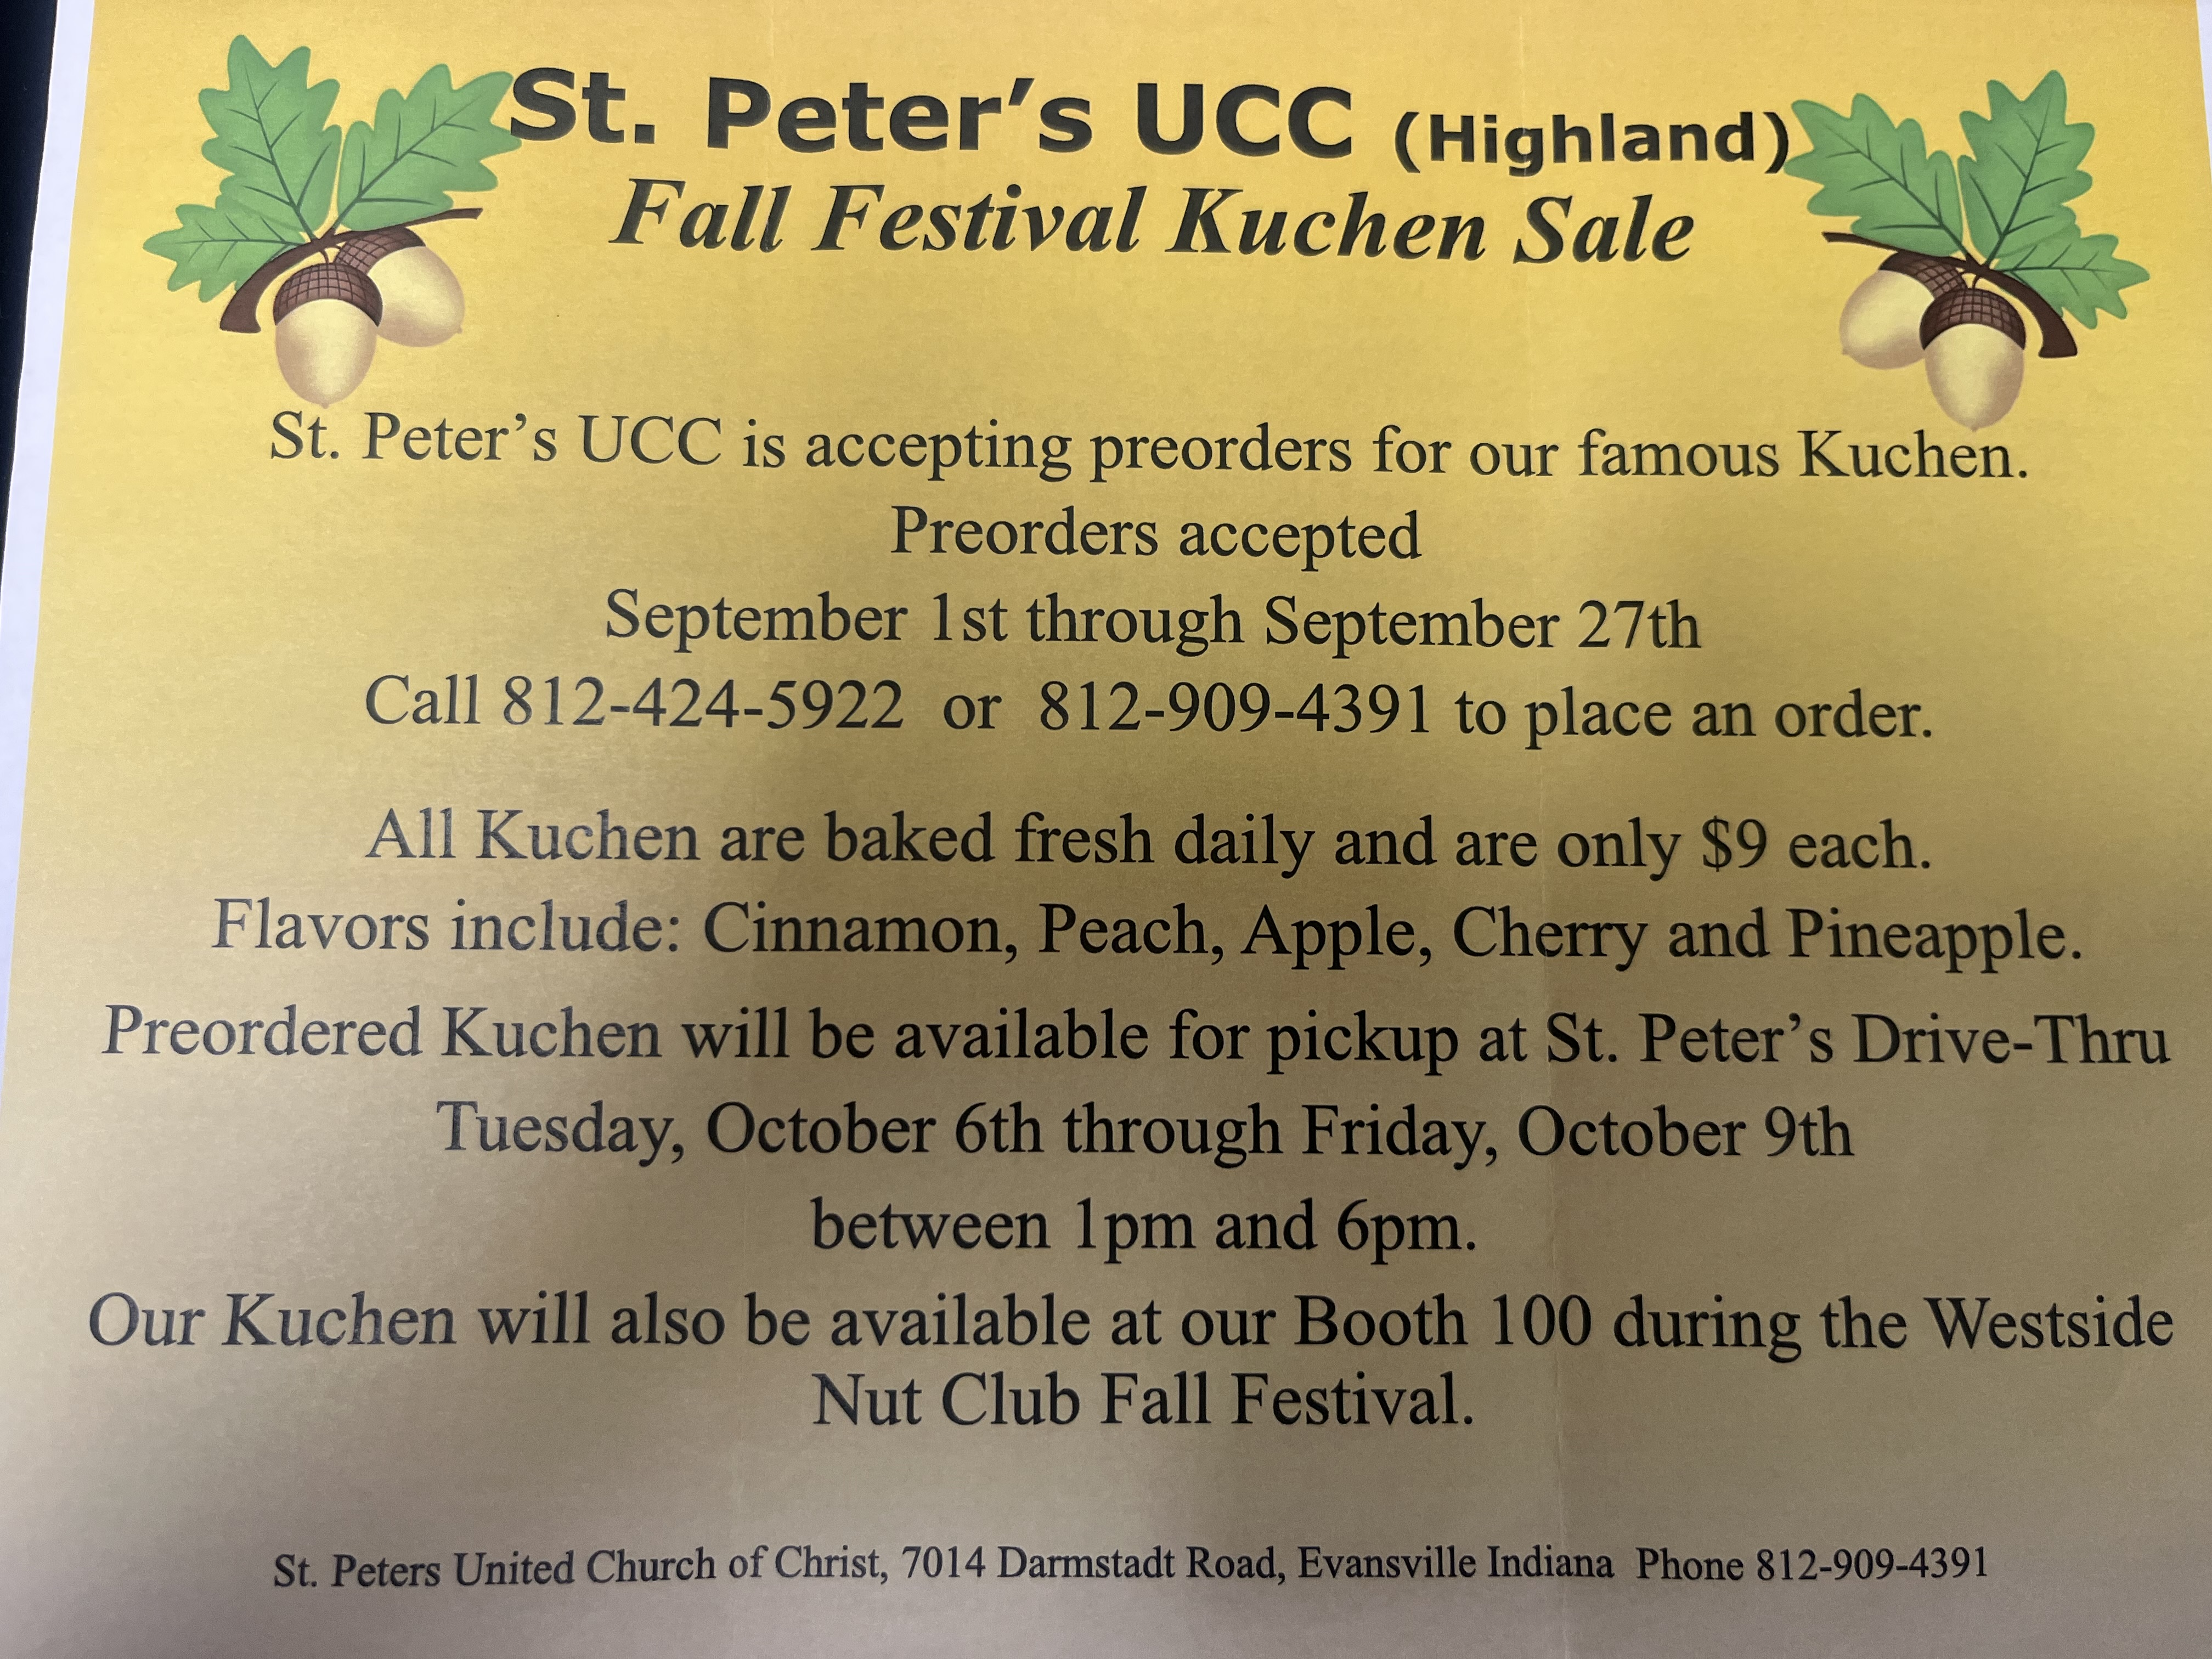


Gentle Exercise Class . . . designed for 40+
Every Thursday morning at 9:30 am in the Fellowship Hall
Breath & Movement 45 mins~
Discussion on creating a positive mindset 15 min~
Led by De Brown, certified Yoga Instructor and Immanuel UCC member!
*Suggested donation: $5-

THIS WEEK

SUNDAY 13th SIXTEENTH SUNDAY AFTER PENTECOST
9:00 a.m. Adult Sunday School
10:00 a.m. Worship
5:30 p.m. – 6:30 p.m. AA Meeting

MONDAY 14th 8:30 a.m. God’s Storehouse

TUESDAY 15th

WEDNESDAY 16th

THURSDAY 17th 9:30 a.m. Exercise Class
5:30 p.m. Council Meeting

FRIDAY 18th

SATURDAY 19th

SUNDAY 20th SEVENTEENTH SUNDAY AFTER PENTECOST
9:00 a.m. Adult Sunday School
10:00 a.m. Worship Service
5:30 p.m. – 6:30 p.m. AA Meeting



September 14 – Paul Williams



September 13 – Mark & Becky Brenner

