

**August 31, 2025**

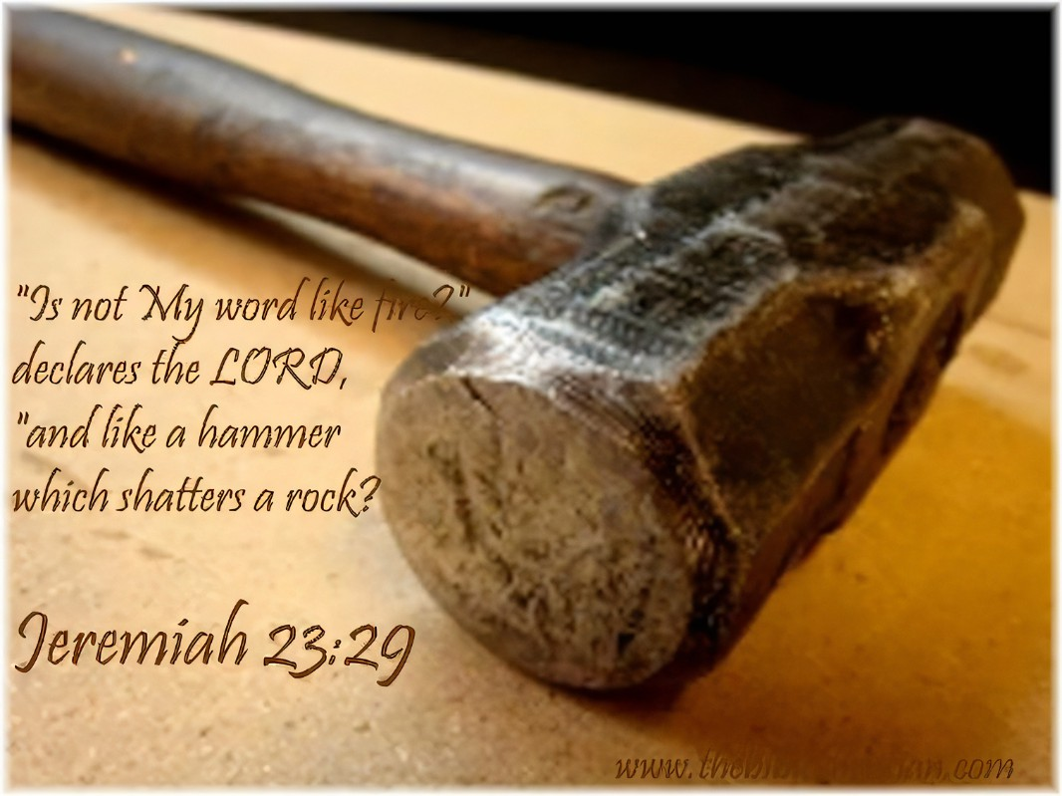



**5812 Ford Rd. N. Mt. Vernon, IN 47620 (812) 985-3115**

**Facebook:** Immanuel United Church of Christ **Church Website:** [www.immanueluccmv.com](http://www.immanueluccmv.com)

**Church Email:** [info@immanueluccmv.com](mailto:info@immanueluccmv.com) **Administrative** **Assistant:** Janie Meinschein

**Our Vision? *“To grow a vibrant church by sharing Christ with the community . . .”***

**Our Mission? *“To invite, inspire, involve, increase . . .”***

**Twelfth Sunday after Pentecost**

August 31, 2025

**RINGING OF THE BELL** Keith Deig

**WELCOME AND WORDS OF GREETING** Paula Boarman

**PRELUDE “Romanze”** By Beethoven

**\*CALL TO WORSHIP** (Based on Psalm 82)Paula Boarman

Leader: In the midst of the divine council, our God holds judgment.

**People: God demands to know how long we will judge unjustly and show partiality to the wicked.**

Leader: Our God seeks justice for the weak and the orphan; seeking to uphold the rights of the lowly and the destitute.

**People: That the weak may be rescued and the needy delivered from the hands of the wicked.**

Leader: All who are without knowledge or understanding, ignorantly walking around in darkness, deserve and require saving from all would exploit them.

**People: Rise up people of God! Cast down wicked mortals and princes for all the nations and earth belong to God. Amen.**

**\*OPENING HYMN #373** ***“Praise the Lord, His Glories Show”***

**\*PRAYER OF INVOCATION** (Unison)Paula Boarman

**Gracious God, we thank you for always being with us. Thank you for being a saving force we can count on through thick and thin. We reach out to you today to help us in this hour of worship. Help us to be fully present and open to your Holy Spirit. Fill us with praise and purpose. Abide in us Lord as we pray to you. Guide us. Renew us. Inspire us. Keep us from wickedness and from following the wicked. Grant us the joy, peace, tolerance, and harmony of your Good News. We offer the power of our lives in service to your everlasting glory. Receive our songs and our thanksgivings, we ask, in Jesus' name. Amen.**

**\*GLORIA PATRI**

***Glory be to the Father, and to the Son, and to the Holy Ghost;***

***As it was in the beginning, is now, and ever shall be,***

***world without end. Amen.***

**SCRIPTURE – Jeremiah 23:23-29** Paula Boarman

**23**Am I a God near by, says the Lord, and not a God far off? **24**Who can hide in secret places so that I cannot see them? says the Lord. Do I not fill heaven and earth? says the Lord. **25**I have heard what the prophets have said who prophesy lies in my name, saying, “I have dreamed! I have dreamed!” **26**How long? Will the hearts of the prophets ever turn back—those who prophesy lies and who prophesy the deceit of their own heart? **27**They plan to make my people forget my name by their dreams that they tell one another, just as their ancestors forgot my name for Baal. **28**Let the prophet who has a dream tell the dream, but let the one who has my word speak my word faithfully. What has straw in common with wheat? says the Lord. **29**Is not my word like fire, says the Lord, and like a hammer that breaks a rock in pieces?

Leader: The Word of God for the People of God.

**People: Thanks be to God. Amen.**

**STORYTIME – All Ages and Stages** Rev Jason Emmerson

**HYMN #2172 (Black Hymnal) *“We Are Called”***

**PRAYERS OF THE PEOPLE** Rev. Jason Emmerson

Silent Prayer ~ Pastoral Prayer ~ Lord’s Prayer

**Our Father, who art in heaven, hallowed be thy name. Thy Kingdom come; Thy will be done on earth, as it is in heaven. Give us this day our daily bread. And forgive us our debts, as we forgive our debtors. Lead us not into temptation but deliver us from evil. For thine is the kingdom, the power, and the glory, forever and ever. Amen.**

**SERVICE OF GIVING**

**Invitation**

Leader: For the ministry and mission of God’s church, we give our morning offering.

**Offertory “Melodie Celeste”** By Thomas Koschat

\***Response No. 382**

***Praise God, from whom all blessings flow;***

***Praise Him, all creatures here below;***

***Praise Him above, ye heavenly host;***

***Praise Father, Son, and Holy Ghost. Amen.***

**\*Prayer of Dedication** (Unison)Paula Boarman

**Gracious God, accept these gifts for what they are and what they represent – our words of thanksgiving made real as evidence of our faith. May all that we receive and offer to you through our service be used through your church for the work of your merciful mission and loving purposes, through Christ our Lord. Amen.**

**SCRIPTURE – Luke 12:49-56** Rev. Jason Emmerson

**49**“I have come to cast fire upon the earth, and how I wish it were already ablaze! **50**I have a baptism with which to be baptized, and what constraint I am under until it is completed! **51**Do you think that I have come to bring peace to the earth? No, I tell you, but rather division! **52**From now on five in one household will be divided, three against two and two against three; **53**they will be divided: father against son and son against father, mother against daughter and daughter against mother, mother-in-law against her daughter-in-law and daughter-in-law against mother-in-law.”

**54**He also said to the crowds, “When you see a cloud rising in the west, you immediately say, ‘It is going to rain,’ and so it happens. **55**And when you see the south wind blowing, you say, ‘There will be scorching heat,’ and it happens. **56**You hypocrites! You know how to interpret the appearance of earth and sky, but why do you not know how to interpret the present time?

**SERMON “Fire Upon the Earth – Part 2”** Rev. Jason Emmerson

**\*CLOSING HYMN** **#618 *“I Will Sing the Wondrous Story”***

**\*BENEDICTION**

Leader: May the Lord of Fire bless you and keep you; may the Lord of Energy shine upon you and be gracious to you; and may the Lord of Love give you an abundant, rewarding, and generous life.

**People: In the power of the Holy Spirit, we now go forth into the world, our mission field, to fulfil our calling as the people of God, the body of Christ. Amen.**

**\*BENEDICTION SONG *“Lord of Life, Lord of Love”***

**Lord, of life, Lord of Love, Walk forever beside us.**

**Day by Day, Show the Way, With your Vision to guide us,**

**Striving to Follow Your Will and Way, Nothing can divide us,**

**Lord of Life, Lord of Love, Walk forever beside us.**

**POSTLUDE “Menuetto”** By Wagner

Used by Permission. CCLI License # 20658309, Streaming # 20658316

**+++++++++++++++++++++++++++++++++++++++++++++++++++++++++++++++++++++++++++++**

**Today** **September 7**

|  |  |  |
| --- | --- | --- |
| Lay Leader  Ushers/Greeters:  Pianist/Organist:  Children’s Moments: | Paula Boarman  Nelda Hickey, Chris Moers  Gail Angel  Rev. Jason Emmerson | Jennifer Willett  OPEN  Beth Folz  Rev Robert Walker |

|  |  |
| --- | --- |
| **ATTENDANCE** | LAST WEEK: 41 LAST YEAR: 86 |



**OUR IMMANUEL UCC PRAYER LIST**

***\*Charles Behrick*** ***\*David Behrick******\*Cherry Chase******\*Janice Jones***

***Ken Willett******David Frye Kenny Meinschein***

***Teresa Topper*** *(Friend of Chris Moers)* ***Tom Howard*** *(Brother of Angela Clark)*

***Kiersten Ferguson-Cremin*** *(Niece of Paula Boarman)*



**VISITORS: We invite you to sign our Guest Book, located in the Narthex., as well as the attendance book in the pews.**

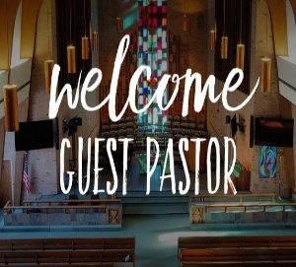

Today we welcome **Rev. Jason Emmerson**.

Lay Leader will be Paula Boarman.

Next Sunday, September 7th, we welcome **Rev. Robert Walker**.

Lay Leader will be Jennifer Willett.

-----------------------------------------------------------------------------------------------------



|  |
| --- |
| trail clean up - Protecting the New Jersey Pinelands and Pine Barrens ... **TRAIL CLEAN UP WORK DAY**  September 20th at 8:00 a.m.  Sign up sheet in the Narthex  Coffee & Donuts will be provided |





**SUNDAY** **31st** **TWELFTH SUNDAY AFTER PENTECOST**

9:00 a.m. Adult Sunday School

10:00 a.m. Worship

5:30 p.m. – 6:30 p.m. AA Meeting

**MONDAY 1st**

**TUESDAY** **2nd**

**WEDNESDAY** **3rd**

**THURSDAY** **4th** 9:30 a.m. Gentle Exercise Class

**FRIDAY** **5th**

**SATURDAY** **6th**

**SUNDAY** **7th THIRTEENTH SUNDAY AFTER PENTECOST**

9:00 a.m. Adult Sunday School

10:00 a.m. Worship & Communion

5:30 p.m. – 6:30 p.m. AA Meeting



*September 2 – Zachary Risher*

**Gentle Exercise Class . . . designed for 40+**

Every **Thursday morning at 9:30** **am** in the Fellowship Hall

Breath & Movement 45 mins~

Discussion on creating a positive mindset 15 min~

Led by De Brown, certified Yoga Instructor and Immanuel UCC member!

*Suggested donation: $5-