IMMANUEL UNITED CHURCH OF CHRIST
August 30, 2026
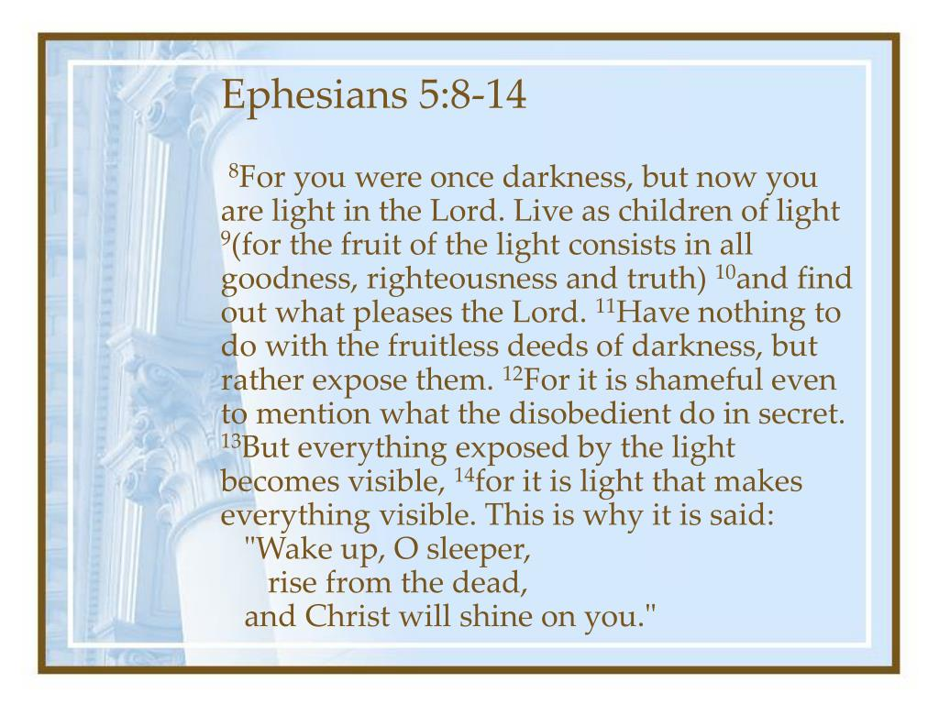

5812 Ford Rd. N. Mt. Vernon, IN 47620 (812) 985-3115
Facebook: Immanuel United Church of Christ Church Website: www.immanueluccmv.com
Church Email: info@immanueluccmv.com Secretary: Janie Meinschein (812)483-3578
Council President: Bret Baldwin (930) 465-5471
Our Vision? “To grow a vibrant church by sharing Christ with the community . . .”
Our Mission? “To invite, inspire, involve, increase . . .”

Fourteenth Sunday after Pentecost
August 30, 2026

Guest Speaker: Dr. Tom Hickey

RINGING OF THE BELL Keith Deig

WELCOME AND WORDS OF GREETING De Brown

PRELUDE “Holy, Holy, Holy” Handbell Choir

*CALL TO WORSHIP De Brown

L: We have come to praise God, who made heaven and earth, and who set the stars in the sky above.

P: We rejoice in the source of love and peace: our living God.

L: We praise His name and open our hearts to God’s spirit and grace.

P: With joy, we lift up our voices rejoicing that God dwells in our hearts, renewing us each and every day.

*OPENING HYMN - #630 “There is Sunshine In My Soul Today”

*PRAYER OF CONFESSION (Unison) De Brown

Risen Lord, We seek to follow you in thought, word, and deed. When we fail to follow, forgive us. When we neglect to ask for your guidance, forgive us. Lead us in the ways of Jesus, always seeking to glorify your Holy Name. We pray this in Jesus’ name. Amen

WORDS OF ASSURANCE De Brown

Our loving God, ever mercifully loves us always,
God forgives and set us on a path of new Life.
Thanks be to God.

*GLORIA PATRI

Glory be to the Father, and to the Son, and to the Holy Ghost;
As it was in the beginning, is now, and ever shall be,
world without end. Amen.

CHILDREN’S MOMENTS Ashton Wagner

SPECIAL MUSIC Dulcimers
“Nothing But the Blood”
“Leaning on the Everlasting Arms”
“When the Roll is Called Up Yonder”

PRAYERS OF THE PEOPLE
Silent Prayer ~ Pastoral Prayer ~ The Lord’s Prayer

SERVICE OF GIVING

Lay Leader: Generosity helps us to forgive and to heal; it helps us to make peace in the world; it helps to bring justice and mercy to those in need. Our gifts this morning are one way we prepare for God’s coming into the world in the most unexpected ways. Let us gather our gifts together in the plates, online, or mailed to the church and offer them to God in gratitude and praise.
Let the offering begin.

Offertory “It is Well with My Soul” Handbell Choir

*Response No. 382

Praise God, from whom all blessings flow;
Praise Him, all creatures here below;
Praise Him above, ye heavenly host;
Praise Father, Son, and Holy Ghost. Amen.

*Prayer of Dedication (In Unison) De Brown

Lord God, our Creator, we joyfully present to you our tithes and offerings. May they be a blessing to you and your ministry here at Immanuel. May our inspiration be so bold as to proclaim Your Holy Name is all that we say and do. We pray this in Jesus’ name. Amen.

SCRIPTURE – Ephesians 5: 8-14 (See Front Cover) De Brown

SERMON HYMN - #636 “The Light of the World is Jesus”

SERMON “Children of God” Dr. Tom Hickey

*CLOSING HYMN – #2173 (Black Hymnal) “Shine Jesus Shine”

*BENEDICTION
*BENEDICTION SONG “Lord of Life”

Lord, of life, Lord of Love, Walk forever beside us.
Day by Day, Show the Way, With your Vision to guide us,
Striving to Follow Your Will and Way, Nothing can divide us,
Lord of Life, Lord of Love, Walk forever beside us.

POSTLUDE “I Saw the Light” By Hank Williams
Used by Permission. CCLI License # 20658309, Streaming # 20658316
+++++++++++++++++++++++++++++++++++++++++++++++++++++++++++++++++++++++++++++

Today Sept 6
Lay Leader:  Ushers/Greeters:  Pianist/Organist:  Children’s Moments: | De Brown  Nelda Hickey  Judy Grebe  Ashton Wagner | OPEN  Tina Kissinger  Beth Folz  Ashton Wagner

ATTENDANCE | LAST WEEK:46 LAST YEAR: 41

OUR IMMANUEL UCC PRAYER LIST

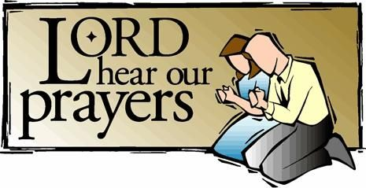

*Charles Behrick *David Behrick *Becky Brenner Cherry Chase

*Janice Jones *Kenny Kuebler *Dan Riddle *Ruth Rueger

David Frye Norma Houghton Tom Howard Denis Lambrech

Kenny Meinschein Teresa Topper Ken Willett Eli Williams

If you have names to be added or deleted from the Prayer List, please obtain permission from the person or a family member for their name to be published.
A phone call or a card will let people know we miss them and we care for them.



We wish to welcome all in the name of Christ.
We invite you to worship with us every Sunday...
and to become a part of this faith household.

We invite you to sign our Guest Book, located in the Narthex.

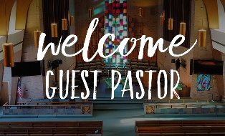


TODAY NEXT SUNDAY
Dr. Tom Hickey Rev. Bob Walker

We pray their message will touch our hearts and inspire our faith.
Thank you for blessing our congregation with your time, wisdom and love.

THIS WEEK

SUNDAY 30th FOURTEENTH SUNDAY AFTER PENTECOST
9:00 a.m. Adult Sunday School
10:00 a.m. Worship
5:30 p.m. – 6:30 p.m. AA Meeting

MONDAY 31st

TUESDAY 1st

WEDNESDAY 2nd

THURSDAY 3rd 9:30 a.m. Exercise Class

FRIDAY 4th

SATURDAY 5th

SUNDAY 6th FIFTEENTH SUNDAY AFTER PENTECOST
9:00 a.m. Adult Sunday School
10:00 a.m. Worship Service
5:30 p.m. – 6:30 p.m. AA Meeting



September 2 – Zachary Risher


Gentle Exercise Class . . . designed for 40+
Every Thursday morning at 9:30 am in the Fellowship Hall
Breath & Movement 45 mins~
Discussion on creating a positive mindset 15 min~
Led by De Brown, certified Yoga Instructor and Immanuel UCC member!
*Suggested donation: $5-

