**IMMANUEL UNITED CHURCH OF CHRIST**

**August 3, 2025**

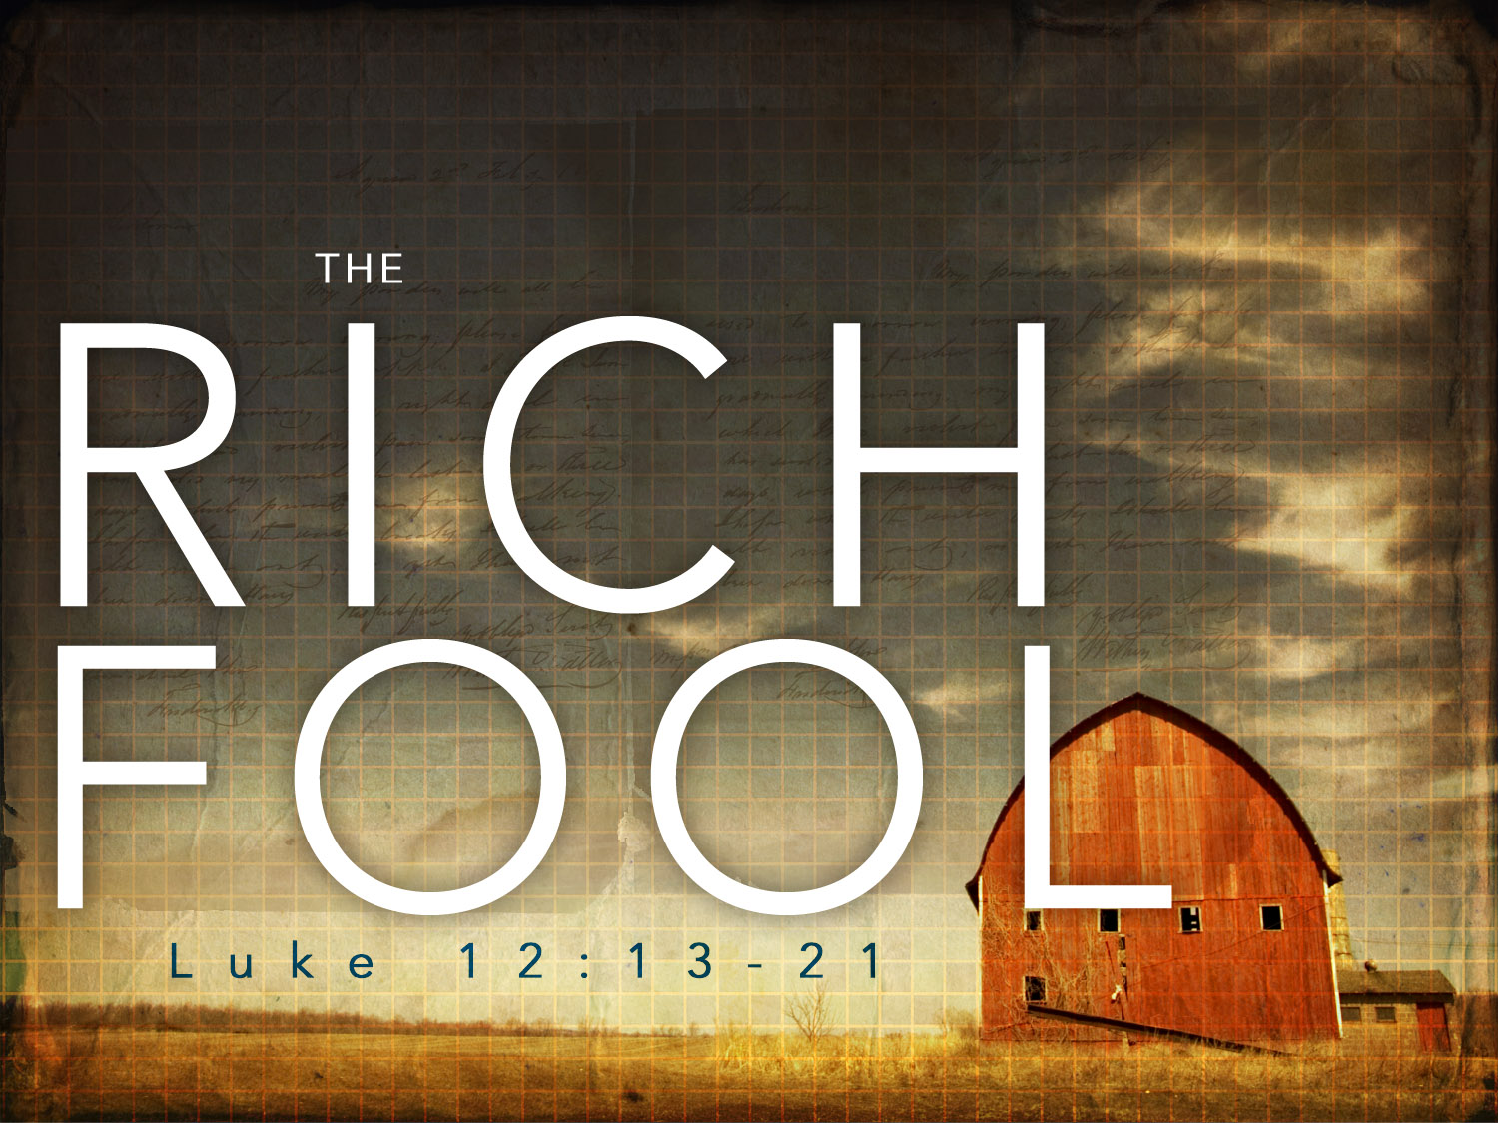

**5812 Ford Rd. N. Mt. Vernon, IN 47620 (812) 985-3115**

**Facebook:** Immanuel United Church of Christ **Church Website:** [www.immanueluccmv.com](http://www.immanueluccmv.com)

**Church Email:** [info@immanueluccmv.com](mailto:info@immanueluccmv.com) **Administrative** **Assistant:** Janie Meinschein

**Our Vision? *“To grow a vibrant church by sharing Christ with the community . . .”***

**Our Mission? *“To invite, inspire, involve, increase . . .”***

**Eighth Sunday after Pentecost ~ Holy Communion**

August 3, 2025

**RINGING OF THE BELL** Keith Deig

**WELCOME AND WORDS OF GREETING** Bret Baldwin

**PRELUDE**

**\*CALL TO WORSHIP** Bret Baldwin

Leader: Give thanks to the Lord, the maker of heaven and earth.

**All: We gather to give God thanks and praise.**

Leader: Make an offering in God's holy temple that is acceptable to him.

**All: We come to worship God in Spirit and in Truth.**

Leader Love the Lord your God with all your heart, and all of your mind,

and all of your strength and all of your soul.

**All: We are here because our desire is to know and to serve God,**

**in the way he desires, freely and completely, both now and forevermore. Amen.**

**\*OPENING HYMN #21 *“Love Divine, All Loves Excelling”***

**\*PRAYER OF CONFESSION** (Unison) Bret Baldwin

O God, you have spoken to men and women of old through dreams and visions, yet we confess we seek to rely on reason and tradition alone. Fill us with vision, lead us into the future, and enable us to grow toward a deeper understanding of you, through the power of your Holy Spirit, now and forever. Amen.

**\*WORDS OF ASSURANCE** Rev. Robert B. Walker

**\*GLORIA PATRI**

***Glory be to the Father, and to the Son, and to the Holy Ghost;***

***As it was in the beginning, is now, and ever shall be,***

***world without end. Amen.***

**TIME FOR THE YOUNG AT HEART** Rev. Robert B. Walker

**PASTORAL PRAYER – THE LORD’S PRAYER** Rev. Robert B. Walker

**SERVICE OF GIVING**

**Invitation** Rev. Robert B. Walker

**Offertory**

\***Response No. 382**

***Praise God, from whom all blessings flow;***

***Praise Him, all creatures here below;***

***Praise Him above, ye heavenly host;***

***Praise Father, Son, and Holy Ghost. Amen.***

**\*Prayer of Dedication** (Unison)

**Abundant God, we bring you our gifts in gratitude for your generosity. Bless and multiply these gifts in Jesus’ name, so that they can spread your goodness in the world and touch lives of those in need, in Christ’s name. Amen.**

**SCRIPTURE – Luke 12: 13-23;34** Rev. Robert B. Walker

13Someone in the crowd said to him, “Teacher, tell my brother to divide the inheritance with me.”

14Jesus replied, “Man, who appointed me a judge or an arbiter between you?” 15Then he said to them, “Watch out! Be on your guard against all kinds of greed; life does not consist in an abundance of possessions.”

16And he told them this parable: “The ground of a certain rich man yielded an abundant harvest. 17He thought to himself, ‘What shall I do? I have no place to store my crops.’

18“Then he said, ‘This is what I’ll do. I will tear down my barns and build bigger ones, and there I will store my surplus grain. 19And I’ll say to myself, “You have plenty of grain laid up for many years. Take life easy; eat, drink and be merry.”’

20“But God said to him, ‘You fool! This very night your life will be demanded from you. Then who will get what you have prepared for yourself?’

21“This is how it will be with whoever stores up things for themselves but is not rich toward God.”

22Then Jesus said to his disciples: “Therefore I tell you, do not worry about your life, what you will eat; or about your body, what you will wear. 23For life is more than food, and the body more than clothes.

34For where your treasure is, there your heart will be also.”

**SERMON “Finding the Treasure”** Rev. Robert B. Walker

**\*HYMN #567 *“Here, O My Lord, I See Thee Face to Face”***

**THE LORD INVITES US TO HIS TABLE**

**Invitation to Communion**

**Prayer of Consecration**

**Sharing The Bread and Cup**

**Prayer of Thanksgiving** (Unison)

**God of new life, with joy we have received this meal of bread and the fruit of the vine,**

**giving you thanks for Jesus Christ, our peace and our hope. Unite your gathered church in continuing Christ’s ministry of love and servanthood, of joy with each other and reaching out to spread your Good News into a yearning and lost world. May your name be praised in all the earth! Amen!**

**\*CLOSING HYMN #394 *“Rejoice, Ye Pure in Heart”***

**\*PASTORAL BENEDICTION**

**\*BENEDICTION SONG *“Let There Be Peace on Earth”***

**Let there be peace on earth and let it begin with me;**

**let there be peace on earth, the peace that was meant to be.**

**With God our Maker, family all are we.**

**Let us walk with each other, in perfect harmony.**

**Let peace begin with me, let this be the moment now.**

**With every step I take, may this be my solemn vow:**

**To take each moment and live each moment**

**in peace eternally.**

**Let there be peace on earth, and let it begin with me.**

**POSTLUDE**

Used by Permission. CCLI License # 20658309, Streaming # 20658316

**+++++++++++++++++++++++++++++++++++++++++++++++++++++++++++++++++++++++++++++**

**Today** **August 10**

|  |  |  |
| --- | --- | --- |
| Liturgist:  Ushers/Greeters:  Pianist/Organist:  Children’s Moments: | Bret Baldwin  Traci Baldwin, Daryl Shuck  Beth Folz  Rev. Robert Walker | Melody Oeth  OPEN  Beth Folz  Dr. Tom Hickey |

|  |  |
| --- | --- |
| **ATTENDANCE** | LAST WEEK: 43 LAST YEAR: 50 |



**OUR IMMANUEL UCC PRAYER LIST**

***\*Charles Behrick*** ***\*David Behrick******\*Cherry Chase******\*Janice Jones***

***Ken Willett******David Frye Kenny Meinschein***

***Teresa Topper*** *(Friend of Chris Moers)* ***Tom Howard*** *(Brother of Angela Clark)*

***Kiersten Ferguson-Cremin*** *(Niece of Paula Boarman)*



**VISITORS**

We invite you to sign our Guest Book, located in the Narthex.,

as well as the attendance book in the pews.

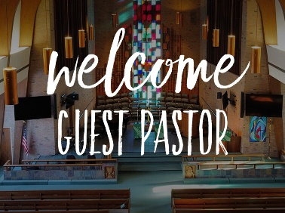***TODAY***

***We welcome our Guest Minister:***

***Rev. Robert Walker***

***With Bret Baldwin as our Liturgist.***

Robert Walker is a native of Evansville and a graduate of the University of Southern Indiana, Eden Theological Seminary, and St. Louis University. Ordained by the Evansville/Tri-State Association, he served churches in Illinois, St. Louis, Evansville, and Ohio., as well as being on the Board of Directors of different Conferences and the German Partnership of the Indiana-Kentucky Conference. He and his wife Janet live in Evansville, Indiana where Robert has served a UCC church in Evansville from 2021-2024. His hobbies include writing Lenten and Advent devotional booklets, church bulletin liturgy (calls to worship, prayers of invocation, pastoral prayers), electronic vintage stereo repair, playing electric bass in different bands and church music, jogging, and even car repair

“just because!”

 ***Next Sunday, August 10th***

***Guest Speaker: Dr. Tom Hickey***

***With Melody Oeth as Liturgist***



**SUNDAY** **3rd**  **EIGHTH SUNDAY AFTER PENTECOST**

9:00 a.m. Adult Sunday School

10:00 a.m. Worship & Communion

5:30 p.m. – 6:30 p.m. AA Meeting

**MONDAY 4th**

**TUESDAY** **5th**

**WEDNESDAY** **6th**

**THURSDAY** **7th** 9:30 a.m. Gentle Exercise Class

**FRIDAY** **8th**

**SATURDAY** **9th**

**SUNDAY** **10th NINTH SUNDAY AFTER PENTECOST**

9:00 a.m. Adult Sunday School

10:00 a.m. Worship

5:30 p.m. – 6:30 p.m. AA Meeting



*August 5 – Dennis & Angela Clark*

*August 8 – Brittaney & Matthew Johnson*

**Gentle Exercise Class . . . designed for 40+**

Every **Thursday morning at 9:30** **am** in the Fellowship Hall

Breath & Movement 45 mins~

Discussion on creating a positive mindset 15 min~

Led by De Brown, certified Yoga Instructor and Immanuel UCC member!

*Suggested donation: $5-



|  |  |
| --- | --- |
|  |  |
|  |  |