

**August 24, 2025**

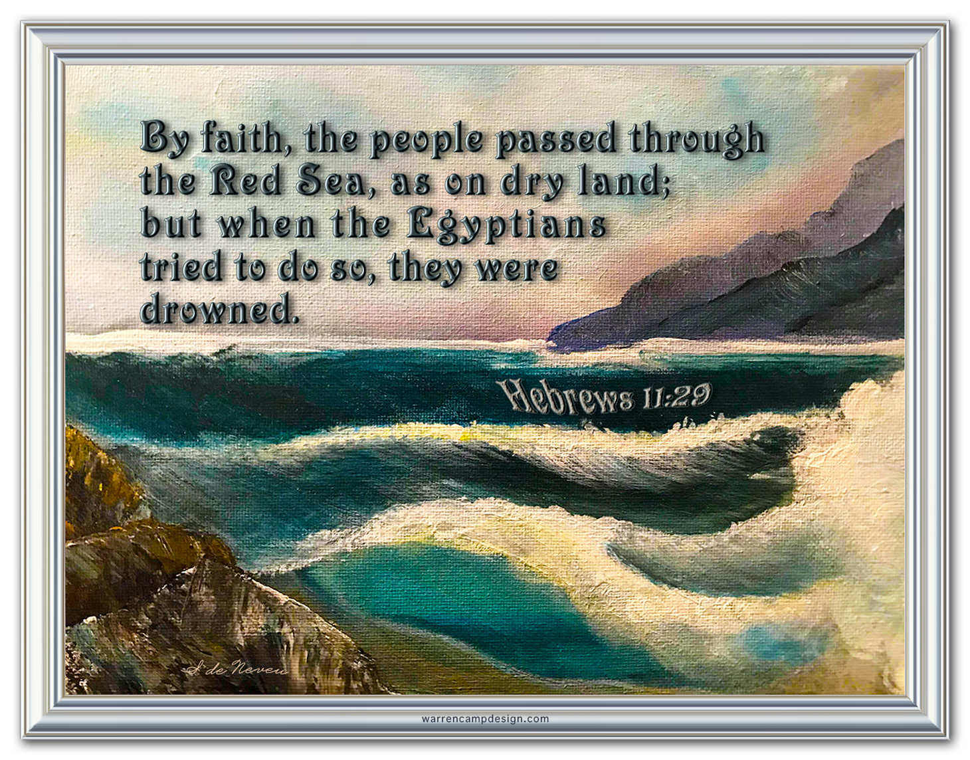

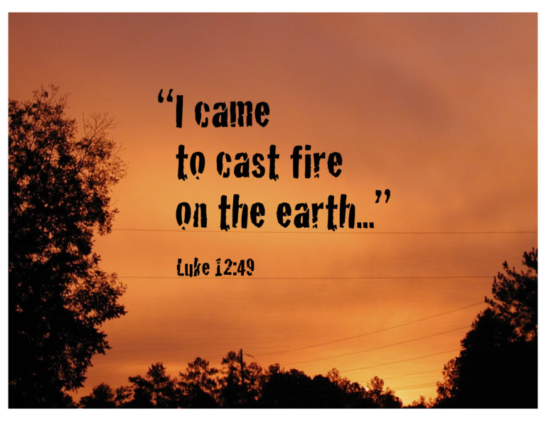

**5812 Ford Rd. N. Mt. Vernon, IN 47620 (812) 985-3115**

**Facebook:** Immanuel United Church of Christ **Church Website:** [www.immanueluccmv.com](http://www.immanueluccmv.com)

**Church Email:** [info@immanueluccmv.com](mailto:info@immanueluccmv.com) **Administrative** **Assistant:** Janie Meinschein

**Our Vision? *“To grow a vibrant church by sharing Christ with the community . . .”***

**Our Mission? *“To invite, inspire, involve, increase . . .”***

**Eleventh Sunday after Pentecost**

August 24, 2025

**RINGING OF THE BELL** Keith Deig

**WELCOME AND WORDS OF GREETING** Judy Deig

**PRELUDE *“Andante con Moto”*** By Schubert

**\*CALL TO WORSHIP** (Based on Psalm 82)Judy Deig

Leader: In the midst of the divine council, our God holds judgment.

**People: God demands to know how long we will judge unjustly and show partiality to the wicked.**

Leader: Our God seeks justice for the weak and the orphan; seeking to uphold the rights of the lowly and the destitute.

**People: That the weak may be rescued and the needy delivered from the hands of the wicked.**

Leader: All who are without knowledge or understanding, ignorantly walking around in darkness, deserve and require saving from all would exploit them.

**People: Rise up people of God! Cast down wicked mortals and princes for all the nations and earth belong to God. Amen.**

**\*OPENING HYMN #373** ***“Praise the Lord, His Glories Show”***

**\*PRAYER OF INVOCATION** (Unison)Judy Deig

**Gracious God, we thank you for being with us and for being a saving force we can count on through thick and thin. We’re reaching out to you today. We call upon you to help us in this hour of worship. Help us to be fully present and open to your Holy Spirit, to enthrone you in praise, and to follow you in joyful obedience. Abide in us Lord as we pray to you. Guide us. Renew us. Inspire us. Keep us from wickedness and from following the wicked. Grant us the joy, peace, tolerance, and harmony of your everlasting Kingdom. We offer the power of our lives in service to your everlasting glory. Receive our songs and our thanksgivings, we ask, in Jesus' name. Amen.**

**\*GLORIA PATRI**

***Glory be to the Father, and to the Son, and to the Holy Ghost;***

***As it was in the beginning, is now, and ever shall be,***

***world without end. Amen.***

**SCRIPTURE – Hebrews 11:29-12:2** Judy Deig

**29**By faith the people passed through the Red Sea as if it were dry land, but when the Egyptians attempted to do so they were drowned. **30**By faith the walls of Jericho fell after they had been encircled for seven days. **31**By faith Rahab the prostitute did not perish with those who were disobedient,[[a](https://www.biblegateway.com/passage/?search=Hebrews%2011%3A29-12%3A2%09&version=NRSVUE#fen-NRSVUE-30187a)] because she had received the spies in peace.

**32**And what more should I say? For time would fail me to tell of Gideon, Barak, Samson, Jephthah, of David and Samuel and the prophets, **33**who through faith conquered kingdoms, administered justice, obtained promises, shut the mouths of lions, **34**quenched the power of fire, escaped the edge of the sword, were made strong out of weakness, became mighty in war, put foreign armies to flight. **35**Women received their dead by resurrection. Others were tortured, refusing to accept release, in order to obtain a better resurrection. **36**Others suffered mocking and flogging and even chains and imprisonment. **37**They were stoned to death; they were sawn in two;[[b](https://www.biblegateway.com/passage/?search=Hebrews%2011%3A29-12%3A2%09&version=NRSVUE#fen-NRSVUE-30193b)] they were killed by the sword; they went about in skins of sheep and goats, destitute, persecuted, tormented— **38**of whom the world was not worthy. They wandered in deserts and mountains and in caves and holes in the ground.

**39**Yet all these, though they were commended for their faith, did not receive what was promised, **40**since God had provided something better so that they would not, apart from us, be made perfect.

**12**Therefore, since we are surrounded by so great a cloud of witnesses, let us also lay aside every weight and the sin that clings so closely,[[c](https://www.biblegateway.com/passage/?search=Hebrews%2011%3A29-12%3A2%09&version=NRSVUE#fen-NRSVUE-30197c)] and let us run with perseverance the race that is set before us, **2**looking to Jesus, the pioneer and perfecter of faith, who for the sake of[[d](https://www.biblegateway.com/passage/?search=Hebrews%2011%3A29-12%3A2%09&version=NRSVUE#fen-NRSVUE-30198d)] the joy that was set before him endured the cross, disregarding its shame, and has taken his seat at the right hand of the throne of God.

Leader: The Word of God for the People of God.

**People: Thanks be to God. Amen.**

**STORYTIME – All Ages and Stages** Rev. Jason Emmerson

**HYMN #2172 (Black Hymnal) *“We Are Called”***

**PRAYERS OF THE PEOPLE Rev. Jason Emmerson**

Silent Prayer ~ Pastoral Prayer ~ Lord’s Prayer

**Our Father, who art in heaven, hallowed be thy name. Thy Kingdom come; Thy will be done on earth, as it is in heaven. Give us this day our daily bread. And forgive us our debts, as we forgive our debtors. Lead us not into temptation but deliver us from evil. For thine is the kingdom, the power, and the glory, forever and ever. Amen.**

**SERVICE OF GIVING**

**Invitation**

Leader: For the ministry and mission of God’s church, we give our morning offering.

**Offertory *“The Last Spring”*** By Grieg

\***Response No. 382**

***Praise God, from whom all blessings flow;***

***Praise Him, all creatures here below;***

***Praise Him above, ye heavenly host;***

***Praise Father, Son, and Holy Ghost. Amen.***

**\*Prayer of Dedication** (Unison)Judy Deig

**Gracious God, accept these gifts for what they are and what they represent – our words of thanksgiving made real as evidence of our faith. May all that we receive and offer to you through our service be used through your church for the work of your merciful mission and loving purposes, through Christ our Lord. Amen.**

**SCRIPTURE – Luke 12:49-56** Rev. Jason Emmerson

**49**“I have come to cast fire upon the earth, and how I wish it were already ablaze! **50**I have a baptism with which to be baptized, and what constraint I am under until it is completed! **51**Do you think that I have come to bring peace to the earth? No, I tell you, but rather division! **52**From now on five in one household will be divided, three against two and two against three; **53**they will be divided: father against son and son against father, mother against daughter and daughter against mother, mother-in-law against her daughter-in-law and daughter-in-law against mother-in-law.”

**54**He also said to the crowds, “When you see a cloud rising in the west, you immediately say, ‘It is going to rain,’ and so it happens. **55**And when you see the south wind blowing, you say, ‘There will be scorching heat,’ and it happens. **56**You hypocrites! You know how to interpret the appearance of earth and sky, but why do you not know how to interpret the present time?

**SERMON “Fire Upon the Earth”**  Rev. Jason Emmerson

**\*CLOSING HYMN** **#618 *“I Will Sing the Wondrous Story”***

**\*BENEDICTION**

Leader: May the Lord of Fire bless you and keep you; may the Lord of Energy shine upon you and be gracious to you; and may the Lord of Love give you an abundant, rewarding, and generous life.

**People: In the power of the Holy Spirit, we now go forth into the world, our mission field, to fulfil our calling as the people of God, the body of Christ. Amen.**

**\*BENEDICTION SONG *“Lord of Life, Lord of Love”***

**Lord, of life, Lord of Love, Walk forever beside us.**

**Day by Day, Show the Way, With your Vision to guide us,**

**Striving to Follow Your Will and Way, Nothing can divide us,**

**Lord of Life, Lord of Love, Walk forever beside us.**

**POSTLUDE *“Air du Dauphin”*** By Joseph Roeckel

Used by Permission. CCLI License # 20658309, Streaming # 20658316

**+++++++++++++++++++++++++++++++++++++++++++++++++++++++++++++++++++++++++++++**

**Today** **August 31**

|  |  |  |
| --- | --- | --- |
| Lay Leader  Ushers/Greeters:  Pianist/Organist:  Children’s Moments: | Judy Deig  Justin, Ashton & Rose Wagner  Gail Angel  Rev. Jason Emmerson | Paula Boarman  Nelda Hickey  Gail Angel  Rev. Jason Emmerson |

|  |  |
| --- | --- |
| **ATTENDANCE** | LAST WEEK: 33 LAST YEAR: 54 |



**OUR IMMANUEL UCC PRAYER LIST**

***\*Charles Behrick*** ***\*David Behrick******\*Cherry Chase******\*Janice Jones***

***Ken Willett******David Frye Kenny Meinschein***

***Teresa Topper*** *(Friend of Chris Moers)* ***Tom Howard*** *(Brother of Angela Clark)*

***Kiersten Ferguson-Cremin*** *(Niece of Paula Boarman)*

**VISITORS**

We invite you to sign our Guest Book, located in the Narthex.,

as well as the attendance book in the pews.

|  |  |
| --- | --- |
| **TODAY**  **August 24th**  **Jay Makowski Preaches - University United Methodist Church**  ***We welcome***  ***Rev. Jason Emmerson***  ***With Lay Leader: Judy Deig*** | **NEXT SUNDAY**  **August 31st**  Guest Preacher | Chehalem Valley Baptist Church  ***We welcome***  ***Rev. Jason Emmerson***  ***With Lay Leader: Paula Boarman*** |



**We wish to express our deepest sympathy to Mellisa Hall.**

**Her husband, Sam passed away on Sunday, August 17th.**

**Our prayers go out to Mellisa and her family.**



**SUNDAY** **24th** **ELEVENTH SUNDAY AFTER PENTECOST**

9:00 a.m. Adult Sunday School

10:00 a.m. Worship

5:30 p.m. – 6:30 p.m. AA Meeting

**MONDAY 25th**

**TUESDAY** **26th**

**WEDNESDAY** **27th** 12:00p.m. Lunch Bunch at Tequila’s

**THURSDAY** **28th** 9:30 a.m. Gentle Exercise Class

**FRIDAY** **29th**

**SATURDAY** **30th**

**SUNDAY** **31st TWELFTH SUNDAY AFTER PENTECOST**

9:00 a.m. Adult Sunday School

10:00 a.m. Worship

5:30 p.m. – 6:30 p.m. AA Meeting



*August 24 – Sondra McNamara*

**Gentle Exercise Class . . . designed for 40+**

Every **Thursday morning at 9:30** **am** in the Fellowship Hall

Breath & Movement 45 mins~

Discussion on creating a positive mindset 15 min~

Led by De Brown, certified Yoga Instructor and Immanuel UCC member!

*Suggested donation: $5-



|  |
| --- |
| **Tequila's Mexican Restaurant 10915 Baymeadows Road - Order Pickup and ...**  **LUNCH BUNCH AT TEQUILA’S**  Wednesday, August 27th at 12:00 noon  Co-leaders of Lunch Bunch are Betty Schuessler and Ruth Duckworth.  *Lunch Bunch meets monthly on the last Wednesday of the month  Mark your calendars! |
|  |