IMMANUEL UNITED CHURCH OF CHRIST
August 2, 2026 @ 10:00 a.m.



5812 Ford Rd. N. Mt. Vernon, IN 47620 (812) 985-3115
Facebook: Immanuel United Church of Christ Church Website: www.immanueluccmv.com
Church Email: info@immanueluccmv.com Secretary: Janie Meinschein (812)483-3578
Council President: Bret Baldwin (930) 465-5471
Our Vision? “To grow a vibrant church by sharing Christ with the community . . .”
Our Mission? “To invite, inspire, involve, increase . . .”

Tenth Sunday after Pentecost
August 2, 2026
Rev. Steve Angel, Guest Minister

RINGING OF THE BELL Keith Deig

WELCOME AND WORDS OF GREETING Bobbie Hoebeke

PRELUDE “Praise to the Lord, The Almighty” Arranged by David Lowe

*PRAISE HYMN #123 “When We All Get to Heaven”
*CALL TO WORSHIP (Responsively) Bobbie Hoebeke
Leader: God is all mercy and grace—
People: not quick to anger, is rich in love.
Leader: God is good to one and all;
People: everything he does is suffused with grace.
Leader: God gives a hand to those down on their luck,
People: gives a fresh start to those ready to quit.
Leader: God’s there, listening for all who pray,
People: for all who pray and mean it.
Leader: God sticks by all who love him,
People: but it’s all over for those who don’t.
Leader: My mouth is filled with God’s praise.
People: Let everything living bless him, bless his holy name from now to eternity!
All: Come, let us worship our Lord God! (Selected verses of Psalm 145:8–9, 14–21
*OPENING HYMN #547 “The Church’s One Foundation”
*PRAYER OF CONFESSION (Unison) Bobbie Hoebeke
We confess that our spirits can be depressed when we allow our problem to overwhelm us. We confess at times we see the world through dark glasses and we think everyone else has it better. We confess that church, seems at times, not that important to our daily lives. We confess that we believe more in ourselves. Forgive us of our selfishness. Forgive us of being self-unworthy. Forgive us of our doubts. Forgive us when we do not allow you to help us with our problems. Thank you for your constant, steadfast love. Thank you for your grace. Thank you for Jesus our Christ who shows us a way out of our situations that causes us to sin. Thank you for listening and responding to our needs. In Jesus name we pray. Amen and Amen.

*WORDS OF ASSURANCE Rev. Steve Angel
Assurance cannot be faked; we need to live it. God knows our truth and gives us grace. The steadfast and trustworthy word of God is alive and real. Be alive and know the real words of God. Through Christ Jesus we are alive and real, too. Know your sins are forgiven. Amen and Amen
*GLORIA PATRI #142
Glory be to the Father, and to the Son, and to the Holy Ghost;
As it was in the beginning, is now, and ever shall be,
world without end. Amen, Amen.

CHILDREN’S MOMENTS Ashton Wagner
HYMN BEFORE OUR PRAYER #155. “Spirit of the Living God” (Repeat Twice)
“Spirit of the Living God, Fall afresh on me,
Spirit of the Living God, Fall afresh on me.
Melt me, mold me, Fill me, use me.
Spirit of the Living God, Fall afresh on me.”

PRAYERS OF THE PEOPLE
Pastoral Prayer – The Lord’s Prayer
SERVICE OF GIVING
Call To Giving Rev. Steve Angel
Offertory “O Lord, How Shall I Meet Thee” By Paul Manx
*Praise Response #382
Praise God from whom all blessings flow;
Praise Him, all creatures here below;
Praise Him above, ye heavenly host.
Praise Father, Son, and Holy Ghost. Amen

*Prayer of Dedication (Unison) Bobbie Hoebeke
We are humbled by your generosity, God. We are encouraged by Jesus’ freeing love. May, we too, be generous and loving. Let our gifts be graciously given whether they be offerings of prayers, tithes or talents. Living God, living Christ, living Spirit, bring living truth and living abundance to our offering. May your will be done. In the name of Christ Jesus, our hope and generosity of living life. Amen and Amen.
SCRIPTURE- Matthew 14:13–21 Bobbie Hoebeke
¹³⁻¹⁴ When Jesus got the news, he slipped away by boat to an out-of-the-way place by himself. But unsuccessfully—someone saw him and the word got around. Soon a lot of people from the nearby villages walked around the lake to where he was. When he saw them coming, he was overcome with pity and healed their sick.
¹⁵ Toward evening the disciples approached him. “We’re out in the country and it’s getting late. Dismiss the people so they can go to the villages and get some supper.”
¹⁶ But Jesus said, “There is no need to dismiss them. You give them supper.”
¹⁷ “All we have are five loaves of bread and two fish,” they said.
¹⁸⁻²¹ Jesus said, “Bring them here.” Then he had the people sit on the grass. He took the five loaves and two fish, lifted his face to heaven in prayer, blessed, broke, and gave the bread to the disciples. The disciples then gave the food to the congregation. They all ate their fill. They gathered twelve baskets of leftovers. About five thousand were fed. (NRSVUE)
*SERMON HYMN #457 “Take Time to Be Holy”
SERMON “What Do We Hear Being Said” Rev. Steve Angel
HOLY COMMUNION
THE LORD HAS INVITED US TO HIS TABLE
*HYMN FOR PREPARATION # 372 “What a Wonderful Savior”
The Words of Institution
The Prayer for the Spirit
Breaking Bread, Pouring of the Cup
Sharing the Elements
*Prayer of Thanksgiving (Unison):
We are assured that we can pray to God and be heard. We are assured that the Holy Spirit will teach us everything. We are assured that Jesus will give us his peace and love. We are assured that as we repent, we will be held blameless for our sin. May we hear the freeing words of Christ Jesus say, “Go and sin no more. Be free to live in the holy light of God.” We are thankful and humbled by God’s gracious Love. In Jesus name we pray. Amen and Amen.
*CLOSING HYMN #421 “Lord, I Want to be a Christian”
*PASTORAL COMMISSION AND BENEDICTION Rev. Steve Angel
*BENEDICTION SONG (Unison) “Lord of Life”
Lord, of life, Lord of Love, Walk forever beside us.
Day by Day, Show the Way, With your Vision to guide us,
Striving to Follow Your Will and Way, Nothing can divide us,
Lord of Life, Lord of Love, Walk forever beside us.

POSTLUDE “Majesty” By Jack Hayford, Settings by Douglas Wagner

Used by Permission. CCLI License # 20658309, Streaming # 20658316

+++++++++++++++++++++++++++++++++++++++++++++++++++++++++++++++++++++++++++++

Today August 9
Lay Leader:  Ushers/Greeters:  Pianist/Organist: | Bobbie Hoebeke  Tim & De Brown  Gail Angel | Angela Clark  Terri, Emmerson & Lennox McCormick  Gail Angel

ATTENDANCE | LAST WEEK: 54 LAST YEAR: 43

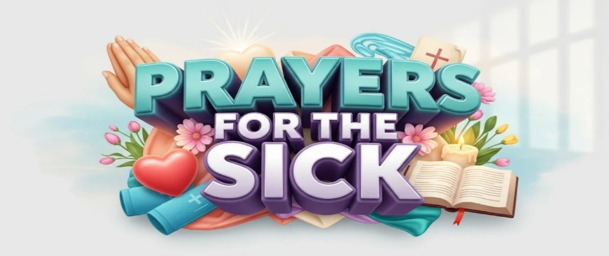

OUR IMMANUEL UCC PRAYER LIST

*Members of Immanuel

*Charles Behrick *David Behrick *Cherry Chase *Janice Jones

*Kenny Kuebler *Dan Riddle *Ruth Rueger *Carol Williams

David Frye Norma Houghton Tom Howard Denis Lambrech

Kenny Meinschein Teresa Topper Ken Willett Eli Williams

If you have names to be added or deleted from the Prayer List, please obtain permission from the person or a family member for their name to be published.



We wish to welcome all in the name of Christ.
We invite you to worship with us every Sunday...
and to become a part of this faith household.

We invite you to sign our Guest Book, located in the Narthex.

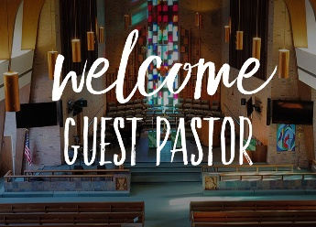  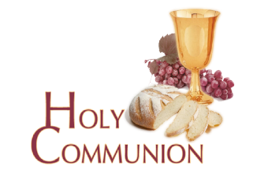  TODAY WE WELCOME  Rev. Steve Angel  who will deliver the message and administer the  Sacrament of Holy Communion. |   NEXT SUNDAY WE WELCOME  Adam McCloud  who will deliver the sermon.



THIS WEEK

SUNDAY 2nd TENTH SUNDAY AFTER PENTECOST
No Adult Sunday School until August 9th
10:00 a.m. Worship
5:30 p.m. – 6:30 p.m. AA Meeting

MONDAY 3rd

TUESDAY 4th

WEDNESDAY 5th

THURSDAY 6th 9:30 a.m. Exercise Class

FRIDAY 7th

SATURDAY 8th

SUNDAY 9th ELEVENTH SUNDAY AFTER PENTECOST
9:00 a.m. Adult Sunday School
10:00 a.m. Worship Service
5:30 p.m. – 6:30 p.m. AA Meeting



August 2 – Rose Brighton Wagner



August 2 – Robert & Eliza Boarman
August 5 – Dennis & Angela Clark
August 8 – Matthew & Brittaney Johnson

