

**August 10, 2025**

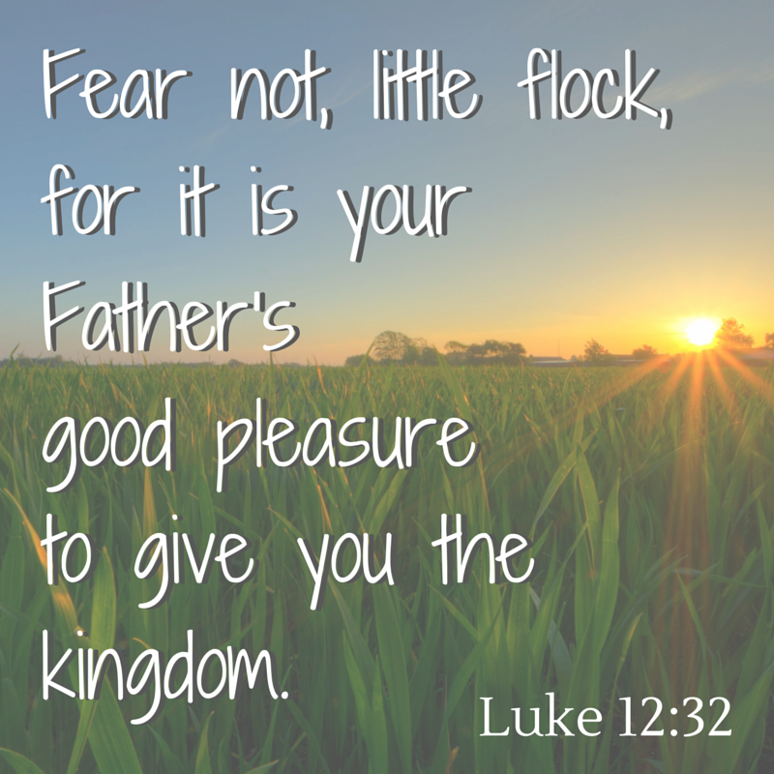

**5812 Ford Rd. N. Mt. Vernon, IN 47620 (812) 985-3115**

**Facebook:** Immanuel United Church of Christ **Church Website:** [www.immanueluccmv.com](http://www.immanueluccmv.com)

**Church Email:** [info@immanueluccmv.com](mailto:info@immanueluccmv.com) **Administrative** **Assistant:** Janie Meinschein

**Our Vision? *“To grow a vibrant church by sharing Christ with the community . . .”***

**Our Mission? *“To invite, inspire, involve, increase . . .”***

**Ninth Sunday after Pentecost**

August 10, 2025

**RINGING OF THE BELL** Keith Deig

**WELCOME AND WORDS OF GREETING** Melody Oeth

**PRELUDE**

**\*PRAISE SONG #2025 (Black Hymnal) *“As the Deer”***

**\*CALL TO WORSHIP -** (based on Psalm 62) Melody Oeth

L: In silence my soul waits for God, who alone is my hope.

**P: God only is my rock and my salvation, my fortress; I shall not be greatly moved.**

L: My deliverance and my honor rest on God, who is my mighty rock, and my refuge.

**P: God only is my rock and my salvation, my fortress; I shall not be shaken.**

L: Trust in God at all times, O people; pour out your heart before God.

**\*OPENING HYMN #76 *“Yesterday, Today, and Tomorrow”***

**\*PRAYER OF CONFESSION (Unison)** Melody Oeth

**We give thanks, merciful God, that in Christ you seek to unite all things in heaven and on earth. You seek to reconcile all people to one another and to you. When we fail to work toward unity, forgive us. Fill us with your Spirit and call us into reunion with You and our brothers and sisters. Amen.**

**\*WORDS OF ASSURANCE**  Melody Oeth

**Hear the Good News:**

**In Christ, we are forgiven and offered new life in the Spirit.**

**Thanks be to God!**

**\*GLORIA PATRI**

**Glory be to the Father, and to the Son, and to the Holy Ghost;**

**As it was in the beginning, is now, and ever shall be,**

**world without end. Amen.**

**CHILDREN’S MOMENTS** Debbie Wells

**PASTORAL PRAYER** Dr. Tom Hickey

Our Lord’s Prayer

**SERVICE OF GIVING** Melody Oeth

**Offertory**

Lay Leader:We hear in Psalm 103, “Bless the Lord, O my soul and all that is within me.

Bless his Holy Name!” May the offering today be a blessing unto God and

bless the mission God sets before us as Immanuel United Church of Christ.

\***Response No. 382**

**Praise God, from whom all blessings flow;**

**Praise Him, all creatures here below;**

**Praise Him above, ye heavenly host;**

**Praise Father, Son, and Holy Ghost. Amen.**

**\*Prayer of Dedication (In Unison)** Melody Oeth

**Everlasting Father, thank you that you are the light of the world, guiding our steps on your path. Your word says that the earth is yours, and everything in it. The world and all its people belong to you. We recognize everything we have belongs to you. We acknowledge that our very lives belong to you. We now offer back to you a portion of what you have given us. May God the Father prepare our journey, Jesus the Son guide our footsteps and the Holy Spirit watch over us, on every path that we follow. Through Jesus Christ, our Lord, Amen.**

**SCRIPTURE – Luke 12: 32-40** Melody Oeth

**32**“Do not be afraid, little flock, for your Father has been pleased to give you the kingdom. **33**Sell your possessions and give to the poor. Provide purses for yourselves that will not wear out, a treasure in heaven that will never fail, where no thief comes near and no moth destroys. **34**For where your treasure is, there your heart will be also.

### Watchfulness

### 35“Be dressed ready for service and keep your lamps burning, 36like servants waiting for their master to return from a wedding banquet, so that when he comes and knocks they can immediately open the door for him. 37It will be good for those servants whose master finds them watching when he comes. Truly I tell you, he will dress himself to serve, will have them recline at the table and will come and wait on them. 38It will be good for those servants whose master finds them ready, even if he comes in the middle of the night or toward daybreak. 39But understand this: If the owner of the house had known at what hour the thief was coming, he would not have let his house be broken into. 40You also must be ready, because the Son of Man will come at an hour when you do not expect him.”

**HYMN #313 *“The King Is Coming“***

**SERMON** “Ready?”Dr. Tom Hickey

**\*CLOSING HYMN**  **#69 *“Soon and Very Soon”***

**Verse 1**  
Soon and very soon, we are going to see the King!  
Soon and very soon, we are going to see the King!  
Soon and very soon, we are going to see the King!  
Hallelujah, Hallelujah, we’re going to see the King!

**Verse 2**  
No more dying there, we are going to see the King!  
No more dying there, we are going to see the King!  
No more dying there, we are going to see the King!  
Hallelujah, Hallelujah, we’re going to see the King!

**Verse 3**  
Soon and very soon, we are going to see the King!  
Soon and very soon, we are going to see the King!  
Soon and very soon, we are going to see the King!  
Hallelujah, Hallelujah, we’re going to see the King!

**\*BENEDICTION** Dr. Tom Hickey

**\*BENEDICTION SONG *“Lord of Life ”***

**Lord, of life, Lord of Love, Walk forever beside us.**

**Day by Day, Show the Way, With your Vision to guide us,**

**Striving to Follow Your Will and Way, Nothing can divide us,**

**Lord of Life, Lord of Love, Walk forever beside us.**

**POSTLUDE**

Used by Permission. CCLI License # 20658309, Streaming # 20658316

**+++++++++++++++++++++++++++++++++++++++++++++++++++++++++++++++++++++++++++++**

**Today** **August 17**

|  |  |  |
| --- | --- | --- |
| Lay Leader  Ushers/Greeters:  Pianist/Organist:  Children’s Moments: | Melody Oeth  OPEN  Beth Folz  Debbie Wells | Debbie Wells  OPEN  Beth Folz  OPEN |

|  |  |
| --- | --- |
| **ATTENDANCE** | LAST WEEK: 42 LAST YEAR: 43 |



**OUR IMMANUEL UCC PRAYER LIST**

***\*Charles Behrick*** ***\*David Behrick******\*Cherry Chase******\*Janice Jones***

***Ken Willett******David Frye Kenny Meinschein Sam Hall***

***Teresa Topper*** *(Friend of Chris Moers)* ***Tom Howard*** *(Brother of Angela Clark)*

***Kiersten Ferguson-Cremin*** *(Niece of Paula Boarman)*



**VISITORS**

We invite you to sign our Guest Book, located in the Narthex.,

as well as the attendance book in the pews.

|  |  |
| --- | --- |
| **SUNDAY**  **August 10th**  Guest Speaker · Parkview Baptist Church  ***We welcome***  ***Dr. Tom Hickey***  ***With Lay Leader: Melody Oeth*** | **NEXT SUNDAY**  **August 17th**  Jay Makowski Preaches - University United Methodist Church  ***We welcome***  ***Rev. Deborah McBride***  ***With Lay Leader: Debbie Wells*** |



**SUNDAY** **10th**  **NINTH SUNDAY AFTER PENTECOST**

9:00 a.m. Adult Sunday School

10:00 a.m. Worship

5:30 p.m. – 6:30 p.m. AA Meeting

**MONDAY 11th 8:30 a.m. God’s Storehouse**

**TUESDAY** **12th**

**WEDNESDAY** **13th**

**THURSDAY** **14th 9:30 a.m. Gentle Exercise Class**

**5:30 a.m. Council Meeting**

**FRIDAY** **15th**

**SATURDAY** **16th**

**SUNDAY** **17th TENTH SUNDAY AFTER PENTECOST**

9:00 a.m. Adult Sunday School

10:00 a.m. Worship

5:30 p.m. – 6:30 p.m. AA Meeting

**

*August 12 – Susan Tucker*

*August 13 – Amelia Johnson*

*August 15 – Ron Tucker*

*August 16 -Julie Renshaw, Greg Renshaw August 12 – Harold & Betty Michael*

**Gentle Exercise Class . . . designed for 40+**

Every **Thursday morning at 9:30** **am** in the Fellowship Hall

Breath & Movement 45 mins~

Discussion on creating a positive mindset 15 min~

Led by De Brown, certified Yoga Instructor and Immanuel UCC member!

*Suggested donation: $5-



|  |  |
| --- | --- |
|  |  |
|  |  |