IMMANUEL UNITED CHURCH OF CHRIST
July 5, 2026 @ 10:00 a.m.



5812 Ford Rd. N. Mt. Vernon, IN 47620 (812) 985-3115
Facebook: Immanuel United Church of Christ Church Website: www.immanueluccmv.com
Church Email: info@immanueluccmv.com Administrative Assistant: Janie Meinschein
Pastor:
Our Vision? “To grow a vibrant church by sharing Christ with the community . . .”
Our Mission? “To invite, inspire, involve, increase . . .”

Sixth Sunday after Pentecost
Independence Day Sunday
July 5, 2026 - Rev. Robert B. Walker

RINGING OF THE BELL Keith Deig

WELCOME AND WORDS OF GREETING Bobbie Hoebeke

PRELUDE “Variations of God Save the King” by Charles Wesley

*Hymn #370 “O God, Our Help in Ages Past”

*CALL TO WORSHIP (written by Rev. RBW) Bobbie Hoebeke

Pastor: May the Lord be with you!
People: And may the Lord be with you, also!
Pastor: The Lord created the world and then,
People: God created us: our ancestors, our families from different continents and islands,
Pastor: from Europe and Asia, from the Middle East and Africa --- from all over the world!
People: Then God’s children came to this land, a land to sharing Freedom, Justice, and Charity.
Pastor: St. Paul tells us, “ Let us then pursue what makes for peace and for mutual upbuilding.” (Romans 14:19)
People: Christ will help us pursue peace and upbuilding here at Immanuel Church and our United States!

*Hymn #690 “America, the Beautiful”

*PRAYER OF CONFESSION (Unison) Bobbie Hoebeke

Wise and patient God, you offer us peace, yet we confess life often feels frustrating and unsettled. You offer us courage, yet we are timid and resentful when life is challenging. You offer us a mission with meaning and purpose, yet we are preoccupied with our own plans and desires. Forgive us, O God, and draw our attention back to you. Amen.

*WORDS OF ASSURANCE Rev. Bob

*GLORIA PATRI
Glory be to the Father, and to the Son, and to the Holy Ghost;
As it was in the beginning, is now, and ever shall be,
world without end. Amen, Amen.

SPECIAL MUSIC “He’s Alive” Dee Temple
“Be Still and Know He is God”

PRAYERS OF THE PEOPLE
Pastoral Prayer ~ The Lord’s Prayer

SERVICE OF GIVING
Call to Sharing – Rev. Bob

Offertory “Simple Gifts” by Russell Schulz-Widmar
*Response No. 382

Praise God, from whom all blessings flow;
Praise Him, all creatures here below;
Praise Him above, ye heavenly host;
Praise Father, Son, and Holy Ghost. Amen.

*Prayer of Dedication (Unison) Bobbie Hoebeke

O Lord, giver of life and source of freedom, I know that all I have received is from your
hand. You call us to be stewards of Your abundance, the caretakers of all you have
entrusted to us. Help us to always use Your gifts wisely and teach us to share them
generously. May our faithful stewardship bear witness to the love of Jesus Christ in our
lives. Amen

SCRIPTURES 1. Joshua 24:14-15 Bobbie Hoebeke

¹⁴ “Now therefore fear the Lord and serve him in sincerity and in faithfulness. Put away the gods that your fathers served beyond the River and in Egypt, and serve the Lord. ¹⁵ And if it is evil in your eyes to serve the Lord, choose this day whom you will serve, whether the gods your fathers served in the region beyond the River, or the gods of the Amorites in whose land you dwell. But as for me and my house, we will serve the Lord.”

2. Mark 12:17
Jesus said to them, “Render to Caesar the things that are Caesar's, and to God the things that are God's.” And they marveled at him.

SERMON HYMN #687 “God of Our Fathers”

SERMON “The Things That Are God’s” Rev. Bob

The Lord Invites Us To His Table

*Communion Hymn # 556 “There’s a Quiet Understanding”

Welcome to The Table

Words of Institution

Prayer of Consecration

The Bread Broken, The Fruit of the Vine Poured
(The Ushers will share the Elements to you in the pews)

*Prayer of Thanksgiving
Heavenly Father, Thank You for this sacred moment of communion. My heart is full of
gratitude for Jesus’ sacrifice, for the forgiveness of my sins, and for the new life I have in
Him. Lord, guide our steps, fill us with Your peace, and use us to be a light for Your glory.
In Jesus’ name, I pray. Amen.

*PASTORAL COMMISSION & BENEDICTION Rev. Bob

*BENEDICTION SONG #692 “Battle Hymn of the Republic”

POSTLUDE “Variations on God Save the King” by Charles Wesley

Used by Permission. CCLI License # 20658309, Streaming # 20658316
+++++++++++++++++++++++++++++++++++++++++++++++++++++++++++++++++++++++++++++

Today July 12
Lay Reader  Ushers/Greeters:  Pianist/Organist: | Bobbie Hoebeke  Terri, Emmerson & Lennox McCormick  Gail Angel | Jennifer Willett  Nelda Hickey  Beth Folz

OUR IMMANUEL UCC PRAYER LIST

*Members of Immanuel

*Charles Behrick *David Behrick *Cherry Chase *Janice Jones

*Dan Riddle *Ruth Rueger David Frye Norma Houghton

Tom Howard Denis Lambrech Kenny Meinschein Teresa Topper

Evelyn Will Ken Willett Eli Williams

If you have names to be added or deleted from the Prayer List, please obtain permission from the person or a family member for their name to be published.


We wish to welcome all in the name of Christ.
We invite you to worship with us every Sunday...
and to become a part of this faith household.

We invite you to sign our Guest Book, located in the Narthex.

WE WELCOME TO OUR CHURCH:

Today: Rev. Bob Walker. He will deliver the sermon and Communion.
Next Sunday: We welcome Wendi Nelson who will deliver the sermon.


Gentle Exercise Class
designed for 40+

Every Thursday morning at 9:30 am in the Fellowship Hall
Breath & Movement 45 mins~
Discussion on creating a positive mindset 15 min~
Led by De Brown, certified Yoga Instructor and Immanuel UCC member!
*Suggested donation: $5-

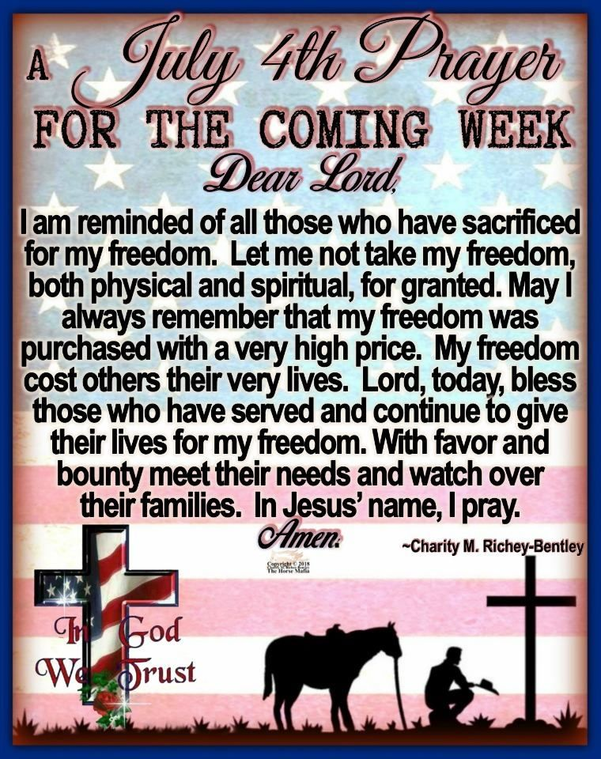

THIS WEEK

SUNDAY 5th SIXTH SUNDAY AFTER PENTECOST
No Adult Sunday School until August
10:00 a.m. Worship
5:30 p.m. – 6:30 p.m. AA Meeting

MONDAY 6th

TUESDAY 7th

WEDNESDAY 8th

THURSDAY 9th 9:30 a.m. Exercise Class

FRIDAY 10th

SATURDAY 11th Fellowship Hall Reserved

SUNDAY 12th SEVENTH SUNDAY AFTER PENTECOST
No Adult Sunday School until August
10:00 a.m. Worship Service
5:30 p.m. – 6:30 p.m. AA Meeting



July 5 – Tom Hickey
July 8 – Beau Baldwin
July 9 – Bret Baldwin
July 10 – Chris Friedman



July 8 – Justin & Ashton Wagner
July 9 – Mike & Mary Ledbetter
July 9 – Ben & Sarah Alexander

